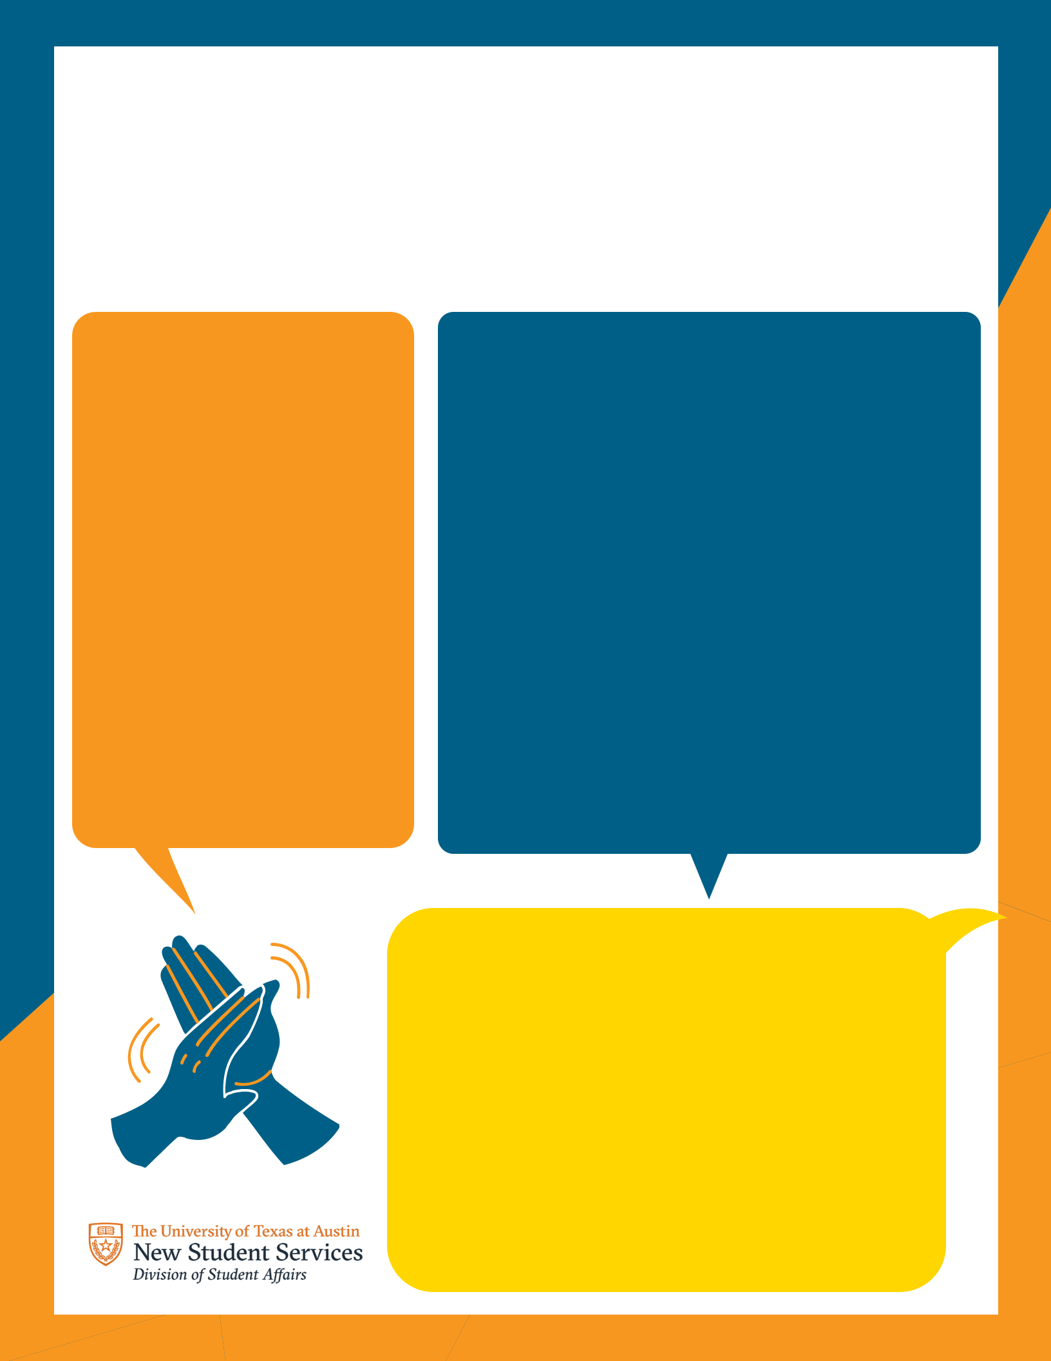Roommate Agreement
Having a roommate is a great_{During}opportunity to_{COVID}expandyoursocial circle and make more

connections, but even in the best situations, it can be stressful at times. Add the current COVID-19 situation, and it can make things even more complicated. Use this worksheet as a tool to have a discussion on how to handle the current COVID-19 situation as roommates.

Cleaning

Do we want to increase cleaning practices?

Who is responsible for cleaning each area?

What are things that need to be wiped down daily?

Are any guests allowed in our apartment? If so, who is allowed or how would you like to notify each other?

How many people at a time can be in the apartment?

What additional items do we need to purchase (hand sanitizer, disinfecting wipes, etc.)?

Communication

If we are not currently comfortable with guests coming over, when might we feel comfortable having guests over in the future?

Guests

How should we notify each other of health changes?

What is the best way to communicate with each other if we are experiencing symptoms?

How would we handle a situation in which one roommate has to self-isolate?

Masks

What are your thoughts on mask usage in the apartment and in the apartment complex?

Are guests required to wear masks in our apartment?
Behaviors
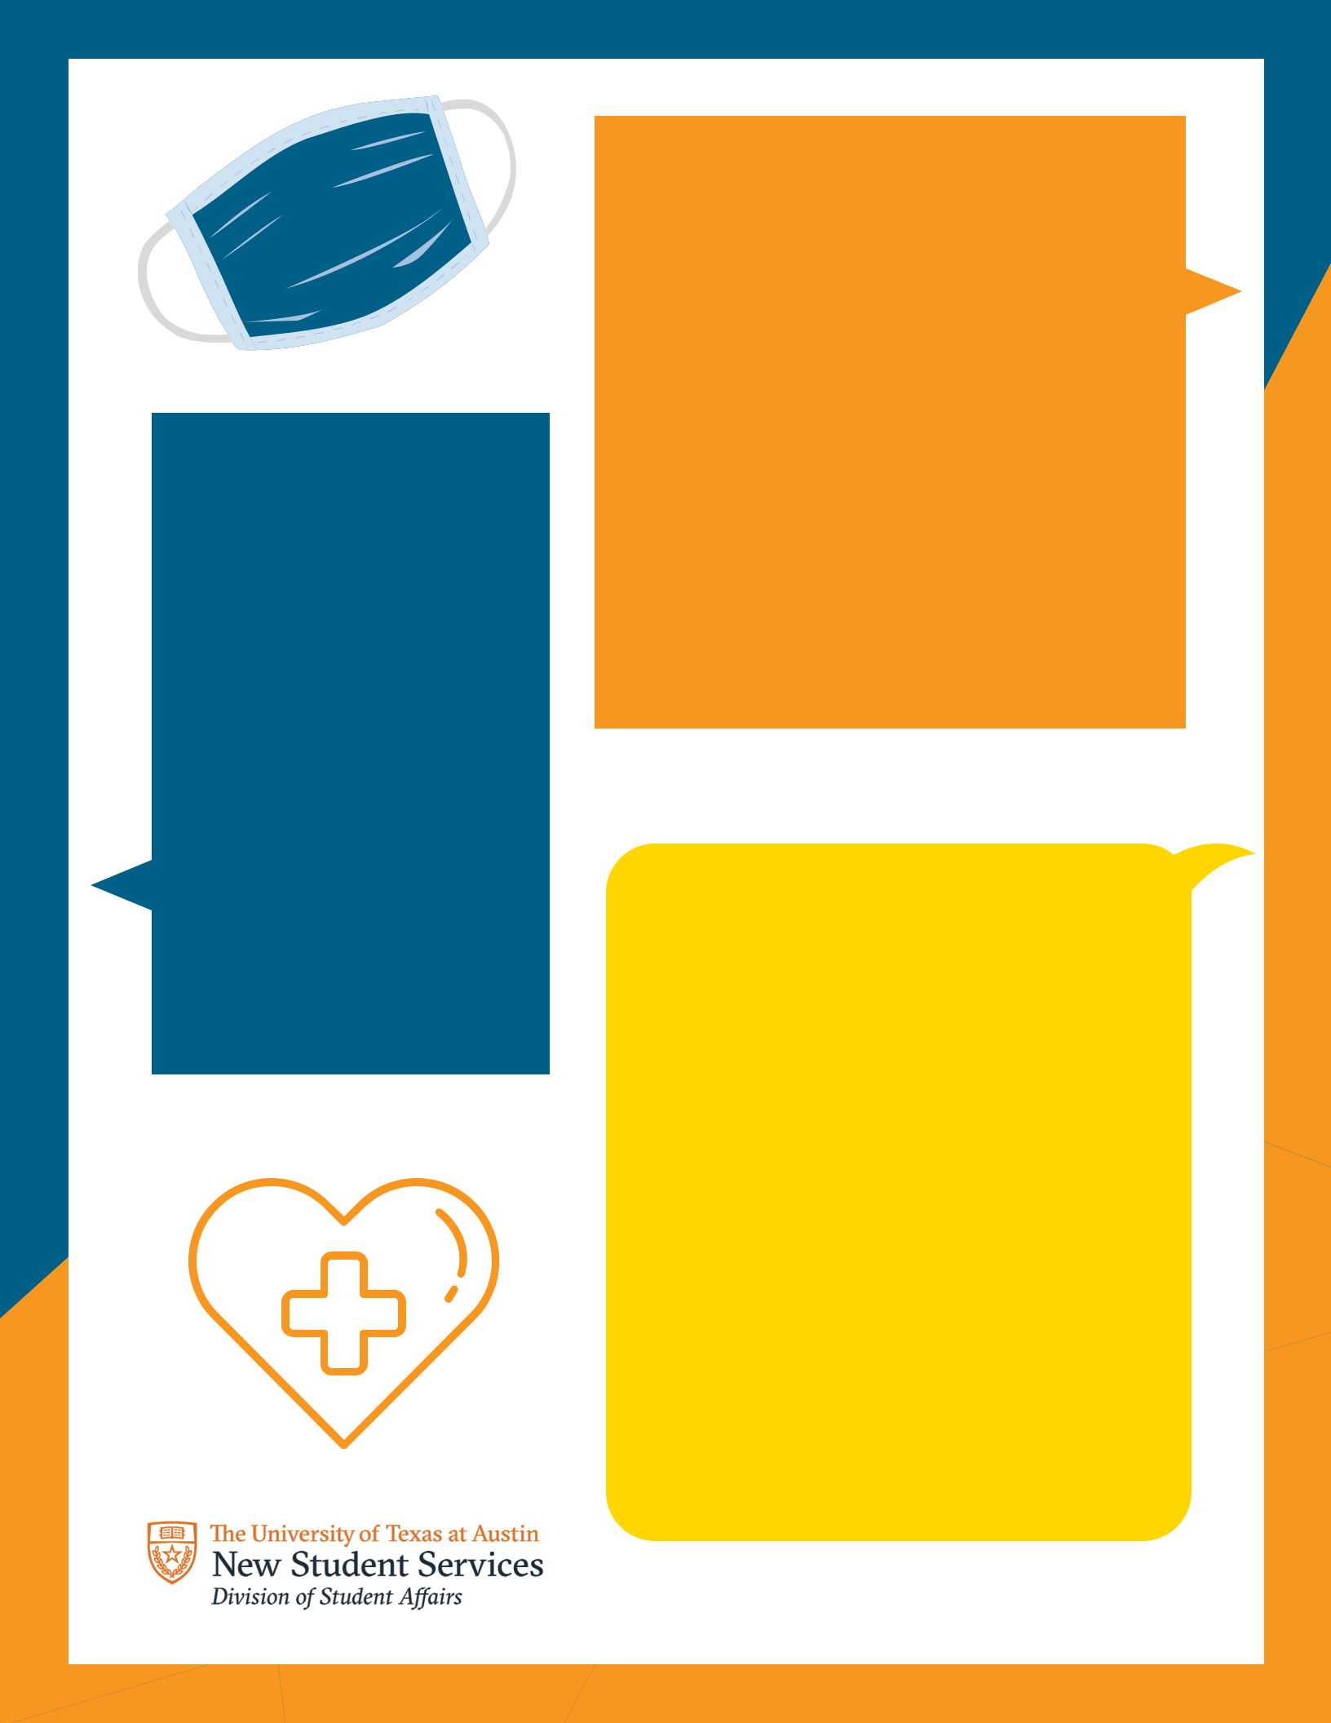

What behaviors will we limit because we consider them to be too risky?

What travel do we have planned for this semester?

How do we want to handle grocery shopping (separate shopping, one person shops, curbside, etc.)?

Support

How can we support each other?

Should we schedule weekly mental health check-ins?

Do we want to set aside space for workout equipment?

Do we need increased quiet hours in the apartment?

Do we want to start a monthly game night or weekly roommate dinner?

