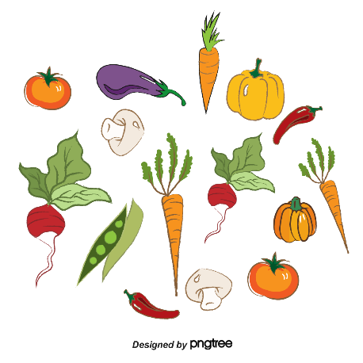
GROCERY LIST
DAIRY  ________________________  ________________________  ________________________  ________________________  ________________________  ________________________  _______________________  ________________________  ________________________  ________________________  ________________________ |  | FRUIT/VEGETABLE  ________________________  ________________________  ________________________  ________________________  ________________________  ________________________  ________________________  ________________________  ________________________  _______________________  _______________________ |  | FROZEN FOODS  ________________________  ________________________  ________________________  ________________________  _______________________  ________________________  ________________________  ________________________  ________________________  ________________________  ________________________
CANNED GOODS  ________________________  ________________________  _______________________  ________________________  ________________________  ________________________  ________________________  ________________________  ________________________  _______________________  ________________________  _______________________ |  | MEAT & SEA FOOD  _________________________  _________________________  _________________________  _________________________  _________________________  _________________________  _________________________  _________________________  _________________________  _________________________  _________________________  _________________________ |  | OTHER  _________________________  _________________________  _________________________  _________________________  _________________________  _________________________  _________________________  _________________________  _________________________  _________________________  _________________________  _________________________

