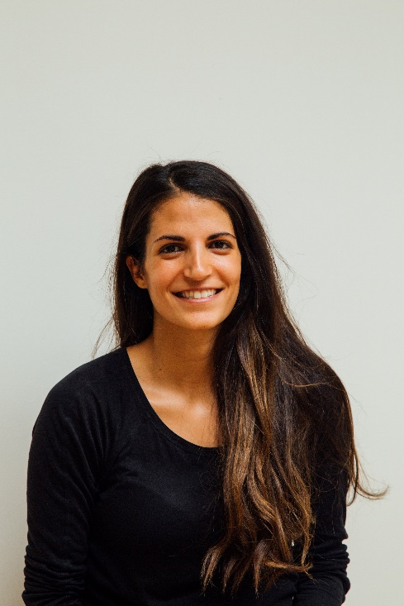

SKILLS

* Adept at managing a large number of students in a classroom to ensure effective learning
* Proficient in developing activities, tools, and methods to help students learn English in different and unique ways
* Superior skills in bridging the gap between Spanish and English
* Excellent ability to connect with students and encourage them to excel
* Dedicated to helping students master English despite learning disabilities or other challenges
* Ability to work with students individually or in groups to increase language development

EXPERIENCE

**ESL Teacher, 20XX – Present, Company Name**

* Create lesson plans, including developing assignments, activities, and projects, and scheduling special events.
* Teach five classes each day with an average of 25 students each, including beginner, intermediate, and advanced levels.
* Use technology to develop interactive teaching activities.
* Encourage students to use English in their daily lives to increase proficiency.

**Spanish Teacher, 20XX – 20XX, Company Name**

* Developed lesson plans for five classes at different levels of proficiency.
* Created activities and assignments to encourage and assist students with language acquisition.
* Encouraged students through special events and fun activities.
* Took students on the yearly trip to Spain to immerse them in Spanish culture.
* Conducted online seminars

EDUCATION

**State of Colorado Teacher’s License** current

Colorado Department of Education

**Dual Master of Arts in Spanish and English** 20XX, Big Sky College

PROFILE

Dedicated ESL teacher focused on providing an innovative, fun, and inspiring classroom. Track record of encouraging students to master English while also nurturing their love of the language. Committed to finding new methods to get better results and improve the ESL program.

CONTACT INFORMATION

123 Fake Street, Fake Town, City, State

[email@email.com](mailto:email@email.com) 000-000-0000

GIORGIA LANE

ESL TEACHER