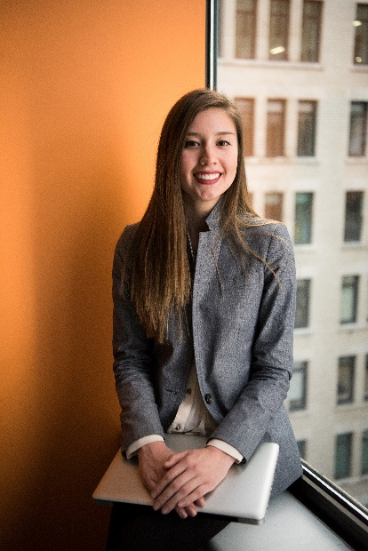

Education

UNIVERSITY OF ALABAMA, Birmingham, AL

Master of Arts in Art Education, April 20XX

Honors: cum laude (GPA: 3.7/4.0)

Additional Skills

* Expert in Microsoft Office (Word, Excel, and PowerPoint), iMovie, and Adobe Photoshop
* Solid expertise in Visual Arts, Photography, Videography, and related tools
* Bilingual in Spanish and English

PROFESSIONAL EXPERIENCE

**TUSCALOOSA MIDDLE SCHOOL MAGNET, Tuscaloosa, AL**

**Art Teacher, September 20XX–Present**

* Teach visual art education to a class of 35 students with different learning styles, which include art history, drawing, painting, sculpture, photography, and videography
* Empower students with the knowledge to utilize their own artistic vision within the world around them through the use of traditional and digital mediums
* Work closely with art education professionals on teaching plans, resulting in achieving 95%+ on quarterly program evaluations
* Motivate students to participate in outside art creativities, sending 20 students to take part in County Art Show, 4 of which won awards for exceptional artistic skills

**MINOR HIGH SCHOOL, Boston, MA**

**Art Teacher, May 20XX–September 20XX**

* Instructed fine arts to 40+ students of K-8 in core areas such as drawing, painting, commercial design, printmaking, aesthetics, art history, and art appreciation
* Developed an enthusiastic and positive classroom environment to target interests and learning styles of students
* Monitored and tracked the progress of 80+ students from which 93% of students achieved two years of growth on cognitive drawing rubric

Highly creative Art Teacher with 8+ years of experience delivering visual art education in the areas of drawing, painting, sculpture, photography, and videography. Skilled in integrating a multi-dimensional, interdisciplinary, and multicultural curriculum that links the arts, history, and social movements.

123 Your Address City, State, Zip Code (xxx)-xxx-xxxx your@email.com

**Art Teacher**

**SAMANTHA  
MORRIS**