**Using Templates to Develop**

**Thesis Statements**

**Claims**

**Counterclaims**

**Draft Document**

Bill Atwood

©2013 Bill Atwood [thebillatwood@gmail.com](mailto:thebillatwood@gmail.com)

**Introduction:**

The Common Core Standards call for an increased amount of opinion and argument writing. Central to effective argument is the skill of crafting an effective claim or thesis. This set of templates will help students practice this skill. Modeling, independent practice, and corrective feedback are critical for students to improve. Structuring the thesis statement on a template makes this process more manageable.

This is a draft document. Your feedback is essential to improving this tool.

Bill Atwood

Collins Education Associates [thebillatwood@gmail.com](mailto:thebillatwood@gmail.com)

**Sample Argument Template/Thesis Level A**

**FCA:**

**Identify the specific topic 20**

**FCA:**

**Clearly present claim (avoid I) 20**

**FCA:**

**2-4 relevant and distinct reasons with parallel structure 60**

**Topic**

Identify specific topic and insert claim (arguable position try to avoid “I”)

insert claim cont. (arguable position try to avoid “I”)

(Insert claim cont.)

succinctly state reasons in order they will be presented (use parallel structure!)

**Samples of Parallel Structure:**

**Cursive handwriting should not be taught in schools because… (base clause)**

1. it is a waste of valuable time, scarce resources, and student energy. (3 adj/nouns: *waste of valuable time, scarce resources, student energy*…)

2. students hate doing it, teachers don’t have time to teach it, and society does not value it. (3 subject/verbs…)

3. it is impractical, tedious and a wasteful. (3 adjectives)

4. spending money and time on a useless skill is wasteful, forcing kids to do something they hate does not build character, and using school time to revive an anachronistic art form is a sad, sentimental folly.

(3 verb phrases)

5. of the exorbitant amount of time it takes to teach, the poor match for today’s skills, and the questionable benefits for motor skill development. (prepositional phrase with 3 nouns: *because of time, match, benefit*)

*Thesis statements probably do not have to exactly parallel to be effective but this structure can build rhythm and make thesis statements more clear and concise. However, in the beginning, there is the possibility that these formats will lose a student’s natural voice and sound awkward. With practice, the statements should become smoother.*

**Other examples:**

**Social studies:**

1. Ancient Egypt and Ancient Greece are more similar than different because of their extensive artwork, important scientific discoveries, and advanced writing system. (because of…)
2. Ancient Egypt and Ancient Greece are more similar than different because both civilizations placed a huge emphasis on gods, architecture, and recording history. (subject/verb *civilizations placed* then preposition *on*… 3 nouns)
3. Ancient Egypt and Ancient Greece are more similar than different because they were advanced in technology, skillful in the arts, and observant in their religions. (3 adjectives)

**Science:**

1. Cloning should not be federally funded because of its questionable benefits, exorbitant costs, and obvious danger to the population. (3 adj/nouns)
2. Cloning should not be federally funded because it’s ineffective, expensive, and dangerous. (3 adjectives)
3. Cloning should not be federally funded because poor people can’t afford it, knowledgeable people don’t trust it, and evil people will misuse it. (3 subject verbs)

**Literature:**

1. In the novella, *Of Mice and Men,* John Steinbeck portrays the loneliness and isolation of humans through the failures of Candy, Crooks, and Curly’s wife to connect to other characters. (prepositional phrase with 3 nouns)
2. In the novella, *Of Mice and Men,* John Steinbeck portrays the post-depression America as an era of loneliness, oppression, and longing. (3 adjectives)
3. In the play Romeo and Juliet, William Shakespeare illustrates how one’s relationships are controlled by fate rather than actions through Romeo and Juliet’s instant connection at the ball, Ben Volio’s role in bringing the pair together, and the tragic timing of their deaths. (3 nouns)

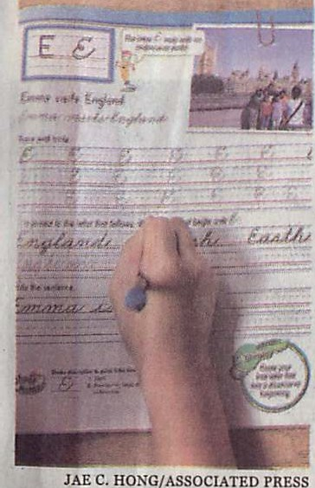

I DECEMBER 2, 2012

**The Nation** Al3 +.

BOSTON SUNDAY GLOBE

**Some states ensure penmanship art won't fade**

Few buck trend to erase cµrsive

By Christina Hoag

**ASSOCIATED PRESS**

LOS ANGELES - The pen

may not be as mighty as the keyboard these days, but Cali­ fornia and a handful of states arenot giving up on handwrit­ ing entirely.

Bucking a growing trend of eliminating cursive from ele­ mentary school curriculums or making it optional, California is among the states keeping long­ hand as a third-grade staple.

The state's posture on pen-

**that don't include cursive writ­** ing but require computer key­ boarding proficiency by the time pupils exit elementary school.

Several states, including Cal­ **ifornia, Massachusetts, and** Georgia have added a cursive writing requirement to the na­ tional standards, while most others, such as Indiana, Illinois, and Hawaii have left it as op­ tional for school districts. Some states, like Utah, are still study­ ing the issue.

Whether it is required or not, cursive is fast becoming a lost art as schools increasingly replace pen and paper with

manship is not likely to under­ cut its place at the leading edge of technology, but it has teach­ ers and students divided over the value of learning flowing script in an age of touchpads and mobile devices.

**Some see it as a waste of**

**time, an anachronism in a digi­** tized society where even signa­ tures are electronic, but others see it as necessary so youths can hone fine motor skills, reinforce literacy, and develop their own unique stamp of iden tity.

The debate comes as 45 states move toward adopting national curriculum guidelines in 2014 for English and math

**classroom computers and in­** struction is increasingly geared to academic subjects that are tested on standardized exams. Even the standardized tests are on track to be administered via computer within three years.

Some educators say writing in block letters may be suffi­ cient when it comes to hand­ writing in the future.

"Do you really need to learn **two different scripts?" said** Steve Graham , education pro­ fessor at Arizona State Univer­ sity who has studied handwrit­ ing instruction. "There will be plenty of kids who don't learn cursive. The more important

**skill now is typing.11**

Cursive still has many pro­ ponent s who say it ben efits **youngsters' brains, coordina­ tion, and motor skills, *as* well as** connects them to the past, whether to handwritten histori­ cal documents like the Consti­ tution or to their parents' and grandparents' letters.

Longhand is also a symbol of **personality, even more so in an** era of uniform e-mails and text­ ing, they say.

For many teachers , having children spend hours copying flowing letters isn't practical in an era of high-stakes standard­ ized testing.

**JAE C. HONG/ ASSOCIATED PRESS**

A student practiced cursive writing at an elementary school in California.

**Fix these actual thesis statements written by students:**

Halloween is better than Valentines Day because you get to dress up, go out at night, and the candy is good.

Valentines day is better than Halloween because is has more delicious candy, more opportunities for love, and the colors are beautiful.

Legos belong in the Toy Hall of Fame because they are imaginative, inexpensive and they last a long time.

Video cameras don’t belong in classrooms because they will make school feel like a prison, interfere with learning, and schools can’t afford them.

Video games are beneficial to children by helping them in future jobs, for health reasons, and in developing challenges.

Shakespeare uses imagery, symbolism and develops characters to demonstrate that Hamlet is insane.

**Fix these thesis statements to make them parallel:**

Halloween is better than Valentines Day because you get to dress up, go out at night, and ~~the candy is good.~~

get tons of candy.

Valentines day is better than Halloween because Valentines Day has more delicious candy, more opportunities for love, and ~~the colors are beautiful.~~

more beautiful colors.

Legos belong in the Toy Hall of Fame because they are imaginative, inexpensive and ~~they last a long time~~.

long-lasting.

Video cameras don’t belong in classrooms because they will make school feel like a prison, interfere with learning, and ~~schools can’t afford them.~~

cost too much for schools to purchase.

Video games are beneficial to children by ~~helping them in future jobs, for health reasons, and in developing~~ ~~challenges.~~

preparing students for future jobs, improving their fine motor skills, and teaching them to overcome difficult

challenges.

Shakespeare uses imagery, symbolism and ~~develops characters~~ to demonstrate that Hamlet is insane.

character development

Resources:

[**http://www.slideshare.net/weigansm/thesis-statement-workshop#btnPrevious**](http://www.slideshare.net/weigansm/thesis-statement-workshop#btnPrevious)

[**http://www.slideshare.net/wendywarren1969/how-to-write-a-three-part-thesis-statement**](http://www.slideshare.net/wendywarren1969/how-to-write-a-three-part-thesis-statement)

[**http://owl.english.purdue.edu/owl/resource/623/1/**](http://owl.english.purdue.edu/owl/resource/623/1/)

[**http://www.slideshare.net/cptjacksparrow/aarrgh#btnNext**](http://www.slideshare.net/cptjacksparrow/aarrgh#btnNext)

[**http://www.ehow.com/info_8406160_must-parallel-structures-thesis-statements.html**](http://www.ehow.com/info_8406160_must-parallel-structures-thesis-statements.html)

**Why Must We Use Parallel Structures in Thesis Statements? | eHow.com** [**http://www.ehow.com/info_8406160_must-parallel-structures-thesis-**](http://www.ehow.com/info_8406160_must-parallel-structures-thesis-) **statements.html#ixzz2FMm9oFIM**

**Sample Assignment**

Which feature of Ancient Egypt is most important in developing a deep understanding of this civilization? After reviewing your notes and sections in your text book, write a letter to the publisher of the textbook arguing for more attention and information on one characteristic of feature of this great civilization. Use details from the text and analysis from your notes to support your argument. Be sure to acknowledge counter claims in your introduction.

FCAs

1. Introduction gives background for argument 10 points
2. Clear thesis which includes counter claim (i.e. “Although…”) 20
3. 2+ reasons with supporting examples and logical, persuasive explanations/ elaboration

Sample beginning of 2-3 paragraph version:

Dear Silver Burdette Publishers,

As a seventh grader studying Ancient Egypt, I have enjoyed the chapters you have included. Because Ancient Egypt is such a complicated civilization, it must be difficult to decide which materials to include in your edition. While many historians might suggest more information on religion and mummies, I suggest you include more on the climate and geography because students have little understanding of the unique terrain of this region and most students don’t understand how geography shapes the entire civilization.

The desert region of ancient Egypt is foreign to many students. In today’s world most students don’t know what it would be like to depend on one river for survival. This makes it difficult for students to understand the life in Ancient Egypt and how worried people must have been about rain, crops, and harvests. If you put in more charts that compare the climate to the US climate it might help students compare the regions. The most important reason to include more on geography is because it shapes both the religion and the economy. Because of the important need for rain and good harvests, Egyptians developed and prayed to many gods to protect this important food source…

Sample of shorter 1 paragraph version:

As a seventh grader studying Ancient Egypt, I have enjoyed the chapters you have included in your textbook. Because Ancient Egypt is such a complicated civilization, it must be difficult to decide which materials to include in your edition. While many historians might suggest more information on religion and mummies, I suggest you include more on the climate because students need to see how climate influences the technology and religion. Because Egypt was so dependent on agriculture it developed many new and innovative technologies to improve irrigation. For example, the shadof was a one-of-kind invention for drawing water to the surface of the ground. (see illustration). Also, the climate influenced the religion because gods were developed to guarantee a good harvest. Both the sun god, Re, and and God of the Nile, Hapi were worshipped to produce a good harvest. If you include more on the climate, students will be able to understand how it shapes both technology and religion and that will help them understand the civilization more deeply.

**Sample Argument Template/Thesis Level B**

**FCA: Thoughtfully acknowledge counter claim ,** 20

**FCA: Clearly present claim (avoid I) 20**

**FCA: 2-4 relevant and distinct reasons with parallel structure**

**60**

**Topic**

(Although, Despite, Even though, While, In spite of…)

insert counter claim

counter claim continued

insert arguable position (avoid pronoun I)

succinctly state reasons in order they will be presented (use parallel structure!)

**(for context see Boston Globe article September 9, 2012**

[**http://www.boston.com/lifestyle/health/articles/2012/09/09/growing_drug_problem_is_being_addressed_at_high_schools/)**](http://www.boston.com/lifestyle/health/articles/2012/09/09/growing_drug_problem_is_being_addressed_at_high_schools/))

**Topic Sentence (does not name reasons!):**

To reduce drug use in high schools, towns should use a community based approach for several reasons.

**A. Thesis (names reasons/ offers points to be proven):**

In order to reduce drug use in high schools, towns should use a community based approach with an emphasis on counseling *because it is less costly, much more effective, and more in line with the educational mission of schools.*

1. (clauses with predicate adjectives/adverbs)

because it is not only less costly and intrusive, it is much more effective in the long term.

2. (verbs with direct objects and phrase)

because it costs less money, builds a positive atmosphere, and actually works better for students with drug problems.

3. (direct objects and phrases)

because this approach will create a better school atmosphere, involve students and families both in and out of school, and focus attention and energy on the student’s emotional state which is at the heart of the problem.

**B. Thesis with a counter claim in 1 sentence:**

Although many would argue that the best way to slow the spread of drug use in high schools is with increased police presence, a community-based counseling approach will create a better school atmosphere, involve students and families both in and out of school, and focus attention and energy on the student’s emotional state which is at the heart of the problem.

**C. Thesis in 2 sentences:**

1. Although many would argue that the best way to slow the spread of drug use in high schools is with an increased police presence, it would be more effective to use a community-based counseling approach. This approach will create a better school atmosphere, involve students and families both in and out of school, and focus attention and energy on the student’s emotional state which is at the heart of the problem.

2. Many would argue that the best way to slow the spread of drug use in high schools is with an increased police presence, drug sniffing dogs, video cameras and drug testing. However, a community based approach is better because…

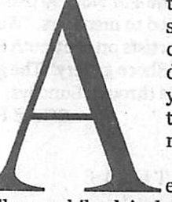

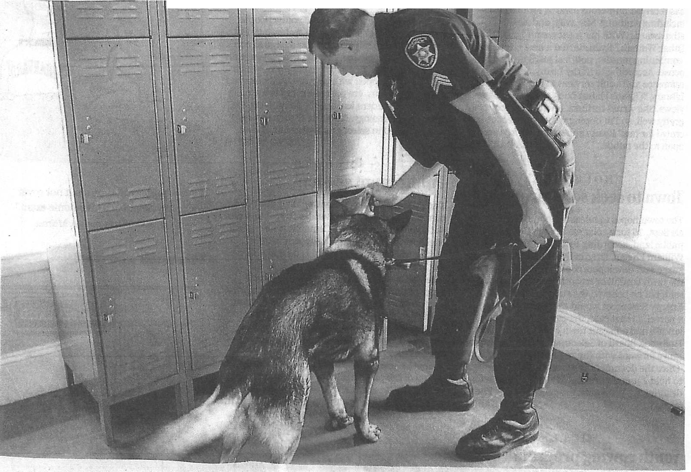

**SOBERING FACTS**

Results from the 2011Massachusetts Youth Health Survey and the Massachusetts Youth Risk Behavior survey of high school stude nst. *

**40** % **reported drinking every month 22**% **binge drink (five or more tlrlnks within two hours) *6***% **report nonmedical use of• prescription 28**% **use marijuana 5**% **use inhalants 30** %**use a drug 4** % **use alcohol during school *6***% **use marijuana during school 27% report being offered, sold,. or given an illegal drug·on school property in the previous 12 months.**

SOURCES: Mass. Department ofPu bcli Health, M**r**a-ss. Depa.rtment o,f Elementary and Secondary Education. "Unel ss noted otherwise, the_use..w..a,_sre,p_orted as occur

J days

-:;-.=.;- - -

_

**ergeant Brian Bersani of the Norfolk County Sheriff's Department and Basko, a 9-year-old drug-sniffing dog, search a school locker.**

**Fighting drugs inschools**

Cameras, dogs, and on-site police watch teens who seem more willing to experiment

**By Steven A. Rosenberg**

GLOBE STAFF

t more than 100high schools in Eastern Massa­ chusetts , drug-sniffing dogs are brought in every year to search for every- . thing from alcohol to marijuana.

In Q,uincy, video cam­ eras followstudents in the

illways while plainclothes securityguards stay

;tertfor drugactivity. AtWestford AcademY,

w'herestudents admitting in a survey to marijua­

**\/JcJ,.**use jumped from 16 percent to 25 percent in

the pastdecade, the principal decided to add a full-time policeofficer to the staff. Meanwhile at Newton North High School, counseling is con­ sidered the bestwayto reach students.

These days, schools are spending more time than ever tryingto prevent teens from using drugs. While dog searches rarely result in major drugfinds or arrests, law enforcement officials, such as Middlesex District Attorney GerryLe-· one, said they are partof a prevention policy­ one that includes communication, education, and surveillance -: that is necessary to reach teens before theybecome addicted.

'1n large measure, the canines are a deter­

rent;•said Leone, who believes increased cooper-

ation between schools, police, stateagencies, and parents is necessary to reduce drug use amongstudents.

In addition, many schools nowhave a full­ time policeofficer who bonds with students and tries tointervene before a student's drugusegets out of hand. District attomeys also regularly come to schools to address students, and they bring along recovering addicts who talk about the dangersof drugs. Health classes discusssub­ stance abuse and the effect drugs haveon a teen's body; school psychologists and counselors are on handto deal with problems.

"There's no magicbullet to this. It'sjust a lot

**DRUGS, Page** 3

ring inthe_ ast 3

.:;.-_-

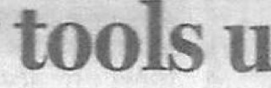

**Ne**

*Continue.dfrom Page 1*

of olling up the sleeves,·and omg the hard work and get­ ting the message out to kids to make good decisions," said Es­

sex District Attorney Jonathan Blodgett.

Even with all of these efforts drugs and alcohol still can b found in and around schools cc?rding to the latest statesta t1st1cs compiled in 20II 40 percent of high school stud nts

r po ding tosurveys reported drinking every month and 22 percent said they binge drink (c_on_sume five or more drinks Within two hours). Also, 28 -

e nt of teens said they use mam-

J ua na at least once a mo

and 27 percent said they ha . been offered or sold an illegal drug on school property Within the past year.

S percent reported non­ me d1 al use of a prescripti on drug ID the last month, and an­ other 5 p_ercent said they had

used an mhalant in the last month.

Blodgett and other district atto neys and educators said manJuana has steadily become ore popular among teens smce the law was eased in 200 , no longer penalizing pos­

s e ss 1_ _on of small amounts of manJuana With jail time. The law now calls for a fine for

**used in fight against school drug**

►**D RUGS**

your friends are,'' said Benja­ min, a senior at Needham High School who said she does not use drugs. "You'll feel it's more normal to do because you lo:ioW others are doing it."

Some, including Haley McDevitt of Nahant, said edu­ cational courses about sub-1 stance abuse had no influence on her decision to avoid drugs.

"I think of my personal health, and I want my lungs healthy and my brain to work," she said.

Joshua Robinson of Beverly said he thinks a heavier police presence at schools will keep most students in line during the daY, but will not deter them· from finding and using drugs after schook Robinso n, 16, at­ tends the Northshore Recovery High School in Beverly. From age 12 to 15, Robinson said be combined alcohol, mari juana, hallucinogens, and Adder all - a prescription amphetamtne - regularly.

He now speaks to m1ddle school students about his ad-: diction and recovecy, and said those like himself - who are just a few years older than stu­ dents in the audience - may have the most impact in pre­ venting kids from taking drugs. "Listening to kids in recov­ ery helps immensely, and I think the age difference is very important," Robinson said. "Repetition helps young peo­

In August, Antonelli - who calls in dogs to search the school several times a year - said he planned to add a full­ time police officer to the school staff.

"It's going to open a new line of communication;' said Anto­ nelli. "Kids will come down and talk to the person and indicate a potential party of drug activi­ ty. A lot of kids don't want tosee it around the building, and they need a conduit to talk to some­ body:•

Herb Levine, executive di­ rector of the New England As­ sociation of School Superinten-

dents, said he thinks schools need to go one step farther and implement random mandatory drugtestin .

"Drugs are everywhere - in the smaller schools, rich towns, poor towns, urban, and subur­ ban. If you want it, it's there," said Levine, a former superin­ tendent in Salem and interim superintendent in Peabody. He now serves as a special adviser to the Peabody mayor and school district.

Levine said drug tests could serve as another part of a com­ munitywide prevention plan that includes a sustained mes­ sagefrom teachers, social work­ ers, drug counselors, prin ci­ pals, coaches, and parents.

"Ifwe don't know about it we can't address it, and the only way we'll actually know about it is if we can test. It's another ar­ row we can give to our parents"

Swampscott High School, par- ents are required to sign a year­ round chemical health policy contract that can have wide­ ranging consequences ifviolat- ed by students, such as being banned from extracurricular activities for a year and having to complete a drug/alcohol counseling program. ·

At Newton North High School, there are no canine drug searches or security guards. Alison Malkin, a social worker and the school's preven­ tion and intervention counsel­ or, said she believes a commu­ nitywide approach is best to deal with students who take drugs: She said counseling starts with parents, who need to deliver a firm message to their children.

"Be direct, set boundaries, and be consistent:• Malkin said. "For parents, it's an opportuni­ ty to tell their kids what their hopes are for them and how they can support *them:•*

Malkin said she thinks bringing a heavy police pres­ ence into the school will not scare students into abstaining. She offers several group thera­ py sessions for students, includ­ ing for youths who are strug­ gling with alcohol and drugs.

''Being able to look at a long­ term solution that's going to work better through your life is

'

1

,

1

)

tho

se found in possession of an

our gqal," she said.

Teens interviewed for this story said a combination of fac­ tors are considered before they decide whether or not to use al­ cohol or drugs. Many, such as Needham's Ellie Benjamin, said kids are more likely to mirror their friends' behavior.

·

ounce or less.

.

' '.1 re?"y believe the decrimi­

ple. They need to be informed

nahzat10n of marijuana sent th wrong message to kids . It said you can get away with it and I believe it is a gatewa; dr_ug:" said James Antonelli, pnnc1pal of Westford Academy

a pu_?lic school. "The use of manJuana in this adolescent community is pervasive."

Anto?e i s id heopposed e de nnnnalization, and ear- l er th15 year he initiated a bill

filed by state Representative James Arciero that called for a

$ ,O?O fine and a loss of a driv­

about how bad drugs really I

I

ar:e•

said Levine.

'

In Quincy, Superintendent

*Steven A. Rosenberg can be reached at srosen­* [*berg@gl.obe.com.Follow*](mailto:berg@gl.obe.com.Follow) *him an*

Richard DeCristofaro said the

city's two high schools use drug-sniffing dogs on occasion along with other measures t limit drug use.

''Drugs are much more prev­ alent. It's the biggest obstacle that .:ommunities and schools face;' he said.

In addition to having police officers and security guards in the hallways, video cameras have been placed throughout the schools and are monitored by Quincy Police.

"We want to deter as many students as possible. It's always a possibility that our students . will be in an area where drugs

are being used,'' DeCristofaro said.

At s_o e sc.!_iools, such as

"The norm is set by who

*Twitter @W riteRosenherg.*

*I*

ers lice?Se for youths caught in

car With any amount of mari­

Juana.

While that bill found little sup ort on Beacon Hill, Anto­ nelli has had stronger backing cl ser to home. Noting that ad­

1 tted marijuana use had Jumped among Westford Acad­ emy students in the past de­ cade, be town held a forum on dru_gs ID t e s -