WEEK BEGINNING: / / Planned Weekly Hours: ___________
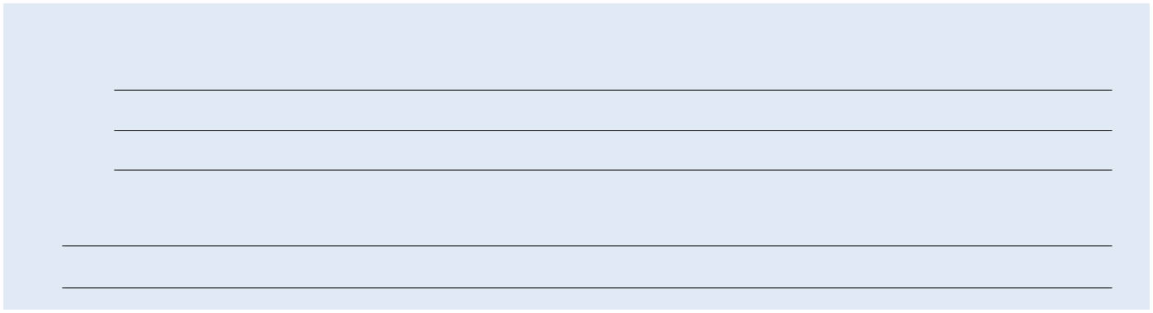

GOALS: (check as achieved)

1.

2.

3.

WEEKLY THOUGHTS:

MONDAY: / /

WORKOUT TYPE:

walk run swim bike yoga other

WORKOUT NOTES:

(weather, soreness, attitude, how session felt)

TUESDAY: / /

WORKOUT TYPE:

walk run swim bike yoga other

WORKOUT NOTES:

(weather, soreness, attitude, how session felt)

WEDNESDAY: / /

WORKOUT TYPE:

walk run swim bike yoga other

WORKOUT NOTES:

(weather, soreness, attitude, how session felt)

DAILY:

weight:

resting hr:

energy: poor good excellent

RESULTS:

time:

distance:

intensity: easy medium hard

DAILY:

weight:

resting hr:

energy: poor good excellent

RESULTS:

time:

distance:

intensity: easy medium hard

DAILY:

weight:

resting hr:

energy: poor good excellent

RESULTS:

time:

distance:

intensity: easy medium hard

THURSDAY: / /

WORKOUT TYPE:

walk run swim bike yoga other

WORKOUT NOTES:

(weather, soreness, attitude, how session felt)

FRIDAY: / /

WORKOUT TYPE:

walk run swim bike yoga other

WORKOUT NOTES:

(weather, soreness, attitude, how session felt)

SATURDAY: / /

WORKOUT TYPE:

walk run swim bike yoga other

WORKOUT NOTES:

(weather, soreness, attitude, how session felt)

SUNDAY: / /

WORKOUT TYPE:

walk run swim bike yoga other

WORKOUT NOTES:

(weather, soreness, attitude, how session felt)

DAILY:

weight:

resting hr:

energy: poor good excellent

RESULTS:

time:

distance:

intensity: easy medium hard

DAILY:

weight:

resting hr:

energy: poor good excellent

RESULTS:

time:

distance:

intensity: easy medium hard

DAILY:

weight:

resting hr:

energy: poor good excellent

RESULTS:

time:

distance:

intensity: easy medium hard

DAILY:

weight:

resting hr:

energy: poor good excellent

RESULTS:

time:

distance:

intensity: easy medium hard

