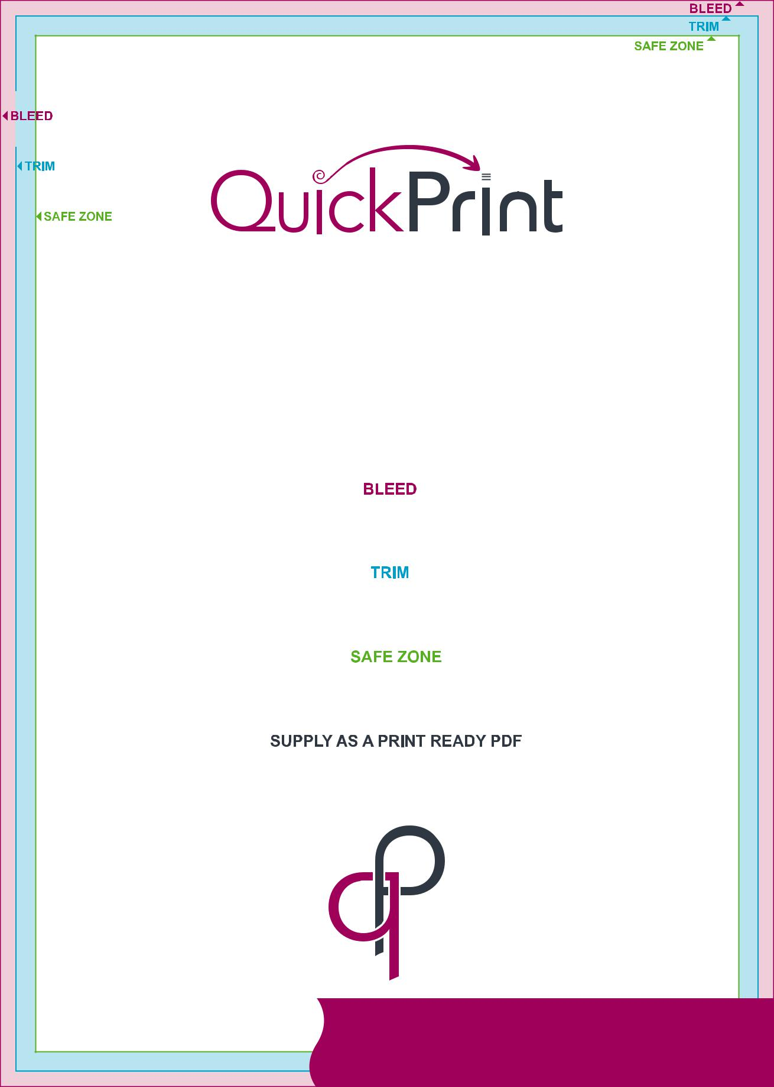A4:A5

Booklets

when supplying artwork with multiple pages

please supply one PDF document with individual pages from 1 to ‘?’

in the order they are to be read and bleed as below

for more details please email web@quickprint.co.uk

extend the background or image to cover this area - this area is trimmed off

A4: 303 x 216mm · A5: 216 x 154mm

this is where the product will be cut

A4: 297 x 210mm · A5: 210 x 148mm

ensure all text and important content is placed within this area -

A4: 289 x 202mm · A5: 202 x 140mm

you can create your booklet in any software, ensuring the artwork is exported as a

high quality, print ready PDF - ensure the text is embedded and images are minimum 300dpi

web@quickprint.co.uk

