BRIEFING NOTE
24th September 20XX
The Impact of Local Government Funding Cuts

Introduction

This briefing note is intended to provide some background information on the depth of the financial challenges facing Cambridgeshire County Council. It is not intended to create alarm but simply to provide some greater understanding of the scale of the financial challenge. It is therefore hoped that it will provide some context for the difficult decisions that lie ahead.

We recognise that we have a duty to provide efficient and cost effective services and we believe that we have a demonstrable track record that can more than adequately demonstrate that this is the case. We are not complacent and we will always continue to push the boundaries and look for new opportunities to drive our costs even lower.

The simple truth is however that we have reached the point that delivering further efficiencies is simply not enough to balance the books and therefore there will be some difficult decisions ahead regarding service delivery. These are not easy times and these decisions will not be taken lightly.

Impact of funding cuts on Cambridgeshire County Council

The chart below illustrates our estimate of the funding levels required over the next five years to deliver our current level of service and compares this with the actual funding we are forecasting to receive.

Forecast Funding Gap for Cambridgeshire County Council from 2014-15 to 2018-19

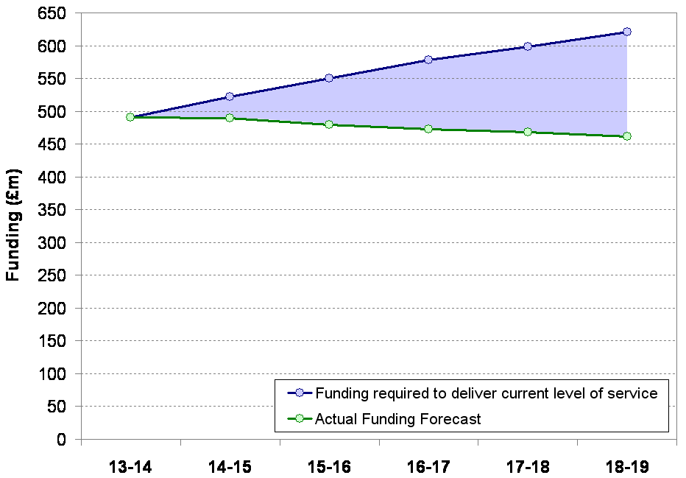
Funding gap:£159m savings required(£498m cumulatively)

The increased funding requirement is largely due to the impact of demographic growth in Cambridgeshire on Council services (the 2011 Census confirmed Cambridgeshire as the fastest growing county in the UK), inflationary pressures, and the growing cost of repaying increased borrowing to fund investment in infrastructure.

The decrease in actual funding is due entirely to reductions in government grants. Expected future increased Council Tax revenues in future years will only offset an element of our forecast overall funding reductions.

The cost of providing appropriate and statutory service levels and infrastructure to support this growth is never fully funded from developers and additional revenue streams and therefore the shortfall falls upon existing residents. The Council will continue to negotiate robustly with developers over the level of contributions required to support new infrastructure but there will always be a limit that will make the developments unsustainable.

Although this funding position is nothing new given the level of growth in the County the position is rapidly becoming untenable.

Since the 2010 Spending Review, the Council has budgeted to make savings of £124m to 31st March 2014. Current estimates suggest further savings of £159m may be required over the next five year. The following chart outlines savings on a year by year basis.

Historical and Current Estimate of Future Savings for Cambridgeshire County Council

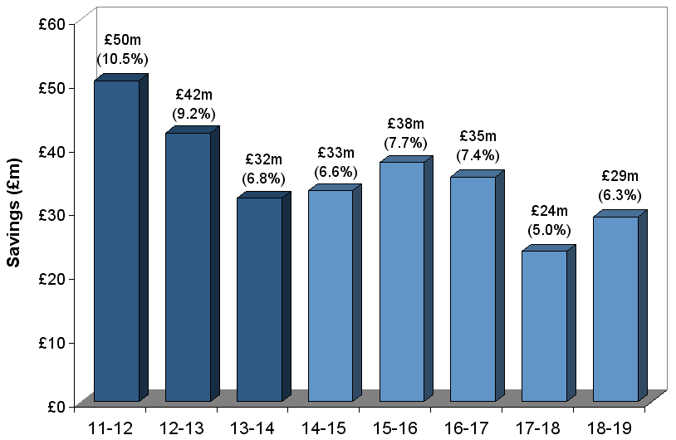

Note: percentage figures are savings as a percentage of the previous year’s total gross budget (excluding schools), not just the element funded by government.

Comparison of Cambridgeshire cuts with other County Councils

We recognise the need for austerity, and we also accept that we are not alone in this position. All public services are having to tighten their belts as the pressures of austerity start to bite. Local Government has been particularly badly hit which is demonstrated in a table later in this note. However we are concerned that the impact of demography is not being adequately reflected within the grant funding mechanism and neither is the speed of this growth. This position is compounded by a low starting point of funding which has resulted in Cambridgeshire being harder hit than other comparable organisations.

The chart overleaf sets out the 2013-14 Settlement Funding Assessment (SFA) for each County Council and the cuts expected by the 2014-15 and 2015-16 SFAs, as announced in the June Spending Round. Councils are ranked in order of increasing percentage cut over the next two years.

Cambridgeshire stands out as one of the hardest hit authorities, with a reduction in its Settlement Funding Assessment of 20.9% (£29.9m) – and this ignores the demographic growth pressures which only exacerbate this position.

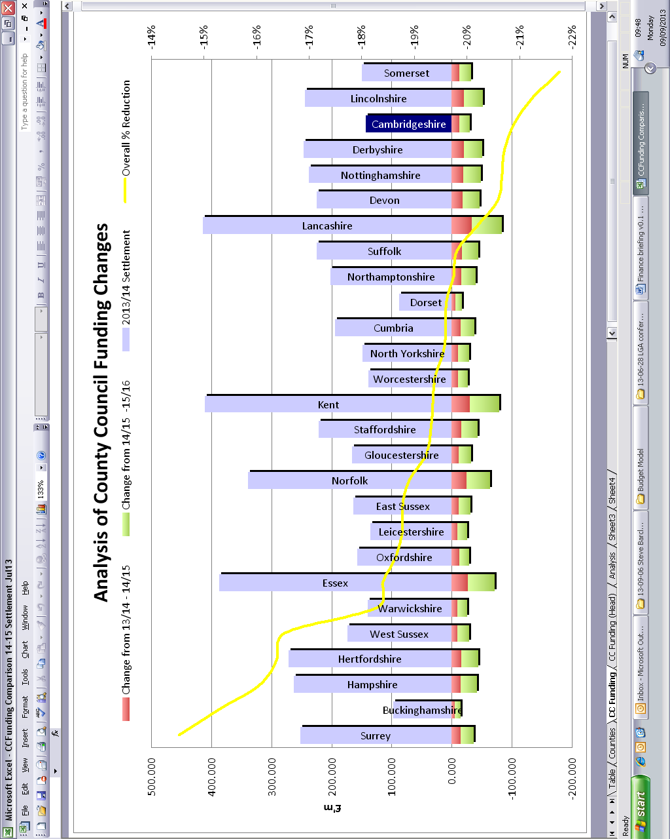

Cuts to Education Funding

This treatment appears to have been replicated in other funding areas such as Schools funding. A summary of the position of our schools is set out below:-

National funding formula commencing in 2015-16
Of the 151 local education authorities we are currently 151 on the latest published schools block figures. This position has arisen because of the number of smaller remotely located schools in the County. The funding formula therefore doesn’t effectively recognise issues of rurality.

The Council wants to see redistribution between different areas of the country to improve Cambridgeshire schools funding position. DfE's new sparsity factor for rural areas is not a complete solution to this issue.

Demographic pressures
The Council is set to open around 20 new schools over the next decade. The compound impact of revenue start-up costs and lagged arrival of pupils as schools fill to funded capacity leads to a multi-million pound burden on existing local schools over that period. Government needs an improved strategy for the revenue funding of new schools. The Council is concerned that the process for awarding growth in high needs block of DSG (mainly special educational needs) is too limited and disadvantages authorities with the fastest growth in high needs pupils.

Education Services Grant
There is a proposal to reduce the overall level of funding through the Education Services Grant in the sum of £200m. At this point we do not know how much of that will be allocated to this county’s schools. Local authorities continue to have statutory duties in relation to schools and need to be funded accordingly.

Comparison of Local Government cuts with other Departments

The chart overleaf compares the change in government departments’ Resource Departmental Expenditure Limits (Resource DELs) in cash terms over the five year period covered by the 2010 and 2013 Spending Rounds.

In cash terms, the Local Government element of DCLG will see a budget reduction of £5bn, from £28.5bn in 2010-11 to £23.5bn in 2015-16. The largest impact of any government department in either cash or percentage terms.
Cash change in Resource DEL from 2010-11 to 2015-16
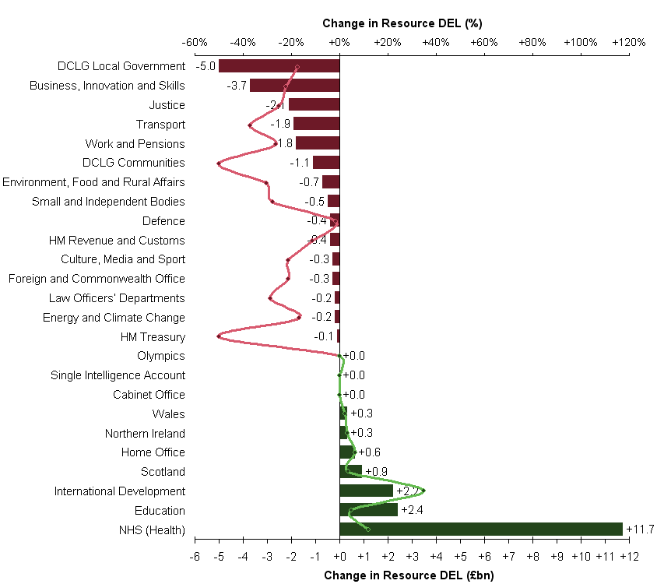

Note: There is a greater degree of error inherent in the percentage change figures for smaller government departments as the Spending Round figures are only presented to one decimal place. I.e., there is more error in determining the percentage reduction of a £0.5m cut applied to a department with an initial budget of £1.0m than a cut of £5.0m applied to a department of £50.0m.

Rising to the Challenges of Austerity

As can be seen from the savings table earlier in this note the Council has already made significant savings in this and last year to rise to the challenge of increasing demand for services and reduced funding levels. This ‘perfect storm’ has been weathered largely through the delivery of operational efficiencies.

The following paragraphs highlight a few of the innovative opportunities that the Council has taken and highlight some further opportunities that are currently being evaluated.

LGSS

We have with our core partner Northamptonshire County Council established a successful shared service offering for back office services that is now the largest public sector shared service organisation in the country. The partnership has delivered huge efficiency savings and operational improvements not just to the core partners but to other organisations such as Norwich City Council, Northampton Borough Council, Huntingdonshire and East Northamptonshire District Councils. It continues to grow and deliver financial savings for all stakeholders. Savings to date are as follows:-

2010/11 1,717k
2011/12 1,893k
2012/13 2,096k
2013/14 2,354k

Total 8,060k

Making Assets Count

The Making Assets Count (MAC) Programme brings public sector organisations together in a partnership that uses their combined property portfolio in a more efficient and effective manner. The primary drivers for MAC are to deliver better public services for communities and reduce the cost of property occupation.
The Cambridgeshire project was one of the first wave of Capital and Asset Pathfinders, led by Baroness Hanham, and is considered to have moved closer to full integration of property and related services than any other area.
Estimated net book value (as at 31st March 2012) of assets that could be included in MAC across the public sector in Cambridgeshire is around £586 million. This includes the non-schools County Council estate (net book value of around £311 million).
The MAC Board has agreed a minimum target of 20% reduction in the public sector estate through rationalisation/disposal. The estimated net book value of this 20% reduction of assets is around £117 million across Cambridgeshire as a whole.
It is estimated that around 15% of the net book value lies within the South Cambridgeshire/Cambridge City Council areas.

Current MAC projects include a number of market town regeneration schemes (outside the City Deal area), a Joint Operations Centre in the south of the county (within the City Deal area), delivery of Cambridgeshire’s Asset Management Strategy (countywide), and development of efficient short-term arrangements for MAC partners to share space and reduce costs (countywide).

In addition, MAC is currently focused on the creation of a public property company (MAC Public Property Partnership) that will deliver the market town schemes and the wider management of public sector assets across Cambridgeshire. MAC partners would transfer relevant assets into this structure which, as an arms-length body but with governance from investing bodies, then delivers projects, manages transferred assets and pays dividends to MAC partners. All MAC partners would benefit from the uplift in value created.

As an example of the figures involved; the potential capital surplus to the MAC partners for the four market town schemes is estimated at £39m-£43m, with a 50% saving in revenue costs (£1m).

CCS ‘right sourcing’

Cambridgeshire Community Services is a Trust delivering both health and social packages in an integrated way. Although the principle for the delivery of services in this way was sound operational delivery and planning fell well short of our expectations. The Council has been bold and rather than allowing the position to continue has taken the step to in-source the care elements of the provision back into the Council. Showing we are not only bold but decisive.

Cambridge and Counties Bank

The Cambridgeshire Pension Fund administered by the County Council has joint equity ownership of a commercial bank with Trinity Hall College. The bank is focussed on lending to SME’s. A start up bank that has now been trading for just over 12 months and is now in an operating profit position. Expected returns over the next 12 months expected to significantly outstrip ‘normal’ investment returns. Whilst these returns go to the Pension Fund and they do help to minimise the revenue impact of pension strain.

Science Park Station

Another scheme where we are working closely with key partners from local government and the rail industry to improve the transport links into Cambridge, particularly the Science Park and other commercial developments in the north of the City. It will also act as a regional transport hub facilitating commuter transport through the region and into London.

Other Asset Related Opportunities

In order to mitigate the financial challenges of the future we are evaluating many opportunities. These include the potential for becoming a ‘housing developer’ where using our land holding we would generate a more effective return on our assets.

We are considering building our own care home in order to mitigate the spiralling costs of adult social care.

We are currently evaluating the opportunities of introducing solar farms in the County in order to make a more effective return on some of our low grade arable farm holdings.

These are just a few examples of how far the Government’s austerity measures are driving us down a path of greater risk appetite. Not all of the schemes that we are evaluating will sit comfortably with our core raison d’être but we are left with no options.

Summary

This paper sets out the overall financial context, as best we can predict at this point in time, for the Council in the medium term. It doesn’t make great reading and although the Council has risen to the challenges it has faced to date without a significant impact on services this cannot continue. The Council will be facing some very difficult decisions in the coming months over the level of services that it provides. Some of these will be unpalatable but unfortunately we are left with very few options.

