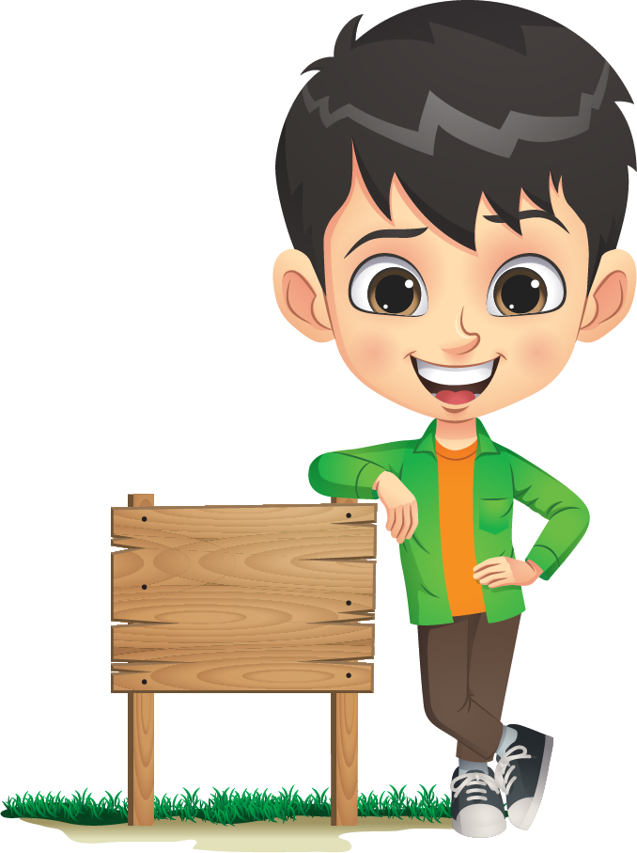

**STORY**

**MAP**

**SETTING**

**_____________________________________________________________________________________________________________________________________________________________________________________________________________________________________________________________________________________________________________________________________________________________________________________________________________________________________________________________________________________________________________________________________________________________________________________________________**

**PROBLEM**

**_____________________________________________________________________________________________________________________________________________________________________**

**ACTIONS**

**_____________________________________________________________________________________________________________________________________________________________________**

**OUTCOME**

**_____________________________________________________________________________________________________________________________________________________________________**

**Title:** _______________________________

**Author:** ____________________________

**CHARACTERS**

**_____________________________________________________________________________________________________________________________________________________________________**