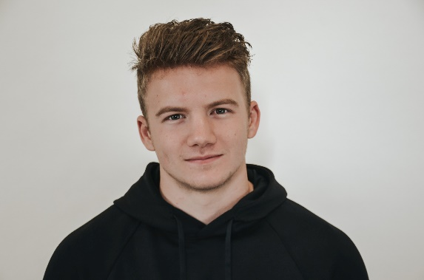

RELEVANT EXPERIENCE

**University of California, Research Experience for Undergraduates Intern, Jan 20XX – Mar 20XX**

Attended lab group meetings, developed presentations, conducted successful research projects and recorded results within a thesis paper. Organized and maintained lab instruments, equipment and reagents. Cleaned, maintained, and assembled the extruder and its auxiliary parts and implemented the frequent calibration of liquid feed pumps and solid feed hoppers.

PROFESSIONAL EXPERIENCE

**Vanguards Limited, Junior Manager, Apr 20XX – Jun 20XX**

Identified and qualified prospective clients through research and marketing strategies such as social media listening, search engine optimization, and other advertising models. Contributed to the development of an automated weekly payroll system and used it for surreptitious tasks such as sales and marketing.

OBJECTIVE

Performance-driven individual, technologically savvy and self-taught in the field of Marketing and Analytics. Searching for a Marketing Coordinator or Managerial role where I can use my business and management education to effectively execute marketing campaigns and operations.

EDUCATION

Florida State University

B.A. Marketing Communications

May 2016

GPA – 3.5

RELEVANT COURSEWORK

Content Creation

Content Marketing Strategy

Social Promotions

Email Marketing

Social Media Marketing

SEO – Advanced

ADDITIONAL SKILLS

* Interpersonal skills
* Analytical abilities
* Organizational abilities

ADAM MILL

INTERNEE RESUME

COTACT INFORMATION

123 Your Address

City, State, Zip Code

(xxx)-xxx-xxxx

your@email.com