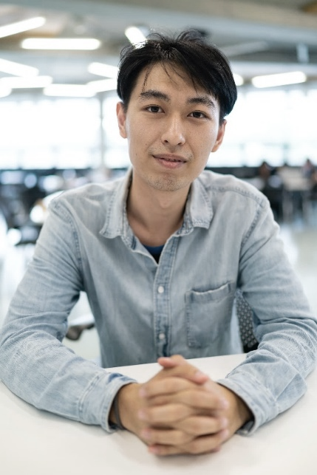

EDUCATION & CERTIFICATES

* Class of 20XX, University of California San Diego, Computer Science major, GPA 3.6
* CompTIA A+ certification

PERSONAL SUMMARY

IT desk technician knowledgeable in information technology, software, and hardware systems. Familiar with HTML, CSS, JavaScript, and Python. Exceptional at critical thinking and analytical problem-solving.

CONTACT INFORMATION

12-5245-9081

phi23@gmail.com

Ho Chi Minh, Vietnam

SKILLS

* Software debugging.
* Hardware repair.
* Intranet maintenance.
* Upgrade computer system.
* Communication skills
* Patience
* Effective problem-solving procedure.
* Attentive attitude.

PROFESSIONAL EXPERIENCE

**IT Support Engineer, Cultivar Asia PTE. LTD., 12/20XX - 06/20XX**

• Remotely supported customers with IT issues.

• Troubleshot hardware.

• Identified problems of desktop, notebook, printer, and tablet.

**Technical Support Engineer, Assa Abloy, 09/20XX - 10/20XX**

• Held product usage training for staff.

• Drafted guidelines to common technical problems.

• Developed product mock-up and display.

PHILIP NGUYEN

IT TECHNICIAN  
A debugging expert having resolved 500+ hardware and software problems