***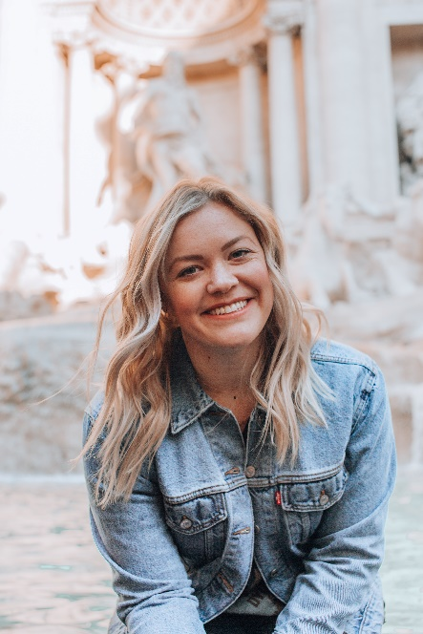

**EDUCATION**

TEXAS A&M, COLLEGE STATION

B.S. Interdisciplinary Studies / concentration in Special Education, 20XX-20XX

**PROFESSIONAL EXPERIENCE**

**Fifth Grade Teacher**

**Northwood Elementary School, San Antonio, TX / 20XX - Present**

* Prepare and administer regular subject tests to 24 students, complete with detailed quarterly progress reports for parents
* Create and adapt lesson plans according to students’ academic needs, including both individual and group work
* Maintain an open-door policy for 6:30–8:00 am parent/teacher conferences three days a week
* Develop TEKS-compatible health and nutrition activities to promote better food and exercise habits

**First Grade Teacher**

**Lamar Elementary School, New Braunfels, TX / 20XX – 20XX**

* Designed and implemented daily lesson plans for classroom of 22 students
* Fostered student curiosity and interest in learning through hands-on activities and field trips
* Planned, advertised, and executed a weekly after-school art class open to all grade 1–3 students
* Met with parents, guardians, administrators, and counsellors to address and resolve students’ behavioural issues

**CERTIFICATIONS**

Texas Teacher Certification, 20XX

Special Education (ec–grade 12) Teaching Certificate, 20XX

Elementary School Teacher with 6+ years of experience managing classrooms of 20–25 students. Adept at using positive reinforcement teaching techniques to encourage student behaviour and growth. Licensed teacher in Texas, with a B.S. in Interdisciplinary Studies and Special Education certificate. Looking to leverage creativity and teaching experience to engage at-risk students.

**CONTACT INFORMATION**

(123) 456-7895

SophiaRobinson@gmail.com

45 Winfield Dr., San Antonio, TX 78006

Linkedin.com/in/username

**MILLIE ROBIN**