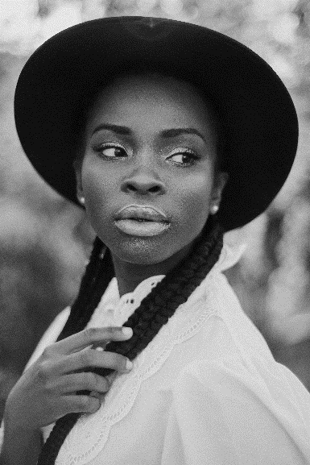

**EDUCATION & LICENSE**

* Cosmetology associate degree, International Beauty Academy (Santa Monica, CA), 20XX–20XX
* Taken part in a one-year cosmetology program covering: skin care expertise training, introduction to sociology, and chemical safety.
* State Esthetician License, July 20XX
* IPL Hair Removal Certificate, June 20XX

**PROFILE**

Licensed esthetician with 4+ years of experience in performing advanced beauty treatments, including IPL hair removal. At Norma Esthetic Clinic US maintained 96% client satisfaction, boosted product sales by 10% over 4 months, and successfully trained 3 new employees. Seeking to contribute to HealSpa with proven management skills and beauty service expertise.

**WORK EXPERIENCE**

**Lead Esthetician, Norma Esthetic Clinic US, July 20XX–July 20XX**

* Performed skin care treatments such as microdermabrasion, chemical peels, exfoliation, tinting, and deep cleansing facials.
* Consulted clients on skin care and beauty products.
* Managed scheduling and organized promotional events that increased sales by 10% over the course of 4 months.
* Supervised 3 new employees and supported the manager with the clinic hiring operations.

**Esthetician, Lavender Spa NY, March 20XX–June 20XX**

* Run the salon’s schedule of appointments and managed the inventory.
* Provided waxing and IPL hair removal services.
* Performed 30+ make-up application treatments per week.
* Kept spa equipment sanitized.

Sarah Kelley  
LEAD ESTHETICIAN  
  
karen.s.kelley@email.us 813-476-6683