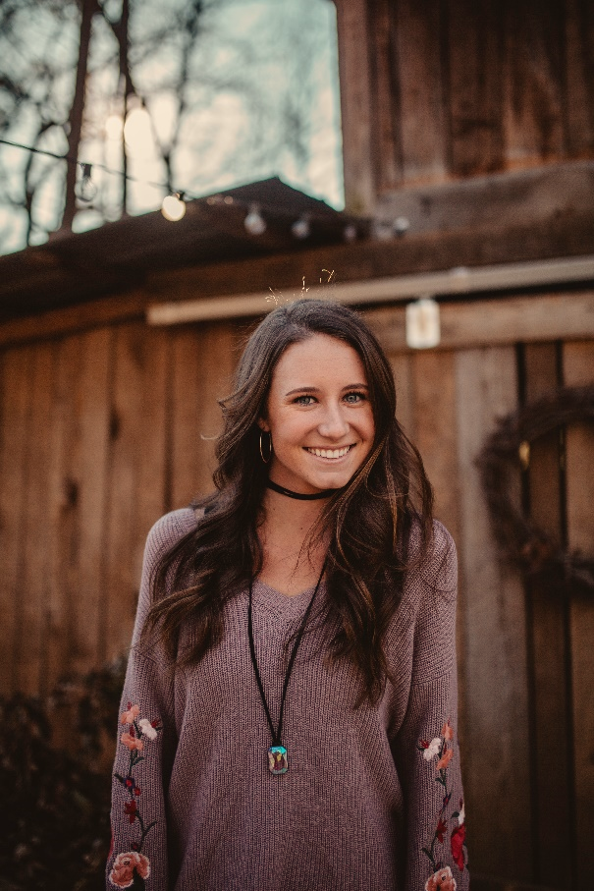

AREA OF EXPERTISE

* Creative Lesson Planning
* ELA Preparation
* Standardized Testing
* Learning Centers
* Technology Integration
* IEPs
* Experiential Learning
* Classroom Management
* Literature Circle
* Phonics

EXPERIENCE

**BATEMAN ELEMENTARY SCHOOL – TACOMA, WA. 20XX – PRESENT, ESL Teacher (3rd Grade)**

* Title 1 school with 90% Hispanic students; approximate student body of 1,000 learners.
* Teach core curriculum to 3rd grade English as a Second Language learners, covering subjects such as reading, language arts, writing, math, science, health, and social studies. Actively prepare students for MSP (Measurement of Student Progress) reading, language arts, and writing standardized testing. Collaborate with faculty members on joint class activities that include school government, plays, programs, and guest speakers.

**BARBARA BANTON'S ELEMENTARY SCHOOL – TACOMA, WA 20XX – 20XX, ESL Teacher (4th Grade)**

**Also worked as an educator with**

Cedar Green Elementary School-Grade 1 ESL Teacher

J.P. Hanson Elementary School-Grade 1 ESL Teacher

Poplar Elementary School-Grades 3 and 4 ESL Teacher

Dear Hurst Elementary School-Multi Grade Teacher.

PROFILE

Dynamic and results-oriented ESL teacher committed to inculcating a passion for learning, creating multicultural awareness through teaching the fundamentals of the English language. A strong talent to develop and implement creative, hands-on curriculum that reaches every student's learning style and ability, empowering students to succeed and realize their individual goals. A trustworthy and approachable individual with excellent communication to cooperatively work with parents and faculty to meet the needs of students and promote the philosophy and goals of the school.

CONTACT INFORMATION

7398 91st Street, Tacoma, WA 98275

(425) 555-2376

monabuttons78@mail.com

EDUCATION

Bachelor of Science (20XX) Major: Elementary Education

Freedman's University Tacoma, WA

Honors: Cum Laude

**MOANA BUTTONS**

ESL TEACHER