Prepared By: Name XYZ
Strategic Plan
Table of Contents
- Strategic plan 2
The Vision
The Mission
- Strategic plan Overview 4
Overview
Inputs
Activities
Outputs
- Use Hindsight when Strategic Planning 5
- Effect not Equal to Cause when Planning Strategy 6
- Keys to Business Strategies 6
- Simple & Short Strategic Plans 6
Determine where you are.
Identify what’s important.
Define what you must achieve
Determine who is accountable
Review. Review. Review
- Using the Strategic Planning Worksheet 7
- Copyright & Legal Stuff 7
- Profit versus Nonprofit Strategic Planning 8
- Threats & Opportunities 8
- Benefits of Strategic Planning 8

Strategic plan
A strategic plan is a document used to communicate with the organization the organizations goals, the actions needed to achieve those goals and all of the other critical elements developed during the planning exercise.
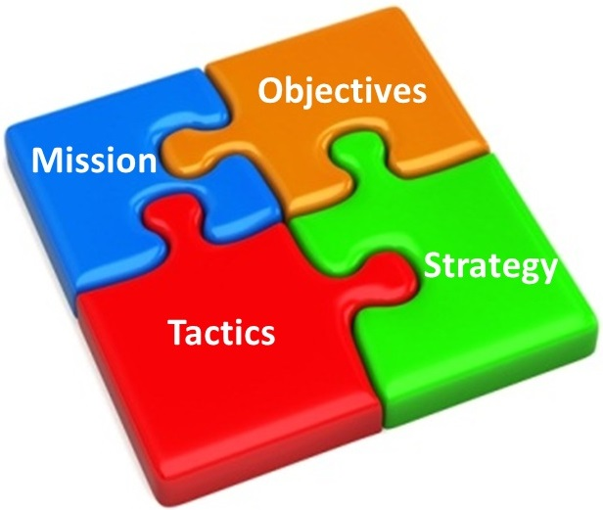

The Vision

The first step is to develop a realistic Vision for the business. This should be presented as a pen picture of the business in three or more years’ time in terms of its likely physical appearance, size, activities, structure, scale offerings etc. Answer the question: "if someone from Mars visited the business, what would they see (or sense)?" Consider its future products, markets, customers, processes, location, staffing etc. Here is a great example of a vision:
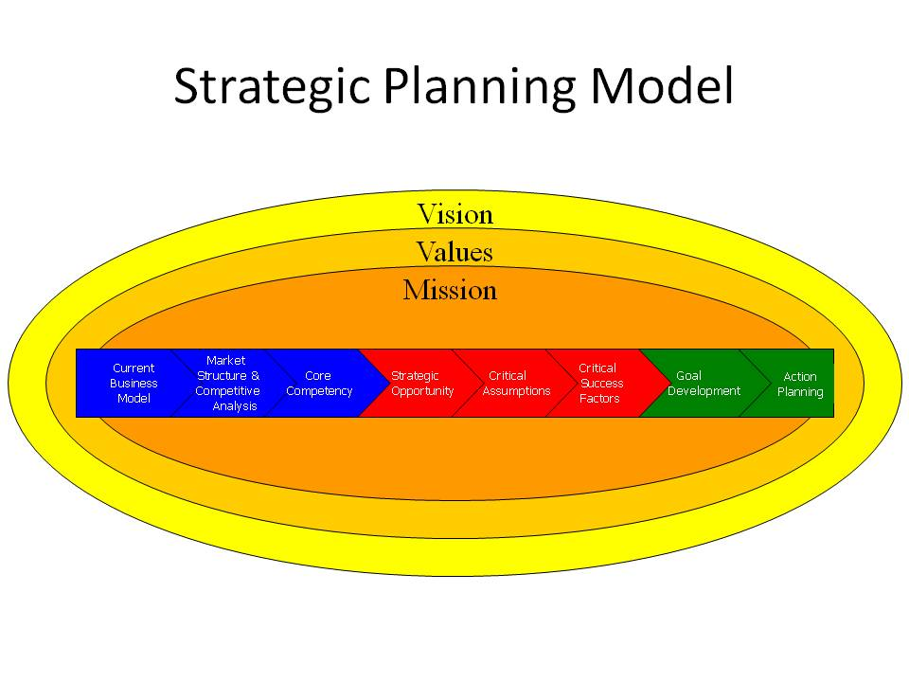

The Mission
The nature of a business is often expressed in terms of its Mission which indicates in a factual way the purpose and activities of the business in terms of operations, (unique) characteristics, functions, customers, offerings, sectors.
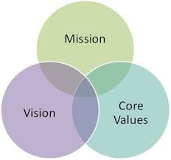

Strategic plan Overview

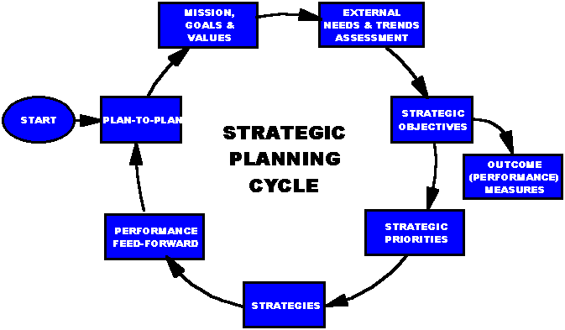

Overview
Strategic planning is a process and thus has inputs, activities, outputs and outcomes. This process, like all processes, has constraints. It may be formal or informal and is typically iterative, with feedback loops throughout the process.

Inputs
Data is gathered from a variety of sources, such as interviews with key executives, review of publicly available documents on the competition or market, primary research (e.g., visiting or observing competitor places of business or comparing prices), industry studies,
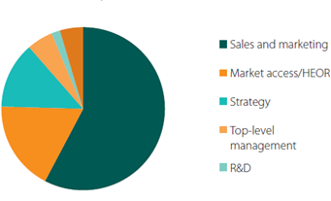

Activities
The essence of formulating competitive strategy is relating a company to its environment.
Strategic planning activities include meetings and other communication among the organization's leaders and personnel to develop a common understanding regarding the competitive environment and what the organization's response to that environment (its strategy) should be

Outputs
The output of strategic planning includes documentation and communication describing the organization's strategy and how it should be implemented, sometimes referred to as the strategic plan. The strategy may include a diagnosis of the competitive situation, a guiding policy for achieving the organization's goals, and specific action plans to be implemented.[2] A strategic plan may cover multiple years and be updated periodically.

Use Hindsight when Strategic Planning
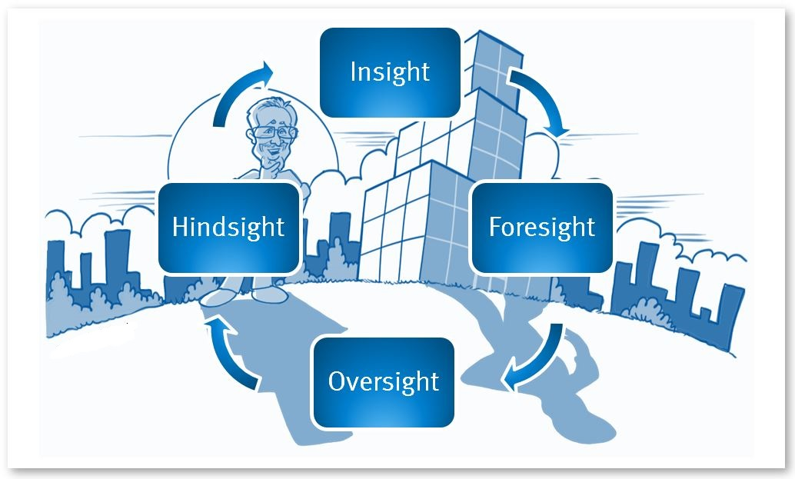

Effect not Equal to Cause when Planning Strategy

Keys to Business Strategies
- Sales - marketing - distribution - promotion - support;
- Management - systems - expertise - resources;
- Operations - efficiency - capacity - processes;
- Products - services - quality - pricing - features - range - competitiveness;
- Finances - resources - performance;
- R&D - effort - direction - resources;
- Costs - productivity - purchasing;
- Systems - organization - structures.

Simple & Short Strategic Plans
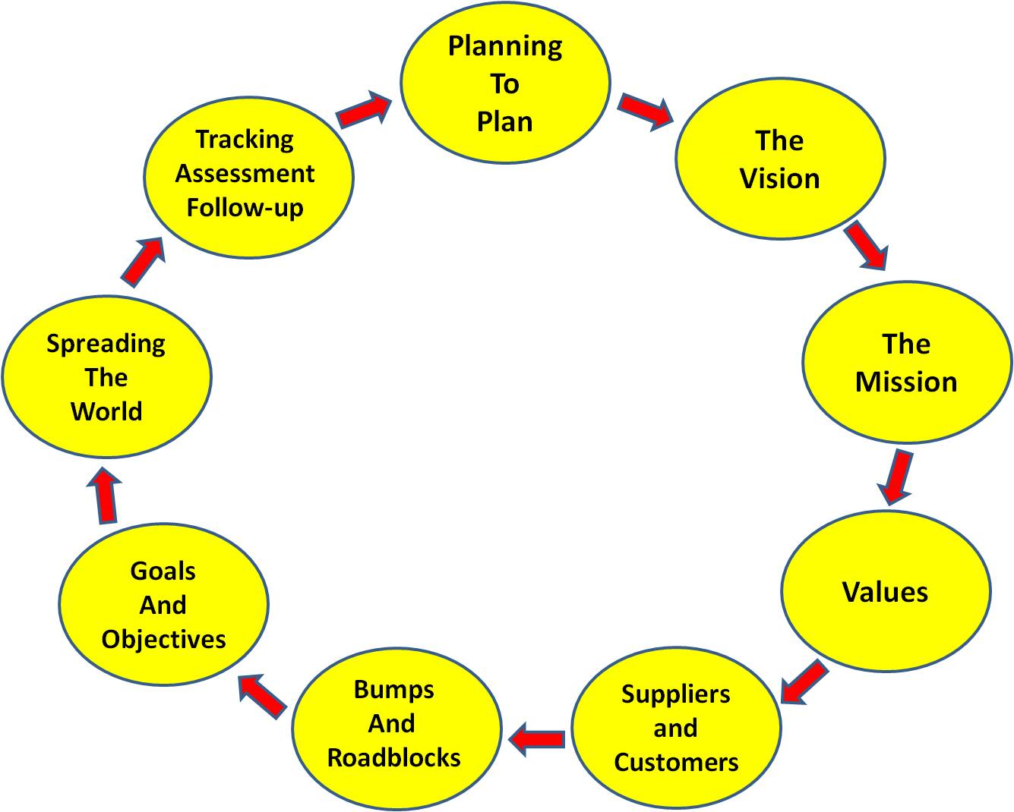

Determine where you are.
This is harder than is looks. Some people see themselves how they WANT to see themselves, not how they actually appear to others. Many small businesses get snared in this same trap.

Identify what’s important.
Focus on where you want to take your organization over time. This sets the direction of the enterprise over the long term and clearly defines the mission

Define what you must achieve
Define the expected objectives that clearly state what your organization must achieve to address the priority issues.

Determine who is accountable
This is how you’re going to get to where you want to go. The strategies, action plans, and budgets are all steps in the process that effectively communicates how you will allocate time, human capital, and money to address the priority issues and achieve the defined objectives.

Review. Review. Review
It’s not over. It’s never over. To ensure the plan performs as designed, you must hold regularly scheduled formal reviews of the process and refine as necessary. We suggest at least once a quarter.

Using the Strategic Planning Worksheet
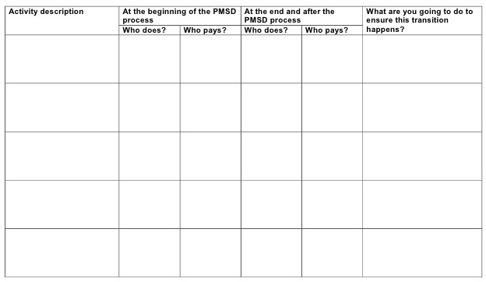

Copyright & Legal Stuff

Profit versus Nonprofit Strategic Planning

Threats & Opportunities
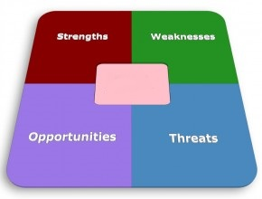

Benefits of Strategic Planning
- Clearly define the purpose of the organization and to establish realistic goals and objectives consistent with that mission in a defined time frame within the organization’s capacity for implementation.
- Communicate those goals and objectives to the organization’s constituents.
- Develop a sense of ownership of the plan.
- Ensure the most effective use is made of the organization’s resources by focusing the resources on the key priorities.
- Provide a base from which progress can be measured and establish a mechanism for informed change when needed.
- Listen to everyone’s opinions in order to build consensus about where the organization is going.

