**HOARDER CLEANING CHECKLIST**

**FEW HEAVY-DUTY TRASH BAGS**



Click or tap to enter a date.

**SOME EMPTY BOXES**



**BROOM AND DUSTPAN**



Use broom and dustpan to remove loose dirt and grime from the floor and ceiling.

This equipment is essential for a deep clean. Pick your vacuum according to your floor materials.

**SELF-PROTECTING ITEMS**



**STEP LADDER**



**TAKE SOME EXTRA BAG**



• Dust musk • Apron •Disposable gloves Overalls

• Goggles

• Repellent spray • First-aid box

• Fire extinguisher

Pick yours one according to the height and loaded the hoard.

Include some extra poly bags into your checklist.

**DISINFECTANTS**

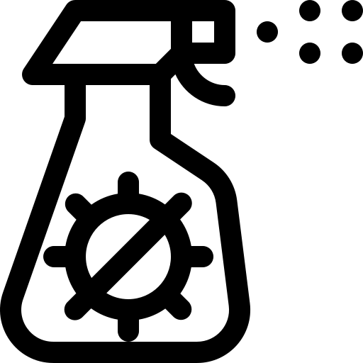

**SHOVEL**



**A SET OF HAND USABLE TOOLS**



Arrange some all- purpose cleaners or disinfectants and apply them by following the instruction on the label.

Add at least one or more shovel into your hoarding cleaning checklist.

keep a set of usable hand tools for an emergency.

|  |  |  |  |
| --- | --- | --- | --- |
| Company Name | Address: | Phone: | Email: |

These heavy-duty trash bags can help you to though away from the garbage.

Use these boxes for collecting absolute trash, donating items, and recycling items.

**MICROFIBER CLOTHS**

**BUCKETS AND MOPS**

**VACUUM CLEANER**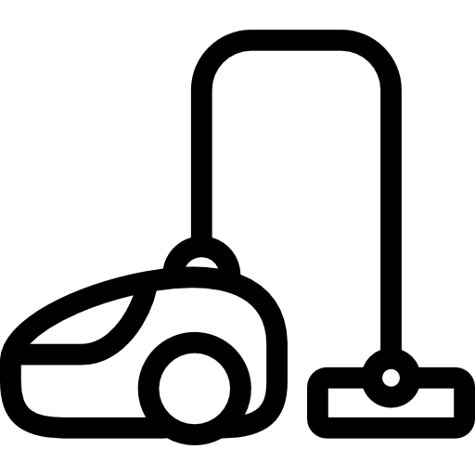

It will help you to sanitize the area.

These heavy-duty trash bags can help you to though away from the garbage.