PARKING RECEIPT |  |  |  | 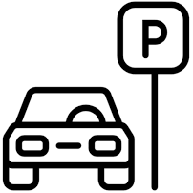
Address
[Contact Number]
 | Entry Time | 00/00/00 | 00:00 PM
 | Exit Time | 00/00/00 | 00:00 PM
 | Duration | 0d 1h 1m
 | Trans #: | 0000000
 | Ticket #: | 0000000
 | Total: $ | 00.00
THANK YOU AND DRIVE SAFELY

