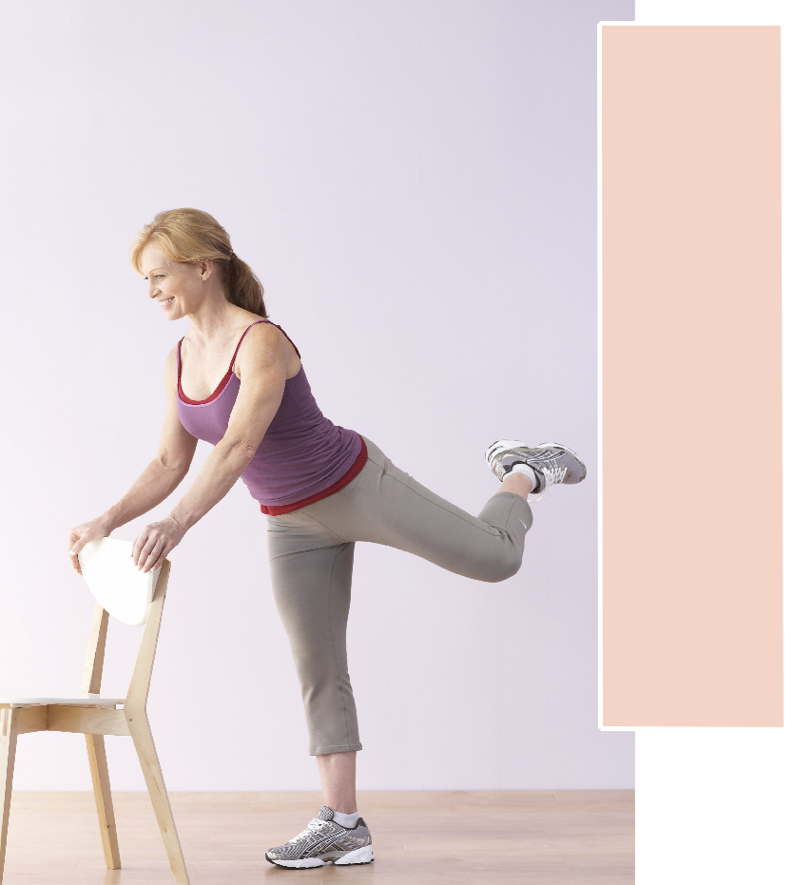
Training guide

Week 1 & 2: 2 sets, 10-12 reps

Week 3 & 4: 3 sets, 10-12 reps

Rear leg lifts

Stand tall, holding the back

of a chair to help maintain

balance, if necessary. Bend

slightly forward at the hips.

Raise one leg to the rear with

loose bend at the knee, knee

turned out with outside of

heel and little toe toward

ceiling. Slowly lift leg in

small pulses. Tilt pelvis and

contract abdominal muscles

to maintain neutral posture

throughout the move. Keep

knee of supporting leg soft;

do not lock it. Complete all

reps before switching legs to

equal one set.

Challenge yourself: From

bent-knee position, keep

lifted knee facing down, and

perform small pulses with

heel toward ceiling for a more

intense butt and hamstrings

workout.

B

Workout Log | Week 1 | Week 2 | Week 3 | Week 4

Date

Reps

Sets

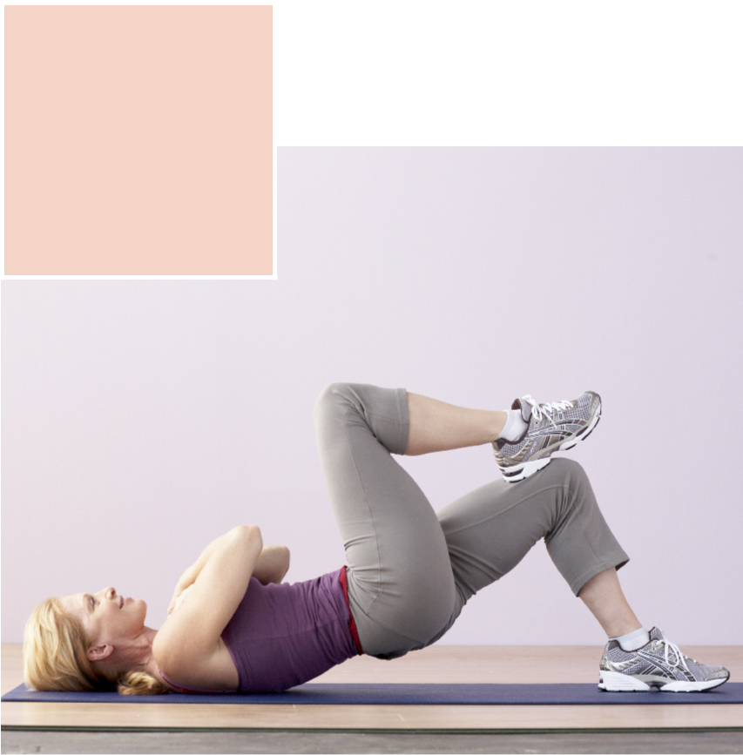
Training guide

Week 1 & 2: 2 sets, 10-12 reps

Week 3 & 4: 3 sets, 10-12 reps

Single-leg bridges

Lie on a mat on your back with hands crossed

on top of chest. Place one foot flat on the mat,

with knee bent, and raise other leg, resting

heel of foot on stationary leg, as shown. Lift

hips about six inches off ground, and hold for

three seconds. Lower to start. Perform all

reps, then switch legs to equal one set.

Challenge yourself: Extend raised leg

toward ceiling for an added core challenge.

Workout Log | Week 1 | Week 2 | Week 3 | Week 4

Date

Reps

Sets

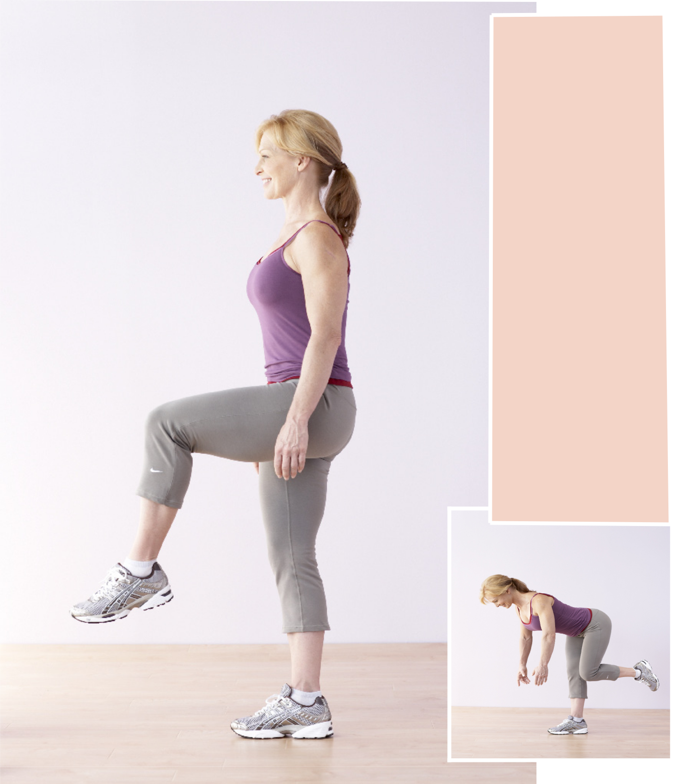
Training guide

Week 1 & 2: 2 sets, 10-12 reps

Week 3 & 4: 3 sets, 10-12 reps

Raised-knee dead lifts

(A) Stand with feet shoulder-

width apart, arms at sides. Lift

one knee up and to front of body

until thigh is parallel to floor.

(B) Slowly lean torso forward at

hips, moving bent leg behind

you while keeping back flat and

abs contracted until chest is

parallel to floor. Allow arms to

drop forward naturally. Rise

back to standing position using

the muscles in the back of legs.

Do not lower leg to the ground

until you have completed full

rep; switch legs to equal one set.

Hold the back of a chair for

support, if needed.

Challenge yourself: Before you

rise back to standing position,

fully extend bent leg out behind

your body for a core challenge.

A | B

 | Workout Log |  | Week 1 |  |  | Week 2 |  |  | Week 3 |  |  | Week 4
 | Date
 | Reps
 | Sets

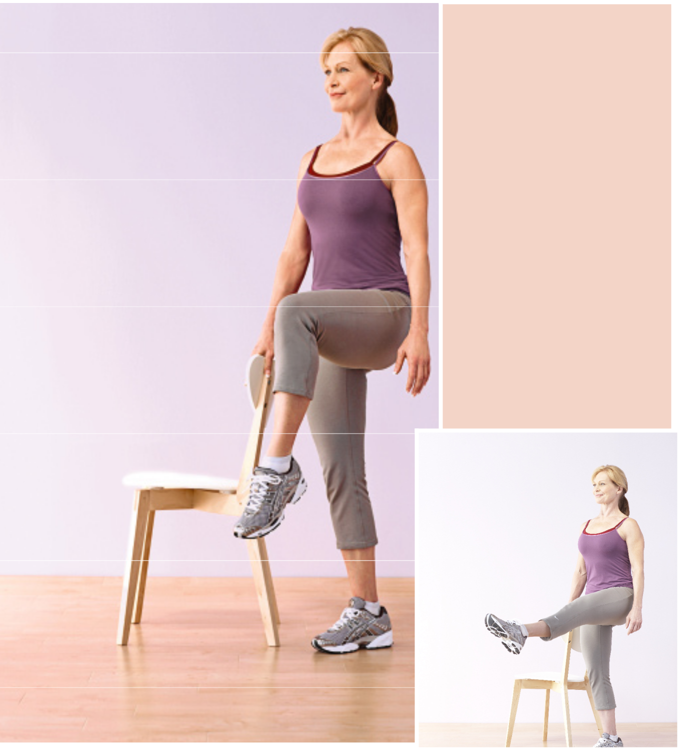
Training guide

Week 1 & 2: 2 sets, 10-12 reps

Week 3 & 4: 3 sets, 10-12 reps

Leg extensions

(A) Stand tall, holding the back of a

chair with one hand to help maintain

balance, if necessary, then lift one knee

to hip level. Keep abs pulled in toward

spine and back straight. (B) Contract the

front of the thigh as you slowly

straighten the knee, extending the leg

out to the front with toe pointed. Try to

keep lifted leg at hip level throughout

the move. Bend knee, bringing leg back

to bent-knee lifted position. Do not

lower foot to the ground until you’ve

completed all reps; switch legs to equal

one set.

Challenge yourself: Point and flex the

foot six to 10 times at the top of each rep

to further target the front of your

thighs.

A | B

Workout Log | Week 1 | Week 2 | Week 3 | Week 4

Date

Reps

Sets

Training guide

Week 1 & 2: 2 sets, 10-12 reps

Week 3 & 4: 3 sets, 10-12 reps

Side-lying leg lifts

Lie on a mat on your right side, right arm resting on

floor, elbow bent. Place left hand on ground in front of

your body for support. Extend legs with knees slightly

bent or straight, and stacked one on top of the other.

Lift top leg through full range of motion, then lower to

hover just above the floor in front of bottom leg. Do not

allow­ lifted foot to touch floor between reps, and

complete all reps before switching to opposite side to

equal one set.

Challenge yourself: Cross top leg over bottom leg, and

place foot flat on the floor. Then, raise and lower

bottom leg, about a foot, without allowing it to touch

the ground for an inner-thigh workout.
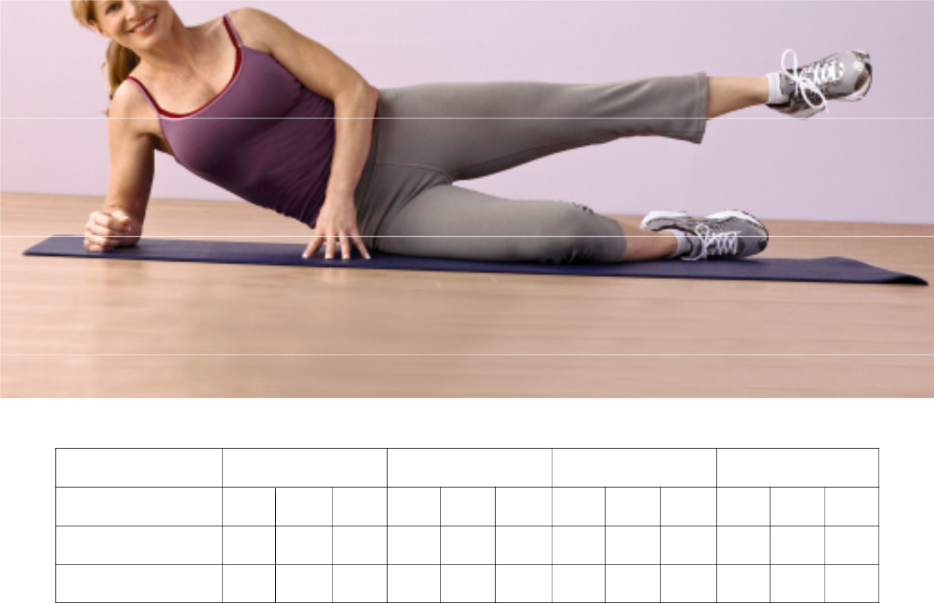

Workout Log | Week 1 | Week 2 | Week 3 | Week 4

Date

Reps

Sets

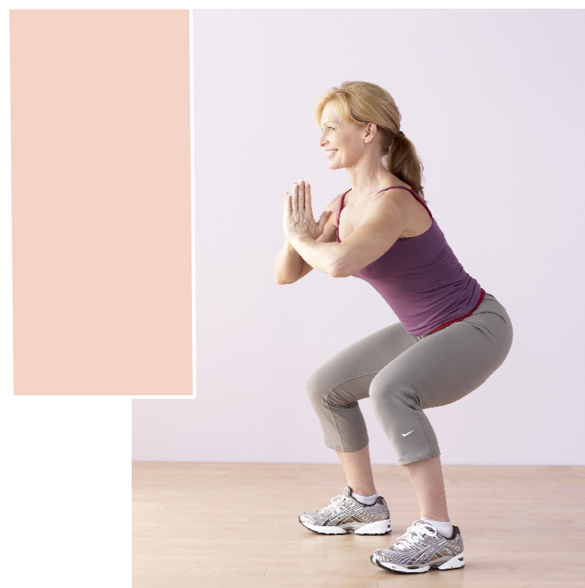

Training guide

Week 1 & 2: 2 sets, 10-12 reps

Week 3 & 4: 3 sets, 10-12 reps

Sumo squats

Stand with feet wider than

shoulder-width apart, and place

hands in front of chest, palm to

palm. Lower body, bending at the

knees while keeping torso

stationary, until thighs are parallel

to floor. Keep abs contracted to help

stabilize the spine, back straight,

heels on the floor, and knees

behind toes. Slowly rise back to

standing.

Challenge yourself: As you rise

from the squat position, lift one

foot slightly off the ground and

hold for five seconds to challenge

your balance and strength and

further concentrate the move;

alternate legs with each squat.

Workout Log | Week 1 | Week 2 | Week 3 | Week 4

Date

Reps

Sets

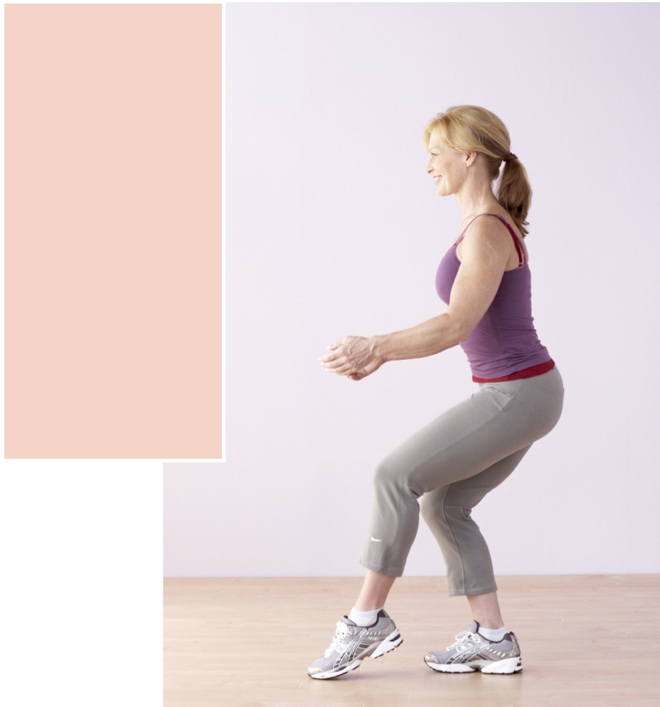
Training guide

Week 1 & 2: 2 sets, 10-12 reps

Week 3 & 4: 3 sets, 10-12 reps

Quarter dips

Stand with one foot six to 12 inches in

front of the other; shift most of body

weight onto back leg. Lightly rest toes

of front leg on floor with knee slightly

bent. Keep torso steady, and slowly

lower into a squat with back leg until

thigh is almost parallel to the ground,

making sure knee does not extend past

toes. Keep only toes of front leg on the

floor. Hold for a second or two, then

rise back to starting position. Perform

all reps before switching legs to equal

one set.

Challenge yourself: Hold a five- to 10-

pound dumbbell in front of body with

both hands at hip level, then slightly

raise the dumbbell in front of body to

chest height as you squat to add

resistance and an arm challenge.

Workout Log | Week 1 | Week 2 | Week 3 | Week 4

Date

Reps

Sets

