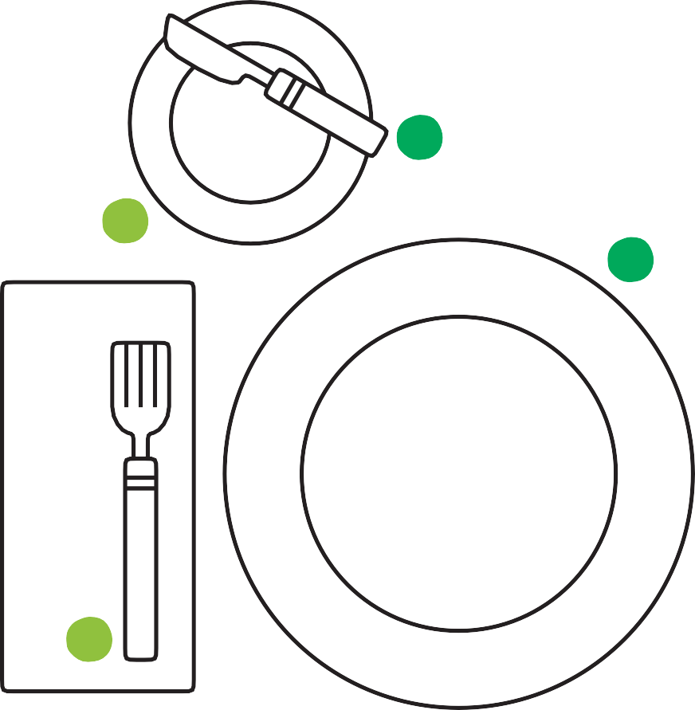

Setting the Table

1

4

7

2

5

8

3

6

9