Template for | DVD – Booklet | Template-No.: 0221
Open format: | 479,0 x 178,0 mm
Closed format: | 120,5 x 178,0 mm
Number of pages: | 8
Fold: | concertina fold
Material: | 160 gsm gloss art paper as standard

Please find the related EPS and layout files attached to this PDF.

Measurement input

3rd fold |  |  |  | 2nd fold |  | 1st fold
119,5 mm |  |  | 119,5 mm |  | 119,5 mm |  | 120,5 mm

178,0 mm

 |  |  | scaling: 36 % • bleed: 3 mm
Folding layout |  |  |  | Printing area
3rd fold |  |  |  | front printing
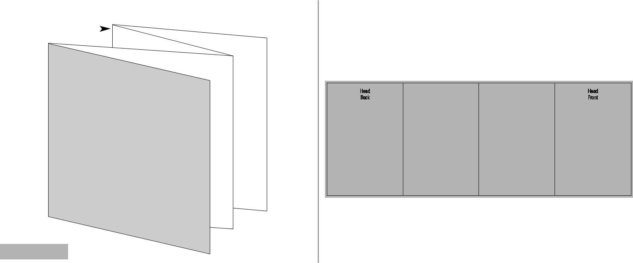

1st fold

2nd fold

Front Panel

