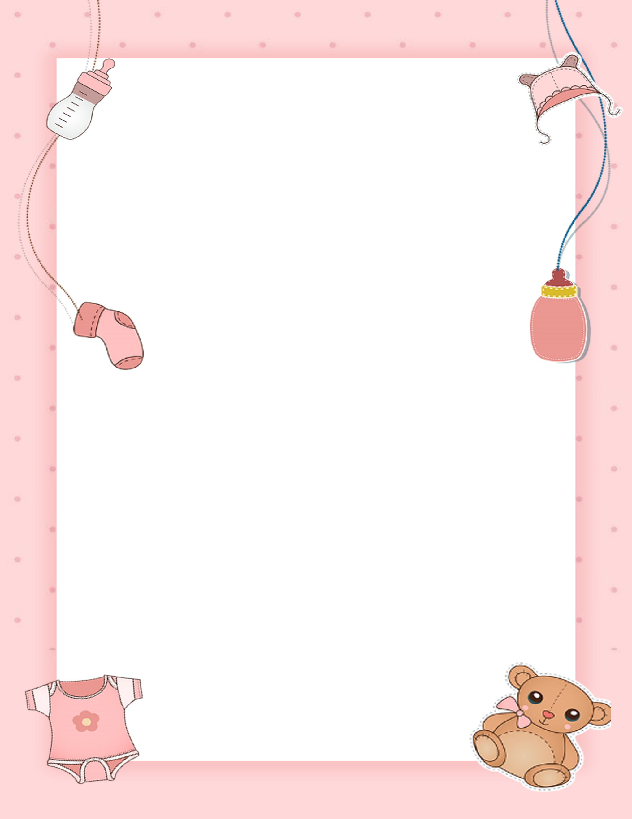
BABY REGISTRY CHECKLIST

BATH ITEMS |  | FEEDING ESSENTIALS |  | BABY CLOTHES
- Baby bathtub |  | - 10-16 bottles and nipples |  | - 4-8 onesies
- Baby shampoo |  | - Pump |  | - 4-8 undershirts
- Baby soap |  | - Milk storage bags |  | - 4-8 one-piece pajamas
- 2-4 soft towels |  | - Nursing pads |  | - 2 blanket sleepers
- Baby hairbrush |  | - Nipple cream |  | - 1-3 sweaters or jackets
 |  | - Nursing pillow |  | - 1-3 rompers or other dress
BABY GEAR |  | - Bottle brush |  | - 4-7 socks or booties
- convertible car seat |  | - Dishwasher basket |  | - No-scratch mittens
- Stroller or infant carrier |  |  |  | - Bunting bag or fleece suit
- Baby swing or bouncer |  | DIAPERING MUST-HAVES
- Play yard with bassinet |  | - Changing table |  | HEALTH PRODUCTS
 |  | - cushioned changing pay  for low dresser |  | - Baby nail clippers
BABY BEDDING |  | - Diaper pail and liners |  | - Baby thermometer
- 1-3 washable crib mattress pads |  | - Diaper bag |  | - Petroleum jelly and sterile gauze First aid kit
- 2-4 fitted crib sheets |  | - Diaper cream
- 4-6 soft, light receiving blankets |  | - Unscented baby wipes
- 1-2 heavier blankets |  | - Soft washcloths
 |  | - 6-10 dozen cloth

