BANK COPY
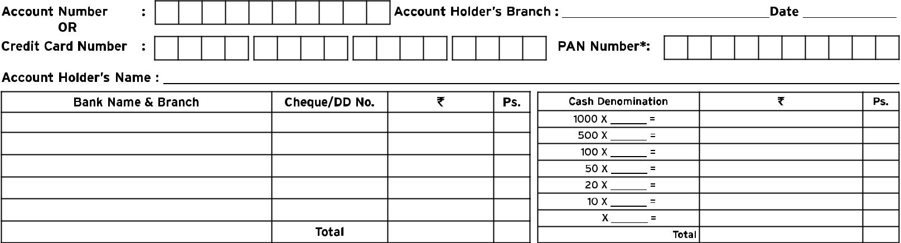

Deposit Slip Version 1.3
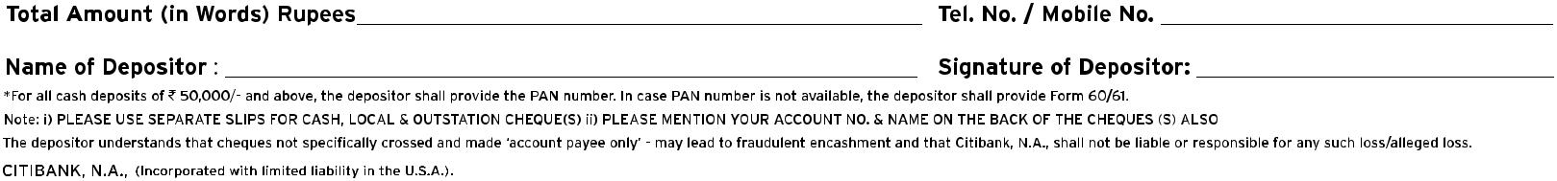

CV/BAN/CASA/Ver1.3/06-14

Deposit Slip Version 1.3

CV/BAN/CASA/Ver1.3/06-14

Deposit Slip Version 1.3
