Synonyms: Antonyms: In My Own Words:

Picture:

Word:

Definition:

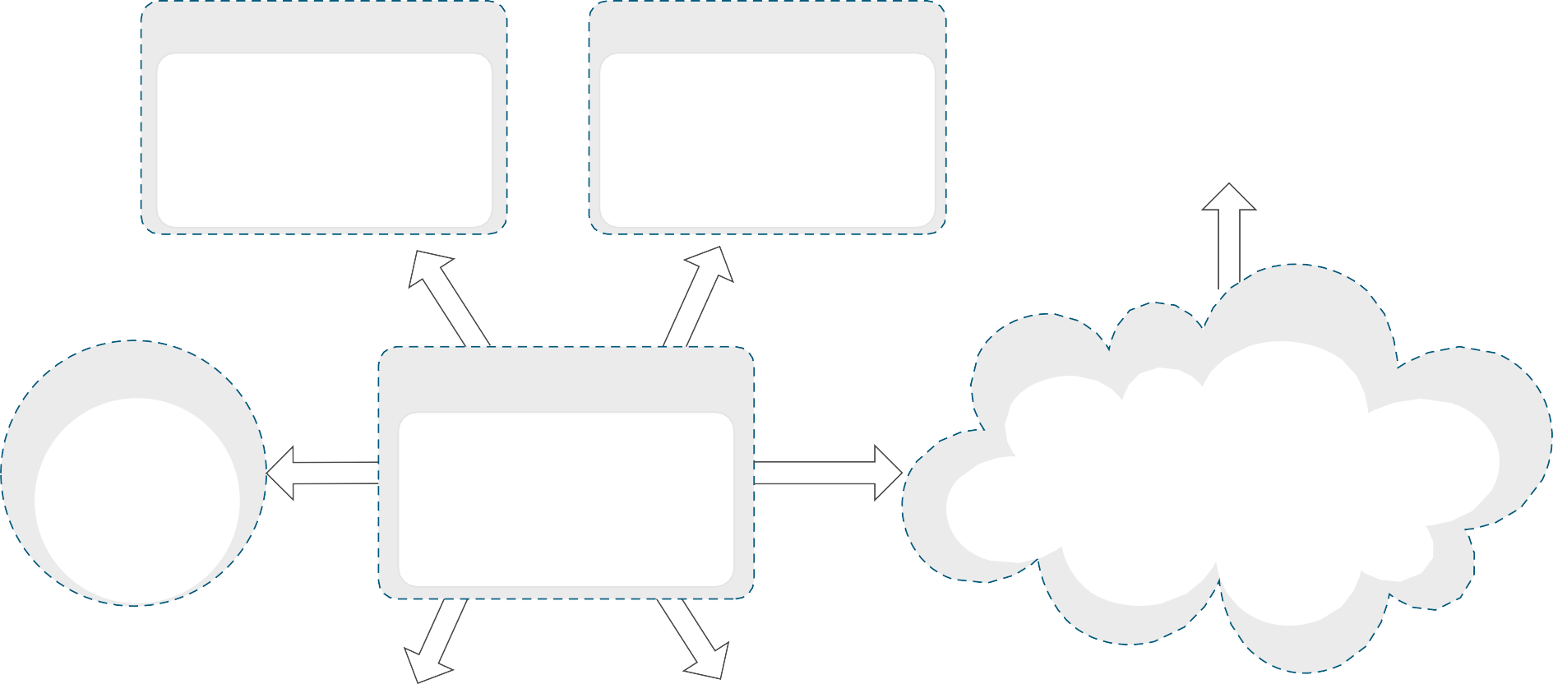
Sentence:

Prefix:
Part of Speech:

