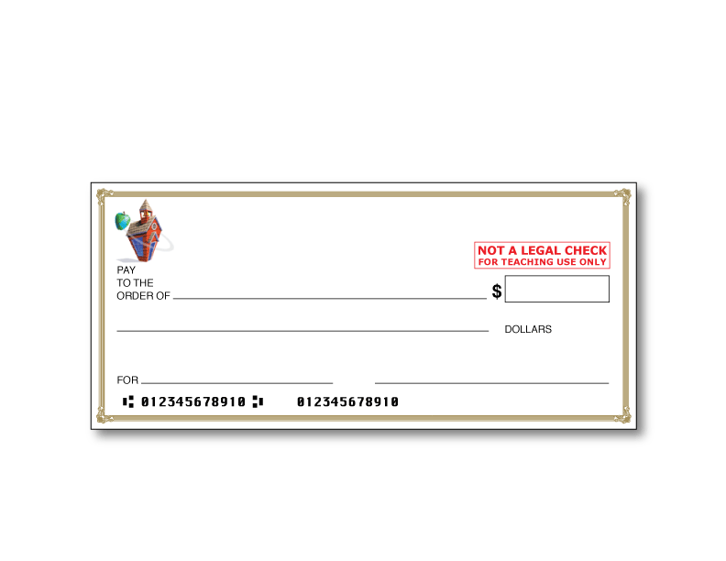

INSERT NAME

ADDRESS

CITY, STATE, ZIP CODE

INSERT Bank Name (example: Bank of 5th Grade)

0001

0001