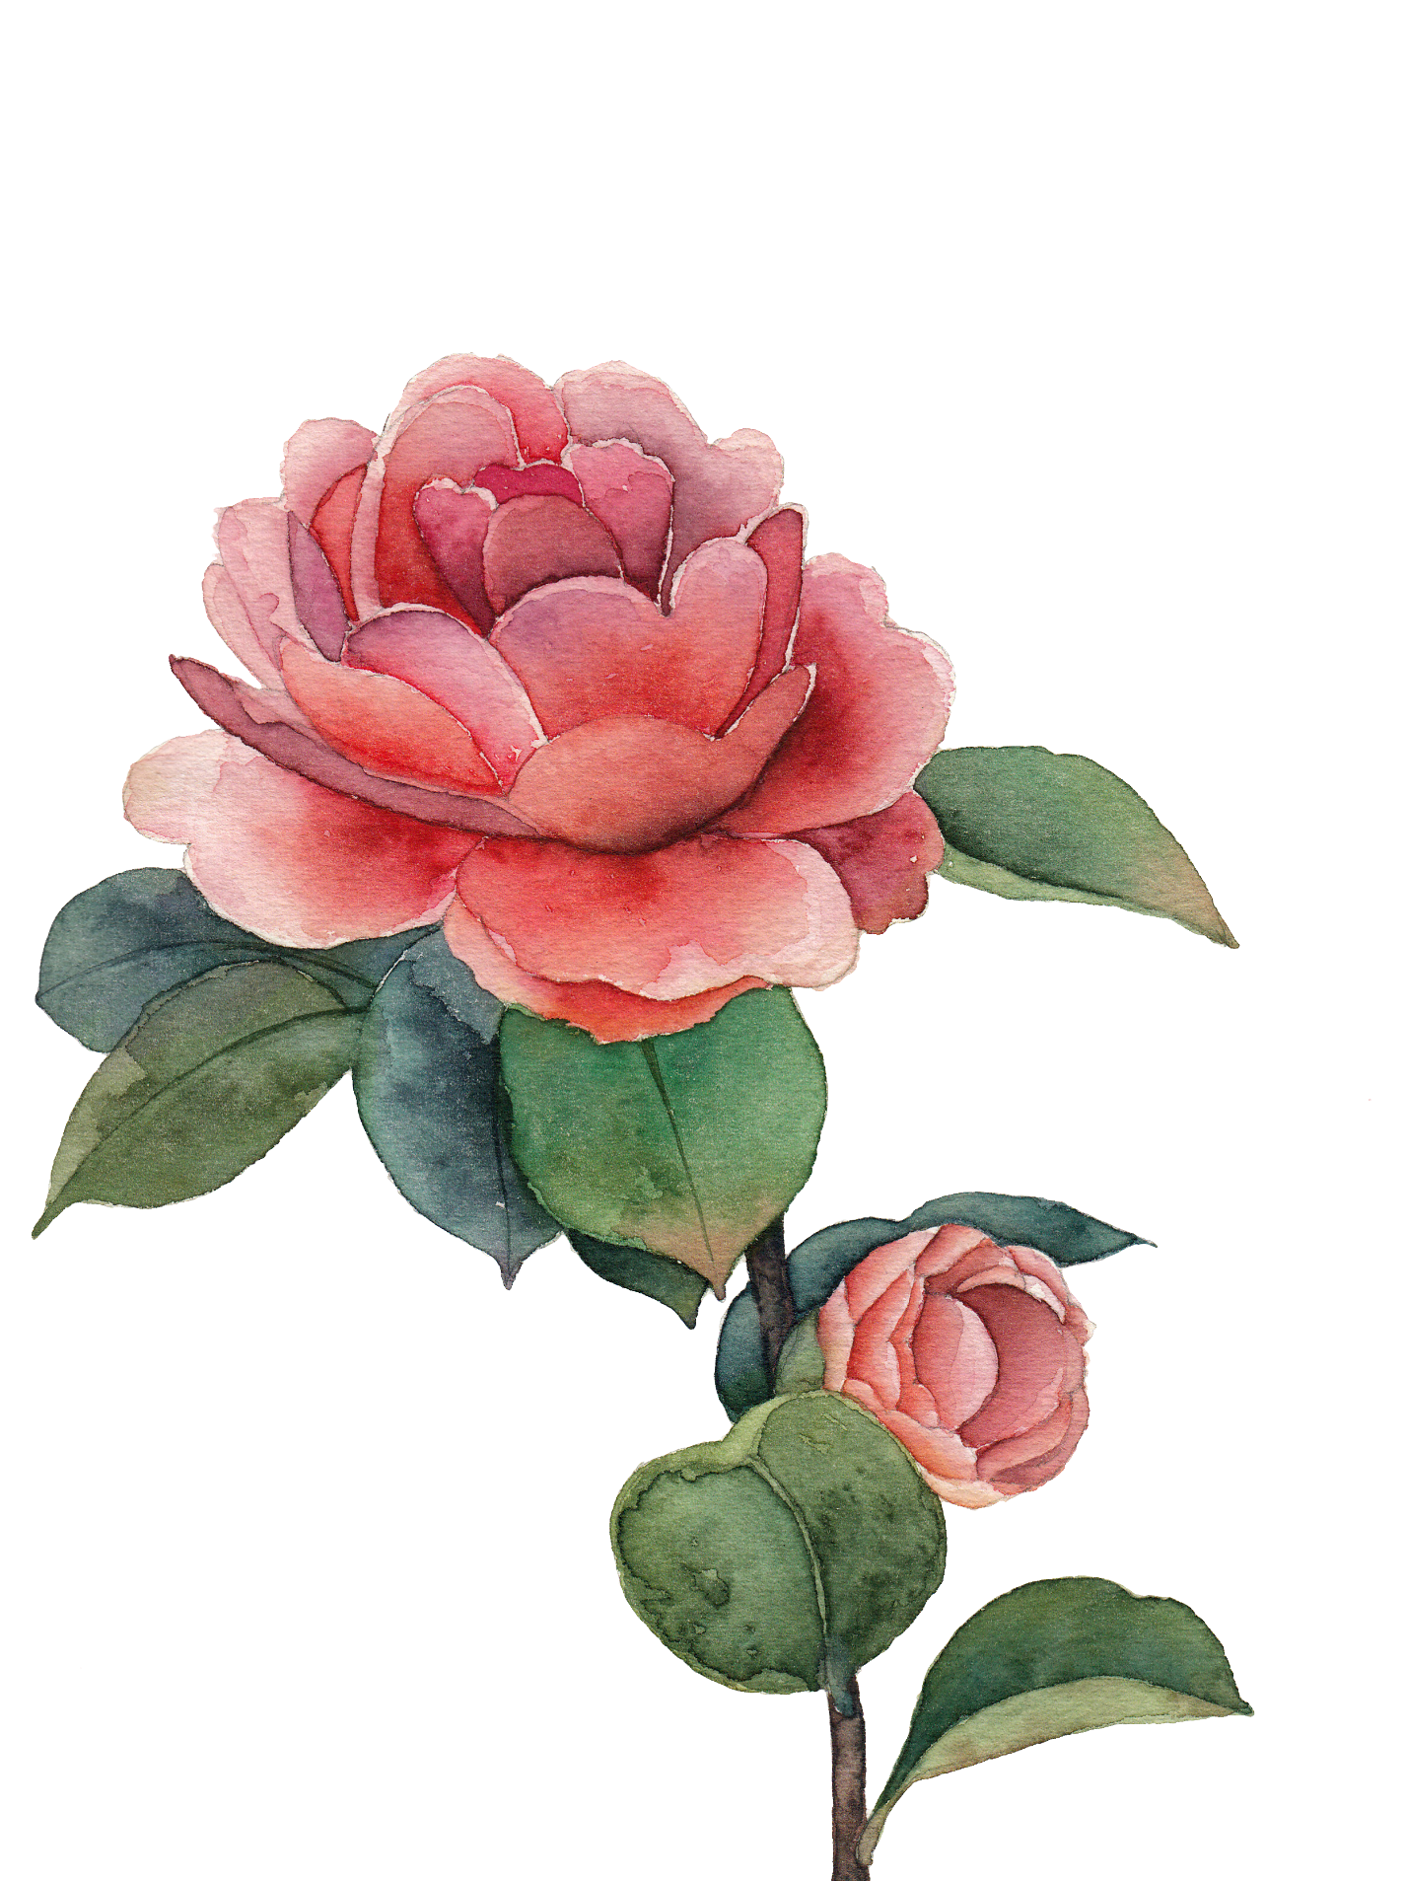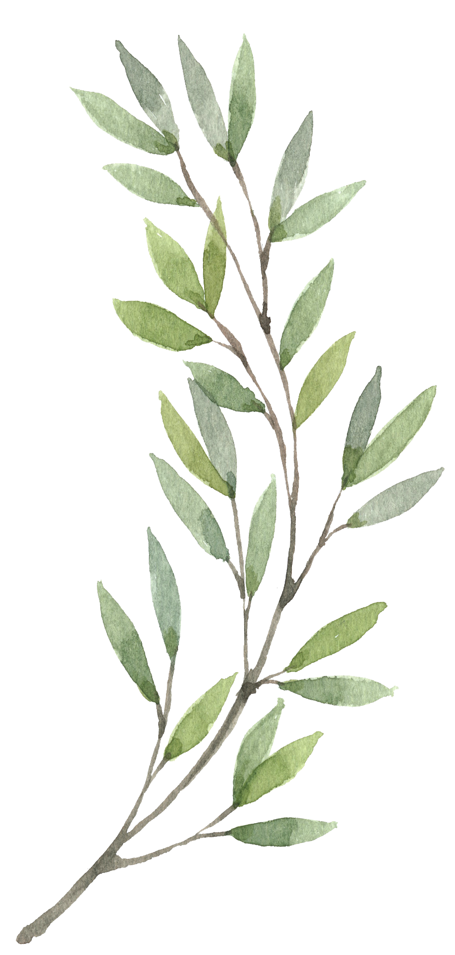

**CONTENTS**

On the Cover Emily Brooke

Dried Flower for Your Indoor Space

Challenges of Indoor Gardening

Green Thumb What it Means To Have One

Bright Colored Flowers

“Flower of the Year”

**1**

**2**

**3**

**5**

**7**

**10**