Cambridge, Massachusetts

May 2004

Professor Charles Fine Massachusetts Institute of Technology

Sloan School of Management

**Value Chain Dynamics**

1

Some material in this presentation is based on: Fine, Charles. *Clockspeed: Winning Industry Control in the Age of Temporary Advantage*. Perseus Publishing, 1999. ISBN: 0-7382-0153-7.



2

**Value Chains and Supply Chains**

**Value Chains**

**System Design**

-Core competences

-Make/Buy

-Relationship Design

-Strategic Intent

-Clockspeed

-Dynamics of

-Disintermediation

-Disintegration

-Dependence

-Capability development

***“The Biology of Evolution”***

**Supply Chains**

**Order fulfillment**

-Inventory

-Quality, cost & service

-Flexibility

-Response times

-Logistics

-Distribution

-Procurement

-Forecasting

-Transportation

-Quantity accuracy

-Timing accuracy

***“The Physics of Flow”***



3

**Dynamic Analysis to Support Industry & Technology Roadmapping**

***Corporate Strategy Dynamics***

***Regulatory Policy Dynamics***

***Industry Structure Dynamics***

***Technology Dynamics***

***Customer Preference Dynamics***

***Business Cycle Dynamics***

***Capital Market Dynamics***



Development Chain (BMW, Nokia, Toyota)

**Supply**

**Develop**

**3-D**

**Concurrent Engineering**

**Voice of the**

**Customer**

**Launch**

**Distribute**

**Production**

**Sell**

**Supply**

**Design**

4

**The Three Chains of Enterprise Design:**

***Fulfillment, Development, & Technology Chains***

**Capability Supply Chain**

**(Intel, Airbus, Citibank)**

**Fulfillment Supply Chain (Dell, Walmart, Amazon)**



5

**Supply Chain Design in a Fast-Clockspeed World: Study the Industry Fruitflies**

***Evolution in***

***the industrial world:* INFOTAINMENT** is faster than **MICROCHIPS** is faster than **AUTOS** evolve faster than **AIRCRAFT** evolve faster than **MINERAL EXTRACTION**

***THE KEY TOOL: Cross-INDUSTRY***

***Benchmarking***

***of Dynamic Forces***

***Evolution in***

***the natural world:***

FRUITFLIES

*evolve faster than*

MAMMALS

*evolve faster than*

REPTILES

***THE KEY TOOL:***

***Cross-SPECIES Benchmarking***

***of Dynamic Forces***



6

**The Strategic Impact of Project Design:**

***(Who let Intel Inside?)***

**1980:**

**IBM designs a product, a process, & a value ch**

**Consumers/ Users**

**Distribution Channel(s)**

**Subsystem Suppliers**

**OEM**

**The Outcome:**

**A phenomenonally successful product design A disastrous value chain design (for IBM)**

**Microsoft**

IBM

***Intel Inside***

**Intel**



7

**LESSONS FROM A FRUIT FLY:**

***THE PERSONAL COMPUTER***

**1.**

**BEWARE OF *INTEL INSIDE***

**(Regardless of your industry)**

**MAKE/BUY IS NOT ABOUT WHETHER IT IS *TWO CENTS CHEAPER* OR *TWO DAYS FASTER* TO OUTSOURCE VERSUS INSOURCE.**

**DEVELOPMENT PARTNERSHIP DESIGN CAN DETERMINE THE FATE OF COMPANIES AND INDUSTRIES, AND OF PROFIT AND POWER**

**THE LOCUS OF VALUE CHAIN CONTROL CAN SHIFT IN UNPREDICTABLE WAYS**

**2.**

**3.**

**4.**



8

**VALUE CHAIN DESIGN:**

**Three Components**

**1. Insourcing/OutSourcing**

***(The Make/Buy or Vertical Integration Decision)***

**2. Partner Selection**

***(Choice of suppliers and partners for the chain)***

**3. The Contractual Relationship**

***(Arm’s length, joint venture, long-term contract, strategic alliance, equity participation, etc.)***



9

**Buzz Groups**

***When have you seen sourcing decisions***

***have a significant impact on a key innovations in the value chain?***

***What are the strengths and weaknesses of***

***how sourcing strategy works at your company?***



10

**Vertical Industry Structure with *Integral* Product Architecture**

Computer Industry Structure, 1975-85

For this diagram, see:

A. Grove, Intel; and Farrell, Joseph, Hunter Monroe, and Garth Saloner. "The Vertical Organization of Industry:

Systems Competition versus Component Competition." *Journal of Economics & Management Strategy* 7, no. 2 (1998): 143-182.



For this diagram, see:

A. Grove, Intel; and Farrell, Joseph, Hunter Monroe, and Garth Saloner. "The Vertical Organization of Industry:

Systems Competition versus Component Competition." *Journal of Economics & Management Strategy* 7, no. 2 (1998): 143-182.

**Horizontal Industry Structure with *Modular* Product Architecture**

11

Computer Industry Structure, 1985-95



**PRESSURE TO INTEGRATE**

**INTEGRAL PRODUCT VERTICAL INDUSTRY**

**MODULAR PRODUCT HORIZONTAL INDUSTRY**

**PRESSURE TO DIS-INTEGRATE**

**PROPRIETARY SYSTEM PROFITABILITY**

**ORGANIZATIONAL RIGIDITIES**

**SUPPLIER MARKET POWER**

**HIGH•**

**DIMENSIONAL COMPLEXITY**

**TECHNICAL ADVANCES**

**NICHE COMPETITORS**

THE DYNAMICS OF PRODUCT ARCHITECTURE AND VALUE CHAIN STRUCTURE:

**THE DOUBLE HELIX**

12

**Source: Fine, Charles, and Daniel Whitney. “Is the Make-Buy Decision Process a Core Competence?" MIT Center for Technology, Policy, and Industrial Development, February 1996. Used with permission.**



13

**THE *DOUBLE HELIX***

**BUZZ GROUPS:**

**IN**

**OTHER INDUSTRIES**

1. HOW HAS THE DOUBLE HELIX AFFECTED A VALUE CHAIN THAT YOU ARE FAMILIAR WITH?
2. WERE THERE ANY “EARLY WARNING SIGNALS” AS TO THE COMING INTEGRATION OR DISTINTEGRATION?
3. WHAT DO YOU THINK MIGHT BE SOME HELPFUL “EARLY WARNING SIGNALS?”



14

**THE *DOUBLE HELIX***

**IN**

**OTHER INDUSTRIES**

•

***TELECOMMUNICATIONS--***

* **“MA BELL” was Vertical /Integral**
* **BABY BELLS & LONG LINES & CELLULAR are Horizontal/Modular**
* **Today’s Verizon is going back to Vertical /Integral**

***AUTOMOTI�VE--***

* **Detroit in the 1890’s was Horizontal/Modular**

•

–

–

**Ford & GM in the mid 1900’s were Vertical /Integral**

**Today’s Auto Industry is going back to Horizontal/Modular**

•

***TELEVISION--***

– **RCA was Vertical /Integral**

–

–

**1970’S THROUGH 1990’S were**

**Horizontal/Modular**

**Today’s media giants are going back to Vertical /Integral**

•

***BICYCLES--***

– **Safety Bikes to 1890’s boom to Schwinn to *Shimano Inside***



**THE**

***Mobile Phone***

**product technology**

**THE**

***Mobile Phone* MANUFACTURING COMPANY**

**organization**

15

**INDUSTRY CLOCKSPEED IS A COMPOSITE: OF PRODUCT, PROCESS, AND ORGANIZATIONAL CLOCKSPEEDS**

***Mobile Phone* INDUSTRY CLOCKSPEED**

**THE**

***Mobile Phone* PRODUCTION PROCESS**

**process technology**



16

***Mobile Phone System* CLOCKSPEED is a mix of Transmission Standards, Software and Handsets**

***Mobile Phone System***

**TRANSMISSION STANDARD**

**slow clockspeed**

**SOFTWARE APPLICATIONS**

**medium clockspeed**

**OPERATING**

**SYSTEM**

**HAND SET**

**fast clockspeed**

**SERVICES**

**fast clockspeed**

**slow clockspeed**

**ISSUE:**

**THE FIRMS THAT ARE FORCED**

**TO RUN AT THE FASTEST CLOCKSPEED**

**ARE THE MOST LIKELY TO STAY AHEAD OF THE GAME.**



17

***Automobile* CLOCKSPEED IS A MIX OF**

**ENGINE, BODY & ELECTRONICS**

***Automobile***

**ELECTRONICS**

**fast clockspeed**

**BODY**

**medium clockspeed**

**ENGINE**

**slow clockspeed**

**ISSUE:**

MOST AUTO FIRMS

OPERATE AT

***ENGINE OR BODY CLOCKSPEEDS***; FUTURE THEY WILL NEED TO RUN AT ***ELECTRONICS CLOCKSPEED.***

IN THE



18

**Buzz Groups**

***What’s the fastest clockspeed component***

***of your company’s value chain?***

***How is your company responding to the***

***speed of this fast-moving component?***



19

**Clockspeed drives**

***Business Strategy Cadence***

***BUSINESS STRATEGY & CORE***

***CAPABILITIES***

***Project Design & Tactical Decisions***

**Dynamics between New Projects and Core Capability Development: PROJECTS MUST MAKE MONEY AND BUILD CAPABILITIES**



**3-D Concurrent Engineering &**

20

***the imperative of concurrency***

**Product**

**Process (Project Plan)**

Supply Chain

**(Deliverable**

(Partners/Suppliers)

**Development & Tech. Chains**

**Fulfillment Supply Chain**

Fulfillment Architecture Technology

**Supply Logistics**

**Chain & Coord**

**Architecture System**

***Sourcing Information***

***Selection Inventory***

***Relationship Integration***

**Production System**

***Objectives Systems People Capacity***

Unit Processes

***Technology Equipment***

**Product/ System Architecture**

***Modular/ Integral***

***Life Cycles***

Detailed Design

***Specs Materials Functions***



21

**Controlling the Chain Through Distribution:**

**The End of *P&G Inside* ?**

•

•

*Controlling the Channel Through Closeness to Customers:*

*consumer research, pricing, promotion, product development*

Customers

Retailer

Retailer

**P&G**

Retailer



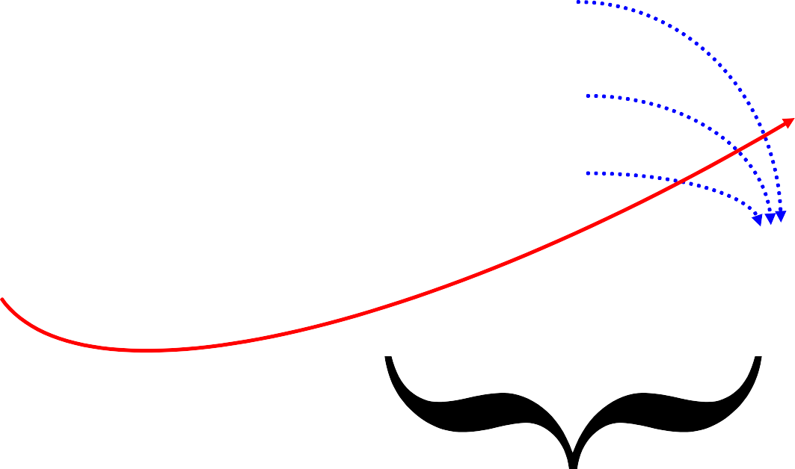

22

**Controlling the Chain Through Distribution:**

**Beware of *Walmart Outside***

*Controlling the Channel Through Closeness to Customers:*

*Chain Proximity*

Customers

Vertical Growth on the Double Helix

**WalMart Private Label**

**P&G**

**WalMart**

Retailer

Retailer

Retailer



23

***lockspeeds accelerate as you head downstream closer to the final customer* ;**

**Clockspeed = f(technology push, customer pull, system complexity)**

**Automobile**

**Vehicle Electronics Architecture**

**Telematics System**

**In-Vehicle Services**

**Chip maker**

**PC Maker**

**Semiconductor Equipment Maker**

**Web Site Developer**

**New Phone Applications**

**Handset Platforms**

**Telecom Equipment**

**Optical Components**



**ALL COMPETITIVE ADVANTAGE**

**IS TEMPORARY**

***Autos:***

***Ford* in 1920, *GM* in 1955, *Toyota* in 1990**

***Computing:***

***IBM* in 1970, *DEC* in 1980, *Wintel* in 1990**

***World Dominion:***

***Greece* in 500 BC, *Rome* in 100AD, *G.B.* in 1800**

***Sports:***

***Bruins* in 1971, *Celtics* in 1986, *Yankees* no end**

***The faster the clockspeed, the shorter the reign***

24

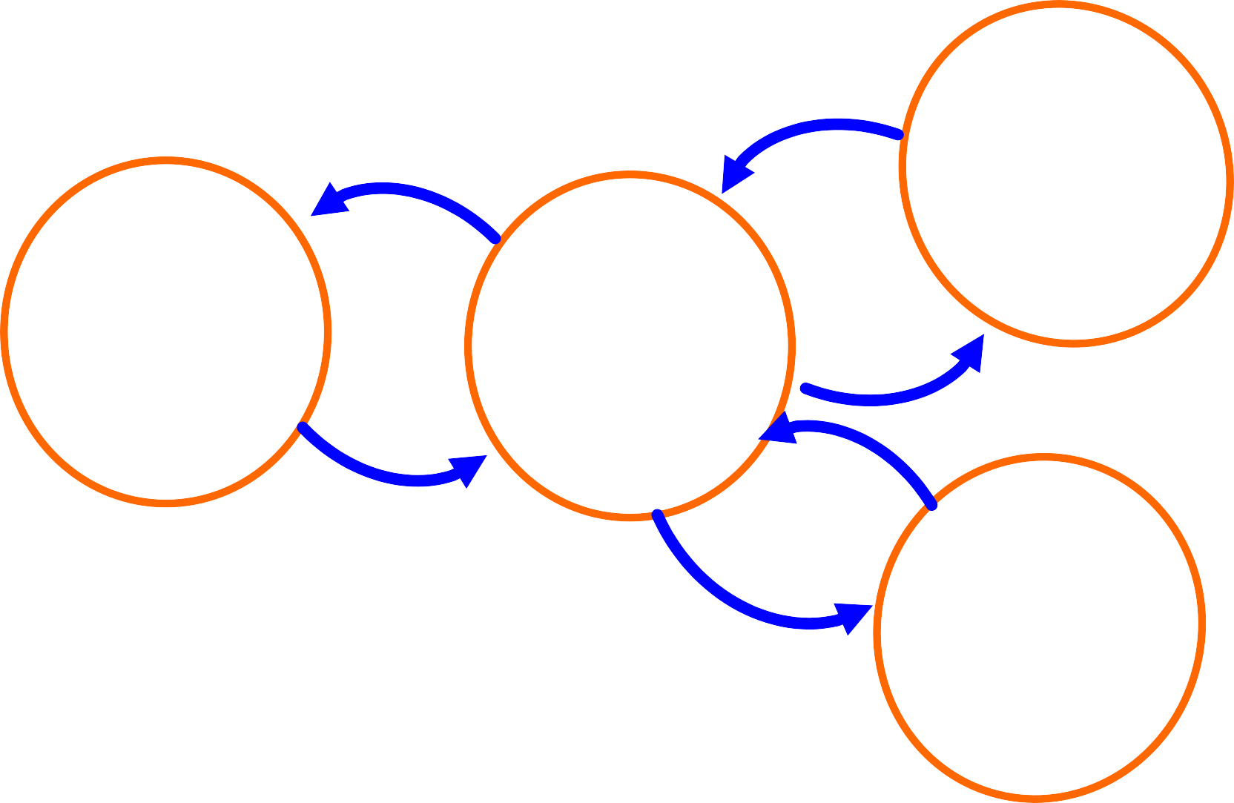

25

**Projects Serve Three Masters: Capabilities, Customers, & Corporate Profit**

**PROJECT DESIGN**

**(New products, new processes, new suppliers)**

**CORE CAPABILITIES**

**CORPORATE**

**VALUE**

**PROPOSITION**

**CUSTOMER**

**VALUE**

**PROPOSITION**



26

**IMPLEMENTATION OF *PROJECT DESIGN:***

**FRAME IT AS 3-D CONCURRENT ENGINEERING**

**Recipe, Unit Process**

PRODUCT

**Performance Specifications**

PROCESS

**Technology, & Process Planning**

**Details, Strategy**

**Product Architecture, Make/Buy components**

**Time, Space, Availability**

VALUE CHAIN

**Manufacturing System, Make/Buy processes**



27

**ARCHITECTURES IN 3-D**

***INTEGRALITY* VS. *MODULARITY***

***Integral product architectures* feature close coupling among the elements**

* Elements perform many functions
* Elements are in close spacial proximity
* Elements are tightly synchronized

- Ex: jet engine, airplane wing, microprocessor

***Modular product architectures* feature separation among the elements**

* Elements are interchangeable
* Elements are individually upgradeable
* Element interfaces are standardized
* System failures can be localized

- Ex: stereo system, desktop PC, bicycle



28

***VALUE CHAIN ARCHITECTURE***

Integral value-chain architecture

features close proximity among its elements

- Proximity metrics: Geographic, Organizational

Cultural, Electronic

-

-

-

Example: Example: Example:

Toyota city

Ma Bell (AT&T in New Jersey)

IBM mainframes & Hudson River Valley

Modular value-chain architecture features multiple, interchangeable supplier and standard interfaces

* Example:
* Example:
* Example:
* Example:

Garment industry PC industry

General Motors’ global sourcing Telephones and telephone service



29

**BUSINESS SYSTEMS**

**ALIGNING ARCHITECTURES:**

**& TECHNOLOGICAL SYSTEMS**

**BUSINESS SYSTEM/SUPPLY CHAIN ARCHITECTURE**

**(Geog., Organ., Cultural, Elec.)**

INTEGRAL

MODULAR

**MODULAR**

**INTEGRAL**

**TECHNOLOGY/PRODUCT ARCHITECTURE**

Microprocessors

Mercedes & BMW

vehicles

Lucent Nortel

Polaroid

MSFT Windows

Chrysler vehicles

Cisco

Digital Rights/ Music Distribution

Dell PC’S Bicycles



30

**Demand-Supply Chain Management @ Dell**

**Demand Management: Forecast = Buy = Sell**

**Buy to Plan, but Build to Order**

**Inventory Velocity is a wonderful thing …**







•

•

Customers have immediate access to the latest technology.

Suppliers get their products to market quickly Quality is improved with fewer touches.

Cash is generated through negative cash cycle.

Model efficiencies drive Market Share gain.

•

•

•

•



31

***“Dell Direct”* Work for Autos?**

* **Appealing to OEM’s on Many Dimensions**

–**Satisfy customer need for Speed**

–**Reduce Supply Line Inventories**

–**Reduce mismatches and discounting**

–**Direct OEM-Customer Relationships (& Data!)**

–**Information Transparency**

**Ideas adapted from Prof. John Paul MacDuffie, IMVP (International Motor Vehicle Program at MIT) and The Wharton School of the University of Pennsylvania**



**A Car is not a Computer!!**

33

**BUT,**

**Ideas adapted from Prof. John Paul MacDuffie, IMVP (International Motor**

**Vehicle Program at MIT) and The Wharton School of the University of Pennsylvania**

* ***Car***
* **~ 4000 components**
* **100 key subsystems**
* **300 key suppliers**
* **12 month validation**
* **1,000,000**

**variations**

* **Integral**

**Architecture**

* ***Personal Computer***
* **~50 components**
* **8-10 key parts**
* **40 key suppliers**
* **24 hour burn-in**
* **100 design**

**variations**

* **Modular Architecture**



34

**Strategic Sourcing as a Driver of Dynamic Evolution of Capabilities Along the Value Chain**

**Distinguish between**

dependence for knowledge or dependence for capacity

Independence

Dependence

**Amount of Work**

**Outsourced**

**knowledge**

**Amount of**

**Work Done In-house**

**knowledge**

**+**

**+**

**+**

**+**

**+/or supply**

**+/or supply**

**Supplier Capability**

**Internal Capability**

**Amount of Supplier Learning**

**Amount of Internal Learning**

**+**

**+**



**Technology Dynamics in the Aircraft Industry:**

**LEARNING FROM THE DINOSAURS**

35

**Japanese appeal as**

**+**

**U.S. firms’ appeal as subcontractors**

**subcontractors**

**+**

**+**

**Japanese Industry**

**Boeing outsources**

**to Japan**

**Autonomy**

**+**

***(Mitsubishi Inside?)***

**Japanese**

**U.S.**

**industry size &**

**industry size &**

**+**

**-**

**capability**

**capability**



36

**SOURCEABLE ELEMENTS**

**PROCESS ELEMENTS**

**ENGINEERING**

**ASSY**

**TEST**

**CONTROLLER**

**I4**

**V6**

**V8**

**PRODUCTS**

**VALVETRAIN**

**BLOCK**

**SUBSYSTEMS**



37

**Strategic Make/Buy Decisions:**

**Assess Critical Knowledge & Product Architecture**

**INDEPENDENT FOR KNOWLEDGE & DEPENDENT FOR**

**DEPENDENT FOR KNOWLEDGE**

**& CAPACITY**

**INDEPENDENT FOR KNOWLEDGE & CAPACITY**

**Adapted from: Fine, Charles, and Daniel Whitney. “Is the Make-Buy Decision Process a Core Competence?" MIT Center for Technology, Policy, and Industrial Development, February 1996. Used with permission.**

**ITEM IS INTEGRAL ITEM IS MODULAR**

**A POTENTIAL**

**OUTSOURCING TRAP**

**CAPACITY**

**BEST OUTSOURCING OPPORTUNITY**

**OVERKILL IN VERTICAL**

**INTEGRATION**

**WORST OUTSOURCING SITUATION**

**CAN LIVE WITH**

**OUTSOURCING**

**BEST INSOURCING SITUATION**



43

**Value Chain Mapping**

***Organizational Supply Chain***

***Technology Supply Chain***

***Capability Chain***

Underlying Assumption:

You have to draw

the maps before you can assess their dynamics.

**R&D**

**NVH engineering**

**Quality assurance**

**Supply Chain Management**

**clay chemistry**

**casting manufacturing**

**process**

**valve lifters**

**engines**

**clay supplier**

**casting supplier**

**Eaton**

**Chrysler**



44

**VALUE CHAIN DESIGN IS**

***THE ULTIMATE***

**CORE COMPETENCY**

***Since all advantages are temporary,***

***the only lasting competency is to continuously build and assemble capabilities chains.***

**KEY SUB-COMPETENCIES:**

1.

Forecasting the dynamic evolution of market

power and market opportunities

1. **Anticipating Windows of Opportunity**
2. 3-D Concurrent Engineering: Product, Process, Value Chain

***CAPABILITIES***

***PROJECTS***

***Fortune Favors the Prepared Firm***





45

**PROCESS**

**FOR**

**VALUE CHAIN DESIGN**

1.

2.

Benchmark the Fruit Flies Map your Supply Chain

-Organizational Value Chain

-Technology Value Chain

-Competence Chain Dynamic Chain Analysis

at each node of each chain map Identify Windows of Opportunity

**DOUBLE**

**HELIX**

**BOEING**

3.

4.

5.

Exploit Competency Development Dynamics with 3-D Concurrent Engineering

***CAPABILITIES***

***PROJECTS***



46

**DOT.COM COMPETITION: FOCUS ON THE SUPPLY CHAIN**

**Napster’s New Supply Chain Strategy**

**(go to the end and steal everything!)**

Record Music

Customer Consumption

**Alternate Solution: partner with your competitor**

Press CD’s

Steal Songs

Sell to Retail

Promote Music

Develop Songs

**Vertically Integrated Music Giants**

Identify Talent



47

**STRATEGY IN 3-D:**

**CASE EXAMPLES**

**Boeing:**

**Static 3-D in airplane Projects Dynamic, Strategic Value Chain,**

**unintegrated w/ Product & Process**

**Intel:**

**Modular Product vs. Process Integral Process and Value Chain**

**Chrysler:**

**Modular Product & Value Chain (weak on process?)**

**Toyota:**

**Integral 3-D in Nagoya (weak on global 3-D?)**



48

**Team Exercise: Value Chain Analysis**

Consider one of these five industries (or one of your own):

-Food

-Defense aircraft

-Automobiles

-Handheld electronic organizers/communicators

-Music

What are the key elements in the value chain?

What are the key dynamic processes influencing power in the chain?

What are the key dependency relationships in the value chain? What is driving the clockspeed in the chain?

What are the opportunities for outsourcing ? What are the windows of opportunity in the chain?



49

**Dynamic Analysis to Support Industry & Technology Roadmapping**

***Corporate Strategy Dynamics***

***Regulatory Policy Dynamics***

***Industry Structure Dynamics***

***Technology Dynamics***

***Customer Preference Dynamics***

***Business Cycle Dynamics***

***Capital Market Dynamics***



50

**Cisco’s End-to-End Integration for**

**its Fulfillment Supply Chain**

**Cisco**

**Finished Product flows direct to customer via logistics supplier**

**Order info flows direct to**

**Cisco and suppliers**

**Basic Design Principle:**

**Arm’s length**

**Relationship with Fulfillment Chain Partners**

**Component**

**Suppliers & Distributors**

* **Single enterprise information system**
* **Dynamic replenishment, direct fulfillment, merge in transit**
* **Customer orders through Cisco Connection online**

**Contract Manufacturers**

**Customers**

* **New product development on-line with supply base**
* **Technology Supply Chain Design:**

**Innovation through Acquisition**



51

**Cisco’s Strategy for Technology Supply Chain Design**

1. **Integrate technology around the router to be a communications network provider.**
2. **Leverage acquired technology with**
   * **sales muscle and reach**
   * **end-to-end IT**
   * **outsourced manufacturing**
   * **market growth**
3. **Leverage venture capital to supply R&D**

**Basic Design Principle:**

**Acquisition**

**Relationship with Technology Chain Partners**



52

**Volatility Amplification in the Supply Chain:**

***“The Bullwhip Effect”***

Customer

Retailer

Distributor

Factory

Equipment

Tier 1 Supplier

Information lags Delivery lags

Over- and underordering Misperceptions of feedback Lumpiness in ordering Chain accumulations

SOLUTIONS:

Countercyclical Markets Countercyclical Technologies Collaborative channel mgmt. (Cincinnati Milacron & Boeing)

53

**Supply Chain Volatility Amplification: Machine Tools at the tip of the Bullwhip**

For this chart, see:

Anderson Jr., Edward G., Charles H. Fine, and Geoffrey G. Parker. "Upstream Volatility in the Supply Chain: The Machine Tool Industry as a Case Study." *Production and Operations Management* 9, no. 3 (Fall 2000): 239-261.



55

**LESSONS FROM A FRUIT FLY:**

***CISCO SYSTEMS***

1. KNOW YOUR LOCATION IN THE VALUE CHAIN
2. UNDERSTAND THE DYNAMICS

OF VALUE CHAIN FLUCTUATIONS

1. THINK CAREFULLY ABOUT THE ROLE

OF VERTICAL COLLABORATIVE RELATIONSHIPS

1. INFORMATION AND LOGISTICS SPEED DO NOT REPEAL BUSINESS CYCLES OR THE BULLWHIP.

***Bonus Question:***

**How does clockspeed impact volatility?**



56

**BUZZ GROUPS**

1. HOW HAS THE BULLWHIP AFFECTED A BUSINESS THAT YOU ARE FAMILIAR WITH?
2. HOW FAR UPSTREAM OR DOWNSTREAM DID YOU SENSE THE IMPACT OF THE BULLWHIP?
3. WHAT MIGHT HAVE BEEN DONE DIFFERENTLY TO REDUCE THE NEGATIVE IMPACT OF THE BUILLWHIP?



57

**Dynamic Analysis to Support Industry & Technology Roadmapping**

***Corporate Strategy Dynamics***

***Regulatory Policy Dynamics***

***Industry Structure Dynamics***

***Technology Dynamics***

***Customer Preference Dynamics***

***Business Cycle Dynamics***

***Capital Market Dynamics***



58

**All Conclusions are *Temporary***

**Clockspeeds are increasing almost everywhere**

**Many technologies and industries exhibits fast clockspeed & high volatility**

**Value chain design and service system competencies**

**key**

**Study of**

**Fruit Flies can help with crafting**

**strategy**