U.S. EXPERIENCE WITH SPRINKLERS FACT SHEET

Sprinklers save lives and protect property from fires.

Compared to properties without automatic extinguishing equipment and specifying wet-pipe sprinklers

- The death rate per fire in sprinklered homes is lower by 82%.

- Direct property damage per fire in sprinklered homes is lower by 68%.

Damage per Fire with Wet Pipe Sprinklers versus

Without Automatic Extinguishing Equipment, 2007-2011

Eating or |  |  |  |  |  |  |  |  |  | $53,000
drinking |  |  | $13,000
 |  |  | $21,000
Educational
 |  |  | $8,000
 |  |  | $14,000 |  |  |  | Without automatic
Health care*
 |  |  | $5,000
 |  |  |  |  |  |  | extinguishing equipment
 |  |  |  |  |  |  | With wet pipe sprinklers
Home including |  |  | $20,000
apartment |  |  | $7,000
 |  |  |  |  |  |  |  |  |  | $55,000
Store or office
 |  |  |  |  |  | $38,000
$0 |  |  | $20,000 |  |  | $40,000 |  |  |  | $60,000
*Health care includes hospitals, nursing homes, clinics, and doctor’s offices.

Sprinklers are reliable and effective.

In reported structure fires large enough to activate them, sprinklers operated in 91% of fires in sprinklered properties.

Wet-pipe sprinklers operated in 92% of these fires vs. 81% for dry-pipe sprinklers.

In reported structure fires large enough to activate them, sprinklers operated and were effective in 87% of fires in sprinklered properties.

Wet-pipe sprinklers operated and were effective in 89% of fires vs. 76% for dry-pipe sprinklers.
NFPA’s Fire Sprinkler Initiative: Bringing Safety Home seeks to encourage the use of home fire sprinklers and the adoption of fire sprinkler requirements for new construction.

In 2007-2011 fires large enough to activate them, sprinklers operated in 91% of fires in sprinklered properties. The graph below is based on the other 9% in which sprinklers should have operated but did not.

Reasons When Sprinklers Fail to Operate, 2007-2011

System shut off before fire |  |  |  |  |  |  |  |  |  |  |  |  |  |  |  |  |  |  |  |  | 64%
Manual intervention defeated system |  |  |  |  |  | 17%
Damaged component |  |  | 7%
Lack of maintenance |  |  | 6%
Inappropriate system for fire |  |  | 5%
0% |  |  | 10% |  |  | 20% |  |  | 30% |  |  | 40% |  |  | 50% |  |  | 60% |  |  | 70%
In 2007-2011 fires where sprinklers operated, they were effective in 96% of the cases. The graph below is based on the other 4% in which the sprinkler was ineffective.

Reasons When Sprinklers Are Ineffective, 2007-2011

Water did not reach fire | 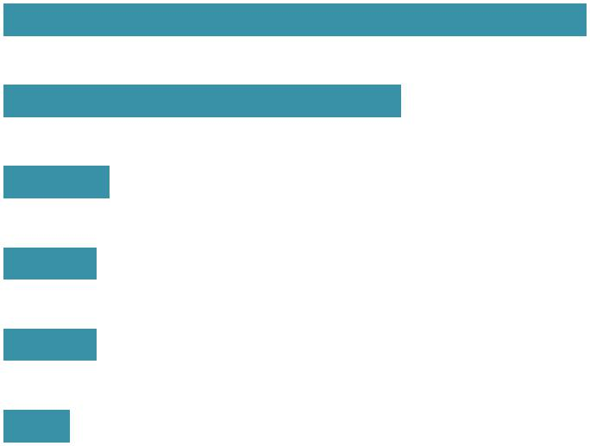 |  |  |  |  |  |  |  |  |  |  |  |  |  | 44%
Not enough water released |  |  |  |  |  |  |  |  | 30%
Damaged component |  |  | 8%
Manual intervention defeated |  |  | 7%
system
Lack of maintenance |  |  | 7%
Inappropriate system for fire |  |  | 5%
0% |  |  | 10% |  |  | 20% |  |  | 30% |  |  | 40% |  |  |  | 50%

Usually only 1 or 2 sprinklers are required to control the fire.

When wet-pipe sprinklers operated, 88% of reported fires involved only 1 or sprinklers.

For dry-pipe sprinklers, 73% involved only 1 or 2 sprinklers.

