Housing and Residence Life

RESIDENCE HALLS - ROOMMATE AGREEMENT

Instructions:

- Read and complete each item.

- Each roommate/Suitemate should make his/her individual response. Being honest will save time and minimize hurt feelings later.

- If responses to questions are different, discuss that difference and try to reach an understanding that roommates can live with.

- Write down your agreements. If there are things not listed in the agreement that you feel may be important to you, write them down and discuss them too.

- After the Roommate Agreement has been signed, return it to your RA for safekeeping and for Housing & Residence Life records.

- If problems arise, start with discussion. If you want a mediator, utilize your RA or Housing Coordinator.

Roommate Bill of Rights
The basic rights of a roommate include:

- The right to read and study free from undue interference in one’s own room. Unreasonable noise and other distractions inhibit the exercise of this right.

- The right to sleep without undue disturbance from noise, guests of roommate, etc.
- The right to expect that a roommate will respect one’s personal belongings.
- The right to a clean environment in which to live.

- The right to free access to one’s own room and facilities without pressure from a roommate.
- The right to privacy.

- The right to houseguests with the exception that guests are to respect the rights of the host’s roommate and other hall residents.

- The right to conflict mediation. Residence hall staff members are available for assistance in settling conflicts.
- The right to be free from fear of intimidation, physical and/or emotional harm.
- The right to expect reasonable cooperation in the use of room-shared appliances (such as the TV, micro-fridge, etc.)
- The right to be free from pressure or ridicule regarding your lifestyle choices.

Please print legibly

Resident Name | Room Number
A ____________________________________ | __________
 | Hall: ___________________
B ____________________________________ | __________
 | Room #: _________________
A ____________________________________ | __________
B ____________________________________ | RA Name: ____________________________
 | __________
I. Community Living:
*Check those that apply
-Security

This will always be locked:

Entry Door

Suite Door

Use of Each Other’s Belongings (Sharing is Caring)

Roommate A:

You may use these possessions of mine:

Movies/DVDs/Video Games

TV/DVD Player/ Game system

Clothes

Personal Care Items

Computer and related equip.

Appliances

Food

Temperature: _____________

_______________________

If you borrow something of mine:

____________________________

____________________________

____________________________

Roommate B:

You may use these possessions of mine:

Movies/DVDs/Video Games

TV/DVD Player/ Game system

Clothes

Personal Care Items

Computer and related equip.

Appliances

Food

Temperature: _____________

_______________________

If you borrow something of mine:

____________________________

____________________________

___________________________

Roommate A:

You may use these possessions of mine:

Movies/DVDs/Video Games

TV/DVD Player/ Game system

Clothes

Personal Care Items

Computer and related equip.

Appliances

Food

Temperature: _____________

_______________________

If you borrow something of mine:

____________________________

____________________________

____________________________

Roommate B:

You may use these possessions of mine:

Movies/DVDs/Video Games

TV/DVD Player/ Game system

Clothes

Personal Care Items

Computer and related equip.

Appliances

Food

Temperature: _____________

_______________________

If you borrow something of mine:

____________________________

____________________________

____________________________

Roommate Agreement FY 2019-20XX

II. Courtesy Hours:
*Establish acceptable hours, to engage in the following categories:

Roommate A: |  | Roommate B: |  | Roommate A:
*Example= Sleeping: 1am-9am |  | *Example= Sleeping: 1am-9am |  | *Example= Sleeping: 1am-9am
Sleeping:_______________ |  | Sleeping:_______________ |  | Sleeping:_______________
Studying:_______________ |  | Studying:_______________ |  | Studying:_______________
Personal: _______________ |  | Personal: _______________ |  | Personal: _______________

- Visitation --*Check the one that applies: Guests:
Housing and Residence Life

Roommate B:

*Example= Sleeping: 1am-9am

Sleeping:_______________

Studying:_______________

Personal: _______________

Roommate A:

Guest will be allowed when:

Welcome Anytime

I'm not trying to sleep

I'm home and not studying

___________________________

Roommate B:

Guest will be allowed when:

Welcome Anytime

I'm not trying to sleep

I'm home and not studying

___________________________

Roommate A:

Guest will be allowed when:

Welcome Anytime

I'm not trying to sleep

I'm home and not studying

___________________________

Roommate B:

Guest will be allowed when:

Welcome Anytime

I'm not trying to sleep

I'm home and not studying

___________________________

Significant Others:

Roommate A: |  | Roommate B: |  | Roommate A: |  | Roommate B:
Significant others are okay: |  | Significant others are okay: |  | Significant others are okay: |  | Significant others are okay:
Anytime |  | Anytime |  | Anytime |  | Anytime

When I'm not trying to sleep

When I'm not trying to sleep

When I'm not trying to sleep

When I'm not trying to sleep

If _______________________

If _______________________

If _______________________

If _______________________

Not Okay

Not Okay

Not Okay

Not Okay

If there is at least (1) resident under the age of 21 the entire suite is DRY, therefore NO alcohol is allowed.

IV. Cleaning Standards
  - Establish cleaning schedule- See attached chart to get you started ☺
  - Cleaning Chart was established- Date: ________________

V. Conflict Resolution

When a conflict arises, we will compromise as follows (Examples: Violation of the agreement, Noise level):______________

____________________________________________________________________________________________________

____________________________________________________________________________________________________

____________________________________________________________________________________________________

____________________________________________________________________________________________________

VI. Additional Comments:

Use this space for any additional comments of items that were not otherwise covered in this agreement and suggest how you will address them. You may also use the space to add further comments about topics that have already been discussed.

____________________________________________________________________________________________________

____________________________________________________________________________________________________

____________________________________________________________________________________________________

____________________________________________________________________________________________________

____________________________________________________________________________________________________

VII. Signatures:

We, as roommates enter into this agreement in good faith. We fully intend to abide by all policies that we have made and as they are written in the Residence Life Handbook.

Roommate A: ____________________ Date: ______ Roommate A: ____________________ Date: ______

Roommate B: ____________________ Date: ______ Roommate B: ____________________ Date: ______

Resident Assistant: ________________________

Roommate Agreement FY 2019-2020

Roommate Cleaning Schedule

FOR THE WEEK OF: | SAT SUN MON

TUE

WED

Housing and Residence Life

THU FRI

TASK

WHO | DONE | WHO | DONE | WHO | DONE | WHO | DONE | WHO | DONE | WHO | DONE | WHO | DONE
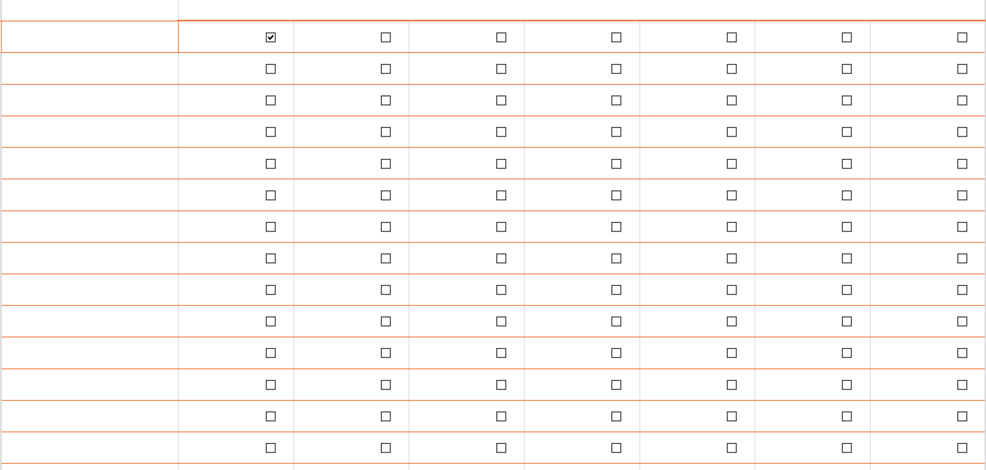

Sweep Room

Terry

