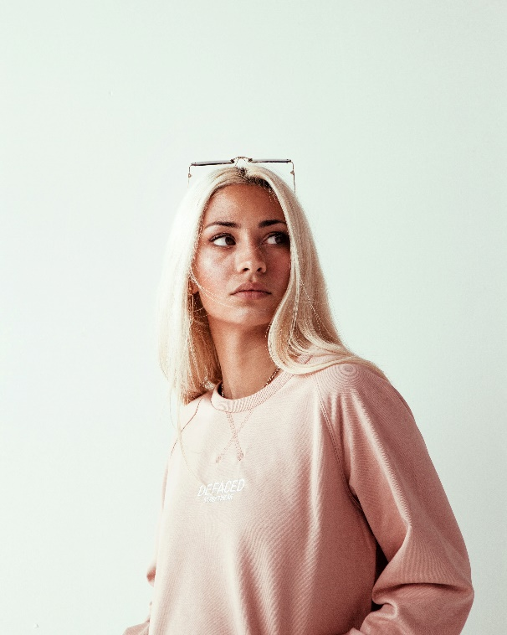***

**CERTIFICATIONS**

* Esthetician Certificate, 20XX
* Specialized Skincare Certificate, 20XX

**EDUCATION**

Bachelor's Degree Education

20XX – 20XX

Kent State University, Kent, OH

**AMANDA BARNES**

**PROFESSIONAL EXPERIENCE**

**Esthetician, 20XX – Present, Equinox, Greenwich, CT**

* Assist the staff and clients in work related to the spa/skin care center as requested by the management.
* Perform facials, microdermabrasion, and chemical peels; Product sales (skinceuticals/lather); Promote spa business.

**Esthetician, Makeup Artist, 20XX – 20XX, MAC Cosmetics, New York, NY**

* Provided exceptional customer service on sales floor.
* Welcomed and engaged with customers to provide customized skincare analysis,makeup applications, and product recommendations.
* Performed make-up applications for everyday wear, bridal makeup, runway, and special events.

**Brand Representative, 20XX – 20XX, J. C. Penney, Kent, OH**

* Maintained established merchandising standards, including window, sales floor and promotional displays.
* Performed important daily tasks such as counting diamonds when opening or closing the jewelry section.
* Processed customer jewelry repair orders via computer and manual logs.
* Assisted customers with purchases Organized Sales Pitches for new store items Prepared Cash reports and balance cash drawer Inventoried store shipment

**SKILLS**

* Positive Attitude
* Facials
* Brand REP
* Clients’ Needs
* Retail Sales
* Patient Care
* Body Treatments
* Massage Envy
* Individual Needs
* Customer Confidence

**CONTACT INFORMATION**

(123) 456-7895

Amanda.b@gmail.com

Bloom Avenue, Seventh Block, Ridgewood, Na

Linkedin.com/in/username