REFLECTIVE ESSAY
As a part of my degree we as a group of students undertake a module named advanced outdoor practice. During this module, each student including myself must complete an intensive professional development skills programme. I chose to participate in the RYA Powerboating Level 2 course. This took place at the Mount Batten Centre in Plymouth on consecutive Thursdays for a period of four weeks.
The principle behind RYA schemes is to educate those undertaking the course (RYA, 2013). Mendez (2009) states that these courses provide potential powerboaters with the opportunity to gain the skills and knowledge to safely and competently control a powerboat. An additional aspect to the module is to critically analyse the physical, social/ emotional and cognitive areas of my learning during the powerboat course.
As a means of critically analysing my personal learning I am going to use reflective practice to delve back into my experiences, feelings and thoughts during the powerboat level 2 course. Reflective practice allows for exploration of learning from personal experience to decipher how they can model our future experiences and practice (Thompson and Thompson, 2008).
Similarly, Boud et al. (1985) states that reflection is a developmental process of exploration that can lead to unforeseen results. Moon (2004) argues that reflective practice can be considered one of the key elements in experiential learning. Pearson and Smith (1985, cited in Moon, 2004) states that without reflection, adults cannot learn from their experiences.

I will convey my physical, social/ emotional and cognitive aspects of learning using Rolfe et al. (2001) Reflective cycle. Rolfe’s model is built upon three areas; what, so what and now what (University of Cumbria, 2016). I will use sub questions under these three areas to analyse in deeper detail. The questions will include; what was the learning experience or situation, so what have I discovered and how can I apply this somewhere else (College of Policing, unknown) (See Appendix 1 for figure).

The physical aspect most prominent over the powerboat course was the effect the cold conditions had on my physical and mental abilities (See Appendix 2 for image). I have chosen to explore this through a theory named conditions of favourability. Conditional favourability relies upon the five following factors: Environmental dangers, Individual competences, Group unity, leader proficiency and decision consequences (Martin et al., 2006).
Though conditions of favourability are usually in cohesion with leadership, I believe it has a strong impact upon myself as a participant also. The conditions were considered unfavourable for myself and some of the others for effective learning and participation. In relation to my experiences during the course, the aspect which presented itself as the most prominent was that of the cold and windy weather which is included in the environmental factor (Martin et al., 2006).

Blog Example: I decided to check the weather myself that night to investigate into what conditions we should be expecting tomorrow. It was pretty unanimous across all weather sources that it was going to be bloody windy… Got to Mount Batten the next day and I learnt the internet does not lie! The water was intriguing, filled with waves, ripples and resistance. It looked like it was going to be a very interesting day for being on the water.
(Blog Entry from The Perfect Storm- 23/11/17) (Hook,2017)

On certain days during the course there were large wind chills and as a result made me and the others quite cold. As we were not sheltered whilst on the boats we were at times heavily effected by the prevailing weather conditions. As stated by Cool Antarctica (2001) layering is the most important factor when undergoing an activity in cold conditions in order to stay warm, comfortable and will affect how well the muscles will perform.
As seen in the image found on Appendix 2 (also can be seen in the other images found in Appendix 3 and 4), each session we individually bought and wore lots of layers to ensure we stayed warm for the duration we would be on the water that day. However, at cold temperatures the areas that were the furthest away from my core were the most vulnerable to losing their internal heat (Cold Antarctic, 2001). With this in mind, my hands suffered in addition to them being bare to the forces of the weather in combination. Consequently, they often became uncomfortably cold and as a result made basic actions quite difficult. The cold temperatures affected my physical strength and reaction time due to having cold nerve endings and a lower muscle temperature (Cold Antarctic, 2001) (Grayson, 2013).
Having these minor physical issues caused by the cold weather effected my ability (minimally) in carrying out some basic physical tasks that needed to be carried out on the boat. Moreover, the cold feeling in my hands occasionally distracted my attention away from the information being given because I was concentrating more on the condition of my hands than the task.
This made prolonged powerboating throughout the day quite difficult on particular sessions. I believe that overall the physical aspect of my learning wasn’t the most prevailing of my personal learning, though it did affect minor areas throughout the course the physical side of things had a minimal impact.

From this I have found that it is key to think about the importance of the surrounding conditions from two separate perspectives. The first as an individual and taking responsibility for placing the correct measures (such as clothing and checking weather conditions) in place to make sure I stay comfortable for the duration of the activity, to make sure these physical infractions don’t happen again in future experiences. Secondly, from the point of view as a current and future group leader to consider the effect that certain unfavourable conditions can have on the participants mental, physical and emotional well- being.

As a leader I must consider if the conditions are of low, medium or high favourability (Priest and Gass, 2005) and how this will affect the completion of the task, myself and the individuals within the group. As a leader it would be my responsibility to make sure that the learning would still be beneficial to the individuals in those conditions (Ewert and Sibthorp, 2014).
These areas I will consider when I undertake another intensive course or when going on to work in the outdoor adventure education sector.
One emotional and social aspect that sticks out for myself the most was the sense of group cohesion throughout each week of powerboating (See Appendix 3 for image). Ewert and Sibthorp (2014) state that group cohesion is related to the factors that keep the group together, generally either task or socially related motives. Task motives can include areas such as completion of an exercise, whereas social motives relate to enjoyment of working together (Ewert and Sibthorp, 2014). In this particular context, I believe the sense of community and cohesion whilst powerboating was socially motivated.

Blog Example: Everyone on our boat had such a great time and we just couldn’t stop laughing at Fiona laying down taking photos and videos of us nor could we stop laughing at each other… But Fiona got some great videos of us and Anna got some great pictures of us all! Though I was nervous to start with, once I got used to the speed going straight (reasonably) the turning manoeuvres were easy and were really fun and exciting. We all felt like kids on a rollercoaster!
(Blog Entry from The Adventure Begins-16/11/17) (Hook, 2017)
As a result of our small size, conflict can arise however as we are a small group we are able to avoid cliques and strong disagreements (Walsh and Golins, 1976 cited in Berry and Hodgson, 2009). Additionally, the time we have all spent together over the past three years have grown strong bonds with one another (Levi, 2015). Having these connections means that within this community, we have built compassionate and trusting friendships (Carter, 2007). Through this compassion and trust, I have grown comfortable and confident with the other students and staff and as a result have built good strong friendships with those in the group especially with the females.
This particular session was my favourite one of the four as I learnt new things, whilst also spending the day with like- minded, funny people and that I consider to be my close friends (See Blog Extract above). Furthermore, this particular day I worked with all female friends of mine. It is found that friendships between females is built upon the sharing of feelings and confiding in one another (Lowenthal et al., 1976 cited in Aries and Johnson, 1983). With this in mind, I have grown strong ties to the females of our group. Berndt (2002) claims that close friendships such as the ones I have with the other women on the course, lessen the chances of individuals acting withdrawn socially.

As seen in Appendix 3, this particular session was our first session and I spent the day with two close female friends, Maddie and Anna and our female lecturer, Fiona. As a result, I felt I was in a comfortable learning environment in which I felt I could thrive and try new manoeuvres without judgement or fear of embarrassment or failure. Additionally, spending the day with those particular friends dispensed the nervousness I was feeling because we spent the day happy, making jokes and laughing, as you can see in appendix 3.

Stambor (2006) states that laughter and other forms of humour can improve student performance because it reduces levels of anxiety and encourages participation in the students, it further improves motivation for students to learn the subject at hand. I found this particular environment very effective for me to learn in because it was relaxed, filled with laughter and fun. This fun and humorous environment made by those I was with defused the emotional and physical stress I was experiencing about controlling a large motor boat having had very little experience prior to the course. The humour acted as a stress reliever (Stambor, 2006) and allowed me to enjoy the experience and retain the skills and information being given.

Though I found the environment enjoyable and educational, there were times where the fun overtook the educational aspects and lead to distractions that had a minor negative impact upon my learning. Steele (1998) states that there are many benefits related to humour and retaining information, however humour works most proficiently when it is linked to the subject at hand. The conversation and jokes would sometimes become off topic and I would become engrossed in the joke and not in the learning. Steele (1998) claims that humour aids in building positive and strong rapport between lecturer and students. As a group, we have great rapport with our lecturers due to the humour between us the students and lecturers themselves (see blog extract below).

Blog Example: During this time, our lecturer Fiona was trying to do Instagram live videos of us driving the power boat… that didn’t quite go to plan either! Eventually with some help she finally managed to do what she wanted and the results were hilarious! It’s quite sad how different and what’s the word… awful you sound on video!
(Blog Entry from The Adventure Begins- 16/11/17) (Hook, 2017)

On this particular occasion, I offered a helping hand but as a result I became engrossed in helping Fiona that I wasn’t watching Maddie and Anna drive, I usually watched because it helped when I came to drive the boat myself. Berk (unknown, cited in Stambor, 2006) proclaims that humour should complement the course material in order to avoid distraction from learning. Though it was very funny and made the whole day even more enjoyable, I felt I did get distracted from the physical learning of the skills which my have helped me when reversing for the first time.

Overall, I found that taking part in this course with a group of people that I have strong cohesion with and enjoy spending time with, allowed for myself and others to be comfortable and have an enjoyable experience and as a result create an effective enriched learning environment. Subsequently, as Steele (1998) suggests an environment that doesn’t hold these qualities can prove to be a hostile and apprehensive environment for participants, these feelings as a result can distract from the learning. Respectively, in the future I hope to be able to work in close knit groups such as the one I have experienced at university, not only to continue my learning throughout my future career and experiences but to also create an enjoyable professional working environment.

The cognitive aspects I have taken from the powerboat level 2 course was the way in which I learnt the manoeuvres and retained the relevant information given to me. Davis (1993, cited in Martin et al., 2006) states that the way in which an individual prefers or best gathers, interprets and retains information is referred to as their personal preferred learning style. In an effort to explore my cognitive learning aspects deeper I used the VAK learning style model and applied it to my experiences to differentiate what worked most effectively for me throughout the course. This particular model refers to three sensory areas- visual, auditory and kinaesthetic (Gholami and Bagheri, 2013). Throughout the course, we were taught the manoeuvres and information through all three of those forms of learning previously mentioned, such as; practical demonstrations both carried out by staff as well as students, drawings on the whiteboard and verbal instruction, an example of this can be found in appendix 4.

Blog Example: She told us that we were starting the day by righting some single hander sailing boats. She drew some lovely pictures on the board to try and explain a bit clearer because there were quite a few different scenarios of flipped boats… well it seemed like it to me anyway. It’s fair to say though the drawings went exactly Di Vinci standard, but they made more sense than the talk through.
(Blog Entry from The Boat that Rocked- 7/12/17) (Hook, 2017)

I found that during my time on the course that the best way for myself to gather and interpret information being given and taught to us was by looking at pictures, videos and watching demonstrations given by someone else such as one of the lecturers. As a result, I have concluded that I am a visual learner predominantly based upon the VAK learning model. Oxford (1995, cited in Gholami and Bagheri, 2013) states that visual learners are individuals who learn through visual aids such as whiteboards and videos and benefit greatly from detailed written instructions.
I found that during the course I would understand the task and the manoeuvre greater after having seen it in the form of a picture drawn on the whiteboard before getting on the water, as displayed in the image found in appendix 4, we had many of these whiteboard gatherings before getting onto the boats. Visual learners are shown to have trouble remembering and interpreting verbal information, but remember diagrams and pictures more profoundly than words (Study and Learning Centre, 2007).
Moreover, I found watching demonstrations and observing the other students very helpful, especially when they had a practice before myself. This allowed for me to watch their movements and the resulting effect those had on the movement of the boat itself and be able to apply those motions when my turn arose.

Blog Example: However, I was determined to do the best a possibly could in the conditions. I had a generally idea what to do after having watched Anna have her go and listening to Emma’s instruction towards Anna.
(Blog Entry from The Boat that Rocked- 7/12/17) (Hook, 2017)

During the course, not everything was in the form of an image or a demonstration, sometimes I had to take what I could verbally. Which I am able to do but with lesser an understanding of the information or task than with visual aids. Felder (unknown) states that those with unimpaired vision or hearing are able to learn using both, however can have a preference for one or the other that can vary.
During my experience on the course I found that I have a high preference for visual and a much lower preference for verbal. For example, there was a time when Emma, one of the Plymouth Youth Sailing volunteers tried to explain to me verbally what she wanted me to do. I felt rather embarrassed sitting at the wheel not understanding what she was saying. Emma’s verbal instructions would have probably been very helpful for those who are Auditory learners and learn from discussion and relay more on verbal directions (Oxford, 1995 cited in Gholami and Bagheri, 2013).
However, for myself I asked for a demonstration in addition to the verbal direction to try to apply words to the visual and that worked more proficiently, rather than just verbal alone. Felder (unknown) claims that ‘good learners’ grasp concepts and information greater when there is a mixture of both verbal and visual components (see blog extract above).

Going forward in my education and outdoor adventure education as a career I hope to keep this in mind in future endeavours. For example, moving onto participating in intensive training courses in other activities. By remembering this I can perhaps ask for information in a visual way if I am struggling to understand all the informational components.
Overall, it will help in my future development as a practitioner and as participant to know the best way in which I learn and succeed. Additionally, as a leader would give me greater understanding of how individuals gather and interpret information differently and adapt my leading to support all areas of preferred learning.

The learning undertaken during the powerboat level 2 course was vast and came from a variety of areas such as the ones spoken about throughout. What could be considered as a small aspect had made a large impact on the enjoyment and learning during the course, it is not till I reflected and explored these areas, that their impact is realised. Through reflecting I can create emphasis on what I have learnt through questioning such as through Rolfe’s model and in turn develop an understanding (Smyth, 1992, cited in Loughran, 2002).
I found that the weather, the company throughout the sessions and my learning style were major contributors to my personal outcome of the course, having completed the course I can see the positives and negatives of how each of those effected my learning in a variety of ways. From having explored my learning, I can now take on what I have learnt personally and about the activity (powerboating) into future endeavours and employment.

References
Aries, E. J. and Johnson, F. L. (1983) Close friendship in adulthood: Conversational content between same-sex friends. Sex Roles. Vol. 9, No. 12: 1183–1196.
Berndt, T. (2002) Friendship Quality and Social Development. Department of Psychological Sciences, Purdue University. Vol. 11, No. 1: 7-10.
Boud, D., Keough, R. and Walker, D. (1985) Reflection: Turning Experience into Learning. New York: Nichols Publishing Company`.
Carter, J. (2007) Leadership the Outward-Bound Way. Seattle: The Mountaineers Books.
College of Policing (2017) Rolfe's Reflection Model. [Online] Available from: http://www.college.police.uk/What-we-do/Development/professional-development-programme/Documents/rolfereflectionmodel.pdf [accessed 22 December 2017].
Cool Antarctic (2001) Cold Weather and Sport Exercise in Low Temperatures. [Online] Available from: https://www.coolantarctica.com/Antarctica%20fact%20file/science/cold-weather-sportUK.php [accessed 28 December 17].
Ewert, A. W. and Sibthorp, J. (2014) Outdoor Adventure Education. Leeds: Human Kinetics.
Felder, R. (2017) Learning Styles and Strategies. [Online] Available from: http://www4.ncsu.edu/unity/lockers/users/f/felder/public/ILSdir/styles.pdf [accessed 30 December 17].
Gholami, S. and Bagheri, M. (2013) Relationship between VAK Learning Styles and Problem-Solving Styles regarding Gender and Students' Fields of Study. Journal of Language Teaching and Research. Vol. 4, No. 4: 700-706.
Grayson, M. (2013) Exercising in Cold Environments. [Online] Available from: http://www.dna-sports-performance.com/exercising-in-cold-environments/ [accessed 28 December 17].
Hook, K. (2017) Powerboat Day One: Plymouth Adventure- 16/11/17. [Online] 21 November 17. Available from: http://sites.marjon.ac.uk/khook/[accessed 04 January 2018].
Hook, K. (2017) Powerboat Day Two: The Perfect Storm- 23/11/17. [Online] 24 November 2017. Available from: http://sites.marjon.ac.uk/khook/[accessed 04 January 2018].
Levi, D. (2015) Group Dynamics for Teams. (5th ed.) London: SAGE Publications.
Loughran , L. (2002) Effective Reflective Practice: In Search of Meaning in Learning about Teaching. Journal of Teacher Education. Vol. 53, No. 1: 33-44.
Martin, B., Cashel, C., Wagstaff, M. and Breunig, M. (2006) Outdoor Leadership: Theory and Practice. (1st ed.) Leeds: Human Kinetics.
Mendez, J. (2009) Start Powerboating. (2nd ed.) Southampton: The Royal Yachting Association.
Moon, J. A. (2004) Reflection in Learning & Professional Development. Abingdon: RoutledgeFalmer.
Priest, S. and Gass, M. (2005) Effective Leadership in Adventure Programming. (2nd ed.) Leeds: Human Kinetics.
Stambor, Z. (2006) How laughing leads to learning. American Psychological Association. Vol. 37, No. 6: 62.
Steele, K. (1998) The Positives and Negatives of the use of Humour in the Classroom Setting. [Online] Available from: https://files.eric.ed.gov/fulltext/ED426929.pdf [accessed 01 January 18].
Study and Learning Centre (2007) Learning Styles. [Online] Available from: https://www.dlsweb.rmit.edu.au/lsu/content/1_StudySkills/study_tuts/learning%20styles/visual.html [accessed 30 December 17].
The Royal Yachting Association. (2013) Powerboat Scheme. Southampton: The Royal Yachting Association.
Thompson, S. and Thompson, N. (2008) The Critically Reflective Practitioner. Basingstoke: Palgrave Macmillan.
University of Cumbria (2016) Rolfe et al.’s (2001) reflective model. [Online] Available from: https://my.cumbria.ac.uk/media/MyCumbria/Documents/ReflectiveModelRolfe.pdf [accessed 22 December 2017].

Image References
Leather, M. (2017) OAEH01. [Online] Available from: https://www.facebook.com/groups/818128431632967/ [accessed 04 January 18].
Nicholls, F. (2017) Day 3 - RYA PB L2 & RYA Sailing. [Online] Available from: https://www.facebook.com/groups/818128431632967/ [accessed 05 January 2018].
Oxford Brookes University (2017) Reflective writing: About Gibbs reflective cycle. [Online] Available from: https://www.brookes.ac.uk/students/upgrade/study-skills/reflective-writing-gibbs/ [accessed 22 December 2017].
Percival, A. (2017) Great First Day Powerboating. [Online] Available from: https://www.facebook.com/Curlytop96 [accessed 04 January 18].

Appendix 1
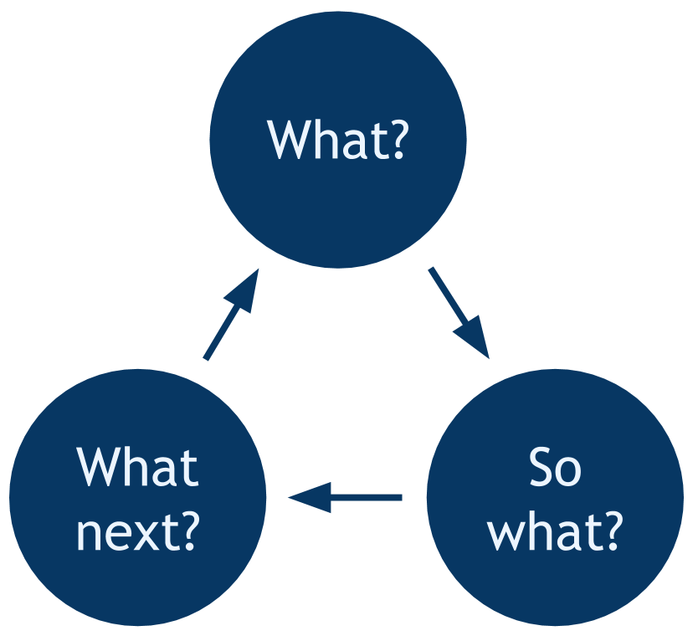
Figure 1: Rolfe's Reflection Model (Open Learn Create, 2017)

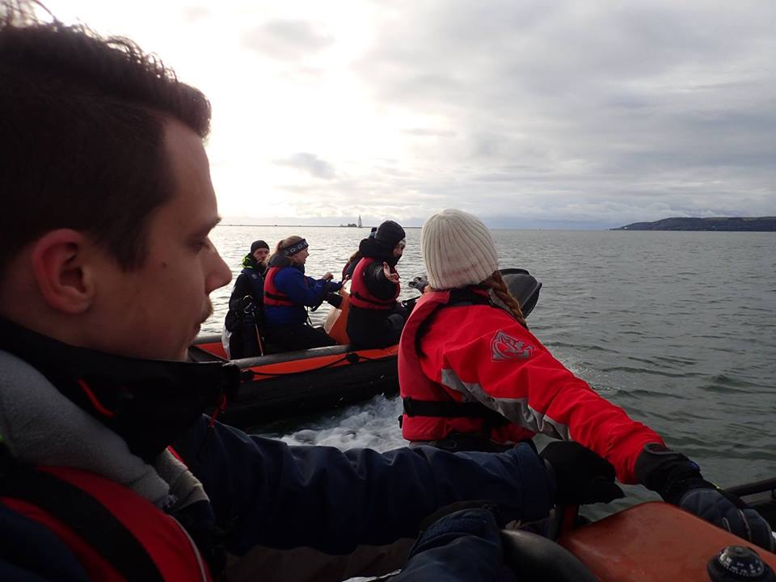
Figure 2 Coming alongside with lots of clothing layers (Nicholls, 2017)
Figure 3 Coming alongside with lots of clothing layers (Leather, 2017)
Appendix 2
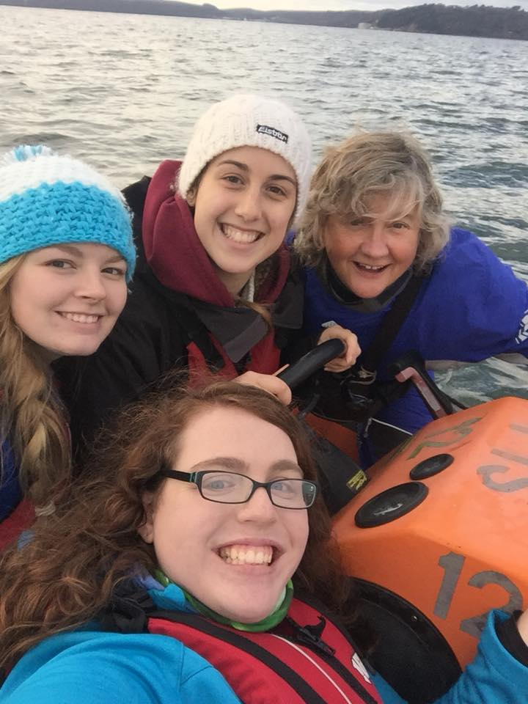
Appendix 3
Figure 4 Maddie, Anna, Fiona and myself powerboating on day one (Percival, 2017)
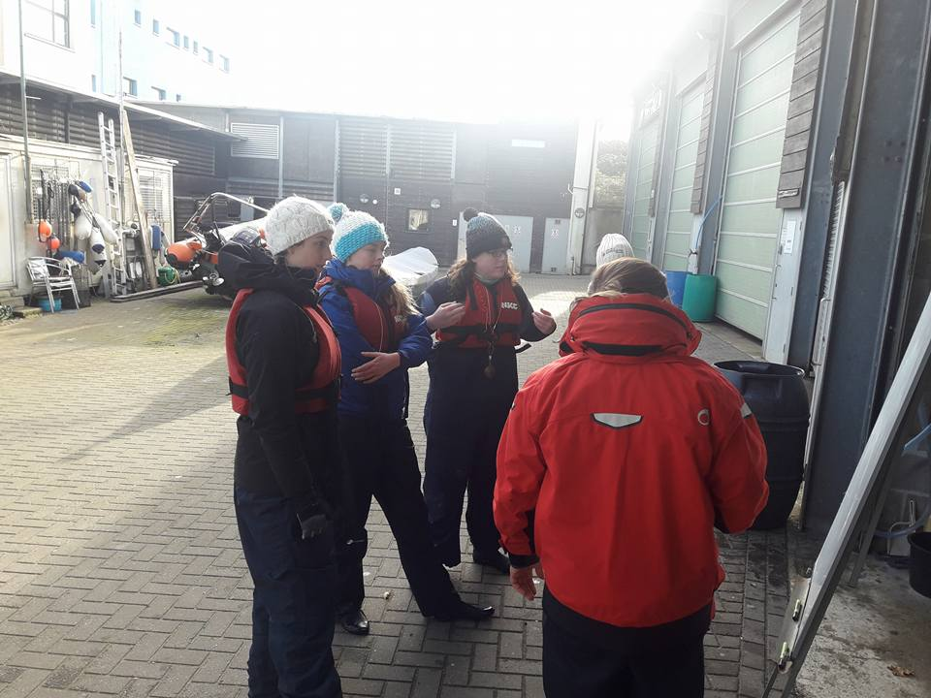
Appendix 4
Figure 5 The group observing the teaching on the board (Leather, 2017)

