Name : Date :
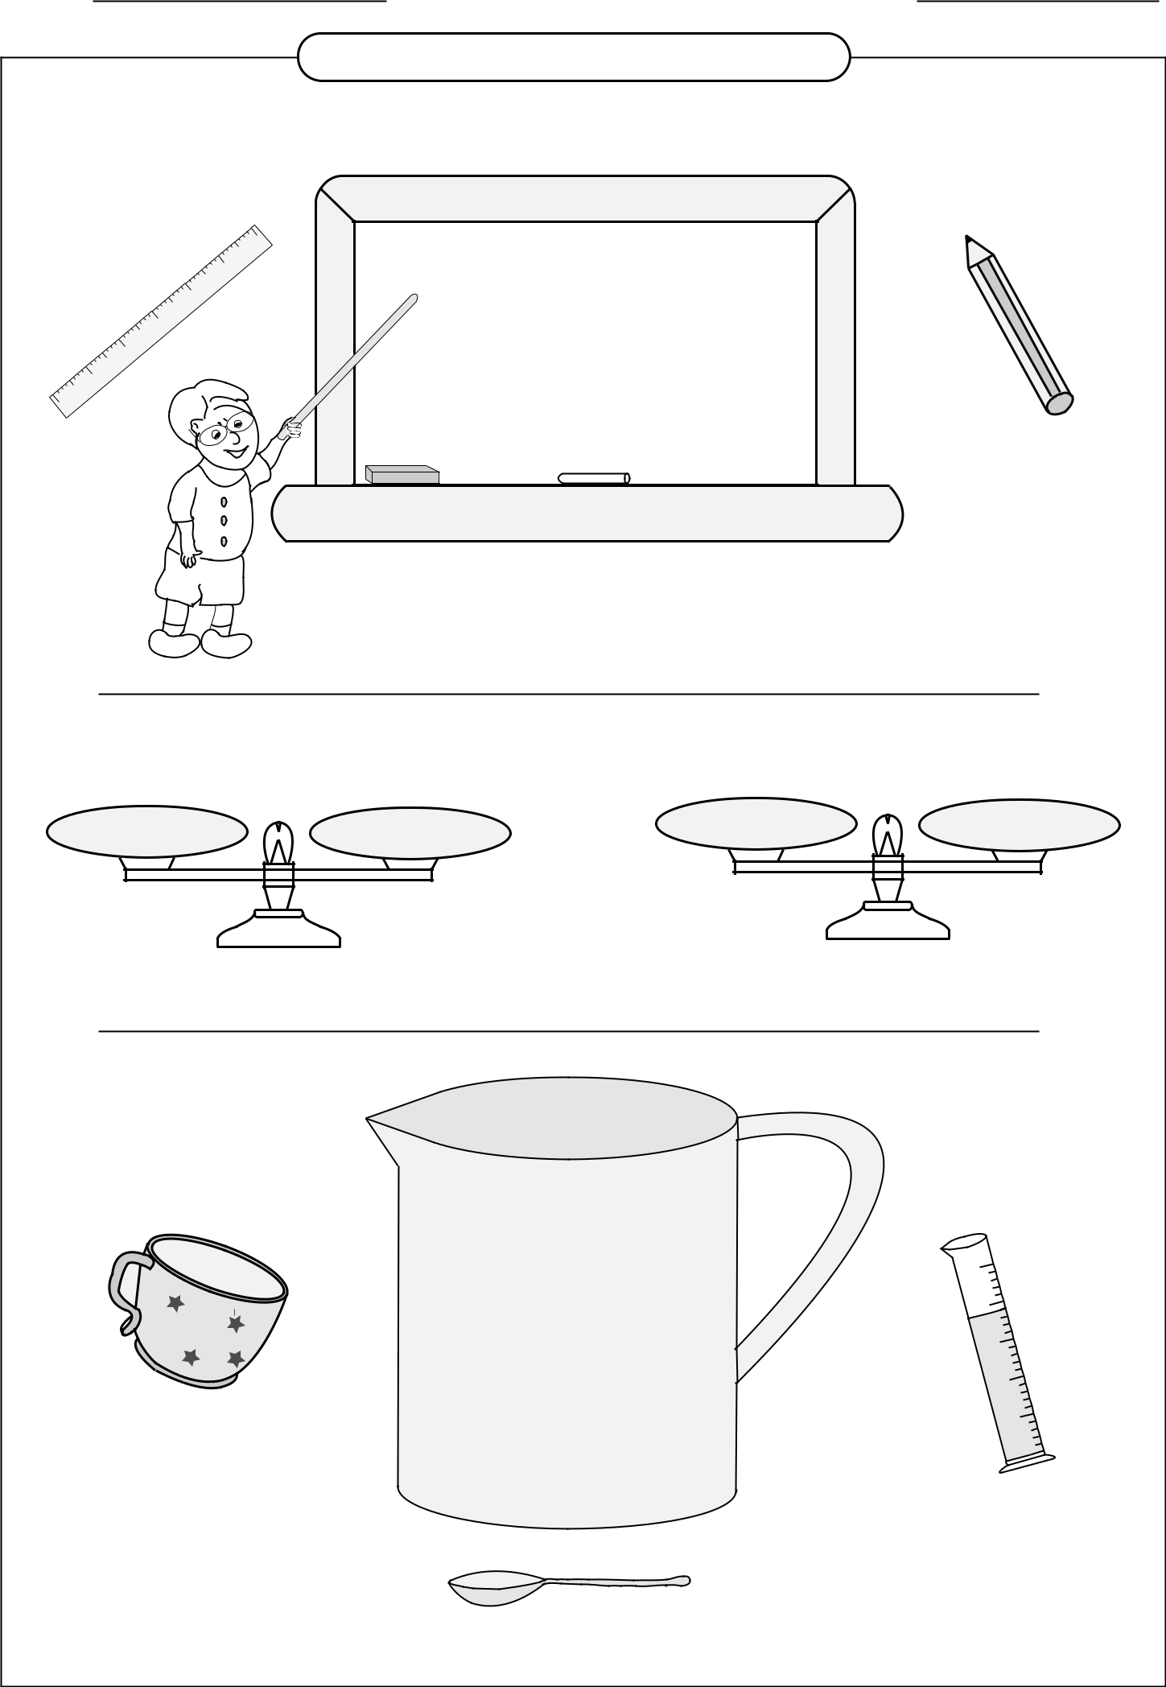

 | Unit Conversion Chart
 |  | Measuring Length
 | 6
5 |  | 12 inches = 1 foot
4 |  | 36 inches = 1 yard
3
2 |  | 3 feet = 1 yard
1 |  | 5280 feet = 1 mile
0
 |  | 1760 yards = 1 mile
 |  | Measuring Weight
16 ounces | 1 pound | 2000 pounds | 1 ton
 | Measuring Capacity
 | 3 teaspoons = 1 tablespoon
 | 2 tablespoons = 1 !uid ounce |  | mL
 |  |  | 500
 | 8 !uidounces = 1 cup |  | 400
 |  | 2 cups = 1 pint | 300
 |  | 2 pints = 1 quart | 200
 |  |  | 100
 |  | 4 quarts = 1 gallon

