Packaging Content Management

Technical Whitepaper

Jijo Dominic
Karsten Daemen
Shalet K.Varghese

September 2015

Table of Contents

1 | An Introduction to Packaging Content Management ...................................................................................... |  | 3
 | 1.1 | Definition and scope of Packaging Content Management ...................................................................... | 3
 | 1.2 | Terminology ........................................................................................................................................... | 3
2 | Why are our customers looking for a Content Management Solution? .......................................................... |  | 4
 | 2.1 | Proliferation of packaging ....................................................................................................................... | 4
 | 2.2 | Lack of standardized process and clear ownership ................................................................................ | 4
 | 2.3 | Unstructured content communication ..................................................................................................... | 4
 | 2.4 | Artwork creation errors ........................................................................................................................... | 5
3 | What can be the Solution? ............................................................................................................................. |  | 5
 | 3.1 | Standardization of Content Management Process ................................................................................. | 5
 | 3.2 | Establishing the Packaging Content Manager Function ......................................................................... | 5
 | 3.3 | Packaging Content Management System .............................................................................................. | 6
 | 3.4 | Structured external stakeholder communication .................................................................................... | 8
4 | Why does Esko want to bring a solution for this? .......................................................................................... |  | 8
5 | The Esko Solution .......................................................................................................................................... |  | 9
 | 5.1 | WebCenter Content Management Basics .............................................................................................. | 9
 | 5.2 | Dynamic Content - Linking with Adobe® Illustrator® ............................................................................ | 17
6 | WebCenter Content Management and CHILI Publisher .............................................................................. |  | 18
7 | Sources........................................................................................................................................................ |  | 19

2

1 An Introduction to Packaging Content Management

1.1 Definition and scope of Packaging Content Management

A piece of packaging has three distinctive attributes namely its shape, color and content. Efficient Packaging development demands controlled execution of these attributes. The Packaging content can be text statements, symbols and codes along with the artwork. Among them, the text content is particularly important because of the multiple language variants and the repeated use of the same text in different packaging, either in the same language or in other languages. For example, a statement can appear on the same packaging in different languages or a text statement can appear in different locations, for example, on the front and back.

To efficiently manage the content, you need a solution that has the necessary intelligence to address these complexities of packaging content and its relationship with packaging artwork (“pieces of art”).

This document gives an overview of Esko’s Content Management Solution to Esko Associates. This document takes you through the text management challenges faced by our customers and describes the best practices and the Esko solution to address these challenges.

1.2 Terminology

The following terminology will be used extensively in this document.

WebCenter: WebCenter is a unique and powerful web-based platform that manages packaging pre-production specification, approval and project life cycle.

Dynamic Content plug-in for Adobe Illustrator®: The Dynamic Content plug-ins allow you to edit and maintain text from outside Adobe® Illustrator®, directly link an AI text object to an XML file.

GS1 XML: It is a global standard defined by the GS1 organization to standardize the packaging content communication.

Packaging Content: is a relatively generic term used to represent the content that is placed on a packaging. Following specific terms are used interchangeably to represent the content on the package.

- Packaging Text: A piece of text that appears on packaging such as: product name, marketing claim, promotional statements etc.

- Packaging Copy: A piece of text that appears on packaging such as: product name, marketing claim, promotional statements etc.
- Packaging Claims: A piece of text that appears on packaging to represent a claim. For example, a content claim or a legal claim,

- Dynamic Content: A piece of text that appears on packaging design when it is used in the content of Dynamic Content plug-in for Adobe Illustrator®

Copy Sheet: A term used to describe the document used to collect all the content needed for a particular ‘Piece of Art’ or printed item.

CHILI Publisher: An online editing solution which can be integrated with WebCenter. The integration with Chili allows the users to open packaging designs in WebCenter. This enables them to create, edit and modify the packaging content.

3

- Why are our customers looking for a Content Management Solution?

In the US, FDA had 19 million food units recalled in Q1 of 2015 alone, about 40% more than the previous quarter (Source: Stericycle Inc). According to FDA, the majority of these recalls were due to packaging content related issues such as missing ingredients or undeclared allergens.

A study conducted by a global CPG company revealed that 58% of the packaging errors are attributed to packaging content related errors. These errors occur largely due to:

- The proliferation of packaging variations. Different variants are being created for different sizes, flavors, languages, regions, etc.

- The lack of standardized packaging content management process and ownership

- Unstructured content communication

- Copying and pasting content during artwork creation
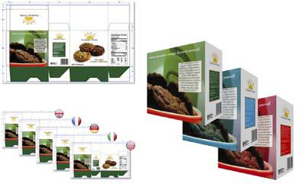

2.1 Proliferation of packaging

Brand owners are continuously innovating in the area of packaging design and production. The main drivers of this innovation growth are the requirements to personalize and regionalize packaging. This introduces a lot of variation in packaging.

In a new product launch scenario, a brand owner typically starts with a selected market with a limited number of packaging options. Packaging variants will be introduced consecutively for different flavours, sizes, etc. However, when the product gets expanded to other geographical markets, the brand owner needs the respective language variants. As a result, there will be a multiplier effect on the number of packaging variants requiring similar text content but adapted to specific product markets.

2.2 Lack of standardized process and clear ownership

The packaging proliferation comes with some specific business process issues with regard to the content management. A major shortcoming is the fact that the stakeholders are not identified or involved in the definitive steps of the process. Also, the content authors and the content reviewers do their work without knowing the big picture.

The lack of standardization of the text management processes bring in various risks and that can result in wrong or missing content on the packaging.

2.3 Unstructured content communication

The content collation and approval workflows in many organizations are managed without standard communication format. In some cases, the content is managed as Office documents such as Excel, Word or sometimes even PowerPoint. In many other cases, the correction and changes are communicated over repeated telephone calls.

The text content is then submitted to an Artwork studio in variety of unstructured forms. These unorganized communication methods are error prone and often lead to the content getting lost or the wrong content being used on the packaging.

4

2.4 Artwork creation errors

In a typical packaging development process, the designers are responsible for analyzing and organizing the text content in the design layout. Also, they manage the conversion of hard copy sheets to digital content statements. The digital content is then copied and pasted in appropriate locations in the packaging artwork.
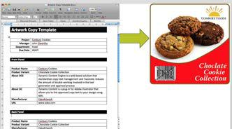

Designers may lack information with regard to various important aspects of text statements on packaging. This puts the accuracy at stake. In addition, copying and pasting content creates numerous errors.

3 What can be the Solution?

This section discusses the fundamentals of a solution to address this complex problem. The approach described here is based on the learning from the industry and from the experience of deploying a packaging content management solution at customer premises.

The solution should have capabilities to:

- Standardize the content management process

- Define clear ownership for various roles involved in the process. The role of the packaging content manager should be established for clear content ownership.

- Optimize and organize the communication with different stakeholders such as Translation Agency, Artwork Studio etc.

3.1 Standardization of Content Management Process

Packaging content management can be a very complex and tedious process. The complexity is attributed to the types of packaging, which requires appropriate content. For each type of packaging, the amount of content on the packaging, the compliance requirements, the number of geographical markets (language variation), and the external involvement might vary.

Therefore, the customer solution should begin by understanding and mapping the packaging content management process within the scope of the packaging development process.

3.2 Establishing the Packaging Content Manager Function

The content manager will be responsible for the entire Content Management process including the maintenance and renewal of the process. This function ensures accuracy, legal compliance and efficiency.

This role will also be responsible for improving the copy management process in consultation with the Artwork Manager and the IT admins. Further, the content manager will also liaise with the copy owners (internal) and translators (external).

The day-to-day operations of this function will include:

5

- Managing the Packaging Content Database; including co-administering, coordinating, editing and maintaining

- Validating the copy sheet templates for consistency, accuracy and compliance with the established content management process

- Editing copy in view of the final approved artwork

- Reviewing and approving copy sheet as a back-up proof-reader

- Training different stake holders with regard to the various content related responsibilities. This role will also create and maintain content management tutorials

- Managing proofreading

3.3 Packaging Content Management System

Identifying and implementing a suitable Packaging Content Management (PCM) system is critical in the success of the packaging development process. The following section lists the highlights of such a system.

3.3.1 Process management capabilities with templates

As explained the section 3.1, the process mapping and timelines are critical elements for managing packaging projects. In a typical scenario, the packaging due dates are generally driven by dates when the product is scheduled to be on a store shelf or in a distribution center. The ideal PCM system should have the capability to combine the Packaging development and the Content creation processes.

- The system should allow mapping of the current process and should have the flexibility to continuously evolve.

- The packaging content creation and validation touches many functional departments in the organization. Because of this, the system should have comprehensive support for roles and functions.

- As the standardization and harmonization is the best practice in the process management space, the system should support template-based implementation. This will increase efficiency, as you only need to ‘implement once and can use many times’.

- This system should support a content-centric process and an Artwork-Centric process.

3.3.2 Specification and Content gathering Support

A packaging content management system should have features to support the initial content gathering and the finalizing/approval of the packaging content. It should also communicate additional information relating to producing the package – such as dieline number, product number, color spec, etc. to communicate the context and scope.

The system should essentially have features for easy input, review and approval of the text content. A PCM should be able to:

- Start with a previously-approved package text content to minimize rework.

- Assign owners (content authors) depending on the type of content. This may be done on individual fields or pre-defined groupings of fields.
- Define and build content hierarchies so that content fields shared across multiple labels are entered only once.

Esko’s Content Management Solution – March 2015 | 6

- Define size limitations for copy in a particular field. This helps prevent too much copy being written for a particular package element from the start.

3.3.3 Translation support

Many companies sell their products in multiple geographical markets demanding text statements in multiple languages. Sometimes, this demands the creation of packaging in different languages specifically serving certain geographical markets. For instance, in Canada packaging contains both English and French text.

It is a very well established practice that packaging project initially focuses on preparing a master artwork for primary language. Once that is validated and approved, the language variants are created. To create these language variants, the content collected in primary language needs to translated to different target languages. A PCM system should have the capabilities to manage the text content translation workflow. It should be able to:
- Store translation with master text content

- Search and find text statements based on master or translation

- Support inline translation

- Import or export content from and to a dedicated translation management system

3.3.4 Integration

Many companies maintain their technical and regulated data in systems outside the Packaging Content Management system (PCM) that are specifically designed to manage that data. The integration between the PCM and these systems is important to maintain data integrity and to improve productivity by eliminating unnecessary data entry and duplication. A PCM should have:

- The ability to receive pushed data from a System of Record (SOR).

- The ability to pull data from a System of Record (SOR). In some situations, a system trigger will pull the information. In other cases, where there are multiple legal values, an interface will need to be created to search for, choose and pull in the correct information.
- Data from other systems must be locked down in the PCM, in most cases, so that changes cannot be made. This is usually in the case for regulated data, where the system of record is the only allowed editing point of this information.

3.3.5 Artwork Review Cycles

At this point in the process, the content is merged on to the updated artwork and a single document is made ready for the review and approval process. This is the final review of the completed package artwork before sending it to the converter or printer. If errors are found at this stage, a re-run through the review cycle is required. A PCM should be able to:

- Set parallel or serial approval paths and sometimes even a combination of both.

- Define approvers for each type of text content at the field (attribute) level. This may be done on individual fields or pre-defined groupings of fields.
- System should automatically review and highlight errors based on the business logic and pre-defined profiles. For example, spell check, minimum font size, accuracy of Barcode etc.

- Automate the approval process and be able to define different approver lists based on pre-defined criteria.
- Approve with a comment. It should also allow typing and editing the text during approval.

- Define a set of “Rejection Types” that are chosen by the approver when rejecting a field.

- Reroute the text content through additional review cycles.

- Exclude users who previously approved the content during a repeated review cycle.

7

- Group products in a single route to allow a single approval or rejection for all the related text content.

- Save the history/audit trail of approvals, rejections and comments.

3.3.6 Content Repository

Packaging content elements should be managed in the context of the product hierarchy to promote consistency across the product line and the reuse of text. An ideal PCM should treat text content as a reusable asset within a classified storage.

The PCM should have simple search options to find the text statements based on both the content and the metadata and also find the linked artworks using those statements.

3.3.7 Reporting

Reporting is critical in assessing the performance of the process and to identify areas for potential improvements. Reports should be able to aggregate data at the company level and at sub-levels – such as by division or by brand.

Additionally, there is a need for ad-hoc reporting in response to interdepartmental inquiries or to support various initiatives. For example:

- In response to consumer concerns, there may be a need to determine how many and which products contain a particular statement, in order to determine risk/exposure.

- Type of query may be related to determining what products contain a particular symbol or were part

of a particular promotion.

The data queried this way is often sourced from other systems, but the extraction of that data can be challenging. The PCM generally becomes the system of choice for performing these queries because of the ease with which searches can be run and also because it is the central repository of all packaging related information.

3.4 Structured external stakeholder communication

Establishing a structured communication between the content owner and artwork creator is imperative to reduce errors that appear on the final packaging. A lot of error happens during the artwork creation stage because of simple copy-paste issues.

Therefore, a good PCM solution should connect content authors (the brand owner) and the content users (the artwork designers) using a standard for text communication. The solution should also separate ownership, rights and actions.

In this standardized process, the artwork creator should be able to exercise freedom around layout, styling and all the visual aspects and the content owner should own the rights for creation and validation of the content.

4 Why does Esko want to bring a solution for this?

Brand owners want a seamless process to define, manage and approve their packaging labels. This includes the packaging content, the artwork creation and packaging production. Currently, there are no systems that cater to the entire process. Most companies have an application that covers part of the process and handle the rest of the process outside the system.

8

In a few cases, Brand owners have multiple systems integrated in varying degrees to get greater process coverage. To have a single application – or at least a seamlessly integrated group of systems – to manage the entire package content lifecycle with in Packaging lifecycle is a wish among most of the brand owners.

With our unique capabilities and market-leader status in Packaging Management with WebCenter, Esko is in a position to provide a powerful solution for packaging content management that is strongly integrated with packaging development process. There is a very definite appetite and desire for a single-solution system managing both the content process and packaging development process.

This position combined with Esko’s desire to win Brand Owner market makes is an ideal recipe for success.

5 The Esko Solution

The WebCenter Content Management solution is a WebCenter module to specify and manage content (text, claims, etc.) which will then be placed on artwork designs.

The Esko WebCenter Content Management feature offers:

- A repository / library for your text content

- Re-use of your content across multiple projects

- Support for a multi-language translation based workflow and a single language scenario

- Export to and import from industry standard formats

- Ability to view and edit your text in the context of your artwork in the WebCenter Viewer.

- A complete approval workflow

- Established content rights facilitating the ownership at different stages

5.1 WebCenter Content Management Basics

5.1.1 Text Content Document

We developed a WebCenter specific Document Type especially for Esko’s Packaging Content Management solution. The Text Content Document is an XML file that contains:

- Text that is to be placed on Artwork. This includes the master text and the translated versions.

- Approval states and comments on different text elements (the master and the translated)

- Clearly defined ownership rights

- The category of the text namely the Element Type that is used to classify.

- Versioning/revisioning

- The documents are housed in projects or libraries (for re-use)

- Attributes

- Can be streamed through a workflow

- Download rules

- Can be referenced by other documents. For example an artwork can refer to various text content documents via document reference attributes

- Can be created via document sources, including from document templates

9

5.1.2 Text Content Statements

A Text Content document has text elements such as the master text and translated versions of this text. When a text element is specified as the master, it is mandatory to have it approved before translating.
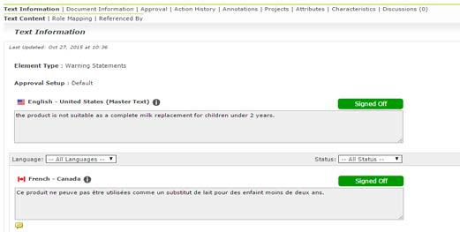

The text content statements can be viewed together. In a translation workflow, you can view the master and its translations together.

5.1.3 Text Content Approval

In our solution, the master and the translated text elements have separate approval processes. This is important in the case of packaging projects with language variants. All the approval information with regard to the master and translated content stays within the text content document. Once approved, the master and translated text remain locked for regular users.

The Content Manager can change the signed-off elements into draft mode. Note that only the Content Manger has the rights to change the text element to draft.

The text element can be in one of the following states:

- Draft

- Pending Sign-off

- Signed-off

- Rejected

In situations where you do not require a translation, the Content Manager can specify the text element as an “invariant” to avoid translating a particular master statement. For example, a text document containing the Brand name.

Note: This approval process is different from the regular WebCenter approval process.

5.1.4 Multilingual and Invariant Text

The solution has the ability to manage packaging statements as either multilingual or as a single language statements. Multilingual statements are those that require translation for the language variants.

Esko’s Content Management Solution – March 2015 | 10

If your statement is a Brand name or a website address, you can specify the text content as “Invariant” to keep only the master element in the text document type.

5.1.5 Text Content Element Type

WebCenter uses the Element Types concept from the GS1 standard to categorize the text statements. We use the same terminology as the GS1 standard to refer to the types of content.

The Text Content Element Type categorizes the text content documents, using the GS1 standard set of types. This also maps to the artwork tagged by Esko's Dynamic Content Plugin Content Types. See the Element Type categorization below.
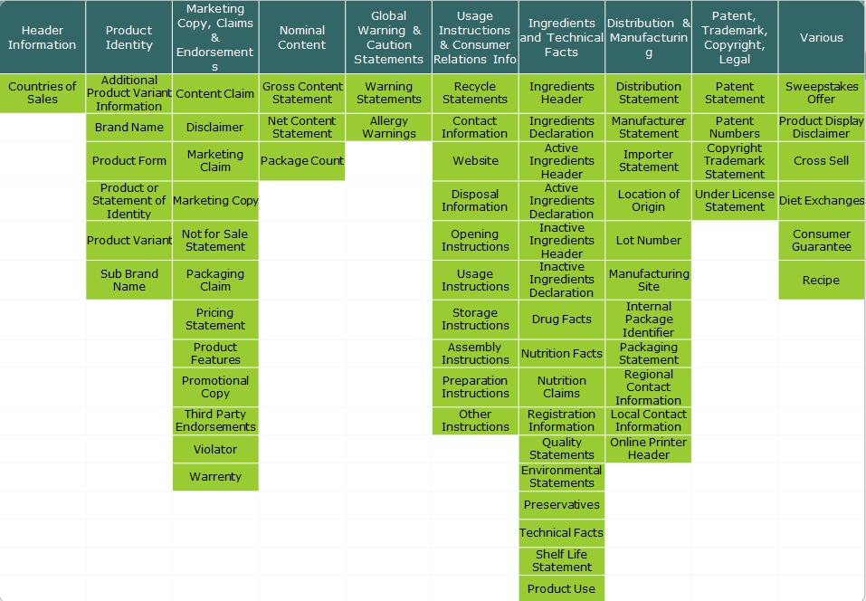

It is possible to add custom Element Types. Read about this in the Lists section of WebCenter documentation.

5.1.6 Text Content Ownership

For text content, you can define certain permissions for content management, editing and approval to user roles. These text permissions, when mapped to the WebCenter roles, allow you to allocate certain project members (roles) to perform a certain function. The permissions are set at each text document (.wcc) level and will be passed on along with the document and its versions.

During project creation, the Project Manager can create or copy existing content. This right is implicitly attributed to the current Project Manager. However, once the project is created and project roles are defined, these roles need specific content permissions to edit the text and approve it. This facilitates established ownership for different text elements in the different phases of the text approval process. You have three types of WebCenter content permissions: Content Manger, Editor and Approver. To activate these permissions, the project manager needs to assign at least the Content Manager permission to a relevant role.

Once a project has been created and the Content Manager permission is assigned to a WebCenter Role (who is in the project), this role gets the “manager” role and decides on the mapping of other permissions. These permissions stay within the text document and get transferred when copied to another project.

11

To automate the assignment of the Editor and Approver permissions, the solution includes a smart mapping feature.
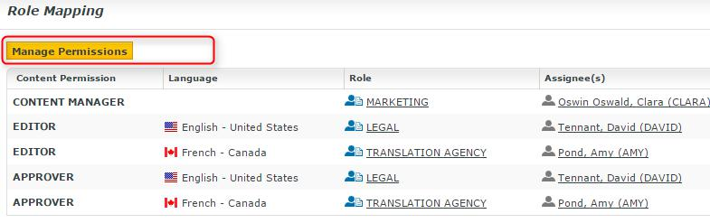

5.1.6.1 Content Manager Ownership

This function facilitates the entire content management process to ensure accuracy and compliance. For example, the role Marketing could have this permission where the Marketing has the responsibility of the content. The Content Manager role will manage all text content including the translations. Therefore, there is no language associated with this permission.

This permission when assigned to an appropriate WebCenter role, allows the role to set up other text permissions and change them. For example, you can configure a Role, Marketing to have the Content Manager function and then this role gets the right to choose the Editors and Approvers. The Content Manager assigns these Text permissions to WebCenter Roles invited to the project.

This role decides on:

- The Editors and the Approvers in the current document

- The master and translation languages

- The Element type (such as the GS1 standard) of the text

Content Manager Role cannot act as an Editor unless this permission is granted to the same role.

5.1.6.2 Editor Ownership

The Content Manager typically assigns this right to the dedicated roles who will create and translate the text statements. This can be assigned per language. The Editors, with this right, can create, edit or revise the text.

If there are roles in the project for all languages to which the content should be translated, the content manager can assign the Editor permission in a smart way. For example, the permission “EDITOR fr-FR” can be assigned to the role “TRANSLATOR FRENCH”. Editors create the text and define the state as ‘ready for approval’.

A WebCenter user can edit a text statement with this Editor permission when it is not ‘signed-off’ or ‘ready-for-review’. The Editors can also set the status of a text statement as ‘ready-for-review’.

When your content workflow contains translations into different languages, you may have Editor and Approver permissions to Roles (text authors/editors and approvers such as legal or marketing) associated with these languages.

12

Based on a Preference setting, it is possible to specify the prefix for the placeholder Roles mapped to the Editor and Approver permissions. This will automate the process of assigning the permissions when the Project Roles have names containing this prefix and language code.
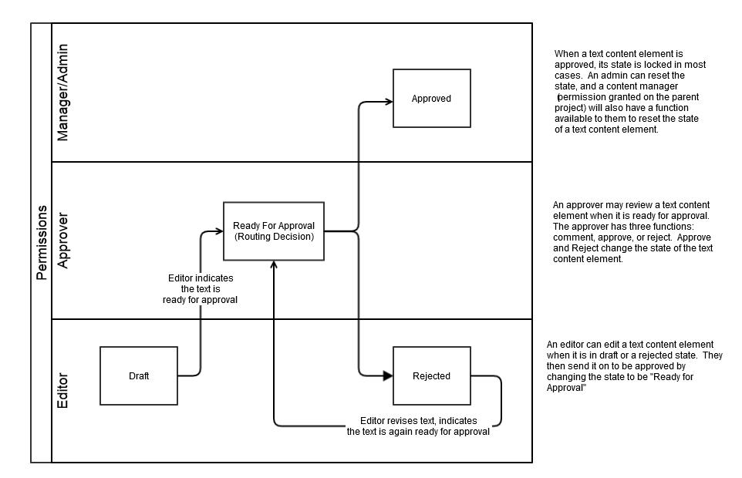

5.1.6.3 Approval Ownership

The Approver permissions are assigned to the Master and Translation approvers. For example, The Legal and Marketing roles typically can be assigned as approvers. When a translation workflow is needed, the master text is approved by the Marketing or Legal role and sent to the language translators.

The Content Manager decides on the Approvers. These are also assigned in the same way as in the case of Editors. If you have multiple languages and approver roles dedicated for these languages, you can use the smart role mapping as in the case of Editors. A WebCenter user with the Approver permission can review and approve the text statement when the status is set as “ready-for-review”.

The text permissions are active in a text document when they are mapped to the Roles. To allocate these permissions or rights to certain roles, you need to invite the specific roles to the project / template and allocate the content permissions to these specific roles within the context of a text document. Further, if required, you have the flexibility to give two types of permissions to a Role.

A user without any of these permissions can only view the text content documents depending on their rights to view a document.

5.1.6.4 Text Document Related Information

You have a view of all the details and permissions associated with a Text Document in the Document Details. When you click on a text content type of document in a project, the Document Details will have a ‘Text Information’ tab detailing the Text Content, a ‘Role Mapping’ tab detailing the content rights and another tab listing the artwork documents where a text document is referred in (Referenced By).

Esko’s Content Management Solution – March 2015 | 13

5.1.7 Text Content Management in WebCenter
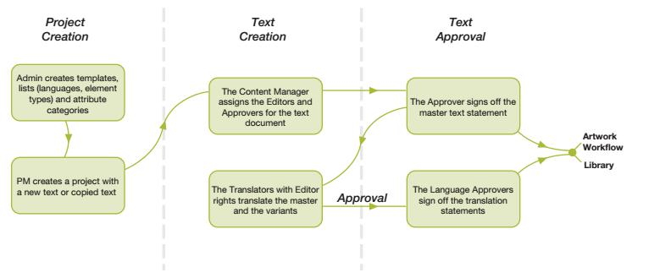

5.1.7.1 Types of Projects

We currently envision that WebCenter users will work with three distinct types of projects in regards to content management.

Content Library / Repository Projects

A Content Library is a project or template that is designed to contain the Signed Off Text Content Documents both the master and translated. These projects/templates facilitate a re-use of Text Statements across WebCenter. Just like packaging assets, this will allow our customers to create a library of re-usable text statements in a categorized way. The categorization of the text library can be done via WebCenter Attributes. For example, using the attributes feature, the text statements can be linked to a brand, sub-brand and both. It is possible to create an asset browser for applying product-brand attribute categorization.

These types of projects will function as the source of all content when you build content hierarchies using the document reference feature of WebCenter.

Content Centric Projects

For the text content creation, a Project Manager or Content Manager will create projects to create, update, translate and approve the packaging text content. After the sign-off, these text statements will have to be saved to the “Content Library”.

In an example scenario, to update a Text Document in one of the “Content Libraries”, the content manager creates a project from a template (with configured document sources). This template will include a Document Source. The content manager can use this source to create a new text statement or copy a statement that requires an update from the Content library. In this scenario, it is possible to copy or refer to an existing document in the library but you cannot link to a text statement.

The project will also have necessary workflows and tasks that will be launched after project creation in order to direct the editing, translating and approving to the right roles. After the approval, the updated or newly created Text Content Document will be copied to the “Content Library”. This way, it becomes a new statement in the library or an updated version of an existing statement.

Esko’s Content Management Solution – March 2015 | 14

After the ‘sign-off’ of the master and translated text, these cannot be assigned as draft again. The only way to change it would be to copy it to a content creation project and following the process described above. A content library together with the content creation project provides the ability to start with a previously-approved package label or claim that is similar minimizing the re-entry of data.

An artwork centric approach

For the artwork based content creation, a Project Manager or Content managerwill create projects to update, translate and approve the packaging text content that is referred in an artwork. The aim of these projects is to assemble or change text statements on artworks. In this workflow, the packaging content managers will create projects to update artworks with reference to text documents.

After approving these text statements, they will be stored in the “Content Library”.

5.1.7.2 Attribute Categories

The content-centric and artwork-centric projects require language attributes in order to properly work with Text Documents. You need to attach a project attribute category containing the “MASTER TEXT LANGUAGES” and “TRANSLATION LANGUAGES” (multi-valued) attributes. During the creation of the projects, the PM can select the master and translation languages for that project.

Note: The Master and Translation languages should be configured as Lists in WebCenter. These lists should

be configured to the project attributes: the “MASTER TEXT LANGUAGES” and the “TRANSLATION LANGUAGES”.

We recommend the use of document reference attributes in order to work with the text content documents in the content-centric and artwork-centric projects. This means that the projects will always refer to the Text Content Documents associated with them. The PMs/Content Managers can create or copy a text statement to a project or simply refer to already existing statements from the Library.
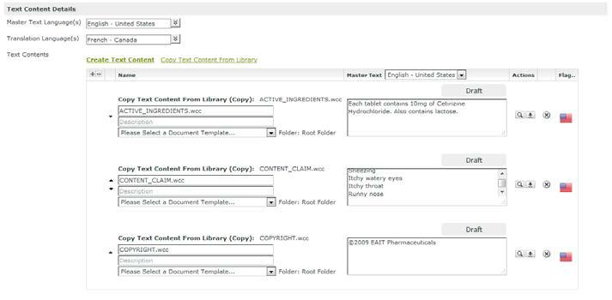

There are a few advantages in the use of document references. Firstly, it promotes the re-use of existing statements. Another advantage is that the Text Content Documents are displayed as a table of Documents under the hood of the Attribute Category. This is powered with highly customizable “Text Content Columns” that allow the user to quickly manipulate multiple Text Content Documents at once.

You can configure the text attribute to be non-editable in cases where you need it. Also, you can create different attribute category views.

5.1.7.3 Document Templates

Esko’s Content Management Solution – March 2015 | 15

As explained earlier, we recommend document referencing to use the text management solution to its maximum capacity. When working with this Document Reference table, you have to configure the “Document Sources” for individual table entries. These define how documents can be added to the table. You can reference documents from a “saved search”, link documents from within the project or create documents from a template.

You can use the Document Templates feature to create text content documents on the fly. When the PM or Content managerclicks the “document source” link, he/she can select one template to create the new document. The advantage of using document templates is that you can configure blank templates for different types of statements. You can set different language settings, role permission mapping and Element Type settings. For instance, a “Claim” template will have the GS1 “Content Claim” type and the Editor permissions will be mapped to the LEGAL role of the project. However, in the case of a Brand name template, the Editor permission will be typically given to the Marketing role.

To use document templates as a document source for “create new” statements, it is necessary to create a Document Template Library with all the required Text Content templates of Text Content Document type. The admin has to upload these templates in WebCenter XML format.
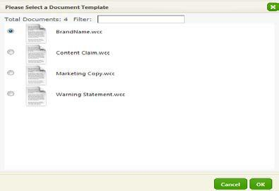

Note: There’s currently no “Create Text Content Document from scratch” functionality in WebCenter.

5.1.7.4 Tasks

In the Text Management scenario, the entire workflow of drafting, approving and translating Text Content Documents should typically happen through a Workflow. Based on the state and type of the Text Content Document, the workflow will assign the appropriate tasks to the assigned roles or users.

The Document Table listing the Text Content Documents can be configured in the Task Type in the same way as in Attribute Categories and it comes with the same customization features.

You can set up the document table in such way that the Editor can draft the text from within the Task page.

This simplifies the text content related communication through the Task Execution Page.
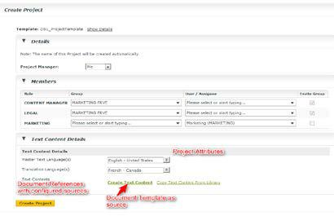

Esko’s Content Management Solution – March 2015 | 16

5.1.7.5 Viewing the Text Content on an Artwork

During the artwork review process, the text statements are merged on to the updated artwork and a single document is made ready for the review and approval process. This review is possible in the WebCenter Viewer. A user can review the text within the artwork context when the artwork document refers to the various text elements using the text document references. The text content referenced in the artwork will be shown in the “Text Content” widget of the WebCenter Viewer. If the artwork has been created with the Dynamic Content plugin and processed by the “Import Dynamic Content” Node, the Viewer widget will indicate in the location of the statement on the artwork.

The user can see the master and translated text statements in this widget. It is also possible to comment, edit, approve and reject master / translated statement of the Text Content documents from the Viewer.

Note that the users need permissions to view the text content documents on permissions see the Permission Model document
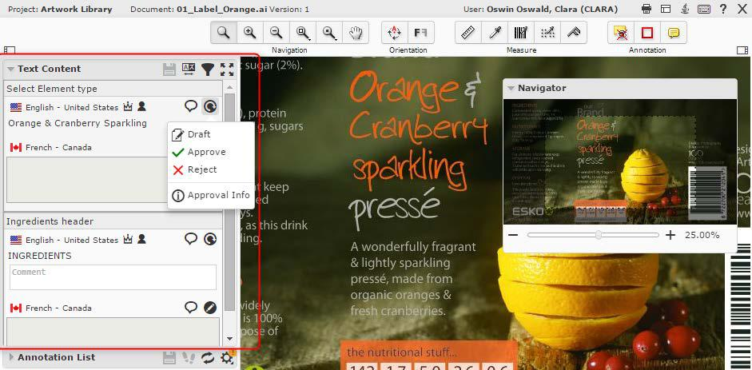

It is also possible to open a ‘full view’ of the text attributes of the artwork. In the full view, the user can edit the draft statements (with the right content permissions) and save these changes.

5.1.7.6 Searching for Content

The WebCenter search has options to find the text statements based on both the content and / or metadata. A user can ‘search for’ ‘text content’ type document and specify the following criteria: Element Type, Document Status (Text Document Status) and Statement criteria such as: Piece of text in the statement, Statement’s Language, Status and Type (whether master or translated).

It is possible to configure ‘search result options’ and setup ‘saved searches’ to serve as document sources for content centric or artwork centric projects. The admin user has the option to enable or disable ‘view’ or a certain criterion and can also configure the sort order. The search results will appear based on this configuration.

Esko’s Content Management Solution – March 2015 | 17

5.2 Limitations

5.2.1 The Expected Limitations of WebCenter 16.0 Release

- The WebCenter Content Management system does not offer dedicated Nutritional Facts Table support in this release.

- There is no current option to highlight differences across text document versions.

- While searching for content, the search results does not show highlighted search terms.

- There is no support for Rich Text Formatting.

- Dynamic batch importing of text from PDF is not implemented in the current solution.

5.3 Dynamic Content - Linking with Adobe® Illustrator®

The power of Dynamic Content lies in its ability to create a text link in an Adobe® Illustrator® file directly to an XML file created by a brand owner. A single, XML-based text can be shared across a range of designs, or can contain different language versions and can be linked to a single design. Designers can collect static text from legacy designs and bring them into a dynamically managed content workflow, and can build dynamic templates for products within the same brand umbrella.

Dynamic Content helps designers to be more efficient and win client confidence by minimizing the errors. This process also makes the brand owner the sole owner of the content thereby reducing the liability risks on the designer’s side. As the copy is dynamically linked to the brand owner approved content file, there is a significant cost reduction due to a reduced number of review cycles and hardcopy proofs. By eliminating the process of copying and pasting the ‘revised text’, this will also lead to a significant reduction of errors, cost and lead times.

6 WebCenter Content Management and CHILI Publisher

Chili Publisher is an online document editor that has been successfully integrated with WebCenter and Dynamic Content. This integration allows users to edit the documents online. The solution thus allows the users to edit the artwork content such as text, graphics, images, symbols etc. in a web browser. The integrated interface is simple enough to enable even a non-graphic professional to update the content of the packaging element in context of the final design.

The current integration was designed to collate content for packaging and labels in a graphical context. This simplifies it for non-graphic professionals by giving an accurate representation of the final artwork. While it is a powerful tool to collect the necessary content, it lacks the ability to manage the content itself. The WebCenter Content Management treats text as an asset in a repository and seamlessly run the content creation, translation and approval processes. The main value proposition of WebCenter content management lies in ascertaining the integrity and reusability of the managed content. To implement Content management in WebCenter you are not required to have CHILI Publisher.

18

However, CHILI Publisher can augment the WebCenter Content Management solution. The combination of WebCenter and CHILI Publisher will improve the user experience to collate content in a context of what-you-see-is-what-you-get. This will facilitate the reuse of managed content stored in WebCenter to create packaging artwork variations and point of sales material. CHILI Publisher can design other graphical template documents such as leaflets, signage and other marketing collaterals.
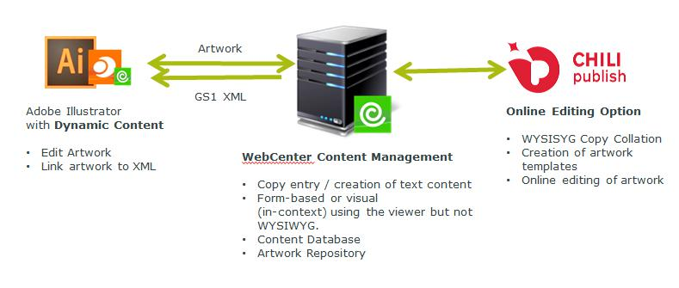

7 Sources

http://www.stericycleexpertsolutions.com/wp-content/uploads/2015/05/Stericycle-Recall-Index-US-Q1-2015.pdf

http://www.packagingdigest.com/packaging-design/own-it-how-more-effective-packaging-approvals-can-help-you-avoid-recall?sf=aapere

http://apps.gs1.org/GDD/Pages/clDetails.aspx?semanticURN=urn:gs1:gdd:cl:CopyElementTypeCode&release= 1

19

