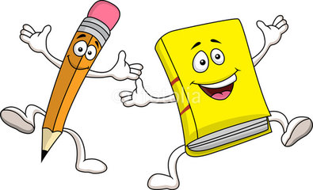
Book Report

Title ______________________________________________
Author___________________________________________
The story was ___________________________________

Describe what happened in the beginning of the story?
____________________________________________________________________________________________________________________________________________________________________________________________________________________________________________________________________________________________________________________________________________________
Describe what happened in the middle of the story?
____________________________________________________________________________________________________________________________________________________________________________________________________________________________________________________________________________________________________________________________________________________
Describe what happened in the end of the story?
____________________________________________________________________________________________________________________________________________________________________________________________________________________________________________________________________________________________________________________________________________________
Did you like this book? Tell why or why not?

