Integrating the Dell EqualLogic FS7500 into an Existing SAN

A Dell Technical Whitepaper

THIS WHITE PAPER IS FOR INFORMATIONAL PURPOSES ONLY, AND MAY CONTAIN TYPOGRAPHICAL ERRORS AND TECHNICAL INACCURACIES. THE CONTENT IS PROVIDED AS IS, WITHOUT EXPRESS OR IMPLIED WARRANTIES OF ANY KIND.

© 2011 Dell Inc. All rights reserved. Reproduction of this material in any manner whatsoever without the express written permission of Dell Inc. is strictly forbidden. For more information, contact Dell.

Dell, the DELL logo, and the DELL badge, PowerConnect™, EqualLogic™, PowerEdge™ and PowerVault™ are trademarks of Dell Inc. Red Hat® is a registered trademark or trademark of Red Hat, Inc., in the United States and/or other jurisdictions. VMware® is a registered trademark or trademark of VMware, Inc. in the United States and/or other jurisdictions. Intel® is a registered trademark of Intel Corporation in the U.S. and other countries. Microsoft®, Windows®, Windows Server®, and Active Directory® are either trademarks or registered trademarks of Microsoft Corporation in the United States and/or other countries. Linux® is the registered trademark of Linus Torvalds in the U.S. and other countries.

Table of Contents

1 | Introduction ........................................................................................................................................................ |  |  | 1
1.1 |  | Audience ...................................................................................................................................................... |  | 1
1.2 |  | Terminology ............................................................................................................................................... |  | 2
2 | Dell EqualLogic FS7500 ................................................................................................................................... |  |  | 3
2.1 |  | EqualLogic FS7500 support for Network Attached Storage.............................................................. |  | 3
3 | Test topology and architecture ...................................................................................................................... |  |  | 5
4 | Test methodology .............................................................................................................................................. |  |  | 7
5 | Test results and analysis ................................................................................................................................... |  |  | 8
6 | Planning and design considerations ............................................................................................................. |  |  | 11
6.1 |  | Network ports ........................................................................................................................................... |  | 11
6.2 |  | IP addresses ............................................................................................................................................... |  | 11
6.3 |  | Pool configuration ................................................................................................................................... |  | 12
6.4 |  | Volume configuration .............................................................................................................................. |  | 13
6.5 |  | Monitoring an existing SAN .................................................................................................................... |  | 13
7 | Summary |  | ............................................................................................................................................................ | 15
Appendix A |  |  | Vdbench scripts ........................................................................................................................... | 16
Related publications ................................................................................................................................................ |  |  |  | 17

1 Introduction

The Dell™ EqualLogic™ FS7500 adds scale-out unified Network Attached Storage (NAS) capabilities to EqualLogic PS Series iSCSI SANs so you can easily enable and manage iSCSI, CIFS, and NFS access from a single management console. The EqualLogic FS7500 incorporates the Dell Scalable File System (DSFS), which is designed to optimize file access performance and hardware utilization while eliminating capacity constraints. DSFS is a high-performance scale-out file system capable of presenting a single file-system namespace through a virtual IP address, regardless of the number of NAS controller nodes in the cluster.

The FS7500 attaches to an EqualLogic PS Series iSCSI SAN and can be deployed with new arrays, or it can leverage an existing EqualLogic PS Series iSCSI SAN deployment. Unlike many unified storage solutions that only scale in capacity, the EqualLogic FS7500 can scale capacity and performance. When more storage capacity or I/O performance is required, adding more EqualLogic arrays or another FS7500 controller pair enables the system to scale out to meet those needs.

While many NAS solutions have strict limits on file share size, the Dell Scalable File System has no such limitations and the FS7500, allows a single file system to use the entire capacity¹ of an EqualLogic pool. As with all Dell EqualLogic products, the entire feature set of the FS7500, software licensing, and future firmware enhancements are all included in the base price.

When integrating the FS7500 into an existing SAN, you need to understand the potential impacts to the existing SAN.

The goal of this paper is to understand:

- What is the performance impact of adding file I/O to an existing block-based SAN with additional hosts attached?

- Is it OK to mix block and file I/O in the same pool, or is it better to keep them separated?

- How much does adding additional arrays to an existing shared pool benefit the overall SAN performance?

- How much free space is required for the FS7500?

- How many additional network ports are required when integrating the FS7500 into an existing SAN?

The results presented in this paper can be used as a guideline to help you determine the right answers for your own environment.

1.1 Audience

This white paper is intended for storage administrators who are involved in the planning and implementation of integrating a Dell EqualLogic FS7500 into an existing EqualLogic PS Series iSCSI SAN. Readers should be familiar with general concepts of the Dell EqualLogic PS Series iSCSI storage as well as Ethernet Local Area Network (LAN) and basic NAS concepts.

1.2 Terminology

The following terms are used throughout this document.

Block I/O

Commonly used to describe how an application on a host server accesses data on a local or SAN connected storage system.

CIFS

Common Internet File System; typically used by Windows clients to access NAS.

File I/O

Commonly used to describe application or client access to a NFS mount point or CIFS share.

Group

A PS Series group consists of one or more PS Series arrays connected to an IP network. A group may contain up to 16 arrays.

LAN

Local Area Network; network usually used for client connectivity

NAS

Network Attached Storage; usually supporting protocols such as CIFS and NFS.

NFS

Network File System; typically used by Unix/Linux systems to access NAS.

Pool

A container that each member (array) is assigned to after being added to a group. A pool can have up to 8 members.

SAN

Storage Area Network; a network used exclusively for storage connectivity that usually supports iSCSI or Fibre Channel access to storage.

Structured Data

Describes data that has a predefined structure of its components such as a database.

Unstructured Data

Describes data that does not have a predefined structure such as user files on a share.
2 Dell EqualLogic FS7500

The FS7500 is a dual active/active architecture that consists of a redundant pair of appliance-like controller nodes with a backup power supply. The large onboard cache gives the EqualLogic FS7500 the ability to scale performance. Each system provides 48GB of RAM (24GB in each controller node) that is used for the operating system and the mirrored, battery protected cache memory. The FS7500 can be expanded by adding an additional pair of controllers and new client connections are automatically load balanced across all nodes.

The EqualLogic FS7500 supports all new and existing EqualLogic arrays with firmware version 5.1 and later. A single FS7500 system can utilize up to eight EqualLogic PS Series Arrays with the ability to add another FS7500 system into the same namespace to improve file performance. Each EqualLogic FS7500 controller has four 1 Gigabit Ethernet ports for NAS connectivity for NFS and CIFS clients. Four more 1 Gigabit ports are used to connect to the EqualLogic PS Series iSCSI SAN. An additional five ports on each controller are used for internal communications such as IPMI, cluster heartbeat, and cache mirroring.

The FS7500 also has built-in snapshot capabilities, using a redirect-on-write method. When a snapshot is enabled, any changes to existing data are preserved in a snapshot, and subsequent read/write access is redirected to the new data area. This method of snapshots is implemented in the DSFS file system and does not require additional physical disk space for holding snapshots and instead it utilizes reserved, unused space from the existing NAS file system.

Although outside of the scope of this document, additional features of the FS7500 also include Active Directory/LDAP integration, NDMP–based backup support, NIS (Network Information Services) and user quotas.

2.1 EqualLogic FS7500 support for Network Attached Storage

Until now, EqualLogic PS Series iSCSI SANs have only supported hosts attached for block storage. With the integration of the FS7500, EqualLogic SAN owners can now support NFS and CIFS file I/O as well. Management of the FS7500 is integrated into the EqualLogic Group Manager so that the administrator can manage both file and block storage from the same application. The EqualLogic Group Manager continues to use the same user interface, so you do not need to learn a new tool to manage NAS.

Traditional file servers, database servers, mail, and other application servers use local or SAN-attached block storage. Sometimes a single traditional file server is adequate, however, in other cases performance, scalability, and even functionality of a single file server can be a limiting factor and using multiple file servers may have additional management challenges. With the FS7500, it is possible to consolidate these multiple file servers down to a single namespace and management entity which can easily be scaled out to meet performance needs due to the scalable nature of both the underlying EqualLogic SAN and the DSFS running on the FS7500.

By adding more arrays to the storage pool, the EqualLogic SAN can be scaled out for capacity and performance. NAS volumes and file systems can also be expanded without interruption or downtime. With support for CIFS connectivity from Windows systems and NFS connectivity from UNIX/Linux systems, the FS7500 and PS Series arrays represent a unified and scalable storage solution.

3 Test topology and architecture

To study the performance impact of integrating a FS7500 into an existing EqualLogic SAN environment, we needed to generate a workload of both block and file I/O. We chose to use the open-source I/O workload generation tool Vdbench, which is available for download on SourceForge.net. Vdbench requires a JAVA runtime environment, so we also installed the Sun (Oracle) JRE version 6u24 on each client.

For clients, we configured four VMware® ESX 4.1 servers. Two of the servers were connected to the back-end SAN switches (and to SAN storage), while the other two were connected to the front-end LAN switches. On each ESX server, we created 8 Virtual Machines (VMs) that ran 64-bit Red Hat® Enterprise Linux® (RHEL) version 5.6. Each VM had 512MB RAM and 4 virtual CPUs. This gave us 16 clients for block testing and 16 clients for file tests.

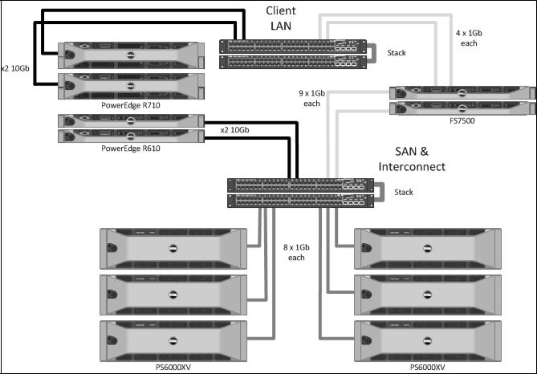

Figure 1: Test topology diagram

Our ESX servers consisted of two Dell PowerEdge R610 servers and two Dell PowerEdge R710 servers. Each had 48GB of RAM and two quad-core processors. We used the onboard 1 Gigabit network ports for management connectivity, and each server also had a pair of dual-port 10 Gigabit network cards.

Our LAN and SAN switches each consisted of a pair of Dell™ PowerConnect™ 6248 switches with stacking modules. For our tests, these switches also contained a pair of 10 Gigabit uplink ports. We connected the 10 Gigabit ports in the ESX servers to their respective switches through these uplink

ports. While this is usually not a recommended best practice for production networks (due to scalability limits), it provided the connectivity we needed for this test environment.

On our SAN network, we configured jumbo frames (MTU 9000). This is established best practice for EqualLogic PS Series iSCSI SANs and is also required for the FS7500 SAN and interconnect network ports (which share the same switches with the SAN). For our client network, we ran some initial tests with both standard and jumbo frames but did not find a significant difference in our particular test cases. We decided to use the standard MTU size of 1500, which is also the most common size for typical client networks.

The EqualLogic PS Series iSCSI SAN consisted of six PS6000XV arrays. Each array contained 600GB 15K SAS drives and was configured for RAID 10. Initially we created two pools – one for arrays dedicated to block storage and another dedicated for file storage (i.e. for the FS7500). Later, we migrated all of our volumes into a single pool that contained three arrays. We ran our tests and then added another array to the pool and gave the volumes time to rebalance across the new array in the pool. We repeated this process until we had all six arrays in a single pool.

For SAN testing, we created sixteen 10GB volumes on the SAN and presented these to each of the 16 VMs as Raw Device Mode (RDM) volumes. For file I/O (CIFS and NFS), we created a file system mount point on the FS7500 which was then mounted from each of the 16 clients. Our NAS reserve was 5TB total, although by comparison, we only used a small portion of that capacity in our tests.

A Vdbench script was created that would generate I/O at the desired block size (or I/O request size) and run for a specific amount of time. After the test was run, we collected the results and analyzed them.

4 Test methodology

We selected Vdbench for its ability to be controlled by a script and parameter file. For the block I/O testing, we configured Vdbench to read and write from RAW disks without a file system. For our block clients we used a working file size of 8GB to minimize the effect of client-side caching in the VM.

For the file I/O tests, we initially ran tests against both CIFS and NFS mount points. The results were very similar, so for the combined block and file testing, we used only NFS mount points for the file clients. We configured Vdbench to create a directory structure that was three directories wide and two directories deep. Each bottom-level directory had sixteen 50MB files which resulted in a total working set of about 5GB for each client.

We used a workload of 8K random I/Os with a read percentage of 70% (30% writes). We chose 8K because it is fairly common for both block I/O enterprise applications and also representative of NAS clients working on office-like documents in end-user collaboration environments. For each client VM, we ran 8 Vdbench worker threads. This resulted in a client that generated more I/O than a typical user, however it minimized the number of overall client systems we required to generate a significant workload on the SAN. We ran each workload for 10 minutes, and then collected the results from each Vdbench client and from a separate management system that was running SAN HQ.

We initially started with only block clients, scaling up our test from 1-16 clients. Then we repeated the tests with CIFS and NFS clients to ensure that each set of clients would also show a similar scale-up behavior. Next, we configured our file clients for NFS access and started scaling up combined file and block tests from 2 clients (first one block, one file; then two of each block and file, and so on) to a total of 32 clients.

For all of our tests we monitored the response time as measured by Vdbench. We established a criteria to keep client response time to under 20ms, and in all of our tests never exceeded this.

5 Test results and analysis

For the combined block and file tests, we observed (see Figure 2) that IOPS increased as additional clients were added. In the three and four array configurations, performance eventually started to level off as the pool reached maximum I/O capacity. Adding an additional array to the mix allowed the same number of clients to gain additional performance and also to scale further before starting to level off again. Additionally, placing six arrays into a single pool demonstrated a very similar overall performance profile to placing three arrays each into two separate pools and separating the file and block I/O from one another.
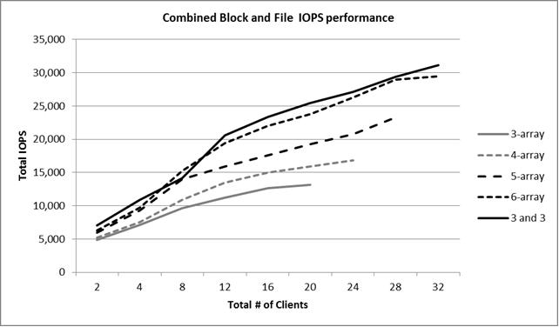

Figure 2: Combined Block and File IOPS performance

Note: The results provided in this paper are intended for the purpose of comparing the specific configurations used in our lab environment. The results do not portray the maximum capabilities of any system, software, or storage.

In Figure 3, the IOPS performance is shown separately for both block and file I/O in the largest configuration that used a single shared pool (six arrays total). In this example, the proportion of I/O from file clients (NFS) is nearly double the I/O from block clients. This indicates that the additional cache memory that is available on the FS7500 contributes to the increased number of I/O completed by NFS clients. Caching requests locally on the FS7500 means the FS7500 can actually deliver greater I/O read performance when it already has the requested data in memory or where it performs a prefetch. In the case of I/O writes, the caching ability of the FS7500 allows it to more efficiently commit data to the back-end SAN either by coalescing adjacent writes or absorbing bursts of I/O requests from network clients.

The caching effect of the FS7500 is also evident when looking at Figure 4, where we see that file I/O clients have a slight performance advantage over the block clients. Furthermore, when we examined the data from SAN HQ, it showed that the total number of I/Os actually completed by the storage system for NFS clients was slightly less than the total number of I/Os from all block clients, again indicating the beneficial effects of caching on the FS7500 system.
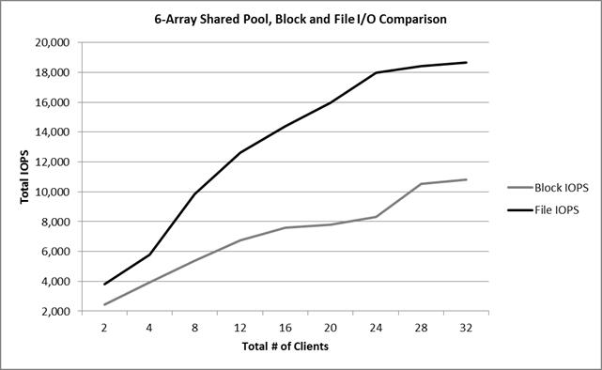

Figure 4 shows the results when the same scaling test was run, except the block and file data were in separate pools. In this case, overall file I/O performance was lower than it was in the shared pool, but the overall block I/O is greater than when it shared the pool with the file I/O (as shown in Figure 3).

This is due to the way volumes are load balanced across arrays. Under normal conditions, a volume on an EqualLogic PS Series iSCSI SAN may be distributed across up to three of the PS Series arrays. When the pool is limited to three arrays, and contains only the volumes for the NAS File System, the volumes that make up the NAS reserve will span the same physical disks. Therefore, any CIFS or NFS workloads will also be limited to the maximum number of IOPS that the three arrays can deliver. When the single pool was expanded to six arrays, each of our two NAS volumes automatically balanced exclusively across three of the six arrays. The first NAS volume is on the first 3 arrays, and the second NAS volume is on the remaining three arrays. This is expected behavior for the SAN as long as adequate free space is available in the pool.
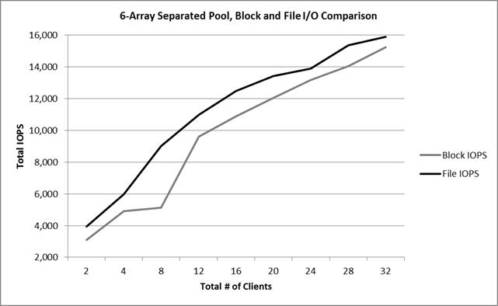

Figure 4: 6-Array Separated Pool, Block and File I/O Comparison

Since additional IOPS capacity was made available to the NAS volumes (doubling the number of physical disk spindles from three to six arrays) we observed that the NAS volume performance increased, but at the same time those volumes now competed for resources with the volumes belonging to the block clients causing the slight decrease in the block performance.

Taking another look at Figure 2, we see that while the performance of the shared pool was similar to that of the separated pools for six arrays, separating the arrays into two pools gave us a slight advantage in total performance. Also, when we examined the average response times (as measured from the clients), we found it was slightly higher for our block clients when sharing the single storage pool with file I/O clients as compared to two pools with both sharing file and block I/O. This again is a result of the file and block volumes now residing on the same physical disks and therefore competing for the same physical disk resources with file I/O exhibiting better performance. When a new FS7500 is added to an existing SAN, configuring the FS7500 to use a separate pool prevents it from impacting the performance of the existing pool.

Planning and design considerations

6.1 Network ports

Each FS7500 controller contains a total of thirteen 1 Gigabit Ethernet ports that need to be connected for optimal performance. A total of 26 network ports are required for each controller pair. Established best practices for EqualLogic SANs recommend that the LAN and SAN be separated, and more specifically, that the SAN is physically isolated from the LAN.

For maximum availability, it is recommended that both the LAN and SAN have redundancy in the switches. Connections from the FS7500 can be staggered across redundant switches in a stack or modules in a chassis so that a single switch (or module) failure does not prevent connectivity from the client to the FS7500 or from the FS7500 to the SAN storage.

On each controller node there are four ports for client connectivity. All four should be connected to a LAN switch for maximum performance. The four LAN ports can be configured for ALB (Adaptive Load Balancing) mode or Link Aggregation Control Protocol (LACP; IEEE 802.3ad). If LACP mode is used, it requires further configuration of the network switches (on the LAN or client side) to support it. A total of 8 LAN ports are required for each controller pair.

On the SAN, there are four 1 Gigabit ports per controller node for iSCSI connectivity. An additional five ports per controller node are used for cache mirroring, heartbeat between nodes, and for other internal system management functions. These additional five 1 Gigabit ports must also be located on the SAN switch fabric, which results in a total of 9 ports per controller node (or 18 per controller pair).

The FS7500 does not support virtual LAN (VLAN) tagging and VLANs are not required on either the LAN or SAN switch. However, if VLANs are used, then switch ports should be configured as untagged so that any tags are removed on port egress (when the packet leaves the switch).

6.2 IP addresses

Each NAS controller node requires a unique static IP address on the LAN for management and support purposes.

A NAS service IP address is used by clients to access any CIFS shares and NFS exports hosted by the NAS service. When a NAS service is configured, one NAS service IP address is required if clients are on the same subnet as the FS7500 and connections are automatically balanced across all available connections.

If the client network is routed, meaning clients are on a different subnet than the FS7500, the client network configuration can be modified to add additional NAS service IP addresses to allow for proper load balancing across multiple client subnets. The total number of NAS service IP addresses required will depend on the bonding mode used for the NAS service:

BP1016 Integrating the Dell EqualLogic FS7500 into an Existing SAN

- or Adaptive Load Balancing (ALB), four IP addresses are required for each NAS node. For example, in a two-node NAS service, eight NAS service IP addresses are required.

- For LACP, one IP address is required for each NAS node. You need only one IP address for each node because the four client network interfaces are bonded together. For example, in a two-node NAS service, only two NAS service IP addresses are needed.

On the SAN, each NAS node requires four IP addresses for the iSCSI interfaces. One additional SAN IP address is required for management - allowing the NAS service to manage the PS Series storage.

The internal network is used for communication between NAS nodes. It connects to the SAN switches, but requires its own unique block of IP addresses. When the internal network is configured, you can choose one of the following options:

- 256 IP addresses (/24) – specifies 256 for the IP address block size

- 128 IP addresses (/25) – specifies 128 for the IP address block size

- 64 IP address (/26) – specifies 64 for the IP address block size

In most cases, since the SAN should be comprised of physically isolated network switches, the internal network only needs to be unique from the IP addresses used for the storage interfaces on the FS7500 NAS nodes and the storage arrays. The use of private (non-routable) IP address blocks such as 10.0.0.0, 192.168.x.x and 172.16.0.0 are generally OK to use for this purpose and the network block chosen has no impact on system performance.

6.3 Pool configuration

Each EqualLogic group allows up to 4 separate pools. A pool logically separates storage arrays. For example, a volume in Pool A will not share arrays (and therefore physical disk spindles) with arrays in Pool B. Pools can not only be used to keep volumes on separate arrays or RAID levels, but it can also be used to separate application workloads. For example, if a new FS7500 will be added to an existing SAN, depending on the current workloads on the SAN, it may be desirable to configure the FS7500 to use a separate pool so that it does not impact performance in the existing pool(s).

Of course doing this requires at least one new array, or enough free space that an existing array can be moved (evacuated) from the existing shared pool to create a new pool for the FS7500. If an existing array is moved from another pool, also realize that this could affect the performance in that existing pool since the number of spindles available in that pool will be reduced. Careful consideration of the current workload as well as storage capacity should be taken before removing arrays from a pool that contains existing volumes.

In most cases, it will probably be more desirable to add a new array (or arrays), than to allow the FS7500 to reside in the same pool as the other workloads. Using a separate pool provides for greater separation of the block and file I/O workloads, however it may also prevent some efficiency (in disk space utilization) that may be gained by sharing the same pool.

Before installing and configuring the FS7500, the administrator should ensure that there is adequate storage capacity (i.e. free space) in the pool to create the NAS reserve (for NAS volumes) as well as adequate I/O capacity (i.e. the SAN can deliver enough IOPS). EqualLogic SAN HeadQuarters can be used for monitoring and recording these values. If there is not enough free space, then additional arrays must be added to the pool. If there is not adequate I/O capacity to support the new file workload, then the performance of existing block workloads may be affected as the storage system is forced to share resources between them.

6.4 Volume configuration

The FS7500 is able to use the entire capacity of a pool and can support files up to 4TB in size. During configuration of the FS7500, the administrator is allowed to choose the pool that the NAS reserve will be created in. All FS7500 pairs must use the same pool, and if the pool contains existing volumes, there must be adequate free space available to create the NAS reserve.

The FS7500 requires a minimum of 250GB of free disk space (NAS reserve) for each controller pair. A portion of the NAS reserve is reserved space for the system so there must also be sufficient free space to create a NAS file system to hold user data. Best practices also dictate that a minimum of 5% of total pool space be kept free to allow normal volume load balancing and distribution to occur automatically. The amount of NAS reserve can be increased at any time provided there is free pool space.

If the minimum required free disk space is not available, then additional arrays must be added to the group prior to configuring the FS7500. If additional arrays are added to an existing pool which will be shared by block and file I/O volumes, then it is recommended that the group be allowed time to balance existing block volumes across the newly added array(s) before configuring the FS7500. Depending on the number of existing arrays and volumes, this operation could take several hours (or longer based on the SAN workload).

The space that is allocated to the FS7500 will determine the number of volumes that are created for each FS7500 pair. A minimum of two volumes will be created for each controller pair. The maximum volume size supported by the EqualLogic arrays is 15TB, therefore if the space allocated to the FS7500 is greater than 30TB (i.e., two 15TB volumes), an additional pair of volumes will be created for each FS7500 controller pair. This process continues until the capacity requirement is satisfied.

Because the volumes that are allocated to the NAS storage pool are also controlled by the FS7500, many operations that are available for standard block volumes are disabled in Group Manager and CLI access. This includes options such as replication, snapshots, and the ability to online or offline a volume.

6.5 Monitoring an existing SAN

SAN HQ is included with every EqualLogic storage system and is ideal for monitoring EqualLogic SANs over a longer period of time. Administrators can collect data from the SAN and review it to ensure that there is sufficient storage and I/O capacity for current needs as well as future growth. Figure 6 shows an example of the SAN HQ user interface and some of the many statistics that it can provide.

Prior to adding a FS7500 to an existing SAN, Dell recommends using SAN HQ to collect statistics about the existing SAN. Administrators should carefully monitor historical disk capacity usage and trends to ensure that there will be sufficient free pool space to integrate the FS7500. Administrators should examine average IOPS over longer periods of time as well as peak IOPS required during short bursts of high activity. Understanding the sources (i.e. from which hosts) of each type of activity will help the administrator determine optimal configuration for pools and number of arrays needed.

Administrators should also look at statistics such as Queue Depth by disk and volume to understand the average number of outstanding I/Os that are waiting for service. Higher numbers indicate higher workloads from attached hosts and in some cases may indicate the need for additional disk I/O capacity (i.e., the more physical disk spindles) to satisfy performance needs. Latency is also an important factor that affects the response time of applications. Higher latencies may be an indicator of slower response times for the attached hosts and applications running on them. However it is also expected that larger block sizes, such as from backup and restore, may result in slightly higher latencies.
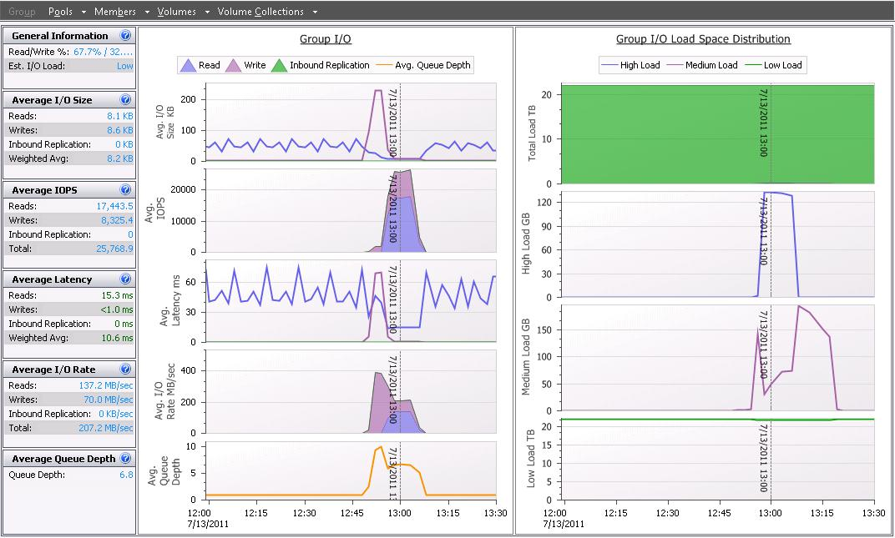

Figure 5 - SAN HQ data

7 Summary

The Dell EqualLogic FS7500 can be deployed as part of a new installation or into an existing EqualLogic PS Series iSCSI SAN. When deploying into an existing SAN, administrators should monitor the existing SAN to understand the availability of not only data storage capacity, but also of I/O capacity. The data presented in this paper can then be used to help determine if there is a need for additional storage arrays and to help guide the deployment of the FS7500. Depending on the type of I/O from network clients, the use of the FS7500 may even enable an increase in overall performance capacity for the SAN through caching of network client requests and thus reducing the number of I/Os that must be completed by the storage arrays.

