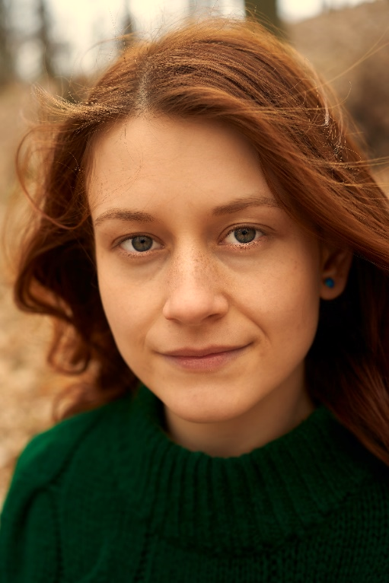

**KEY SKILLS**

Attention to detail Customer service expertise

Excellent written and verbal communication skills

Microsoft Office experience

**PROFESSIONAL EXPERIENCE**

**Junior Writer, Small Paper Daily, Columbus, OH**

**May 20XX to August 20XX**

* Provided copy for numerous newspaper sections, including editorial, arts and leisure and business
* Proofread advertisements prior to publication and verified provided details for correctness
* Worked with photo editors to determine placement with accompanying text

**Receptionist, Regional Floral Magazine, Lancaster, OH, December 20XX – August 20XX**

* Answered phones, transferred callers to the correct parties and provided relevant magazine information to callers
* Answered emails sent to the main magazine email account, including responding to feedback and providing subscription information
* Maintained subscription rolls, including adding new subscriptions and removing cancellations

**EDUCATION**

Bachelor of Arts in English-Creative Writing

Ohio University Athens, OH, August 20XX to May 20XX (anticipated)

**COURSEWORK**

Prose and nonfiction

Poetry and drama

Short story writing

Children’s fiction

Fiction workshopping

JANETTE   
**SMITHSON**

Internship Resume

**PROFILE**  
Passionate creative writer with aspirations in fiction writing and editing seeking an internship in publishing. Winner of 2020 on-campus fiction award for long-form fiction as well as 2019 runner-up for excellence in poetry. Experience serving as support staff for the campus literary magazine, Colorful Words.

**CONTACT**

(719) 343-7782

your.name@gmail.com

3025 Rockbrook Ln, Colorado Springs, CO 80904

linkedin.com/in/profile