Political Cartoon Instructions & Rubric

Requirements:

- One 8½ X 11 White non-lined sheet of paper (you must use the full sheet)
- Hand drawn (stick figures and “Photoshopped” pictures are not acceptable)
- Colored (by color pencils only – no markers, pens, crayons, water colors, etc)
- The BACK of the cartoon should have:
  - Title of Cartoon
  - Name
  - Date
  - Class period
- It does not have to be one “big” drawing. It can be a comic strip format with multiple panels if you would like

How do I begin to create a political cartoon?

First you must ask yourself, “What is the issue I want to write about?” A good way to decide is to look over your notes. What issue stands out to you? Meaning, was there something that shocked you, something that you think is not right, something that seems hypocritical, something that you think needs change, something that is emotional, etc? You should write down your statement and then ask yourself “why do I feel this way and what should be done?”

For example, please see the cartoon below:

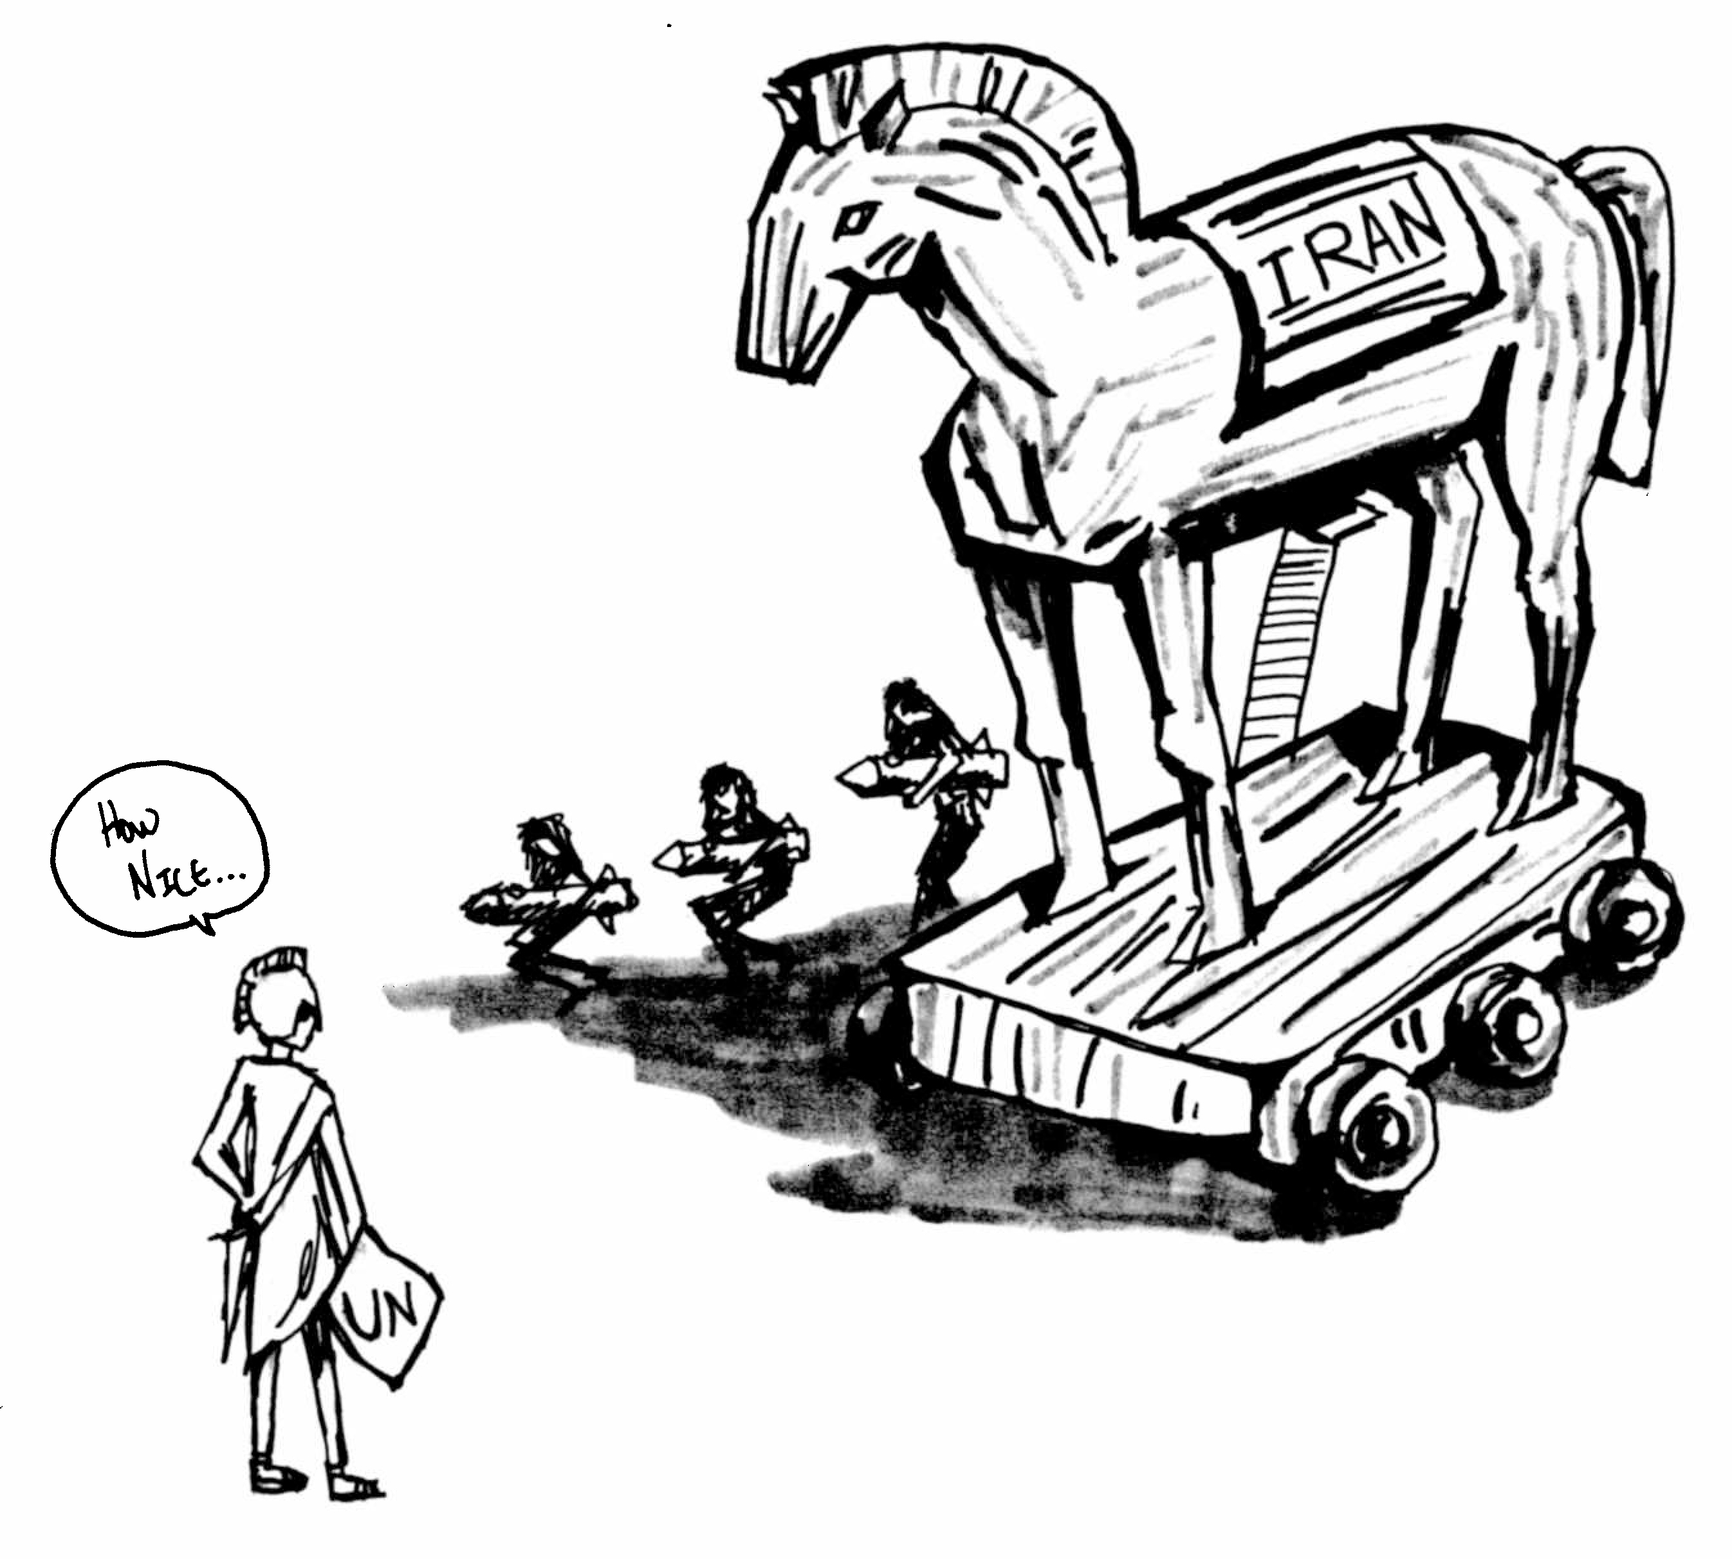
For the example on the first page, before they did any work, I asked the student, “What do you want to say?” The student said, “I believe that Iran is actually trying to build nuclear weapons (not nuclear power for peaceful purposes), that the U.N. is just “standing by” and letting it happen, and that, in the end, it could be very dangerous.”

I then summarized the main point by saying, “So you are saying that someone is being sneaky (not paying attention) and that they are being tricked into something that might end up being dangerous?”

I then asked the student, “Can you think of another example of something that symbolizes your summary?”

The student said, “This kind of reminds me of the whole ‘Trojan Horse thing.’ The student began to explain that Iran is acting like a “Trojan Horse” because, while they say they are working on nuclear energy for peaceful purposes, they are actually working on nuclear weapons which will eventually threaten the world.

As you can see, the political cartoon that the student created is an excellent example of this, and it earned a 30 out of 30.

Question(s) to answer:

What is your specific opinion about something we learned in class?

- Why should we care?
- What should we do about it?
- Why is this important?
- Who is to blame?
- What does this say about what you believe?

Here are some links for political cartoon examples:

http://www.politicalcartoons.com/
http://editorialcartoonists.com/cartoon/display.cfm/29834/
http://www.cartoonistgroup.com/search/results.php

Please note:

It is very tempting to copy cartoons that have already been done. Some students believe that they can take an idea from an artist, change a thing or two, and then claim it is their own. This is plagiarism and will result in a “0” on your assignment. You must come up with an original idea.

Political Cartoon Rubric

 | 6 | 5-4 | 3-2 | 1-0
Meets Basic Requirements | Student’s project follows all five instruction points. | Student’s project is missing a minor point from instructions (for example: date or title) | Student’s project is missing a major point (for example: paper is not 8.5X11) but is still completed | Student’s project does not conform to more than one major point.
Organization & Preparation | The political cartoon is of excellent quality and it is apparent that the student spent time in preparing it. | The political cartoon is of good quality and it is apparent that the student spent some time. | The political cartoon is of fair quality and seems rushed. | The political cartoon appears to have been hastily created and appears messy or disorganized.
Knowledge & Concept of the Topic | The political cartoon demonstrates higher level understanding of an issue. | The political cartoon demonstrates an understanding of an issue. | The political cartoon demonstrates recognition of an issue but not a clear understanding. | The political cartoon demonstrates that the student is still struggling to understand the issue.
Creativity of the Product | The political cartoon’s style, color, and impact align perfectly with the students ideas. | The political cartoon’s style, color, and impact align well with the students ideas. | The political cartoon’s style, color, and impact do not align well with the students ideas. | The political cartoon’s style, color, and impact seem disjointed and rushed.
Visual Expression of Ideas | The political cartoon is rich with symbolism. The message goes beyond a statement and reflects an in-depth opinion answering more than one of the “questions to answer.” | The political cartoon is rich with symbolism. The message goes beyond a statement and reflects an in-depth opinion answering one of the “questions to answer.” | The political cartoon demonstrates little symbolism. The message does not really go beyond a statement (for example “people in Africa are starving”) and does not reflect an in-depth opinion answering more than one of the “questions to answer.” | The political cartoon demonstrates little to no symbolism. The message does not really go beyond a statement (for example “people in Africa are starving”) and does not reflect an in-depth opinion.

