Annotated Logic Model Template

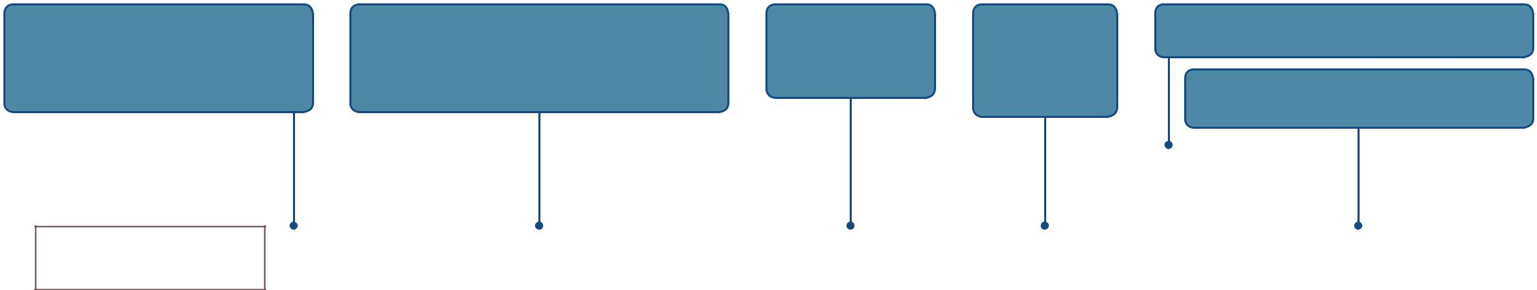
 | TIP (STRATEGIES): | TIP (OUTPUTS): | TIP (S-T OUTCOMES): | TIP (I OUTCOMES):
1. | Organization: Put 1 strategy in each box. | Outputs are different than Outcomes, and distinguishing | These are typically | These are typically
2. | Activities: Adding Activities under | between the two is important. Outputs are products or | changes in awareness | behavioral and
 | Strategies helps make the logic model more | services that result from what you do; whereas, Outcomes | and knowledge. | environmental
 | specific and can aid implementation. | are changes that happen as a result of what you do. |  | changes.

TIP (L-T OUTCOMES): These can also be considered as “impact” and can be synonymous with project “goals.”

TIP (ASSUMPTIONS): Continue to check and clarify assumptions as you develop your logic models.

ASSUMPTIONS |  | What are the principles, beliefs, or ideas about the project or the people involved in the project? What research or experience is driving the way you think about how the project will work?

INPUTS
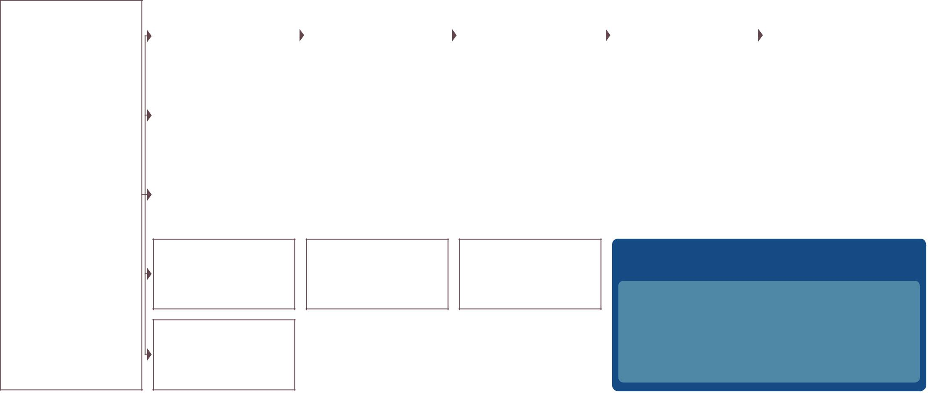

What are tangible resources that exist to support the project?
- Funding

- Personnel

- Materials

- Technology

What are intangible resources that exist to support the project?
- Partnerships

- Time

- Research

- Regulations

- Leadership

- Expertise

STRATEGIES / ACTIVITIES |  |  | OUTPUTS |  |  |  | SHORT-TERM OUTCOMES |  |  | INTERMEDIARY |  |  | LONG-TERM OUTCOMES
 |  |  |  |  |  |  | (1-2 Years) |  |  | OUTCOMES (3-4 years) |  |  | (5+ years)
What are the broad approaches |  |  | What are the observable products |  |  |  | What are the changes expected |  |  | What are the changes expected |  |  | What are the ultimate desired
or sets of actions you are employ- |  |  | or services of your strategies and |  |  |  | directly resulting from your strate- |  |  | directly resulting from your strate- |  |  | results your project is trying to
ing in this project? |  |  | activities? Who will have partici- |  |  |  | gies and activities? |  |  | gies and activities? |  |  | achieve? What are the overall
 |  |  | pated? What will be produced? |  |  |  |  |  |  |  |  |  | changes you want to make in a
 |  |  |  |  |  |  |  |  |  |  |  |  | population or system level?

INSTRUCTIONS: Use the companion Quick Reference Guide to

Logic Models to create your logic model.

TIPS (GENERAL):

1. Clustering: For Strategies, Outputs, and Outcomes, consider grouping similar elements together. This provides a higher-level view of a project and can make the logic model significantly easier to read.

2. Showing Logical Linkages: Making and showing clear logical connections between project components is the crux of what a logic model is designed to do. Examine the logical relationships by asking “If we do this, then is it more likely that that will happen?”

EXTERNAL FACTORS |  | What are the current or anticipated dynamics in the external environment that can affect the success of your project? What is happening politically? Socially? Economically? What are real or
 |  | potential risks?

