[Network Name] Strategic Plan

Project Strategic Plan Template

Rural Health Network Development Program Technical Assistance

525 South Lake Avenue, Suite 320 │ Duluth, Minnesota 55802

- 727-9390 │ info@ruralcenter.org

This is a publication of Rural Health Innovations, LLC, (RHI), a subsidiary of the National Rural Health Resource Center. The Technical Assistance for Network Grantees Project is supported by Contract Number HHSH250201400024C from the U.S. Department of Health and Human Services, Health Resources and Services Administration, Federal Office of Rural Health Policy.

[Network Name] Strategic Plan

Table of Contents

Background and Purpose 2

Instructions 3

Strategic Plan Components 4

Network Purpose and Shared Vision 4

Environmental Scan and Analysis 5

Strategic Objectives 6

Strategic Map 7

Communication Plan 8

Next Steps 9

RURAL HEALTH INNOVATIONS | 1

[Network Name] Strategic Plan

BACKGROUND AND PURPOSE

Rural Health Innovations (RHI), LLC, is a subsidiary of the National Rural Health Resource Center (The Center), a non-profit organization. Together, RHI and The Center are the nation’s leading technical assistance and knowledge centers in rural health. In partnership with The Center, RHI enhances the health of rural communities by providing products and services with a focus on excellence and innovation. RHI is providing TA to the Rural Health Network Development program through a contract with the Federal Office of Rural Health Policy.

This Project Strategic Plan Template was created to provide support to Rural Health Network Development grantees in writing an effective and dynamic strategic plan after you have held a participative planning event as outlined in the Project Strategic Plan Guide.

This template is designed for use in conjunction with the Project Strategic Plan Guide for Rural Health Development Networks. For samples of the completed strategic plan components reviewed in the guide and template, see the Project Strategic Plan Samples for Rural Health Development Networks document. Additional resources on strategic planning can be found on RHI’s Network Aim for Sustainability Portal page.

[Network Name] Strategic Plan

INSTRUCTIONS

Although a specific template for the strategic plan is not required as part of the Rural Network Allied Health Training Program grant deliverable, the following components are recommended:
- Network Purpose and Shared Vision

- Environmental Scan and Analysis

- Strategic Objectives

- Communication Plan

There is no correct way to present a strategic plan. We offer this template to provide your network with ideas and a starting point as you make decisions about creating your report. To use this template for documenting your network’s strategic plan, complete the following steps:

- Revise the cover page to display the appropriate network/program information, including name, location, authors of the report and the date

- Remove the Background and Purpose section and the Instructions section on pages 2 and 3 of this template documents

- Change the headers and footers to reflect your network name

- Complete the sections provided with relevant information in the form of narratives, tables, diagrams and charts as appropriate

- Update the Table of Contents to reflect your new content language and layout

[Network Name] Strategic Plan

STRATEGIC PLAN COMPONENTS Network Purpose and Shared Vision

This section provides a high-level overview of the network’s history, members and mission, and states the shared vision and primary grant goals.

Keep this section to no more than two pages. Standard narrative text is typically the most functional format for this component, although visuals could certainly be created if desired.

See page 10 of the Strategic Plan Guide for Rural Health Development Networks and Project Strategic Plan Samples for Rural Health Development Networks for details.

- Network History

- Network Members

- Network Mission

- Network Shared Vision (along with a brief description of your process for reaching consensus on and/or reviewing the shared vision)

- Primary Project Goals

[Network Name] Strategic Plan

Environmental Scan and Analysis

This section reviews significant characteristics of the network’s internal and external environment in terms of key blocks and strengths of the network.

A summary of the environmental scan can be a narrative form, a chart or diagram. The description of the environment and the accompanying analysis should be not more than two pages.

See pages 11-12 of the Strategic Plan Guide for Rural Health Development Networks. and Project Strategic Plan Samples for Rural Health Development Networks for details.

Summary of Environmental Scan

[Network Name] Strategic Plan

Strategic Objectives

This section identifies the two-to-three-year strategic objectives that will move the network toward its vision.

This information should fit into one page. There are options for presenting this information using the simplified format below, a strategy map or your logic model.

See page 13 of the Project Strategic Plan Guide for Rural Health Development Networks and Project Strategic Plan Samples for Rural Health Development Networks for details.

Goal #1:

- (Strategic Objective)

- (Strategic Objective)

Goal #2:

- (Strategic Objective)

- (Strategic Objective)

Goal #3:

- (Strategic Objective)

- (Strategic Objective

[Network Name] Strategic Plan

Optional: Strategic Map
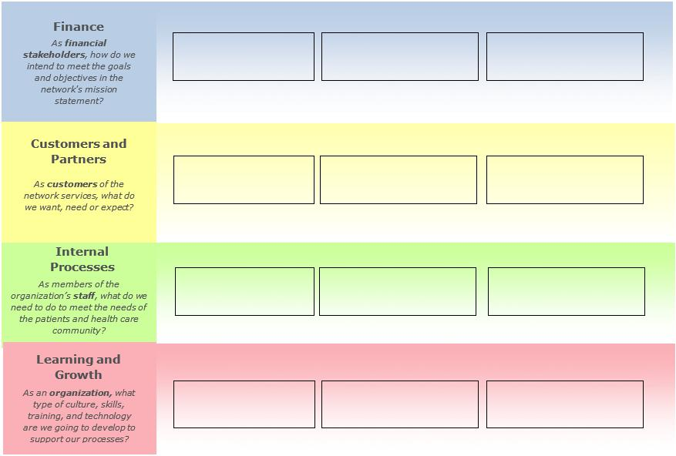

[Network Name] Strategic Plan

Communication Plan

This section details how the strategic objectives and initiatives are communicated throughout the network and partner organizations.

Consider using a visual to illustrate the communication plan. This section should be no more than two pages. Add rows as needed.
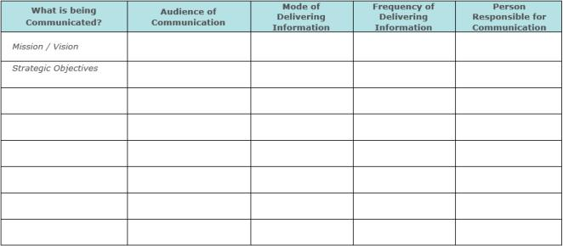

[Network Name] Strategic Plan

NEXT STEPS

This section is to give the reader and idea of what is next. You may use the following or write something from your own network’s perspective.

The work we have completed for this strategic plan has been within the Analyse and Plan phase of the Strategic Planning Cycle. Our next steps are to determine what is going to be measured to show progress toward our goals. Part of this will also be to develop a plan to monitor and adjust. This will complete this first phase of the Strategic Planning Cycle. A communications plan is part of this document, however in the evaluation planning phase there will be much more comprehensive communication plan.

The workplan developed for the grant application will be used for operationalizing the grant project.

Upon completion of the Evaluation Plan, our network will have all the elements of the Strategic Planning Cycle in place to keep moving forward with our grant project.

Recognizing that this is a “living and breathing” document, we will be updating on a regular basis by (fill in how you plan to do that). Our intention is to go through the full strategic planning process again in year (three or four- pick one). The environment we work in is constantly changing and this needs to be reflected in our planning.

