for-word.jpgfor-word.jpg­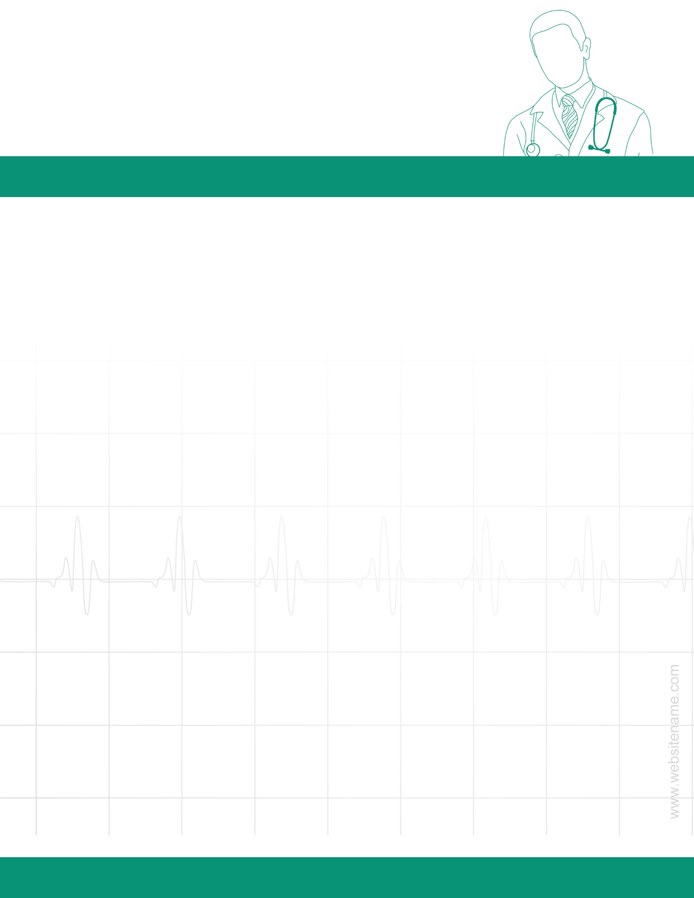

| Date | Nurse Progress Notes |
| --- | --- |
| 24/05 | |
|  | |
|  | |
|  | |
|  | |
|  | |
|  | |
|  | |
|  | |
|  | |
|  | |
|  | |
|  | |
|  | |
|  | |
|  | |
|  | |
|  | |
|  | |
|  | |
|  | |
|  | |
|  | |
|  | |
|  | |
|  | |

Your Address, City, State, Zip code

name@mail.com

+1 551-456 9870

HOSPITAL NAME

NAME: