___________________________________________________________________________

PENTA WHITE PAPER
Pan-European partnership in micro- and Nano-electronic Technologies and Applications
___________________________________________________________________________

Executive Summary

This White Paper is the basis for PENTA, a new EUREKA Cluster in micro- and nano-electronics that will support the vision, strategy and planned implementation contained in the European Industrial Strategic Roadmap for Micro- and Nano-Electronic Components and Systems as prepared by the Electronic Leaders Group. ¹ Its purpose is to catalyse research, development and innovation in areas of micro- and nano-electronics based systems where there is shared high national and industrial interest. Micro- and nano-electronics has been identified as a Key Enabling Technology² for Europe and cornerstone of key economic and societal developments. In this context, the objective of the new Cluster will be to address all research, development and innovation priorities identified through an understanding of rapidly changing needs.

Industry needs a programme that is dedicated to micro- and nano-electronics, complementary to but differentiated from the ECSEL Joint Undertaking, which will support projects that can be set up quickly and implemented in a manner that matches the specific needs of the project objectives and the participants. This should be a flexible and agile programme that identifies opportunities, quickly assesses national governmental support and operates with a short, but effective, approval process. With its focus on smaller, faster and flexible projects, the new Cluster will provide an opportunity to quickly take advantage of rapidly developing markets and their related value chains.

At the start of the programme, the focus of projects will be on applications in automotive, healthcare and production technologies. In all applications it is recognized that security, connectivity and energy efficiency are essential crosscutting contributors. It is also understood that semiconductor processes, equipment, materials and tools are instrumental in all technologies. Implementation of the programme is expected to result in an improved European presence in key electronics markets, with economic and social benefits to European companies and citizens.

A fundamental premise of the new Cluster will be openness and inclusivity. ‘Openness’ will be visibly demonstrated at all levels of the Cluster’s governance, offering equal opportunities to all interested participants, present and future. ‘Inclusivity’ will be ensured through a range of activities centred on the creation of a “market place”, bringing awareness and open interaction of the capabilities that are available across Europe to the key electronics value chains. Managed information exchange and networking will allow the efficient formation of focussed, well resourced, consortia developing leading edge technology and applications. A special focus will be placed on SME involvement.

Finally, best practices from other public private partnerships, including those within EUREKA, will be incorporated in all parts of the programme. Key Performance Indicators will be implemented and monitored to ensure that the new Cluster fulfils all of its obligations in meeting the expectations of both Public Authorities and Industry.

1. Rationale and Vision

The rate of change in the field of micro- and nano-electronics continues to increase providing both immense opportunity and high risk to European companies. The Electronic Leaders Group, established by former European Commission VP Kroes, has defined a strategy for maintaining and enhancing European leadership in micro- and nano-electronic components and systems.³ The new Cluster will be designed to support this strategic roadmap and its related implementation plan in key areas of micro- and nano-electronics based systems.

The Electronic Leaders Group has identified three areas of opportunity for high demand growth which have a good fit with European strengths and skills:

- Existing areas where Europe is strong and there is above average growth in the electronic content, e.g., automotive, energy, industrial automation and security.

- New high growth areas, in particular engaging the Internet of Things, where industry in Europe is well positioned to benefit from the development of anticipated "Smart-X" markets.

- Markets in the changing landscape of mobile convergence which constitute opportunities to be captured e.g. by maintaining leadership in the design of low power processors and growing leading edge semiconductor manufacturing.

Europe is well positioned in having industry leading companies in some of the most active applications segments and also advanced technology that supports competitive exploitation through products and services. However these leadership positions will only be maintained if technology and application development matches the rapidly changing nature of the market. In addition, rapid advantage must be taken of any new market segments as they develop and new opportunities identified that can be built on and exploited.

Further to the European strategy for Key Enabling Technologies⁴, the European Commission established the ECSEL Joint Undertaking⁵. This partnership between the private and the public sectors for electronic components and systems encompasses the areas of micro- and nano-electronics, embedded/cyber-physical and smart integrated systems and application.

Micro- and nano-electronics based systems are at the core of new opportunities and their development and exploitation in “value chains” are of national and European interest and must be helped to innovate and grow. Examples are healthcare, industrial and automotive as illustrated in the picture below. These value chains develop and change continuously and it is important that those that can be most beneficial to the European economy are quickly identified, prioritised and exploited by industry.

Industry needs a programme that is dedicated to micro- and nano-electronics, complementary to but differentiated from the ECSEL Joint Undertaking, which will support projects that can be set up quickly and implemented in a manner that matches the specific needs of the project objectives and the participants. It should be a flexible and agile programme that identifies opportunities, quickly assesses national governmental support and operates with a short, but effective, approval process, to ensure the opportunity for rapid competitive exploitation as soon as the necessary research and development activities have been completed. The programme must take full advantage of all the capabilities available in Europe, encompassing all members of the various ecosystems and with special emphasis on enabling SME’s to bring new capability into the micro- and nano-electronics based systems markets.

With its focus on smaller, faster and flexible projects, the new Cluster will provide an opportunity to quickly take advantage of rapidly developing markets and their related value chains. The following illustration shows the major components of the electronics value chain and their relative size and value:

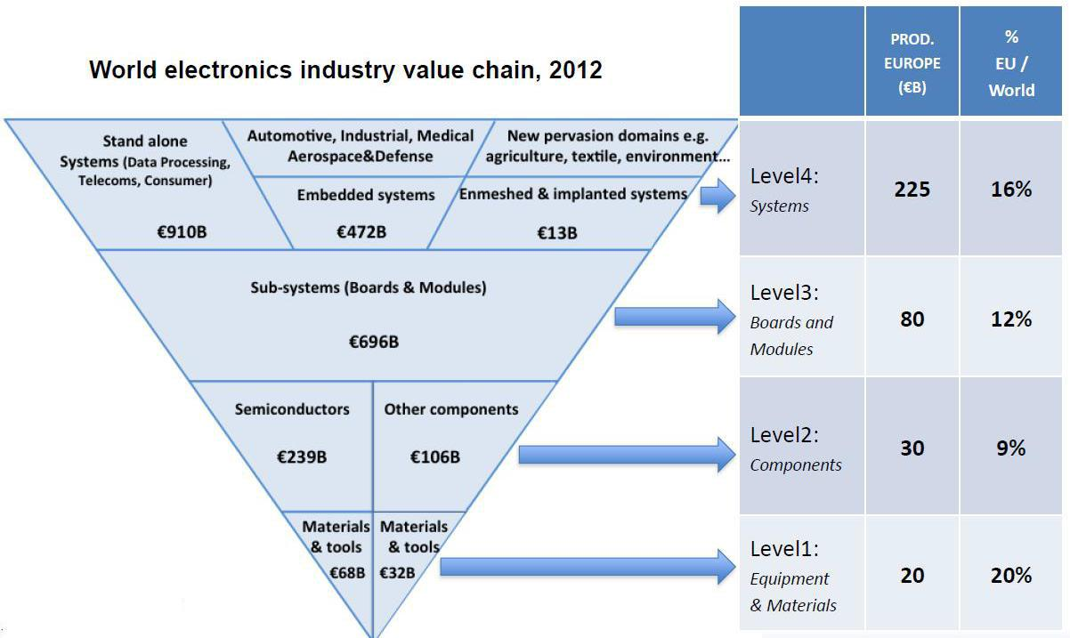

Competitive and Technological Challenges

Competitive Landscape

Micro- and nano-electronics is an identified Key Enabling Technology for Europe and cornerstone of key economic and societal developments. To keep Europe ahead in global markets, a solid understanding of the rapidly changing needs and the establishment of ecosystems involving all stakeholders is essential.

Many companies across the world are already competing vigorously in many of the existing and emerging application areas but the enormous breadth of opportunity should allow European companies of all sizes to participate competitively. However, this can only happen if there is the ambition to lead in these areas and if opportunities are identified and exploited rapidly.

Co-operative “bottom-up” research, development and innovation projects offer the pre-competitive environment to create confidence and build the necessary alliances that will take advantage of these opportunities. Public investment in research is an important instrument to support these “bottom-up” projects.

Technological Roadmaps

The technological roadmaps necessary for Europe to compete with micro- and nano-electronics based applications in present and future markets have been outlined in the inputs of AENEAS to the Multi Annual Strategic Plan of the ECSEL Joint Undertaking. The corresponding grand challenges in the European ecosystem are defined in the AENEAS Multi-Annual Strategic Research and Innovation Agenda⁷ as follows:

Automotive and Transport

Needs-based, user-friendly, affordable electric vehicles embedded in a sustainable mobility infrastructure satisfy the need for individual mobility. Based on highly reliable electronic active safety systems, a major breakthrough will be made on the road to accident-free traffic. Efficient cross-domain and co-operative traffic management systems will ensure substantial progress towards jam-free traffic without any major diversions.

Communication and Digital Lifestyles

Moving towards the convergence of applications, devices and networks,

develop innovative silicon solutions for managing the volumes of data required for future broadband services in the most effective way. Offer consumers multiple multimedia services through a variety of receiving devices connected to ubiquitous networks with improved intuitiveness in interaction in order to enhance user experiences, and enable broadcasters and content providers to produce multi-platform content and seamlessly delivery it in a plurality of new formats at reduced cost. Introduce highly flexible energy-efficiency wireless architectures that support multi-band multi-mode operation. The ubiquity of mobile devices and the deployment of wireless networks offer extensive scope for innovation.

Develop a new class of energy-efficient single-chip systems able to sense, communicate, reason and actuate.

Energy Efficiency

The ultimate vision is virtually loss-free energy conversion and generation. Proven availability of energy-efficient distribution of electrical energy based on central and local sources. No risk of black-outs or over-supply to disrupt grids. The ‘Smart City’ is the place where millions of people live and work. The energy consumed should be precisely that needed, not influenced by oversupply, not wasted by inefficiencies, and not subject to bottlenecks in the distribution system. The vision is to have clean and healthy city environments in which energy is used intelligently.

Health and the Ageing Society

To provide devices and networks that supply high quality remote care to patients at home for the majority of chronic diseases that affect the elderly. Furthermore, to enable an active life despite ageing, by enhancing access (both physical and informational) to social groups or family networks that are supported by professional care givers. To deliver effective diagnosis and treatment based on an individual patient’s specific circumstances and medical condition. Via secure communication networks, appropriate medical specialists will be involved irrespective of whether they are local to or remote from the patient. Diagnosis and treatment will be guided by semi-autonomous workflows and decision support at several scales of magnitude (from ‘whole-body’ to organ, cellular and molecular levels) using multiple modalities, which together provide the best outcome in the least intrusive way. ‘Lab-on-Chip’ technologies allow patients to self-monitor (for example, by performing saliva or blood tests themselves) and make more accurate technologies available to medical

specialists. Diagnosis will only take minutes, because samples will not have to be sent to dedicated laboratories. The availability of biopsy analysis results will be strongly accelerated via digital pathology imaging.

Safety and Security

Take advantage of European leadership and expertise in electronic safety and security to define, develop and implement the required safety and security in new challenging European application domains and stay ahead of world competition. Together with European semiconductor actors and European security and reliability experts, to develop the Building Blocks and Technologies for trust & security and reliability & safety add-ons to provide secure and safe enabling devices.

Design Technologies

Standardized and flexible design flows that start at system-level and take account of hardware and software components to build sophisticated feature-rich innovative products of superior performance and quality. Having a consistent and flexible design flow for complex heterogeneous systems, supporting IC, package and printed circuit board co-design. Consistent design technologies ensure yield, reliability, and robustness for sophisticated feature-rich innovative products of superior performance and quality.

Semiconductor Process and Integration

Develop European know-how on More-Moore semiconductor process technologies for mastering future applications and drive Europe into the ‘beyond CMOS’ era. Develop European competitiveness.

Through semiconductor process differentiation, permitting different European business models and supply chains to succeed. Develop a European System-in-Package supply chain for innovative systems integrating advanced CMOS and differentiating technologies developed in Europe, through 3D and heterogeneous integration, bringing More-than-Moore and More Moore together.

Equipment, Materials and Manufacturing

Develop European know-how for advanced CMOS wafer processing.

Strengthen European competiveness by developing advanced More-than-Moore solutions for front and back-end wafer processing, and device packaging. Develop More-Moore and More-than-Moore software and hardware solutions for highly flexible and cost-competitive semiconductor manufacturing in Europe.

3. Programme Scope

The new Cluster will be designed to support the vision, strategy and planned implementation contained in the European Industrial Strategic Roadmap for Micro- and Nano-Electronic Components and Systems as prepared by the Electronic Leaders Group. Its purpose is to catalyse research, development and innovation in areas of micro- and nano-electronics based systems where there is shared high national and industrial interest.

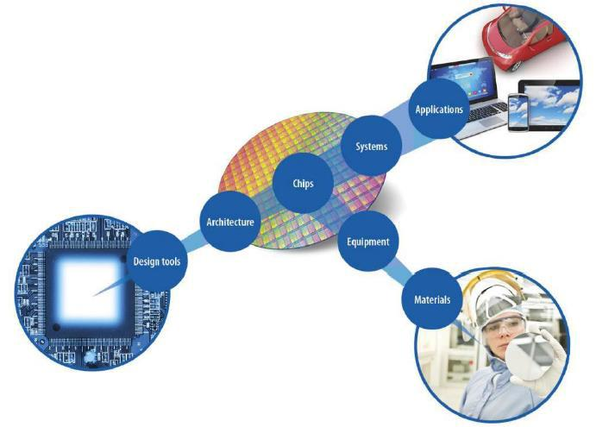
Research, development and innovation on micro- and nano-electronics based systems can occur across the entire application value chain shown in the below picture, and spans material studies, process development, new equipment as well as application based activities.

The new Cluster will have the following lead principles:

- To reinforce and enhance existing strengths in Europe by focussing on areas where Europe has strong leadership

- To close gaps across the European value chain for micro- and nano-electronics based systems from technology providers to end users - thereby stimulating the European Electronics market as a whole

- To identify and develop new market leadership opportunities for Europe’s micro- and nano-electronics industry and associated industry sectors thereby providing the ability to support future European champions through disruptive business or market approaches.

Together, the technological roadmaps outlined in the AENEAS Multi-Annual Strategic Research and Innovation Agenda span a range of major European strengths in the Internet of Things, the recognized main driver of global economic growth in micro- and nano-electronics-based systems.

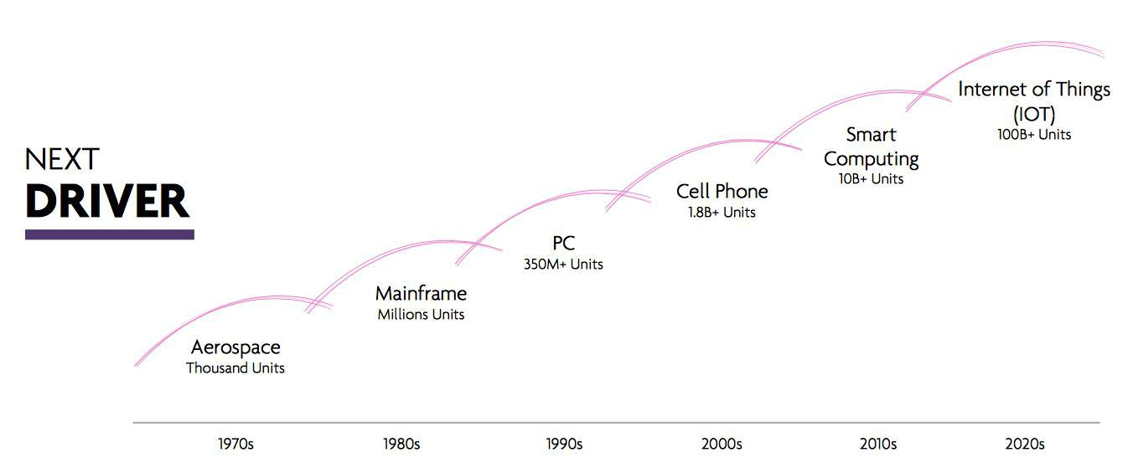

Within this portfolio of technological roadmaps, domains of particular relevance for the micro- and nano-electronics ecosystem will be carved out, with a specific focus on areas of shared high national and industrial interest. Knowledge and innovation will be stimulated through focussed research, development and innovation projects, reaching beyond traditional lines of collaboration.

At the start of the new Cluster programme, focus of the projects will be on applications in automotive, healthcare and production technologies. Examples of topics that could be addressed in each of these priority areas are:

- Automotive: resource-efficient transport, highly automated/autonomous transport, integrated and multimodal mobility networks;

- Healthcare: people and patient centric for the whole care cycle, prevention, diagnosis, treatment/therapy, and after-care;

- Production Technologies: semiconductor equipment and materials, smart production systems, availability, flexibility, controllability, maintainability, secure connectivity, Industry 4.0.

The roadmaps to be followed in the above priority areas follow from the corresponding sections in the AENEAS Multi-Annual Strategic Research and Innovation Agenda, in particular the grand challenges for Automotive and Transport, Health and the Ageing Society, Design Technologies, Semiconductor Process and Integration, and Equipment, Materials and Manufacturing. In all applications it is recognized that security, connectivity and energy efficiency are essential crosscutting contributors. It is also understood that semiconductor processes, equipment, materials and tools are instrumental in all technologies.

These initial focus areas are subject to assessment and revision in planned review sessions between industry and public authorities. By exception, projects in areas outwith of defined core focus areas may be considered, but only if pre-approved by the relevant Public Authorities that will be supporting such project.

4. Strategies

Market Place

The new Cluster shall put in place activities specifically designed to ensure maximum inclusivity across all relevant organisations, with an extra focus on SME’s. The intent is to create an open and vibrant “Market Place” within which the extensive capability that is present across Europe can be showcased and accessed. This new capability for European actors in micro- and nano-electronics to “meet and greet” will allow consortia to be formed from organisations, small and large, which have the best and most innovative solutions to the identified “Value Chain” challenges.

The recruitment of new partners in projects shall be enhanced through networking and events organised in close cooperation with the leading regional clusters of European competitiveness and other national and European organisations as appropriate. In many cases these organisations have already mapped the dynamic organisations in their geographic area. For information, discussion and planning aimed at SME’s, Webinars and similar tools may be used, alongside physical meetings.

SME Engagement

Together with AENEAS, the new Cluster shall implement a major initiative to ensure SME’s have the best possible opportunity to participate in programmes funded by the new Cluster. Public and private bodies will be asked to help in identifying suitably qualified SME’s to apply for participation in new Cluster projects, potentially with a funding incentive to do so (e.g. specific budget for SME’s participation in the national budget to support the new Cluster).

To spearhead this activity, it is planned to form an “SME Engagement Committee” comprising organisations that represent and work with SME’s across Europe. Key roles for the committee will be:

- To understand that SME’s have different needs dependent on their size and development level and that these different needs must be taken into account at all levels in the funding programme;

- To establish a two way dialogue with SME’s across Europe to understand SME needs and provide appropriate information that will allow SME participation in funding programmes;

- To facilitate networking between SME’s and larger companies through an SME matching programme and local, national and European events;

- To organise the Market Place into “Value Chain” categories allowing small and large companies to understand the needs of specific industry sectors and facilitate industry groupings that can maintain or establish leadership in these sectors;

- To provide mentoring and guidance to SME’s throughout the process in partnership with public and private bodies providing support to SME’s, such as the regional competence clusters;

- To actively initiate and develop cooperation involving SME’s by using dedicated tools and events available in the regional competence clusters.

PENTA: Pan-European partnership in micro- and Nano-electronic Technologies and Applications

Openness

The new Cluster shall be open to all relevant participants throughout its lifetime. This should include companies who choose to “self-fund” project participation. The ‘openness’ of the new Cluster will be visibly demonstrated at all levels:

- Every organisation present in the European value chain will have the possibility to express itself as a participant;

- Maximum flexibility will be granted in the project consortia definition, and in the execution of selected projects (inclusion of new partners, change requests justified by technical or market evolutions);

- The new Cluster will offer equal opportunities to all types of participants, in particular to take a seat in its executive bodies, open to large and small companies as well as to RTO’s;

- Communication processes will be put in place to make this openness widely visible; for example by working with regional competitiveness clusters who could be best positioned to identify the dynamism of their ecosystems.

Ecosystem

The new Cluster shall seek advice from the ENIAC Scientific Community Council to explore and open avenues of possible future developments with large added value. It will closely cooperate with the ENI2 group tasked to prepare

medium- to long-term roadmaps for technologies and applications. Both bodies involve a large representation of Universities and RTO’s and are open to all organisations that wish to participate. The inputs received on technologies and applications with market perspectives will help in the preparation of the expected projects in the new Cluster.

The new Cluster shall support projects with the optimum, not the maximum, number of partners to achieve the defined goal in the most effective time frame, including non-European expertise when necessary. In all projects, partners from a minimum number of two countries covering at least an essential section of the total value chain are required.

5. Objectives, Targets and Impact

The overarching objective of the new Cluster is to support European leadership, through developments in micro- and nano-electronics, in key application segments of the electronics market, thereby meeting present and future needs of industry and society. This will be measured through an assessment and analysis of market segments and the position of European based companies in those segments at the beginning and the end of the programme.

Connected objectives include:

- Understand, document and prioritise current and developing market (value chain) segments, thereby allowing appropriate, targeted activity to maintain and develop the position of European based companies in prioritised segments;

- Establish a network (market place) of technology companies across Europe, organised by value chain, that can be nurtured and supported through funding and mentoring, thereby enabling the opportunity for market leadership;

- Develop and implement a project submission, evaluation and approval process that exceeds performance in best practices currently in place in similar collaboration instruments;

The impact from the successful introduction of the new Cluster will be multi-faceted and large. The overarching target is to ensure that the number of European companies having leadership positions in high priority market segments will increase over the duration of the new Cluster programme and beyond, thereby positioning Europe for improved economic and societal development.

6. Programme Plan

The programme shall run for a period of five years, with an intermediate review on progress and overall direction foreseen 30 months after starting. In this way, the new Cluster programme can be concluded simultaneously with the last call of the ECSEL Joint Undertaking under Horizon 2020. Optionally, the new Cluster programme may be extended beyond 2020.

An annual call cycle for project proposals will be installed, with transparent processes and timelines, and clear communication to all public and private stakeholders. In order to maintain overall programme efficiency in alignment with

national support schemes, “unsolicited project proposals” may be accepted throughout the calendar year.

The programme will aim at high predictability and low cycle times for every step until project completion, thereby minimising the time it takes to turn “project ideas” into “project goal achievement”. A two-step process is foreseen, featuring a Project Outline and a Full Proposal phase. Typically, project execution should start less than nine months after Project Outline submission.

To maximise the opportunity for success the following process is foreseen:

- Facilitate networking and value chain activity to stimulate the creation of potential consortia;

- A “rapid review” between proposed consortia and national governments on the basis of a Project Outline to quickly establish compatibility with national priorities and related funding;

- Effective guidance to maximise the success rate for proposals. If appropriate, projects with a similar focus should be encouraged to cooperate/merge to ensure the best return on investment;

- Mentoring for less experienced/under resourced participants in preparing for the Full Proposal.

Timing of the new Cluster start-up is anticipated to proceed as follows:

- March 2015 – White Paper Outline reviewed (done)

- April 2015 – Preliminary White Paper reviewed (done)

- May 2015 – Documentation completed

- June 2015 – Application submitted

- July 2015 – Programme approved by EUREKA

- December 2015 – Organisation installed; KPI’s and targets agreed

- February 2016 – First PENTA Call open

- January 2017 – Execution: First PENTA Projects starte

7. Governance

Frame Agreement

The new Cluster will be governed by a Frame Agreement. This agreement will include the processes for each of the executive bodies including the election of their members, the financing of the new Cluster office tasks through contributions from project participants, and the evaluation, labelling and review of projects. The Frame Agreement will be initiated by the “Core Group” members and is to be undersigned by all participants in the programme. The agreement will allow new participants to enter and current participants to leave, having fulfilled their obligations.

Board

A Board of high-level ecosystem representatives will be entrusted with the overall management of the new Cluster. The Board will be democratically elected by the programme participants, with a balanced representation of SME’s, RTO’s and Large Companies.

The Board will initiate and maintain the annual high-level strategic review with the Public Authorities of the Member Countries. The Board will also guide the operational implementation of the programme in structured exchanges and meetings with the Public Authorities. This implementation will include the annual call process and monitoring progress in realizing the programme objectives.

An efficient interaction with the AENEAS governance bodies will be installed in order to co-manage the new Cluster programme and the related activities in the ECSEL Joint Undertaking. The ENIAC Scientific Community Council and ENI2 will be consulted for scientific guidance to the programme.

Experts from across the value chain will initiate, evaluate and improve project proposals and monitor project progress. The new Cluster programme will conform to the current best practices within EUREKA, in particular openness, transparency and effective avoidance of conflicts of interests.

Forum

The new Cluster and AENEAS will jointly organise an annual Forum where project progress will be demonstrated and where strategies and policies will be shared with the whole pan-European ecosystem of public and private stakeholders in micro- and nano-electronics.

Office

The new Cluster will delegate the execution of its operational office tasks and services for public and private stakeholders to AENEAS. This ensures efficiency and effectiveness because AENEAS also deals with the participation in the ECSEL Joint Undertaking and all further activitie8.

Co-operation in Europe

The new Cluster has its technological basis in the ENIAC European Technology Platform for micro-and nano-electronics.

Within the overall framework of electronic components and systems, the ecosystem of PENTA with ENIAC is positioned next to the ecosystem in embedded systems of EUREKA Cluster ITEA3⁸ with the ARTEMIS European Technology Platform⁹, and the ecosystem in smart systems of EUREKA Cluster EURIPIDES2¹⁰ with the European Technology Platform EPoSS¹¹.
s relating to the ENIAC European Technology Platform.

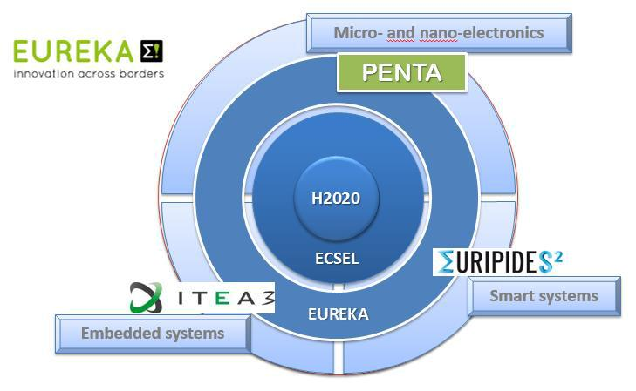

Together with ITEA3 and EURIPIDES2, PENTA will complete and enhance the collaboration and contribution of the three European Technology Platforms in the ECSEL Joint Technology Initiative, as outlined in the above picture. Where appropriate, the new Cluster will seek collaboration with other Clusters and initiatives throughout the EUREKA network.

