Appendix D: Logic model example 2

Inputs

Activities

Outputs

Immediate Outcome

Intermediate Outcome Long-term Outcomes

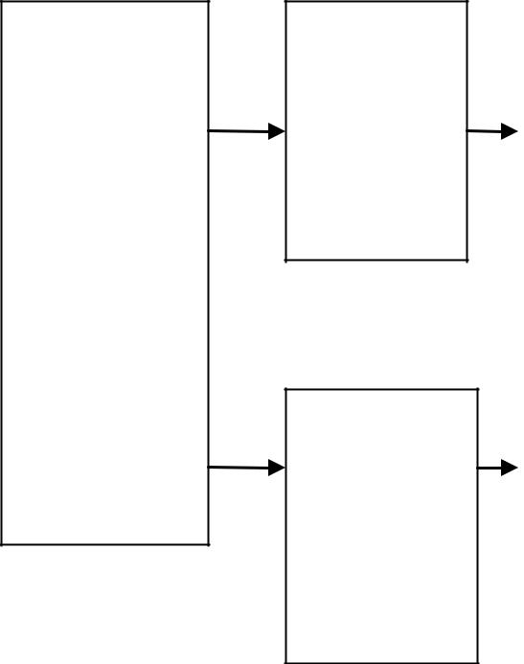
- Program staff
- Trained volunteers

- Educational materials

- Classroom space
- Funding

Provide educational groups for parents

• | # Of
 | parents
 | served
• | # of
 | sessions
 | held
• | Amount of
 | educational
 | materials
 | distributed

• Parents are aware of the
impact of family violence on
their children and recognize

abusive parenting practices

• Parents have increased
knowledge of non-violent
anger management and

parenting strategies

Parents use non-violent anger management and parenting strategies

- Parents provide a safe environment
for children, with appropriate limits, discipline, and structure

- Child abuse is reduced

Provide therapeutic and educational groups for children

• | # Of
 | children
 | served
• | # of
 | sessions
 | held
• | Amount of
 | educational
 | materials
 | distributed

• Children increase their

awareness of safe/unsafe
situations and develop safety
plans

• Children learn strategies for

identifying and
communicating about their
feelings

• Children learn strategies for

resolving conflicts with peers
non-violently

• | Children implement | • | Children are safe
 | personal safety plans | • | Children do not
 | as needed |  | exhibit unhealthy
• | Children effectively |  | coping or conflict
 | communicate |  | resolution
 | regarding their |  | strategies
 | feelings
- Children use strategies for resolving conflicts with peers non-violently

