Draft White Paper on the
Global Ocean Timeseries Observatory System

1) Introduction

The ocean is a key component of the global climate, weather, and ecosystem, a major source of living resources and biodiversity, and is central for shipping, offshore exploitation, tourism and coastal protection. There is now a new awareness of the ocean’s role in climate and global change research, linked both to its enormous capacity to store and move heat and climate-relevant compounds such as CO2, and to its apparent physical and biogeochemical sensitivity to natural and anthropogenically induced changes, including the possibility of complete regime shifts and reversals. The focus of ocean research now is on change and variability, and the predictability thereof, and no longer on describing and understanding its mean state and functioning.

All the research and applied efforts for understanding, detecting, and predicting changes in the ocean or effected by the ocean, require an observing system that is sustained, global, multidisciplinary, and freely available to everybody. Users and customers of such a system include the ocean and climate research&forecast communities, government agencies and policy makers (for climate, fisheries, exploitation, coastal hazards, oilspill prevention, etc), offshore and fishing industry, education and outreach institutions, and national security organizations. The recognition of the need to detect changes and events in the ocean, and to predict their impact on climate, ecosystem, society, and economy, has lead several nations to start the development or to contribute to the development of an Integrated Ocean Observing System. Such a system has research, applied, and operational uses, and needs to include both global and regional observing elements.

The challenge of a sustained global observing system is formidable since the oceans are a vast and hostile environment, only the surface is accessible with space-based remote sensing, the interplay of physical and biogeochemical parameters is important, and an extreme range of space and timescales (meters to thousands of kilometers, hours to decades) need to be covered. In many respects however, we are ready to start the implementation of the required observing system – many of the tools and technologies exist, the knowledge of the ocean functioning allows sensible planning and development, and the modelling capabilities have reached a point to make full use of the observations expected. Work on the implementation of various elements of an integrated ocean observing system is already underway, in the climate community (CLIVAR), for operational purposes (GOOS), in the global carbon cycle community, and on a national/coastal level. For the CLIVAR and GOOS components, a key step was the OceanObs99 conference in St. Raphael/France, where a community consensus was reached on the elements of an ocean observing system for climate.

The present document presents the international global timeseries component of the envisioned integrated ocean observing system. This component complements other elements such as satellite remote sensing, the ARGO array of profiling floats, observations from volunteer observing ships (VOS), and coastal national observing systems. We present the need for timeseries in the overall system, the unique contributions it can provide, the status of the implementation and the technology, the rationale and philosophy, and the way forward.

Rationale For Timeseries Sites And Data

Oceanographers, meteorologists, atmospheric, and climate scientists require measurements made regularly at fixed ocean sites for long periods to understand the processes at work governing variability and the changes that occur over days, seasons, years, decades and longer. These timeseries observations, with regular calibration, provide essential quantitative records of variability and change, are essential to the investigation of causal relationships, and motivate the development of predictive models of oceanic and atmospheric variability and also are used to initialize and test use of these models.

Now, with growing awareness of the role that the ocean plays in weather, climate, and human health and well-being, ocean timeseries observatories have been identified as a critical component of the Global Ocean Observing System (GOOS). Questions that the time series sites would address include: How does the ocean storage and transport of vast amounts of heat, freshwater, CO₂ around the globe vary? How do the ocean and atmosphere exchange heat, freshwater and momentum? How are changes in ocean temperatures and salinity, ocean circulation, biogeochemistry, the ecosystem, and climate all interrelated? Are long-term changes in the oceans naturally occurring, or are they the result of human activities, such as the buildup of greenhouse gases in the atmosphere? How can we predict the oceanic impact of short-term events like algal blooms, storms, spills, earthquakes ?

Fortunately, new mooring and instrumentation technology makes it possible now to effectively deploy and maintain unmanned observatories that will autonomously carry out diverse measurements over extended periods of time while providing much of the data via satellite in near real time. Moorings have relatively large payloads and can be equipped with battery packs or power generators, making them well-suited to support an array of sensors and instruments from users in diverse disciplines. Moorings can place instruments at the sea surface, through the water column, and on the sea floor. These attributes make moorings a key resource for observing cause and effect, as between surface heat loss and sinking of surface water, and interrelationships between diverse fields, as between upper ocean mixing and the bloom of phytoplankton.They are also uniquely suited for sampling critical or adverse regions and periods (e.g straits, boundary currents, boundary layers, ice-covered regions, storm seasons).

Moored timeseries observatories come in two types. Since the 1960s, scientists have used subsurface moorings to observe ocean currents and water properties. These are instrumented cables, anchored to the seafloor and attached to buoyant floats, that reach upward toward, but not to, the sea surface. In contrast, surface moorings have surface floats with downward-hanging cables. The surface floats additionally provide a platform for sensors that measure wind speed and direction, incoming shortwave radiation, incoming longwave radiation, relative humidity, air temperature, barometric pressure, and precipitation. Both types of mooring technologies have matured to the point where they can measure both atmospheric and oceanic changes as frequently as once per minute and can take oceanographic measurements meter-by -meter in the water column. Both are now capable of sustained operation for long periods of time. Many sensors on surface buoys now perform reliably for periods of six to 12 months. Data are both transmitted via satellite and recorded on board. A recent deployment of surface buoys in the Arabian Sea showed that they can perform well in severe environments. And it also demonstrated their ability to collect detailed measurements of previously undetected air-sea processes. Incorporating these previously overlooked processes into numerical weather prediction models will produce significantly more accurate forecasts.

For subsurface moorings, a new class of observing system is approaching operational status: moored profiling instruments. These devices, fitted with a suite of oceanographic sensors, move vertically along conventional mooring cables, returning measurements of water properties and ocean currents at very closely spaced intervals throughout the water column. In each deployment, these instruments can make approximately 200 top- to-bottom ocean profiles—akin to those obtained from ships. Another technology emerging now are autonomous gliders, which can be programmed to dive down and up while holding position, thus acting like a (“virtual”) mooring without a wire.

Later in this paper we present several examples to further demonstrate the value of timeseries observatories.

Here, we identify some of the applications of timeseries collected from representative or critical locations:
- observations and study of variability in the earth system and the interactions between the subsystems (atmosphere, ocean, solid earth, land, cryosphere)
- role of the ocean in climate: physical and biogeochemical ocean processes of climate variability and change, e.g. heat transports and CO₂ sequestration
- Investigating the variability of the ocean’s interior; heat can be moved north and south not only by currents, but also by smaller, more-difficult-to-discern eddies within the oceans which can be observed by moorings.
- Direct measurement of ocean currents; moored buoys can directly measure ocean currents that redistribute heat and freshwater around the globe.
- Obtaining accurate measurements of the exchanges of heat, freshwater, momentum, carbon dioxide and other constituents between the ocean and the atmosphere.
- Examining and monitoring water mass formation and transformation; in some locations surface waters become colder or saltier (and therefore denser) than surrounding waters and sink into the ocean’s interior when the atmosphere cools the waters or where evaporation or sea ice formation leaves salt behind.
- health of the ocean
- detection of changes and events in the ocean (physical, biological, pollution, climatic, seismic,etc)
- operational uses (assimilation, short-term prediction, climate forecasting, e.g. ENSO)
- development and validation of numerical models and of forecasting tools
- ground-truthing/calibration of remote sensing and autonomous instrumentation (e.g. floats)
- Model development

The last item, model development, deserves further discussion. Time series observations of ocean processes are crucial for improvement of ocean models, and for achieving a dynamically consistent description of the state of the ocean used to support comprehensive assessments and to initialize climate prediction models. Time-series observatories will be embedded within the global integrated ocean observing system (including remote sensing from space), and their observations will provide an important benchmark for basin-scale, model-based ocean analyses. Identification of model deficiencies through comparison of model output with time series observations requires knowledge of the statistics of the important signals, the environmental ‘noise’, and the observational errors. These can only be obtained from time series observations. The spatial representativeness of these statistics is often unknown, and must be assessed.

Time-series also help to provide the observational basis for research linking ocean-state assessments and predictions on the basin-scale with those of island coastal regions. In addition, they provide a high quality testbed for development of novel sensor technologies to observe key ocean variables.

An important motivation for the time-series element of the integrated ocean observing system is that it provides the co -located multivariate and multidisciplinary observations required by interdisciplinary scientific objectives (Send et al., 2001). A critical test of ocean models is that they simulate the relationships among two or more state variables accurately enough for climate or ecosystem study purposes. This requires that the dynamics and biogeochemistry be sufficiently correct, and that feedbacks among different parts of the ocean climate and ecosystem system are reasonably modeled. A fundamental multivariate objective for climate models is the correct simulation of T/S variability, as the correlations of temperature and salinity are spatially and temporally variable, and these variations provide important information about climate system physics.For understanding of the carbon cycle through biogeochemical models, multivariate time series such as at BATS and HOT have been critical.

Future objectives for ocean time-series must include: (1) improving our understanding of critical biogeochemical processes for improved predictive ocean modeling capabilities; (2) identifying the most important variables for sustained observations to quantify carbon cycling; (3) continuation and expansion of critical time series measurements, and their enhancement with high frequency and spatial sampling; (4) testing advanced sensors for measuring these variables and integrating them into observational systems; and (5) testing advanced ocean analysis and prediction capabilities.

Rationale For Being Global And Needing A Network

A major effort is underway to establish a Global Ocean Observing System (GOOS)—a worldwide network that would collect the vast, far-flung, ever- changing data necessary to understand the processes by which the oceans help create climate conditions. GOOS would combine a variety of instrumentation. It would include satellite systems providing global coverage of the ocean surface, sampling from ships, surface drifters and profiling floats which move vertically as they drift, and timeseries observatories at strategic sites in the ocean.

The fixed-point Eulerian observatories are uniquely suited for fully sampling 2 of the 4 dimensions (time and vertical) with high resolution and for complementing other planned elements of the ocean observing system. Timeseries at key geographic sites around the globe are unique in this mix of instrumentation because they can provide highly detailed observations of atmospheric processes just above the sea surface, as well as oceanographic measurements all the way from the seafloor to the sea surface, of a wide variety of multi-disciplinary variables.

Different regimes or characteristic types of variability must be sampled to understand and monitor the ocean and its influence on the earth system as well as to provide the records to challenge, assess, and initialize models. Key locations, such as where water masses form or carbon dioxide is exchanged with the atmosphere, where the ocean transports heat in strong boundary currents, where populations are changing or seafloor sites far from existing seismic instrumentation must be instrumented. We find that change and variability in the earth system can have large spatial scales, that for global effects all key locations need to be observed (e.g. carbon uptake/release), that processes at different locations are interconnected (e.g. the global thermohaline “conveyor belt” circulation), and that variability at one location on the globe can drive variability at sites far away; El Niño and its remote influences are a good example of this.

Thus, sites for timeseries observatories have been identified across the global oceans as a single network, and the plan is for a coordinated global array to observe in diverse regions, understand and contrast the processes at work in those regions, and to identify patterns.

The global network of timeseries stations would be a collaborative effort, involving many nations, based on sharing and coordination of technology and free distribution of data. Common advocacy and common data management activities will strengthen the network, and will only be possible if a true joint network is built.

The application of the global timeseries network to ecosystem variability provides a good example. It has become abundantly clear that environmental variability plays a major role in atmospheric and oceanic circulation, biogeochemical cycling of elements in the ocean and the abundance of ocean living resources. It is also clear that unraveling the influence of natural environmental variability requires a concerted global effort. For example, changes in the abundance of sardines off Japan are clearly linked to changes in this same species in the northwest and southwest Pacific, and the southwest Atlantic. These changes are likely driven by observed changes in ocean circulation and atmospheric forcing.

The need for a global view drives the planning for all the required observational networks, including the ARGO array of profiling floats that will observe the thermohaline structure of the ocean, and satellites capable of measuring surface winds, sea surface height, sea surface temperature and sea surface chlorophyll. To complement the global observations a coastal global ocean observation system is slowly coming together based on regional alliances. The project we bring forth here further complements the observing capabilities described above by establishing time series stations in key areas of the global ocean. These areas have been selected on the basis of physical and ecological provinces or key processes present, and the intent is to cover the major ocean ecosystems (i.e. western and eastern boundaries, equatorial, central gyre, high latitude).

A review of ocean time series shows that an individual or institution has primarily driven them. When the individual either runs out of resources or interest the time series typically come to an end. With the very real possibility of human-induced changes in climate and ocean circulation on the horizon, sustained long-term measurements will be needed for determining the reality and consequences of this change. This emphasizes the need to continue existing efforts and begin others as soon as possible, as a global network rather than a collection of P.I. or institution-driven projects. The coordination, support, advocacy, and facilitation by programs such as CLIVAR, GOOS, POGO is therefore essential.

Showcase Examples

a) TAO El Nino

The Tropical Atmosphere Ocean (TAO) array provides an example of sustained time series measurements that have advanced oceanographic and climate research as well as climate forecasting. This array, consisting of about 70 deep ocean moorings that span the tropical Pacific along the equator, was designed to improve our ability to detect, understand, and predict year-to- year climate fluctuations associated with El Niño and the Southern Oscillation (ENSO). The array, which provides physical oceanographic and meteorological data in real-time via satellite relay, was implemented as part of the 10-year (1985-94) international Tropical Ocean Global Atmosphere (TOGA) program (McPhaden et al, 1998). Some of the sites in the array also support biogeochemical measurements for studies of ocean productivity and carbon cycling. Since 2000, the array has been referred to as TAO/TRITON, a joint effort supported primarily by the US and Japan (Figure A).

Many of the sites in this array were first installed in the mid-1980s and most have been occupied since the early 1990s to provide an unprecedented basin scale record of ENSO variability over the past 15 years. The longest records come from 0°, 110°W for which continuous measurements began in 1980. This time series, which is the longest deep-sea moored oceanographic time series in the world ocean, exhibits a range of variability spanning diurnal to decadal time scales. A low pass filtered version of the data (Figure B) reveals a wealth of structure on intraseasonal, seasonal, and interannual times scales including the El Niño and La Niña events over the past two decades. Records like this from the TAO/TRITON array have lead to new discoveries of oceanographic and meteorological phenomena, to new insights into the dynamics of variations across the whole spectrum of resolved time scales, and most importantly to fundamental advances in our understanding of the ENSO cycle. Data from the array have also contributed both to the development of ENSO prediction models with significant forecast skill at lead times of up to one year, and to the routine use of those models in present day seasonal forecasting.
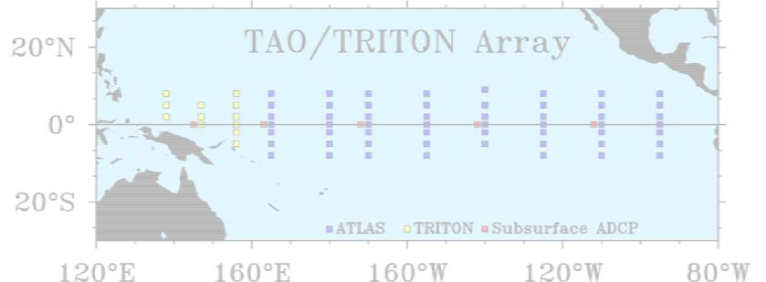

b) Improving surface fluxes

As part of the global timeseries array, surface moorings are planned at key sites to collect long time series in support of climate studies, monitoring, and prediction, of making accurate maps of the air-sea fluxes of heat, freshwater and momentum, of improving numerical weather prediction and other atmospheric models, and of understanding, modeling and predicting ocean variability. These would be known as Ocean Reference Stations (ORS) and would be part of the Integrated Ocean Observing System (IOOS). A key objective of the ORS is to obtain high quality observations of surface meteorology, supported by calibrations and comparison with shipboard sensors, and to use this data to improve knowledge of the air-sea exchanges of heat, freshwater, momentum, and other constituents.

In most ocean locations, the realism of either model-based or climatological estimates of air-sea fluxes is poor. Figure 1 compares monthly averged net heat flux (Q net) from buoys at diverse locations with model-based and climatological estimates of Qnet (NCEP1 and NCEP 2 from the U.S. National Centers for Environmental Prediction; ECMWF from the European Centre for Medium Range Weather Forecasts; and SOC, a climatology for Southampton Oceanography Centre).

Identification of the large biases in the model and climatological estimates is essential information for those who use these products to force ocean models and to quantify air-sea coupling. Data collected at a number of such sites is now withheld from being assimilated into operational models and provided as independent data to the model centers to allow them to study model performance. Identification of the errors in the models at diverse, characteristic regions around the globe is critical information needed to motivate and guide improvement to numerical models and will enable development of models that more faithfully simulate climate variability. As these ORS are occupied the also provide high quality sites used as anchors in work underway to develop much improved basin and global air- sea fields. The surface flux data from the ORS are used as reference data, to identify biases and other errors in model-based and remotely-sensed data and thus to guide assimilation of such data into improved air-sea flux fields.

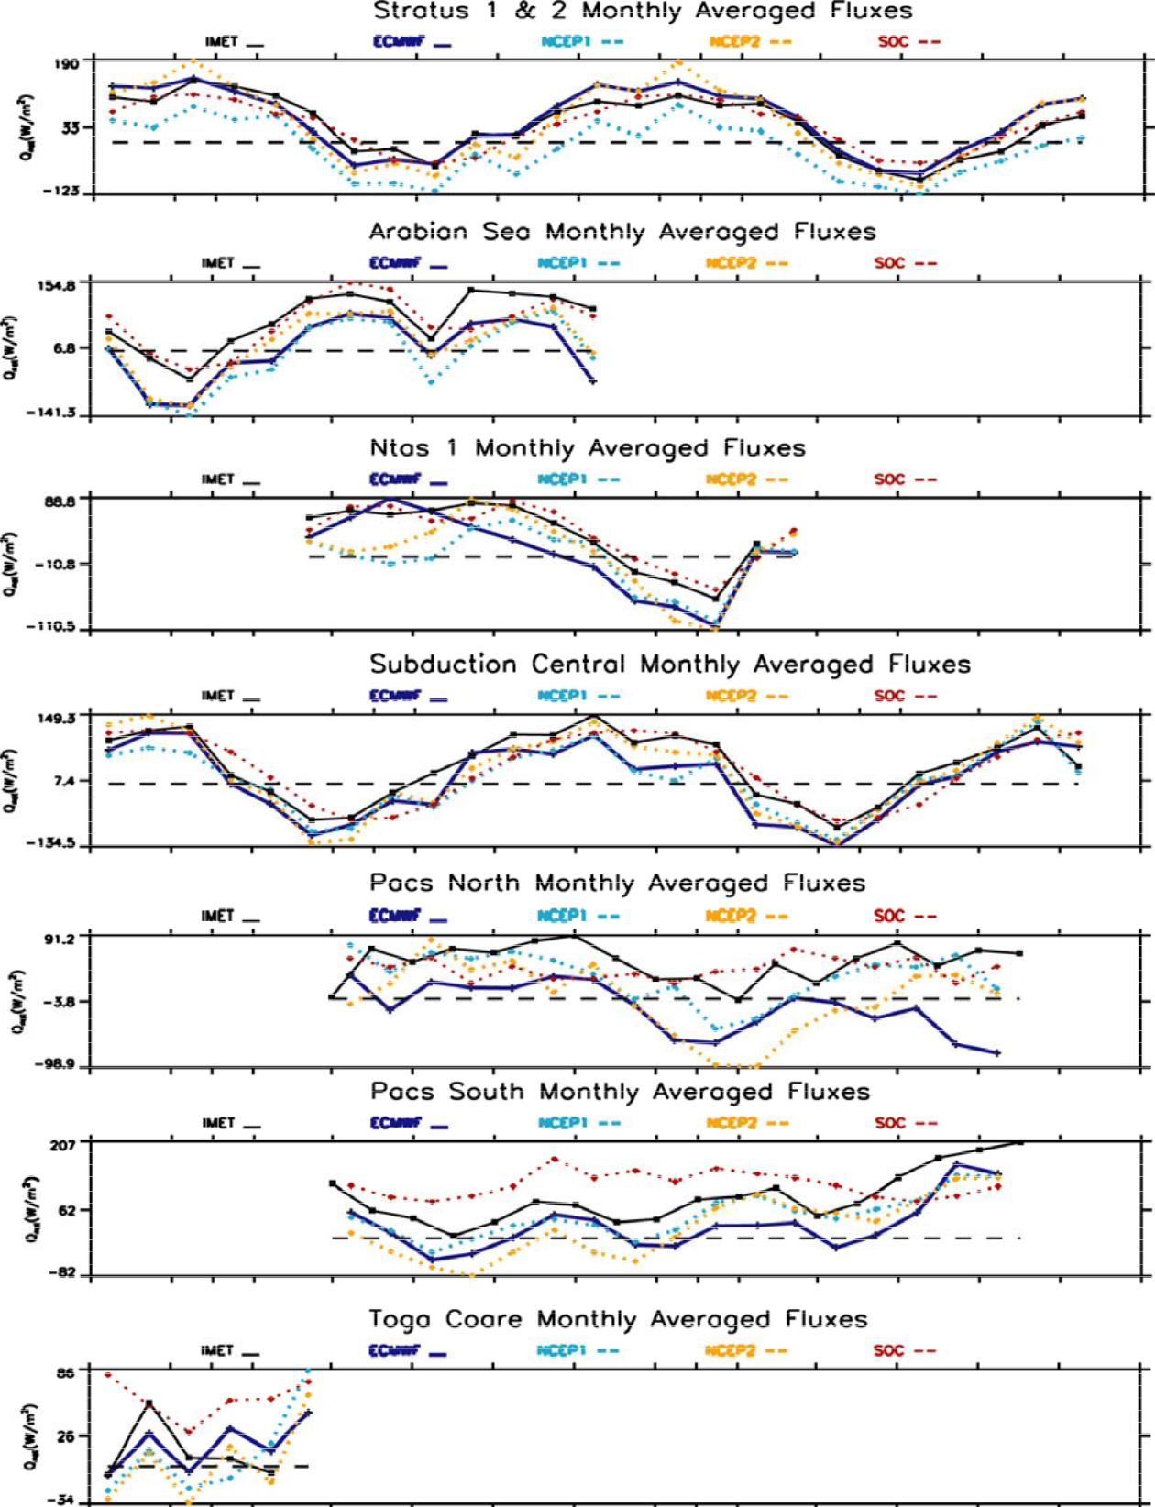

c) CO2 timeseries

At Bermuda and Hawaii long ocean timeseries of CO2 concentration and related quantities exist. Shown here is the station ALOHA one. It shows that the N.Pacific is a net sink for atmospheric CO2, and that the net sink (∆pCO2) is seasonally variable and, perhaps, getting weaker with time over the past decade. These variations
maybe the direct result of physical processes (e.g. evaporation vs precipitation, vertical mixing/advection) or of climate effects on the biological pump. They represent important research issues to address.

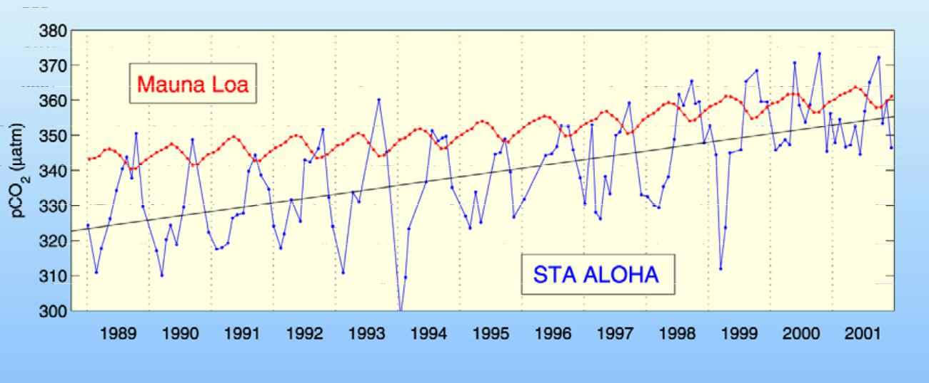

d) Water mass formation and signal propagation

Water mass formation processes in key locations on the globe are now know to be highly variable, driven largely by climate variability. Changes in these processes not only modify the physical properties of important water wasses (their temperature, salinity, density, volume), but affect the large-scale circulation, the uptake and spreading of biogeochemical substances (including CO2), and probably induce ecosystem changes as well. The example shown here includes a long moored temperature timeseries (depth-time) of convection activity in the Labrador Sea (see cold convection reaching large depths to varying degree each winter) where Labrador Sea Water (LSW) is formed, and a timeseries of freon at the depths of LSW off the Bahamas from Molinari et al ‘98, where this water mass passes and where signals/variability imprinted during formation can be recognized and related to the source region and the circulation and mixing along the way.

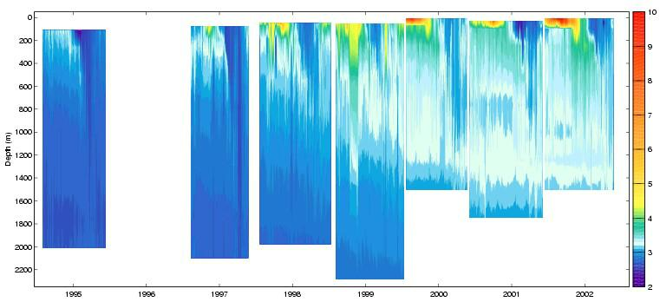
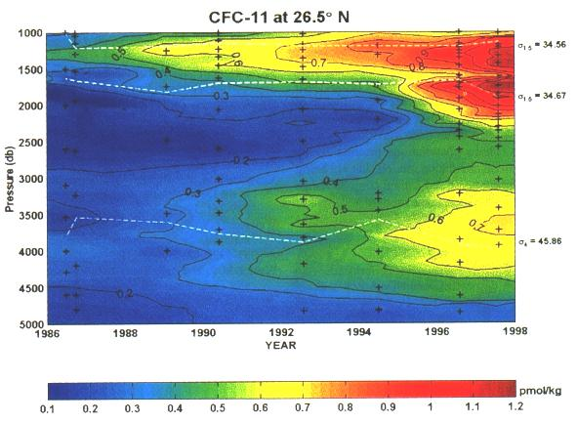
e) Boundary current variability

The figure shows a 16 year timeseries from Baringer and Larsen of the Florida Current transport (daily, monthly and 2-year mean), together with the NAO index in the lower panel.
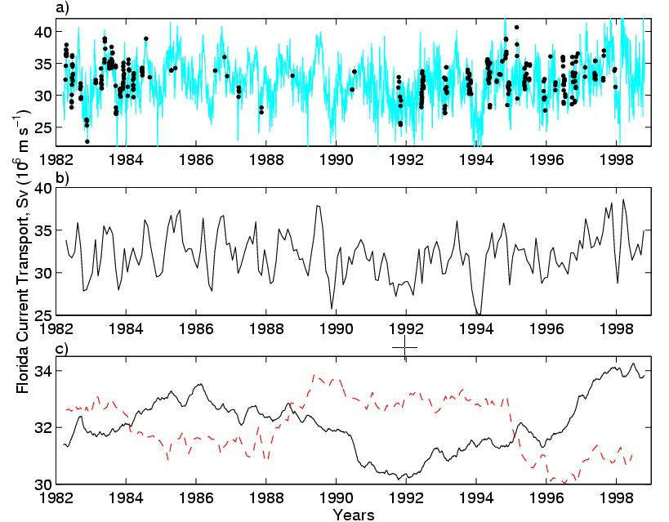

f) zooplankton and NAO in N.Atlantic

Since 1949 samples of zooplankton have been collected in the North Atlantic using commercial ships. Although not all routes have been sampled with the same intensity during this period significant insights have been gleaned about the distribution of this important group of organisms that are a crucial link in the food chain of many commercial fish species. An overriding concern has been to determine the reasons for the distributions observed and the factors that cause interannual variations. From a wider perspective the biological insights provide clues to larger environmental changes that may be difficult to detect in other ways. Until 1996 it seemed that the two overriding factors influencing the zooplankton distributions were the location of the northern wall of the Gulf Stream as determined by the Gulf Stream Index (GSI) and the North Atlantic Oscillation (NAO) which themselves vary in synchrony.

In particular the increase in the NAO during the past 4 decades until 1996 has been correlated with a decrease in the abundance of one particularly important species, Calanus finmarchicus (Fromentin and Planque 1996) (Figure) . Since 1996 this relationship has for some unknown reason completely broken down (Planque and Reid 2002). What is however certain is that in the eastern Atlantic warm water species have tended to occur further north than previously (Beaugrand et al 2002) and the diversity of the community has decreased (Figure 3) (Beaugrand and Ibanez 2002). The CPR is managed by the Sir Alistair Hardy Foundation for Ocean Science (SAHFOS).

Abundance of the important zooplankton species Calanus finmarchicus in the Northeast Atlantic against the NAO. Note that the value for 1996 (and subsequent years) does not follow the trend.

Since 1949 samples of zooplankton have been collected in the North Atlantic using commercial ships. Although not all routes have been sampled with the same intensity during this period significant insights have been gleaned about the distribution of this important group of organisms that are a crucial link in the food chain of many commercial fish species. An overriding concern has been to determine the reasons for the distributions observed and the factors that cause interannual variations. From a wider perspective the biological insights provide clues to larger environmental changes that may be difficult to detect in other ways. Until 1996 it seemed that the two overriding factors influencing the zooplankton distributions were the location of the northern wall of the Gulf Stream as determined by the Gulf Stream Index (GSI) and the North Atlantic Oscillation (NAO) which themselves vary in synchrony. In particular the increase in the NAO during the past 4 decades until 1996 has been correlated with a decrease in the abundance of one particularly important species, Calanus finmarchicus (Fromentin and Planque 1996) (Figure) . Since 1996 this relationship has for some unknown reason completely broken down (Planque and Reid 2002). What is however certain is that in the eastern Atlantic warm water species have tended to occur further north than previously (Beaugrand et al 2002) and the diversity of the community has decreased (Figure 3) (Beaugrand and Ibanez 2002). The CPR is managed by the Sir Alistair Hardy Foundation for Ocean Science (SAHFOS).

Abundance of the important zooplankton species Calanus finmarchicus in the Northeast Atlantic against the NAO. Note that the value for 1996 (and subsequent years) does not follow the trend.

Benefits And Users Of Timeseries Data

A global array of time series stations will be of benefit to a broad community of research scientists, operational agencies, and policy makers. The research and development community will use timeseries data to observe changes in the ocean on many timescales and for wide range of variables, to relate these changes to forcing factors and to interdepencies between the physical and biogeochemical parameters, to develop an understanding and predictive capability of the processes involved, and to detect unkown and unexpected changes and events. They will further use timeseries data to assess and verify model performance. Already now, the global ocean data assimilation efforts (like GODAE or multidisciplinary projects) are looking to timeseries to provide validation data at key locations and for key variables. Instrument developers also use timeseries observatories to test their new equipment, both for logistical reasons (“moorings of opportunity”) and because a wide array of validation measurements is available from the ongoing observatory observations. Ground-truthing for remote sensing is also provided via timeseries data.

Forecast centers are another user group of timeseries data. These include weather, ocean, and climate forecasters, but also cover short event-related forecasts like effects of earthquakes/tsunamis, harmful algal blooms, oil-spi prediction, etc. They all have a need for timeseries observations covering a wide range of timescales and parameters.

Policy makers, including fisheries management, and climate assessment agencies such as the Intergovernmnetal Panel for Climate Change (IPCC) would be users of ocean observations that detect global change in the climate or ecosystem and that allow initialization, validation, and generation of forecast models relating climate change and its impact on society and the economy.

High temporal resolution, long duration, and multi -variate data sets from a timeseries observatory array will provide a unique source of information for studies of physical climate variations, for studies of biogeochemical cycles and ecosystem dynamics, for fisheries research, and for interdisciplinary studies in earth system science. Long time series measurements, in combination with other kinds of data from the global ocean observing system, provide a powerful tool to discriminate between different processes operating across a wide range of time scales and how those processes interact to produce observed patterns of temporal and spatial variability. The data will also be indispensable for the development, validation, and initialization of the next generation of ocean and climate analysis and prediction models. These models will be important assessing the current state of the ocean environment; for forecasting its evolution on daily, seasonal, and longer time scales; and for determining the ocean’s role in mediating anthropogenically forced greenhous gas warming. Ultimately, society benefits from a well-coordinated reference time series network to the extent that it contributes to the development of science-based analysis and forecast products that can used by decision makers in government and the private sector as well as by ordinary citizens who seek reliable information on matters relating to the earth’s environment.

Where Have We Come Since Oceanobs99

At the Ocean Observations 99 meeting in St. Raphael, France in 1999 the idea that long-lived time series stations were an essential element of the ocean observing system for climate was presented (Send et al, 2000), reviewed, and readily adopted by those in attendance. Subsequent to that meeting in St. Raphael, France, there has been considerable effort to further develop plans and support for time series sites. There has also been a very successful effort to coordinate the interests of the diverse disciplines that would benefit from long time series observations from the seafloor through the water column to the sea surface. Indeed, a number of new sites have been occupied and reflect the commitment in many nations to the establishment and maintenance of these sites.

Subsequent to the St. Raphael meeting an International Time Series Science Team was established (described further below, Section 7) with the intent that it would advance the planning for implementation of the time series sites and report to the Ocean Observations Panel for Climate (OOPC), which provides advice to the WMO-IOC Joint Technical Commission on Marine Meteorology, and to the Climate Variability (CLIVAR) Research Program of the World Climate Research Program (WCRP). When the Partnership for Ocean Global Observations (POGO) was organized by Directors of the world’s oceanographic institutions, it identified establishment of time series sites as a high priority and began to provide financial and staff support for the International Time Series Science Team. POGO encouraged the science team to go forward with the fundamental principle that the time series sites of the global ocean observing system would be multidisciplinary in nature, providing physical, meteorological, chemical, biological and geophysical timeseries observations. The Time Series Science Team has evolved in membership to include representation that is not only international but also multidisciplinary. Specific dialogs are being maintained with diverse planning groups, including those for synthesis if global air-sea flux fields, carbon cycle observations, and seafloor observatories.

The International Time Series Science Team has developed a phased perspective on implementation, with an initial emphasis on establishing a number of sites that are feasible to maintain, are of high value to research and to the operational ocean observing system, and can provide openly shared data to both demonstrate the end-to-end use of time series data and the value of such sites. The first phase is known as the Pilot Project, for 2001 to 2006, which is described in Section 8. Work on implementation, data management, and capacity building continues in conjunction with the Pilot Project.

Progress since Ocean Obs 99 can also be demonstrated by citing examples of growth in the time series array and in the funding of timeseries, which are listed in the following.

US NOAA and NSF initiatives:
In the United States, the NOAA Climate Observations Program is now providing support for the U.S. component of the TAO array and to maintain surface moorings at a site under the Chilean stratus cloud deck, further a site in the western tropical North Atlantic, and, in the near future, a site near Hawaii. The U.S. National Science Foundation has identified enabling long time series research as a high priority and has put forward for consideration for funding a major infrastructure program, the Ocean Observatories Initiative (NRC, 2003), which would provide the moorings and other hardware needed to deploy blue water, coastal, and regional time series observatories.

Ocean timeseries at Hawaii:
The Hawaii Ocean Time-series continued with support from NSF (USA), just achieving 15 years of Station ALOHA measurements in October 2003. Numerous fundamental scientific discoveries have been made and reported during this period, building on the prior investments in the time-series. Funding has just been renewed for an additional 5 years. Significant expansion and evolution of the time-series is expected during that time. A proposal to reuse a fiber optic telecommunications cable to support a seafloor junction box at Station ALOHA was funded by NSF, with the expectation of installation in 2005. The MOSEAN testbed
biophysical surface mooring (T. Dickey, PI, NOPP funding) will be deployed in March 2004, and an air-sea flux reference surface mooring is tentatively scheduled for deployment (R. Weller, PI, NOAA support) in July 2004. NSF is supporting upper ocean physics instrumentation on the latter mooring (R. Lukas, PI). A

cabled subsurface profiling mooring is under development at UW/APL (B. Howe, PI, NSF support), scheduled for deployment at ALOHA in 2005.

LOCO Program in the Netherlands:
A consortium of Dutch institutes (Royal NIOZ, IMAU, KNMI) received a grant to aquire equipment for a long term ocean monitoring (LOCO). Until 2008 this equipment is scheduled for the monitoring of the East-Indonesian through-flow, the through-flow through the Mozambique Channel, the thermohaline structure of the Irminger Sea, and the internal wave climate in the North Atlantic Ocean.

Japanese TRITON array:
The Japanese Marine Science and Technology agency (JAMSTEC), which now maintains ?? moorings of the TAO array in the equatorial Pacific, has established 2 surface mooring sites in the equatorial Indian Ocean;

the NOAA Climate Observations Program plans support U.S. contributions to complete a global equatorial moored array as well as to support 16 surface mooring sites outside the equator by 2006. JAMSTEC has also extablished and is maintaining subsurface moorings to collect multidisciplinary time series in the northwestern North Pacific.

UK Program RAPID:

RAPID is a new UK NERC (Natural Environment Research Coincil) thematic program aimed at understanding the causes of rapid climate change, with a main focus on the role of the Atlantic Ocean's thermohaline circulation (THC). New ocean time series observations planned under RAPID, including collaborating U.S. programs, include:

- A transbasin array of current meter and hydrographic moorings along 26.5 N, designed to monitor the Atlantic MOC and meridional heat transport at this latitude. The array consisits of over 18 moorings,

concentrated near the western and eastern boundaries, that will be deployed for a 5-year period beginning March 2004.
- Three lines of bottom pressure recorders, inverted echo-sounders and profiling CTDs deployed at depths of 2-
- 5 km at 38N/69W, 42N/60W and 43N/52W, designed to track the propagation of overturning signals along the western boundary.

EU projects ANIMATE and MERSEA:
A 3-year multidisciplinary timeseries project was funded by the EU in 2001, for implementing three sites in the northeastern N.Atlantic. These observe physical variability, as well as CO2, fluorescence, nutrients, in the upper layer, carry deep sediment traps, and telemeter the data from some sensors via inductive links and satellite transmitters to shore. Details can be found at____________________. A new operational oceanography project MERSEA has recently been funded in the EU, which also contains a timeseries element, in particular partial support for the continuation of the above ANIMATE sites.

EU/US program ASOF:
A large effort consisting of several components in the US and Europe has been funded to study the fluxes and exchanges between the Arctic Ocean and subpolar North Atlantic. By its nature, this program will include a number timeseries sites for observing the fluxes and transports, as well as as regional processes involved. For more information, see_________

The principal objective of the ocean timeseries project is to provide the widest community with the most demanded observational data to understand Global Change. The new HiLaTS Program (High Latitude Time-Series Program) of JAMSTEC is one of the prime examples of programs fusing physical oceanography and biogeochemistry. HiLaTS investigates the NW Pacific for a decadal span, which is a crucial area for understanding the global CO₂ cycle and yet involves serious difficulties due to its geographic access and rough sea conditions. By deploying the R/V Mirai, 8600 ton all weather research vessel, and the advanced underwater platforms and an array of automated instrument with the collaboration of WHOI, HiLaTS has made a significant contribution in gathering a host of unique time-series data and has demonstrated the usefulness of advanced time-series ocean observational technologies since 2001. The US National Science Foundation is forging a new international funding model by encouraging US researchers to collaborate with JAMSTEC scientists in the HiLaTS Observatory thus taking advantage of an outstanding field opportunity to investigate the crucial high latitude ocean environment while gaining high cost efficiency on both wings.

German Clivar project MOVE:
In early 2000, a timeseries transport site was initiated along a 1000km long section off the lesser Antilles (the island of Guadeloupe), for monitoring the deep southward transport of the thermohaline circulation using integrating techniques. This effort is ongoing, and has yielded to date a 3.5 year timeseries of the transport variability of the Nort Atlantic Deep Water flowing south.

Programs in India:

The long-term time-series program under the Ocean Observing System Project has been launched in India in 1997 by the Department of Ocean Development, Government of India. Initially, the time- series programme was started at the National Institute of Ocean Technology (NIOT), Chennai, India as a part of National Data Buoy Programme (NDBP) with a funding support of Rs. 37 Crores [US$7,400,000]from DOD. Six shallow water moored buoys and 5 deep-sea moored buoys were deployed since 1998 and were being maintained by the NIOT since then. NIOT planned to deploy 40 moored surface buoys in the region around India.

Twelve buoys out of 40 are classified as ocean buoys, which measure the basic atmospheric parameters and sea temperature, salinity, currents at 3 m below the surface, wave spectrum at sea surface and subsurface temperature profiles using Thermistor chains. Another 12 buoys are the meteorological buoys and only measure air temperature, pressure, winds, relative humidity and Sea Surface Temperature. Remaining 16 buoys are coastal and environmental buoys and are an extension of the present deep-sea and shallow-water type buoys near the Indian coast. These buoys are being deployed since 2003 and will be continued up to 2007.

While upgrading and expanding the moored buoy net work in the Indian Seas, the NIOT will be incorporating additional sensors to measure parameters such as net radiation. Long wave radiation, rainfall, and humidity.

Another project on time-series of current measurements along the equator was launched by the DOD with financial support in 1997 under the Ocean Observing System Programme. Under this project, 3 locations were selected along the equator for deploying the current meter moorings at 93E, 83E and 76E. The responsibility of
executing this project including the design of the mooring was given to the National Institute of Oceanography, Goa,India. However, this project was implemented at NIO in 2002 after receiving the funds and procuring the current meters and other mooring equipment. The first deep -sea current meter mooring was deployed successfully in February 2002 at equator, 93E. In December 2002, this mooring was successfully retrieved and data obtained. This mooring was redeployed and the second mooring was deployed at equator, 83E in December, 2002. In March 2002, the two moorings were recovered and data obtained. While redeploying these moorings at the same locations, the third mooring was deployed at equator, 76E. In October 2003, all the three moorings were recovered and redeployed for one more year. This project will be continued till March 2007 with funding from DOD.

Carbon cycle plans:
There has been considerable emphasis in the past 5 years on developing a global strategy for ocean carbon observations through a combination of repeat hydrographic sections, volunteer observing ships, time series stations, and remote sensing. Of these platforms, time series stations provide the only means of characterizing the natural variability and secular trends in the ocean carbon cycle and the physical and biological mechanisms controlling the system, and are the foundation of most process studies. Significant advances have been made in recent years to develop pCO₂ systems capable of providing robust, autonomous, and accurate measurements over annual time periods. There are now approximately 10 different autonomous pCO₂ systems for use on moorings or ships of opportunity, and intercalibration exercises between these systems are leading to improvements in practice and design. Currently there are 9 time series stations operational or planned for a 2004 start date that are measuring pCO₂, including BATS, HOT, the TAO/Triton Array, Ocean Weather Ship Mike, the PIRATA array, MBARI station (32° N, 120° W), NIO Goa stations (17°N 68° E and 15°N 72°E), a station off New Zealand (46.7° S, 178.5° E ) and, starting in 2004, a CSIRO station south of Tasmania (47° S, 142° E).

The US and Europe have both recently proposed comprehensive ocean carbon research and observation programs as part of larger climate change initiatives (US Ocean Carbon and Climate Change Program and the EU Carbo-Ocean Project), and include plans and priorities for time series stations making a wide range of measurements for ocean carbons studies. In addition, implementation strategies of the major SCOR – IGBP global research programs SOLAS and IMBER include plans for process studies using time series stations. In 2004, the International Ocean Carbon Coordination Project will make an inventory of the time series stations operating and those being proposed by these various groups to facilitate coordination and aid in system planning.

Summary
Both planning and implementation, as well as funding, has advanced since Ocean Obs 99. Major technological advances are taking place in the areas of high resolution optics and chemical sensors and scientific breakthoroughs are being enabled via high temporal resolution and long- term measurements. Continuing to guide and advance the implementation and support of the time series array and to facilitate and promote the use of its data is the role of the International Time Series Science Team.

The Science Team

The science and technology of oceanic eulerian observations has developed in an uncoordinated way over the past several decades with a range of protocols appropriate to specific aims but not necessarily leading to the best use of resources or the best use of the data obtained. In order to rectify the situation it was decided at the OceanObs meeting in 1999, and endorsed subsequently by CLIVAR and GOOS bodies, that a science team should be formed. Such a team was immediately established, now sponsored by CLIVAR, GOOS, and POGO, under the chairmanship of Professors Bob Weller and Uwe Send. They are able to represent with authority the various disciplines involved in eulerian observations; physical, chemical, biological, biogeochemical and geophysical. Most of the major programs either current or in planning involve members of the team and furthermore members are able to represent all countries and disciplines with significant observatory programs.

The group has met three times leading to agreement on the some key issues such as the requirement for a coordinated data management structure and the key locations where GEO sites should be in order to address the main oceanographic questions. A number of guests have come to the meetings to provide very specific expertise where required.

Current membership:
Ed Boyle (USA), Francisco Chavez (USA), Tommy D. Dickey (USA), Dave Karl (USA), Tony Knap (Bermuda), Yoshihumi Kuroda (Japan), Richard Lampitt (UK), Roger Lukas (USA), Mike McPhaden (USA), Liliane Merlivat (France), Rodrigo Nunez (Chile), John Orcutt (USA), Svein Osterhus (Norway), Philip Boyd (New Zealand), V.S. Murty (India), Hendrik van Aken (Netherlands), Uwe Send (Germany), Bob Weller (USA).

The Pilot Project

At its first meeting in May 2001 the The International Time Series Science Team defined a timeseries pilot project, called Global Eulerian Observatories Pilot Project (GEO-PP). The project will work towards the implementation of a preliminary global array of long-term multi-disciplinary timeseries observatories over a 5-year period with the intent of coordinating present timeseries efforts, developing a basis for advocacy for support of the global timeseries array, and demonstration of the feasibility and utility of the global array of timeseries stations. The ideal mode of implementation for timeseries is via autonomous technologies (moorings, gliders, etc) and this is the long-term goal, including real-time data telemetry. As an interim approach, ship-based repeat occupations is included as long as relevant modes of variability are resolved.

During the pilot project key gaps in the global array will be identified and planning efforts started to address how to fill them. The pilot project will be used as a vehicle to test and advance technologies to enable deployments of platforms in remote and adverse environments, interdisciplinary sensors and systems, and near real-time data telemetry systems. It will also foster multi-community and multi-national implementation efforts. Data collected during the pilot phase will be placed in international data repositories and utilized for several different analytical and modeling activities. Routine provision of data to users and identification of products if use to end users will be carried out. In parallel, the steering committee will inform the oceanographic community about the pilot
project and future plans and will recruit users for the timeseries data sets. The committee will coordinate its Eulerian focused program within the context of GOOS as well as the other large programs mentioned earlier (i.e., CLIVAR, NOAA Climate Change); for example, within the context of complementary observational Lagrangian (Argo) and remote sensing (e.g., WCRP Satellite Working Group) assets as well as global data assimilation (GODAE) and other observational and modeling programs. The steering committee will also promote international participation and funding through the various programs mentioned here in addition to POGO in order to complete the global network. POGO, in particular, will be looked to assist in capacity building, including the transfer of mooring technology to other institutions and nations. It will also work to develop a long-term funding strategy for GEO. Clearly, the in situ, time series-based GEO program represents the logical next step in completing the Global Ocean Observing System.

The initial implementation of the Global Ocean Timeseries Observatory Network consists of all operating sites and those planned to be established within 5 years, subject to evaluation in terms of the qualifying criteria by the Science Team. The system is multidisciplinary in nature, including physical, meteorological, chemical, biological, and geophysical timeseries, has an open data policy, and encourages real-time data delivery. The intial observing system consists of all operating, funded, or planned sites that fulfil a set of criteria that have been established, and will be continually updated by the Science Team. This is the ”Initial Timeseries Observing System”. It was initiated in mid -2001. It will be used to make a convincing case for the global timeseries array to users, to funding agencies, to policy makes, and to the public. At the end of the pilot project the intent is to review all operating sites and indicate the merit of maintaining them in an operational array.

Definition Of A Timeseries Site In The Pilot Project

The global eulerian observatories system will be multidisciplinary in nature, providing physical, meteorological,chemical, biological and geophysical timeseries observations. The data will be publicly available as soon as received and quality-controlled by the owner/operator, or by a data acquisition center performing this taskon his behalf. An international Science Team provides guidance, coordination, outreach, and oversight for the implementation, data management and capacity building

The following criteria have been agreed upon, which need to be fulfilled by a site in order to qualify for being part of the system:

- Sustained in-situ observations at fixed geographic locations of ocean/climate related quantities at a sampling rate high enough to unambiguously resolve the signals of interest. “Sustained“ means a plan/committment for longer than one project/proposal period and intention to pursue funding from "observing system programs" when available. Wherever possible, the observations should be achieved with autonomous instrumentation, in a moored or virtually moored mode. Where/while this option is not available (certain variables, logistical constraints, etc), ship-occupied timeseries may qualify an alternate approach, if at least seasonal variability can be resolved. The rationale for this mooring-based goal is that only in this mode can high temporal resolution be achieved, which is critical for various observations or events (diurnal cycle, convection, blooms, seismic, etc). Also, only this way can the long-term goal of unattended operation over many years be approached or remote glider-based methods be explored.

- Transport sections using whatever technique are included in choke points and major boundary current systems (moorings, gliders, ship ADCP, tomography, etc)

- Coastal timeseries are included when they are instrumented to have multidisciplinary impact on the global observing system and if they are not part of a national coastal buoy network.

- Any implemented site fulfilling the criteria will become part of the system but has to deliver its data into the system and to demonstrate successful operation and value after 5 years.

- Real-time data telemetry of operational variables will be pursued, i.e every effort will be made if it is technically feasible and/or if there are operational users. The rationale for this requirement is: a) Monitoring of instrument functioning (essential for targetting uninterrupted timeseries); b) Some endusers may have requirement for real-time data (ocean forecasting, real-time assimilation, politicians to demonstrate Kyoto monitoring obligations). c) Helpful for outreach and publicity (online public information about ocean state and changes, ability to feed news about events to media), the TAO array is a good example. d)verification and validation, e) event-driven sampling

- Data should be made public in near real-time for real-time data or as soon as processed and post-calibrated for other data; certain quality control standards, data formats, and data centers need to be established

Status of the Global System

The following map shows the current status of the global system, including planned sites. The color code distinguishes implemented or funded sites (green, blue), and sites for which definite plans or a realistic chance of implementation in the near future exist (red, orange). The symbols differentiate air-sea flux reference sites (circles), transport site (lines, hashed boxes), and generic observatory sites which could measure a mix of physical and/or biogeochemical variables in the water column (triangles). The tropical arrays in the Pacific and Atlantic are indicated summarily via boxes around their perimeter. More information on the sites and the status of the system will be available at-----------------.
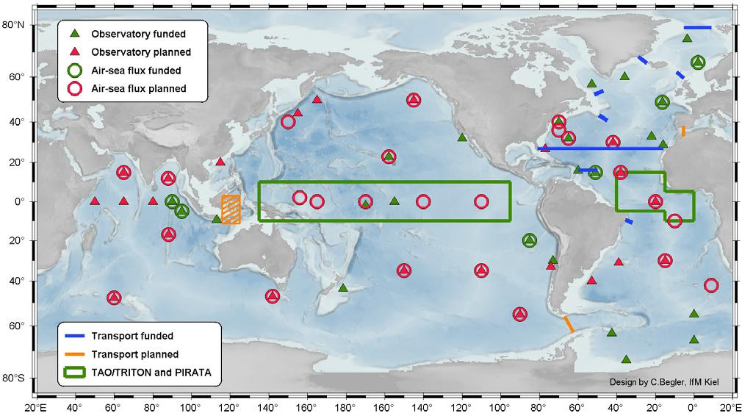

The vision, plan forward, and call to action

The global timeseries network will provide the oceanographic and atmospheric community with interdisciplinary data sets that will be critical for a broad range of applications, ranging from short-range operational forecasts to

climate change and biogeochemical cycling to ecosystem variability to declining fish populations. It will be the key component of the Global Ocean Observing System (GOOS) that provides unique high temporal and vertical resolution, long-term interdisciplinary data sets collected at the surface, at depth, and on the seafloor. The data will complement the spatially effective remote sensing satellites, profiling floats (i.e., ARGO), NOAA Climate Change, and global and regional climate and carbon programs.

Implementation and planning capitalizes upon several successful disciplinary and interdisciplinary and time series programs already operational. These programs serve as the initial basis for the comprehensive global timeseries network and as starting points for the pilot project. The planned global array includes some locations in severe environments, such as in the Southern Ocean. It also includes the plan to field more diverse instrumentation that will require greater power and provide greater volumes of data. Fortunately, in addressing these and other technical challenges, there is great synergy with the U. S. National Science Foundations (NSF) Ocean Observing Systems Initiative (OOI). One goal of the OOI is to develop and provide for deployment the buoys, moorings, and related core instrumentation and hardware required to occupy blue water and coastal sites, including those that are presently beyond our capability due to the severity of the environment. The OOI will provide platforms and technical know-how to add sites in remote areas of the world oceans (e.g., Southern Ocean) to the global array.

At present several well- coordinated programs are in the implementation phase that have a global perspective that links well to our efforts to implement the timeseries array. Among these are the World Climate Research Program’s Climate Variability (CLIVAR) program, the global carbon cycle program, and the U.S. and international effort to examine the Dynamics of the Earth Ocean System (DEOS), which advocates multidisciplinary seafloor observatories. These programs include long timeseries stations as a key element of the observational plans to address their research objectives, and both programs have the desire to understand global variability and change over time scales that extend out to centennial and longer. Links have been made with users of timeseries data, including the numerical weather and climate prediction communities and satellite remote sensing communities; the timeseries data is being used for calibration and validation and examination of errors in the models.

Research programs have helped establishe a number of the present timeseries stations, including the TAO array, the surface flux reference sites off northern Chile and in the Caribbean. In these three cases, the support for these sites has transitioned to the U.S. National Oceanic and Atmospheric Agency’s (NOAA) Climate Observations Program. This program has encouraged the planning and implementation effort of the Timeseries Science Team, and a dialog with this program and similar long term ocean observing programs in other nations and in the international organizations is a key commitment of the Timeseries Science Team. Included in the links to be fostered are those with those planning the national contributions to the international GOOS, the international coordinators of the GOOS, the international Data Buoy Cooperation Panel (DBCP) and the Joint Technical Commission on Meteorological and Oceanographic Observations (JCOMM) of the World Meteorological Organization (WMO) and the International Oceanographic Commission (IOC). The operational observing planning efforts complement the research programs as they add the perspective of additional observations, such as surface waves, to be made in support of transportation, safety, and human well-being.

The international collaboratory of directors of oceanographic institutions around the world, the Partnership for Ocean Global Observations (POGO), has identified the global timeseries array as a high priority in its advocacy for support. Its continued support is essential in achieving the goals of our project and in transitioning from P.I. driven to network driven implementation, and from short-term project funding to sustained national-level funding.

Explaining the timeseries array and garnering long term support are key goals at present where POGO can help. The pilot project was developed as the focus for the near term. It will demonstrate the feasibility and utility of well-resolved, long- term interdisciplinary ocean timeseries data sets, drawing on presently funded sites. It will be us test and advance technologies to enable deployments of platforms in remote and adverse environments, interdisciplinary sensors and systems, and near real-time data telemetry systems. Data collected during the pilot phase will be placed in international data repositories and the science team will promote and facilitate its utilization.

network of timeseries sites. The team will coordinate its Eulerian focused program within the context of GOOS as well as the other large programs mentioned earlier (i.e., CLIVAR, NOAA Climate Change), for example, within the context of complementary observational Lagrangian (Argo) and remote sensing (e.g., WCRP Satellite Working Group) assets as well as global data assimilation (GODAE) and other observational and modeling programs. The steering committee will also promote international participation and funding through the various programs mentioned here in addition to POGO in order to complete the global network and to develop long-term funding strategies. In the post-pilot phase (subsequent 5 years) work would focus on completion of the deployment of the global array using new capabilities developed by the OOI and other activities, with occupation of high value sites identified by research and operational priorities. New sites would be considered, and operational support would be advocated for sites of proven benefit.

The vision is to go beyond the Ocean Weather Stations of the 1950’s and at the end of the next decade have in place a a global array of timeseries stations to advance understanding of the ocean’s role in the earth system, predictive capability, and human well-being. In parallel, the Timeseries Science Team will work to identify the plan for the future global

Contact info

The Timeseries Science Team with the help of the Partnership for Ocean Global Observations maintains a website (http://www.oceantimeseries.org) . This provides more information about the efforts to plan and implement the global timeseries network, as well as presentations, meeting reports, and other documentation. The Timeseries Science Team is cochaired by Uwe Send (usend-ifm.uni-kiel.de) and Bob Weller (rweller@whoi.edu).

