_________________________________________________________________________________

A white paper on the

IBM INTEGRATED PLATFORM FOR TELECOMMUNICATIONS EXTENDED OFFERING

Author: James W. Czyzak and Dave Heller

Date: May 21, 20XX
Version 1.0

_________________________________________________________________________________

Content

Introduction 3
Integrated Platform for Telecommunications Extended Offering concepts 3
Integrated Platform for Telecommunications Extended Offering today 7
Future direction of the Integrated Platform for Telecommunications Extended Offering 12
Summary 13
Notes 14
Acknowledgements 14
Legal statement 14

Introduction

The IBM Integrated Platform for Telecommunications Extended Offering is a carrier grade service enablement environment designed for deployment in today’s rapidly expanding Next Generation Network (NGN) infrastructures. The Integrated Platform for Telecommunications Extended Offering is an open extensible system built on high-performance COTS (commercial off-the-shelf) hardware, Linux with carrier grade enhancements, IBM’s suite of middleware products, and COTS third-party software products. The Integrated Platform for Telecommunications Extended Offering allows Network Business Partners (NBP) to develop and deploy solutions more quickly to the marketplace. More importantly, the Integrated Platform for Telecommunications Extended Offering allows Service Providers (SP) to deploy NGN technology in a scalable, cost-effective manner without sacrificing the reliability they have come to expect from traditional monolithic network architectures.

Due to the very competitive nature of today’s telecommunications industry, cost of ownership and time to market have become important criteria to service providers selecting a platform. Traditional carrier-class switching platforms, while providing the marquis of reliability, have proven to be very expensive to deploy and maintain. These infrastructures are difficult to expand, slow to evolve, and do not provide the flexibility SPs need to meet changing customer demand. Due to their size and complexity, they are often not a cost-effective alternative for small or rural SPs.

NGN architectures mark a departure from the monolithic nature of circuit switched Public Switched Telephone Network technology and give SPs a viable alternative to building their networks on proprietary, single vendor solutions. NGN architectures decouple the three main tiers of the monolithic architecture – Applications and Services, Call Control and Signaling, and Access and Transport. The Integrated Platform for Telecommunications Extended Offering is targeted toward the Applications and Services, and Call Control and Signaling tiers.

Integrated Platform for Telecommunications Extended Offering concepts

Key to this new architecture are the concepts of interoperability and open standards. In order to operate in a multivendor network, each component must be built to a common set of standards – a requirement rarely imposed on the single-vendor monolithic architecture. One of the fundamental concepts of the Integrated Platform for Telecommunications Extended Offering is open architecture. The Integrated Platform for Telecommunications Extended Offering utilizes components that support open standards or at a minimum adopt published interfaces. The Integrated Platform for Telecommunications Extended Offering is designed to enable systems to decrease dependency upon proprietary platforms or operating systems. This allows the service provider flexibility to add new features, create adaptations, and take advantage of new technology as it emerges. To support the open architecture concept, the Integrated Platform for Telecommunications Extended Offering is an instantiation of the open architecture defined by IBM for building telecommunications systems called the “Carrier Grade Open Framework (CGOF).”

The CGOF genesis is grounded in the technology trends instituted by Linux and Open Source software, increased commoditization of hardware, and commercial off-the-shelf components. CGOF intentions are to provide a solution framework for distributed platforms that are the baseline for Next Generation Network services. IBM, through continuing works with Service Providers (SPs), Network Equipment Providers (NEPs), Independent Service Providers (ISVs) core competencies, and open standards groups initiatives, has cooperatively created CGOF to accelerate adoption of new platform infrastructure. The combination of open standards, commodity technology, and COTS within CGOF provides a price discontinuity into the Service Provider Core networks _{1.}

The above philosophy is believed to be conducive to supporting the “Standard Operating Environment” standards that are prevalent in many Service Providers today. Figure 1 shows a component breakout of CGOF.

Ultimately, the open standards approach will continue to address the specifications relevant to a plug-and-play environment for network platforms and applications. The OSDL/CGL and the Service Availability Forum (SAF), for example, are part of this standards process. The OSDL (Open Source Development Lab) is an organization made up of IT industry leaders whose goal is to accelerate the growth and use of Linux in the enterprise environment. The OSDL/CGL is the Carrier Grade Linux Working Group within the OSDL whose mission is to guide the development of Linux to support carrier grade platforms. The SAF is a consortium of communications and computing companies working to create open standard interface specifications.

More information on CGOF can be found in Service Provider Delivery Environment & Carrier Grade Open Framework - Integration by Ed Bailey, Marc Boisseau, James Czyzak, and Gordon Kerr.

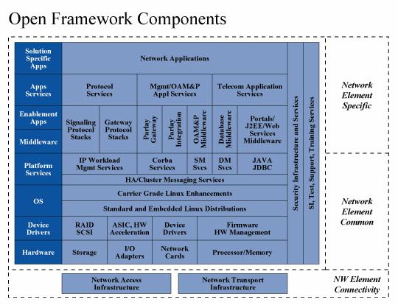

Figure 1. Components of Open Framework

In keeping with the Integrated Platform for Telecommunications Extended Offering’s primary principle of utilizing low-cost, field proven components based on open architectures, Linux is employed as the Integrated Platform for Telecommunications Extended Offering’s operating system component. Linux is open source-based and provides a scalable and enterprise stable operating system that executes on a multitude of hardware platforms. Service Providers have long appreciated the value of UNIX for its reliability, scalability, and sheer processing power. Today’s Linux variants represent the culmination of 30 years of developmental and operational experience in UNIX, providing a first-cl

foundation for a highly available telecom system. Additionally because Linux is Open Source, it delivers the lowest-cost solution available for today’s multiprocessor systems.

In order to meet the stringent demands for performance and reliability associated with Service Provider networks, many Linux vendors offer OS extensions especially designed for this purpose. These are referred to as Carrier Grade Enhancements (CGE), and the resulting Linux distribution is known as Carrier Grade Linux CGL. CGL includes such enhancements as kernel and driver hardening, elimination (or reduction) of kernel panics, and advanced logging and event management features. CGL also includes advanced high availability features such as kernel debugging tools, enhanced file system and RAID support, and support for redundant Ethernet. As mentioned above, CGL is a standard maintained by the Open Source Development Lab. Details of the recently released CGL Requirements Definition V2.0 can be viewed at
_________________________________________________________________________________.

The Integrated Platform for Telecommunications Extended Offering is currently built on SUSE LINUX Enterprise Server version 8.0 (SLES 8), which incorporates many of the functions of the CGL V2.0 specification. In addition, SLES 8 offers one of the richest suites of system management and installation tools of any available Linux. SUSE is based on United Linux, a common Linux base developed by a consortium of four major vendors including SUSE LINUX AG. United Linux and SLES 8 are certified compliant with the Open Group Linux Standard Base (LSB) 1.3 specification.

In addition to its commitment to LSB and CGL, SuSE’s high degree of interoperability with IBM software products (for example, DB2 and WebSphere ) makes it ideally suited for the Integrated Platform for Telecommunications Extended Offering. IBM recently renewed its commitment to SUSE LINUX with the announcement a joint Software Integration Center at the IBM Toronto Lab – a collaboration between IBM and SUSE dedicated to optimizing the interaction between SUSE LINUX and IBM middleware products.

The Integrated Platform for Telecommunications Extended Offering is currently built on SUSE LINUX Enterprise Server version 8.0 (SLES 8), which incorporates many of the functions of the CGL V2.0 specification. In addition, SLES 8 offers one of the richest suites of system management and installation tools of any available Linux. SUSE is based on United Linux, a common Linux base developed by a consortium of four major vendors including SUSE LINUX AG. United Linux and SLES 8 are certified compliant with the Open Group Linux Standard Base (LSB) 1.3 specification.

In addition to its commitment to LSB and CGL, SuSE’s high degree of interoperability with IBM software products (for example, DB2 and WebSphere ) makes it ideally suited for the Integrated Platform for Telecommunications Extended Offering. IBM recently renewed its commitment to SUSE LINUX with the announcement a joint Software Integration Center at the IBM Toronto Lab – a collaboration between IBM and SUSE dedicated to optimizing the interaction between SUSE LINUX and IBM middleware products.

While SLES 8 is the first Linux with carrier grade enhancements to be incorporated in the Integrated Platform for Telecommunications Extended Offering, other Linux distributions such as those provided by Red Hat (such as Red Hat Enterprise Server distributions), are planned for the future.

Because it is a primary design goal of the Integrated Platform for Telecommunications Extended Offering to produce a low-cost platform without sacrificing reliability or performance, the Intel x86 architecture was a natural choice for the Integrated Platform for Telecommunications Extended Offering’s server platform. For Enterprise-computing applications, the Intel -based architecture has long been recognized as one of the platforms best able to deliver reliability, scalability, and raw computing power at the lowest possible cost. Now that NGN architectures are enabling the deployment of enterprise-based technology in the Service Provider space, Intel-based servers are beginning to prove their value for telephony applications as well.

Current Integrated Platform for Telecommunications Extended Offering servers feature Symmetry Multiprocessing (SMP)-capable Intel Xeon processors and parity-enabled, double data-rate (DDR) RAM. The Integrated Platform for Telecommunications Extended Offering has been validated on both a rack-mount configuration based on the IBM xSeries server x335 and blade-server configuration based on IBM BladeCenter servers. Blade servers are rapidly becoming the de facto standard for Service Provider networks due to their flexibility, scalability, ease of serviceability, reduced power consumption, and small footprint.

While the Integrated Platform for Telecommunications Extended Offering has initially targeted Intel-based platforms, other CPU architectures are planned for future implementations, thus giving customers a variety of choices based upon environment and performance parameters. Power PC architecture is planned for inclusion in the near future.

In addition to multiple platforms, the Integrated Platform for Telecommunications Extended Offering offers a number of components that correspond to the functional blocks in figure 1. The components validated can provide all or partial functionality associated with a particular block. Multiple configurations of these different components on multiple platforms will be validated as selected representations of the CGOF and platforms satisfying NGN requirements. The software components are made up of a combination of IBM middleware, Open Source, and offerings from third-party vendors.

Integrated Platform for Telecommunications Extended Offering today

Integrated Platform for Telecommunications Extended Offering configurations have been validated for three server types that are detailed below. Current configurations utilize mostly IBM middleware on Linux and limited third-party products, but plans for 2004 include larger configurations with more third-party components.

Application Server

IBM eServer x343 and BladeCenter Enterprise Chassis with HS20 Blades SLES 8 Service Pack 3

IBM Director 4.12 (Agent implementation)
*

Additionally, a server was set up for the administration functions provided with the various components.

The following figure shows where each of the components in these validated configurations fits in the CGOF.
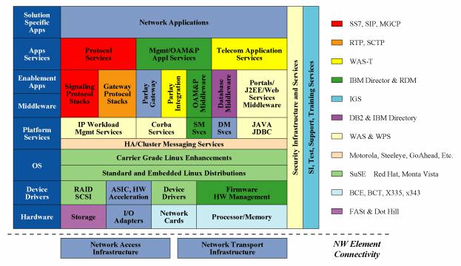

Figure 2. Components in the Integrated Platform for Telecommunications Extended Offering configuration

There are several blocks in which the Integrated Platform for Telecommunications Extended Offering currently has no functional implementations. These are identified by the pale blue color. Most of these uncovered areas will be added in 2004. In some blocks, the Integrated Platform for Telecommunications Extended Offering-identified functionality might not be the full functionality as described by the CGOF. Functionality in those blocks will be expanding as the Integrated Platform for Telecommunications Extended Offering program moves forward.

In 2003, the Integrated Platform for Telecommunications Extended Offering development team initiated the Pilot Evaluation Program, allowing potential customers and business partners to evaluate the Integrated Platform for Telecommunications Extended Offering in their own network environments. This program will be expanded in 2004. Extensive scripting allows Integrated Platform for Telecommunications Extended Offering systems to be installed and configured with various combinations of the currently validated components in a repeatable and reliable manner. This helps reduce the time frame required to deliver a pilot platform to a potential customer, even though there may be some variation of the component combinations,

versions, servers, and storage. In this manner, NEPs, ISVs, and SPs can evaluate Integrated Platform for Telecommunications Extended Offering quickly and thoroughly in a variety of test environments, to truly determine if the Integrated Platform for Telecommunications Extended Offering is suitable for their particular needs.

While each of the Integrated Platform for Telecommunications Extended Offering servers can stand alone as a functional unit within the network, the three server types currently available are being tested interactively together to emulate a proposed system. The following diagrams show an example of this type system where the servers are put together in a cluster forming three functional tiers. Figure 3 shows this as implemented on a BladeCenter.

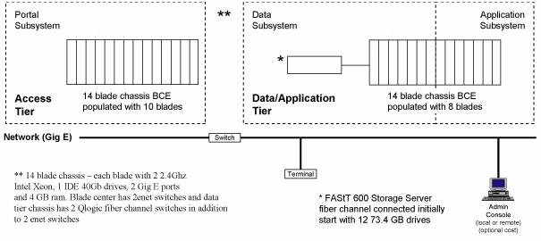

Figure 3. Functional tiers on a Blade Center server

The Integrated Platform for Telecommunications Extended Offering development and test teams have validated a similar but downsized configuration utilizing one of the blades as the administration console. Figure 4 shows how major components could be laid out in a sample hardware configuration. Depending on the hardware platform, number of servers available, number of users being serviced, and the application itself, the configuration can be modified so the http server function and edge server function could execute on the Portal or Application servers.

WebSphere Application Server runs on all the Portal and Application servers. It is not the intent of this paper to provide a complete description of all the features provided by each of the products run on a Integrated Platform for Telecommunications Extended Offering. For those unfamiliar with the major IBM components utilized in this initial Integrated Platform for Telecommunications Extended Offering configuration, see the following links to Web site information:

WebSphere Application Server for Telecom (WAS-T) provides a Parlay environment for supporting NGN telecommunications services. More information on WAS-T can be found at________________________________.

WebSphere Portal provides a unified environment for the user.
More information is available_____________________________________.

WebSphere Edge Server provides load balancing in our sample configuration, but can provide several additional features as well. The additional features are described on the IBM website located at __________________________________.
The Integrated Platform for Telecommunications Extended Offering environment is designed from the ground up with redundancy and high availability in mind. IBM eServers exploit high availability (HA) at the hardware level. Features such as error-correcting (ECC) memory, local HDD mirroring, redundant power, networking, storage, and processors are standard on many platforms. The IBM BladeCenter platform leverages many of these HA components. The Integrated Platform for Telecommunications Extended Offering will utilize a NEBS-compliant IBM BladeCenter for Telco (BCT) in 2004.

To provide high availability of platform services (database, application and portal services, and directory and authentication services), the Integrated Platform for Telecommunications Extended Offering adopts a number of strategies for either active-standby (failover) or active-active operation. The HA methodology chosen can vary between configurations. WebSphere components generally use an active-standby approach, while DB2 can use active-standby or active-active based on a serial or parallel implementation.

HA database services are provided with the assistance of Steeleye LifeKeeper, a 3rd party product. LifeKeeper provides HA database services for both serial and parallel DB2 databases. An external storage subsystem is required, such as IBM FAStT600 available as an option with Integrated Platform for Telecommunications Extended Offering.

LifeKeeper requires a minimum of two inter-node communication paths between cluster nodes, usually a combination of a TCP/IP link and a serial RS-232 connection. Because serial connections between nodes are not available on BladeCenter, two Ethernet Switch Modules are provided to satisfy this prerequisite.

Active-standby operation for IBM Directory and IBM WebSphere components is provided by the products themselves. No reliance on LifeKeeper (or any other open-source or 3rd party HA product) is required or should be implied.

In addition to providing comprehensive support for the J2EE 1.3 application environment with support for JCA 1.0 and JMS 1.0, WebSphere also supports advanced high-availability and workflow management services via IBM Edge Components V5.0.

Through its Network Dispatcher component, the Edge Components package employs sophisticated IP spraying techniques to load-balance requests across a cluster of application servers in a fully active-active configuration. Network Dispatcher routes each incoming request to the server best able to handle the request (based on load, type of request, and session affinity) and verifies that a request is not routed to a server that is unavailable. This approach provides high availability and load balancing in a single integrated solution; hence, the term workload management.

Once the fundamentals are understood, it is easy to see how workload management provides the simplest and most elegant solution possible. A single process manages both high availability and load balancing. Because no application server is kept in standby mode, all resources are fully utilized at all times. There is no failover so there is no failover delay – and no possibility that a failover sequence could itself fail, or that a server could fail to initialize in the transition. Also, no explicit fail-back is required. A server may be added back to the pool as soon as it is available to receive requests, making the entire process somewhat self-healing. In short, workload management generalizes the entire concept of availability for both reliability and performance. When a resource is available, it is used; when it is unavailable, it is removed from consideration – the reason why it is unavailable is of secondary importance.

It should be clear that this approach also provides an optimum in scalability, because resources can be added to or removed from the pool on-the-fly, without typically incurring any service interruption. The desired level of redundancy and performance can be easily achieved as changing requirements dictate.

Finally, WebSphere Edge Server adds the capability to support session persistence for the J2EE environment. With session persistence, it is possible to ensure that any failure will be completely invisible to the end-user, even if the failure occurs while the user is in the middle of a stateful session. The ability of one application server to pick up a session midstream from another requires careful management of session-persistent data, which must be supported by the application as well as the hosting environment. This is not out-of-the-box functionality by any means. Still, one of the reasons why WebSphere is so central to the application services layer of Integrated Platform for Telecommunications Extended Offering is because it does provide mechanisms to implement this kind of advanced functionality.

Figure 4 is a sample implementation and is described by the following flow description.

Web clients access the system through the Network Dispatcher. The system could also be configured to have Web clients access the system through a single http server (with backup), or through the Network Dispatcher and a cluster of http servers. Web client requests are routed to clustered Portal or applications running on the Application Server as appropriate. PSTN (packet switched telephone network) requests are routed to the application server typically through a softswitch.

Portal and applications running on the Application Server route their database requests to DB2; data partitioning is also a possibility here. Data is stored on a shared file system. Application Server applications also communicate with Parlay.

IBM Directory (LDAP) is installed where required for WebSphere authentication. IBM Director can provide some high availability by monitoring http, Edge Server, DB2, and other processes, and can attempt to restart failed processes.

The system is scalable by adding additional Portal, Application Server, and DB2 nodes. High availability for the Network Dispatcher and DB2 nodes (indicated by the words "heart beat" and not implying any specific solution) can be provided by Open Source Heartbeat, SteelEye LifeKeeper, or a similar solution. High availability for a Telco protocol infrastructure can be provided by the implementation or by another third-party solution.
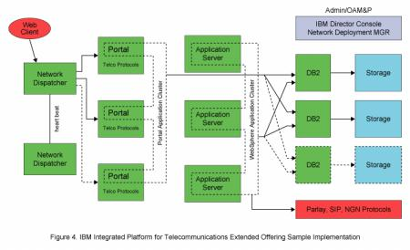

Future direction of the Integrated Platform for Telecommunications Extended Offering

One goal for future Integrated Platform for Telecommunications Extended Offering releases is to steadily increase the functional capability so that the Integrated Platform for Telecommunications Extended Offering can eventually fulfill most implementations of the CGOF architecture. In 2004, the Integrated Platform for Telecommunications Extended Offering will focus on high availability, PowerPC architecture, external storage options, and Session Initiation Protocol (SIP). There will also be an effort to increase the number of Linux distribution

options. Another goal is to be able to provide multiple options for the various CGOF functional blocks. This prevents IBM and consequently its customers from relying on a sole source for components of the solution stack. It will also allow flexibility to customers who have a preference for a particular third-party component over another.

Figure 5 is a solution stack that shows components that IBM is currently providing or will be providing in the near future.

Summary

The Integrated Platform for Telecommunications Extended Offering is IBM’s open architecture solution for Next Generation Network platforms in both NEBS-compliant and non-NEBS servers. The Integrated Platform for Telecommunications Extended Offering is designed to give the Service Provider flexibility in adding new features and decrease dependency upon specific platforms or operating systems. Currently, the Integrated Platform for Telecommunications Extended Offering offers a solution on Intel rack mount and blade servers.

It provides Web services, portal services, J2EE environment, and a Parlay interface. It is anticipated that in the near future, the Integrated Platform for Telecommunications Extended Offering will offer signaling and gateway protocols, additional high availability packages, and a choice of Linux distributions. The Integrated Platform for Telecommunications Extended Offering, by virtue of the open architecture and reliance on Linux, can reduce entry cost and long-term ownership costs.
Notes

- Service Provider Delivery Environment & Carrier Grade Open Framework – Positioning, Ed Bailey, James Czyzak, & Gordon Kerr.

Acknowledgements

Many thanks to the coworkers listed below who provided significant input for this paper.

Ed Bailey, STSM, IBM

Gordon Kerr, Distinguished Engineer, IBM
Lei Lu, Senior Engineer, IBM
Woody Marvel, Senior Engineer, IBM
Don Watson, Senior Engineer, IBM

Legal Statement

Copyright 2004 IBM

IBM, the IBM logo, BladeCenter, DB2, DB2 Universal Database, eServer, PowerPC, WebSphere, and xSeries and are trademarks or registered trademarks of International Business Machines Corporation in the United States, other countries, or both.

UNIX is a registered trademark of The Open Group in the United States and other countries.

Intel is a trademark of Intel Corporation, in the United States and other countries.

Other company, product, and service names may be trademarks or service marks of others. This document is provided "AS IS," with no express or implied warranties. Use the information in this document at your own risk.

References in this publication to IBM products or services do not imply that IBM intends to make them available in all countries in which IBM operates.

