DRIVERS DAILY LOG

Records of Duty Daily Form

The examples provided are of the expected documentation. Please remember to submit 30 days worth of one driver’s Records of Duty.

 |  |  | / |  |  | / |  |  | Original - File at home terminal.
 | (24 hours) | (month) |  | (day) |  |  |  | (year) | Duplicate - Driver retains in his/her possession for 8 days.
 | From: |  |  |  |  |  |  | To:

Mid-
night 1 | 2 | 3 | 4 | 5 | 6 | 7 | 8 | 9 10 11 Noon 1 | 2 | 3 | 4 | 5 | 6 | 7 | 8 | 9 10 11

1. Off Duty

2. Sleeper

Berth

3. Driving

4. On Duty

(not driving)

Mid-
night 1 | 2 | 3 | 4 | 5 | 6 | 7 | 8 | 9 10 11 Noon 1 | 2 | 3 | 4 | 5 | 6 | 7 | 8 | 9 10 11

Remarks

Shipping

Documents:

DVL or Manifest No.

or

Shipper & Commodity

Enter name of place you reported and where released from work and when and where each change of duty occurred.

Use time standard of home terminal.

Recap: |  | 70 Hour/ |  |  |  |  |  |  |  |  |  |  |  | *If you took
Complete at |  | 8 Day |  |  |  |  |  | 60 Hour/ 7 |  |  |  |  |  | 34
end of day |  | Drivers | A. |  | B. |  | C. | Day Drivers A. |  |  | B. |  | C.
 |  |  |  |  |  |  |  |  |  |  |  |  |  | consecutive
 | On duty |  | A. Total |  | B. Total |  | C. Total |  | A. Total |  | B. Total |  | C. Total
 |  |  |  |  |  |  |  |  |  |  |  |  |  | hours off
 | hours |  | hours on |  | hours |  | hours on |  | hours on |  | hours |  | hours on
 |  |  |  |  |  |  |  |  |  |  |  |  |  | duty you
 | today, |  | duty last 7 |  | available |  | duty last 5 |  | duty last 8 |  | available |  | duty last 7
 |  |  |  |  |  |  |  |  |  |  |  |  |  | have 60/70
 | Total lines |  | days |  | tomorrow |  | days |  | days |  | tomorrow |  | days
3 & 4 |  |  | including |  | 70 hr. |  | including |  | including |  | 60 hr. |  | including | hours
 |  |  | today. |  | minus A* |  | today. |  | today. |  | minus A* |  | today. | avaialble

Total Hours

 |  |  |  | Name of Carrier or Carriers
Total Miles Driving Today |  | Total Mileage Today
 |  |  |  | Main Office Address
Truck/Tractor and Trailer Numbers or |  |  |  | Home Terminal Address
License Plate(s)/State (show each unit)

Driver’s time record

Driver’s Name (print) ____________________________________ Employee No. _________
Month _________________________________________________ Year ___________________

Drivers may prepare this report instead of “driver’s daily log” if the following applies:
- Operates within 100 air-mile radius of normal work reporting location
- Returns to the work reporting location and is released from work within 12 consecutive hours
- Is operating a (1) Property-carrying CMV and has at least 10 consecutive hours off duty separating each 12 hours on duty OR (2) Passenger-carrying CMV and has at least 8 consecutive hours off duty separating each 12 hours on duty”

Intermittent drivers
Shall complete this form for 7 days preceding any day driving is performed. This includes the preceding month

Date | Start Time  “All Duty” | End Time  “All Duty” | Total  Hours | Driving  Hours | Truck  Number | Headquarters
1
2
3
4
5
6
7
8
9
10
11
12
13
14
15
16
17
18
19
20
21
22
23
24
25
26
27
28
28
29
30
31

To be prepared monthly by each DOT-certified driver unless time record is exclusively kept on Driver’s Daily Log.
Indicate “days off.” Check box if no driving is performed during this month and the first 7 days of the following month.
Mail this report to your Division Manager of Administration.

Example of supporting documentation

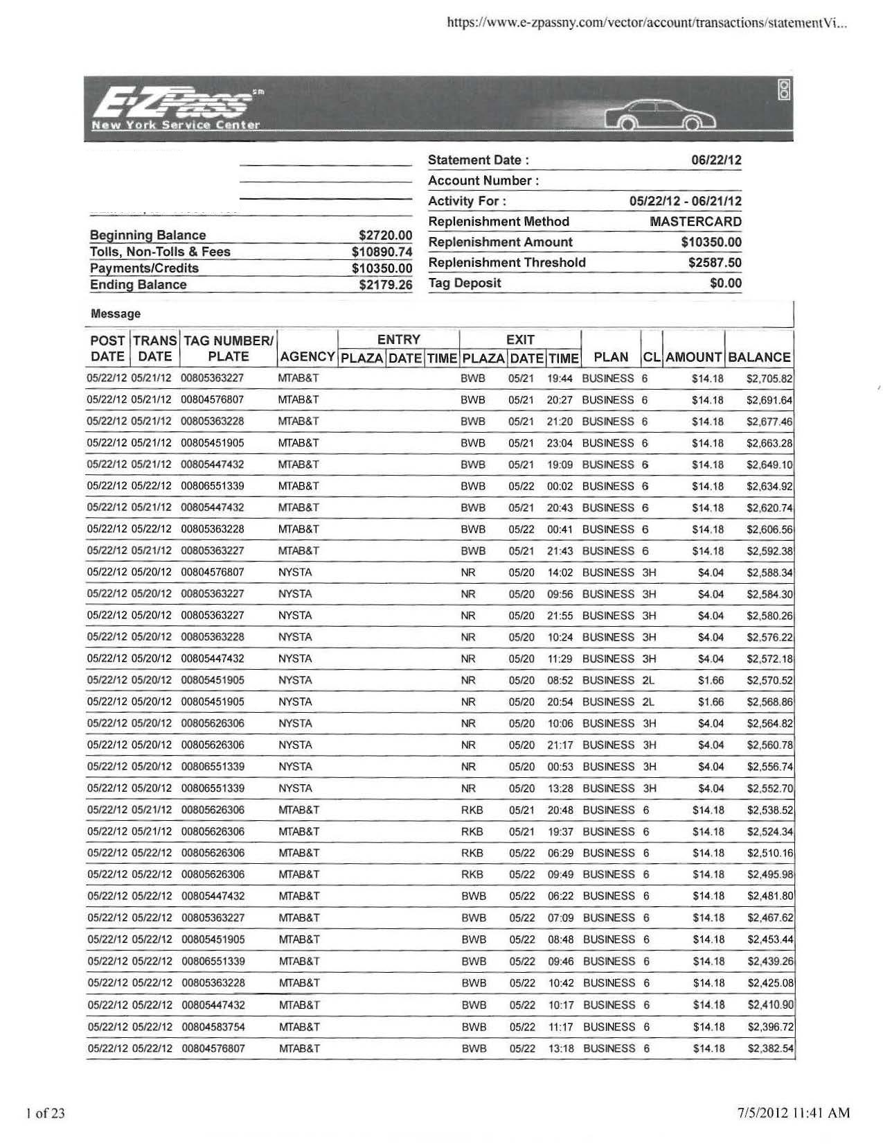

Name

Address

