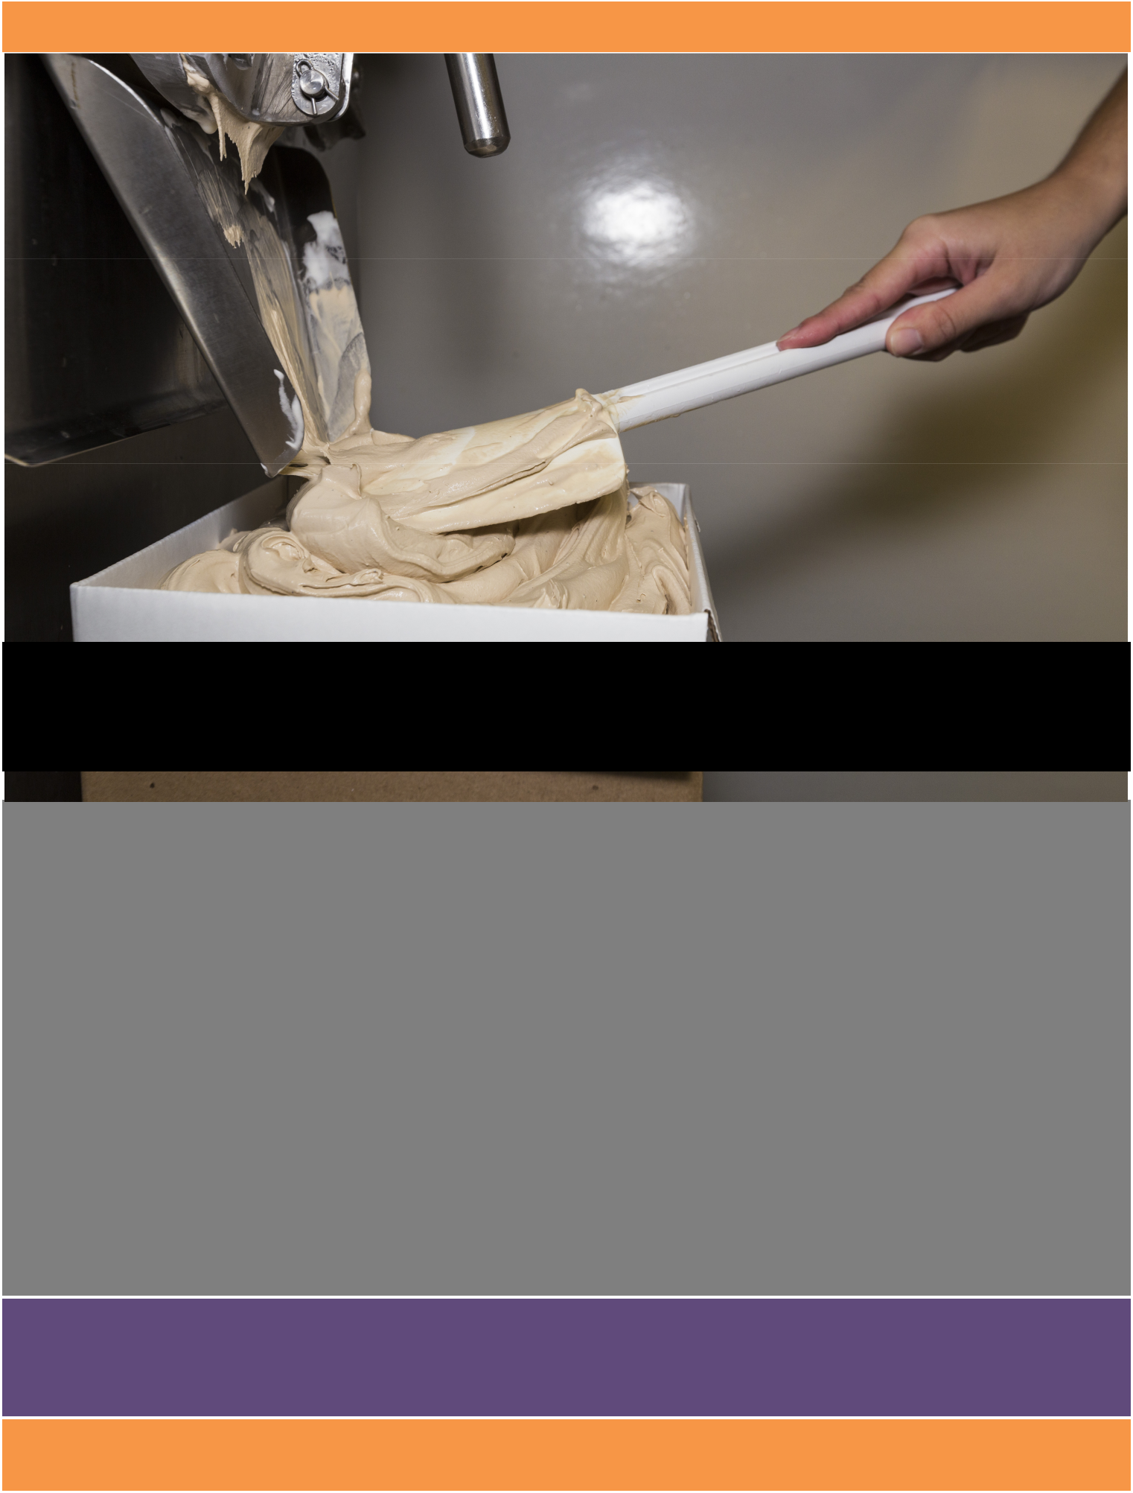

Production Training Manual

Clemson Ice Cream

The production training manual includes Good Manufacturing Practices (GMPs), Standard Operating Procedures (SOPs), and the chemicals used in the facility. It also includes common troubleshooting, the science behind ice cream manufacturing, and the visitor policy.

N e w m a n H a l l , C l e m s o n , S C 2 9 6 3 1

Product: Clemson Ice Cream

Plant Name: Clemson’s ’55 Exchange Creamery Issue Date: 8/19/20XX
Address: Creamery, Newman Hall, Clemson, SC 29634 Supersedes: 7/20/20XX
_____________________________________________________________________________________

Clemson Ice Cream

Producing the World’s Best Ice Cream

Welcome to the team! You have been selected to carry on the tradition of Clemson Ice Cream at Clemson’s ‘55 Exchange. In the following pages you will be guided in the best ways to produce (standard operating procedures) and handle ice cream (good manufacturing practices). This manual explains the basic techniques of freezing ice cream without going into how each specific flavor is made. We hope you enjoy working in the creamery. You have a very important job in carrying on the long-standing tradition of Clemson Ice Cream. The World’s Best Ice Cream made by the World’s Best Students!

Contact list
Name |  | Phone number
Dr. McGregor | 864-650-0817
Kinsey MacDonald | 803-807-6835
Sara Stancil Cothran | 864-508-0875
Food Science Office | 864-656-3397

PRODUCTION TRAINING MANUAL 2

Product: Clemson Ice Cream

Plant Name: Clemson’s ’55 Exchange Creamery Issue Date: 8/19/20XX
Address: Creamery, Newman Hall, Clemson, SC 29634 Supersedes: 7/20/20XX
_____________________________________________________________________________________

TABLE OF CONTENTS

Training Program …………………………………………………………………………………4

Guiding Principles………………………………………………………………………………...5

Good Manufacturing Practices……………………………………………………………………6

Standard Operating Procedures………………………………………………………………..…10

Troubleshooting……………………………………………………………………………….....16

The Science of Ice Cream………………………………………………………………………..17

Chemical List………………………………………………………………………………….…19

Visitor Policy…………………………………………………………………………………….20

Glossary………………………………………………………………………………………….21

Sample Forms……………………………………………………………………………………23

PRODUCTION TRAINING MANUAL 3

Product: Clemson Ice Cream

Plant Name: Clemson’s ’55 Exchange Creamery Issue Date: 8/19/20XX
Address: Creamery, Newman Hall, Clemson, SC 29634 Supersedes: 7/20/20XX
_____________________________________________________________________________________

TRAINING PROGRAM

Who:

- The production manager trains all employees who work in ice cream production.

- The faculty advisor will be in production a minimum of once a semester, within the first month.

When:

- At the start of employment of production staff

- Annually for refresher training

- As changes are made to personnel practices/procedures

- As needed for retraining if employee puts food safety at risk (monitored through the personal practice form)

What:

- Before the first day of work, employees will be required to read the production-training manual. Then the production manager will train verbally and by hands-on demonstration during an ice cream production.

How:

- Employees read the SOP program before training occurs and will be required to read and understand GMP requirements

- Employees may be verbally assessed for understanding of GMP requirements.

- Assess the trainee’s understanding by observing as he/she performs the duties.

Monitoring Training

The trainer and the trainee must sign the training record after each training session is complete.

- All initial training and retraining must be recorded and verified.

PRODUCTION TRAINING MANUAL 4

Product: Clemson Ice Cream

Plant Name: Clemson’s ’55 Exchange Creamery Issue Date: 8/19/20XX
Address: Creamery, Newman Hall, Clemson, SC 29634 Supersedes: 7/20/20XX
_____________________________________________________________________________________

GUIDING PRINCIPLES

- Safety is the most important!

- The safety of our staff is very important to us. Training of employees is crucial to their safety.

  - We are also concerned with food safety. Following this guide will help keep the food safe for our customers!

- Faculty Involvement

  - Faculty advisor will oversee production to ensure proper production and enhance learning at least once a semester

- Learning Environment

  - Students will understand technical information that relates to ice cream production (i.e. overrun, compressor, etc.) while gaining hands-on experience.

PRODUCTION TRAINING MANUAL 5

Product: Clemson Ice Cream

Plant Name: Clemson’s ’55 Exchange Creamery Issue Date: 8/19/20XX
Address: Creamery, Newman Hall, Clemson, SC 29634 Supersedes: 7/20/20XX
_____________________________________________________________________________________

GOOD MANUFACTURING PRACTICES

Personal Hygiene Practices

A high standard of personal cleanliness is required for all personnel in this facility. Proper hygiene can prevent contamination of ingredients, products or packaging. All employees must follow the rules for working in food handling areas.

Employees at ’55 Exchange must follow these practices:

- Come to work clean.

- Keep fingernails trimmed and clean.

- Do not wear fingernail polish, false eyelashes or fingernails, badges, pins, etc.

- Avoid touching body parts, including hair, nose, arms, eyes, etc. If hands become contaminated, wash them.

- Turn away from food, ingredients, packaging materials and food contact surfaces, when coughing or sneezing. Use the crook of your elbow or shoulder. Then wash hands/ exposed arms.
- Do not eat, drink, smoke, chew gum or tobacco, or spit in any food handling areas. All food should be consumed outside of the production facility.

- Do not taste test in production or storage areas. Products can be taste tested outside of the production space or when it reaches the store.

- Do not wear loose items in breast pockets or on shirt collars [or smocks, overalls, lab coats, etc.] This includes pens, thermometers, etc.

- Placed all personal items (phone, keys, etc.) in the proper location. This location is currently in the back storage room.

- Do not store waste on or near food, ingredients, packaging materials or food contact surfaces.

- Throw out any ingredient, packaging, or product that falls on the floor.

- Do not store ingredients or packaging materials directly on the floor.

- Do not wear any exposed jewelry, including watches. The only exception is a medic alert bracelet or necklace, if it’s covered or tucked inside clothing.

- Do not bring glass into food processing and storage areas.

PRODUCTION TRAINING MANUAL 6

Product: Clemson Ice Cream

Plant Name: Clemson’s ’55 Exchange Creamery Issue Date: 8/19/20XX
Address: Creamery, Newman Hall, Clemson, SC 29634 Supersedes: 7/20/20XX
_____________________________________________________________________________________

Hand Washing Practices

Proper hand washing is critical in preventing the spread of bacteria. It greatly reduces the chances of contaminating food and food contact surfaces. All employees must wash their hands thoroughly and frequently.

Hand Washing Procedure

Wash your hands at the designated automatic hand washing station. For proper hand washing, follow these steps:
- Pre-rinse hands with warm clean water.

- Apply soap.

- Rub hands, fingers, nails and wrists to form a lather for a minimum of 20 seconds.

- Rinse hands with warm clean water.

- Dry hands using Xcelerator Hand Dryer

Note: A poster with hand washing instructions is located by the hand-washing sink.

Hand Washing Frequency

All employees must wash their hands:

- When starting or returning to work

- After using the bathroom

- After handling food allergens [lemon custard (egg), pecans (tree nuts), Oreo’s, vanilla wafers and cookie dough (wheat), etc.]

- After touching hair, ears, nose, mouth, etc.

- After sneezing and/or coughing

- After handling garbage or waste bins

- After lunch and breaks

- Every time hands become contaminated

PRODUCTION TRAINING MANUAL 7

Product: Clemson Ice Cream

Plant Name: Clemson’s ’55 Exchange Creamery Issue Date: 8/19/20XX
Address: Creamery, Newman Hall, Clemson, SC 29634 Supersedes: 7/20/20XX
_____________________________________________________________________________________

Clothing, Footwear, Headwear

Employees must wear clean clothing that is designed for the operation to prevent contamination of food ingredients, packaging and food contact surfaces (ex: aprons, rain boots, hair net).

All employees must follow these rules:

- Come to work in clean clothing.

- Put on rain boots, apron, and hair net before starting your shift.

- Keep designated work clothing clean and in good repair (ex: no holes, loose threads, loose buttons, etc.)

- Wear clean shoes/boots inside the facility. You must put on designated work boots before starting a shift and take them off after the shift. If leaving the production area, be sure to remove the work boots.
- Wear suitable hair covering (hair net and beard net when applicable) to prevent hair from directly or indirectly touching food, equipment, utensils, etc.

- Do not wear designated work clothing in bathrooms, lunchrooms or outside the production facility.

- Change designated work clothing if it gets soiled during a shift.

- If boots become soiled, rinse with hot water and apply soap using red brush. If apron becomes soiled, place in orange laundry bag.

- Aprons are worn once before washing and drying at a designated student’s home.

- Store street shoes in the back storage room.

Note: All visitors to our facility, including suppliers and contractors, must wear a head covering (i.e. hat or hair net).

Injuries and Wounds

All employees must follow these rules:

- Report all work related injuries to management immediately.

- When someone is injured or wounded, immediately apply first aid, as stated in the Emergency Procedure Handbook.

- Ensure anyone with an open cut or wound has it securely and hygienically covered if working with food, packaging or food contact surfaces (ex: waterproof bandage covered with a glove).
- Determine which food, ingredients, packaging materials and food contact surfaces were contaminated as a result of the injury or wound.

- Ensure contaminated items are disposed of and food contact surfaces are cleaned and sanitized, using company sanitation procedures.

- Record the incident on the company’s incident report/corrective action form.

- Ensure any visitor with an exposed open cut or wound securely and hygienically covers it before entering the facility.

PRODUCTION TRAINING MANUAL 8

Product: Clemson Ice Cream

Plant Name: Clemson’s ’55 Exchange Creamery Issue Date: 8/19/20XX
Address: Creamery, Newman Hall, Clemson, SC 29634 Supersedes: 7/20/20XX
_____________________________________________________________________________________

Evidence of Illness

Employees should not handle food or work when they are sick. All employees must report any symptoms of illness or any diagnosed illness to the manager immediately.

Symptoms of illness include, but not limited to:

- Diarrhea
- Vomiting
- Jaundice (yellowing of the skin and/or eyes)
- Sore throat with fever
- Infected cuts or wounds, or lesions containing pus on the hand, wrist, and exposed body part (such as boils and infected wounds, however small).

Diagnosed illness includes, but not limited to:

- Norovirus
- Salmonella Typhi (typhoid fever)
- Shigella spp. Infection
- E. coli infection (Escherichia coli O157:H7 or other EHEC/STEC infection)
- Hepatitis A
Note: Manager must report any of these illnesses to the Health Department.

Although you may not have any symptoms or diagnosed illness, you may be in contact with someone who does. If you know that you are exposed to an illness, you must notify the manager when:

- You have an outbreak of Norovirus, typhoid fever, Shigella spp. Infection, E. coli infection, or Hepatitis A.
- A household member has an outbreak of Norovirus, typhoid fever, Shigella spp. Infection, E. coli infection, or Hepatitis A.
- A household member attending or working in a setting with an outbreak of Norovirus, typhoid fever, Shigella spp. Infection, E. coli infection, or Hepatitis A.

If you have any of the symptoms, diagnosed illness, or exposure to the listed illnesses, you may be either excluded or restricted from work. If you are excluded from work, you are not allowed to come to work at all. If you are restricted from work, you are allowed to come to work, but your duties may be limited (to non-food tasks).

If you are excluded from work for having diarrhea and/or vomiting, you will not be able to return to work until more than 24 hours have passed since your last symptoms of diarrhea and/or vomiting.

If you are excluded from work for exhibiting symptoms of a sore throat with fever or for having jaundice, Norovirus, Salmonella typhi, Shigella spp. Infection, E. coli infection, and/or Hepatitis A, you will not be able to return to work until Health Department approval is granted.

PRODUCTION TRAINING MANUAL 9

Product: Clemson Ice Cream

Plant Name: Clemson’s ’55 Exchange Creamery Issue Date: 8/19/20XX
Address: Creamery, Newman Hall, Clemson, SC 29634 Supersedes: 7/20/20XX
_____________________________________________________________________________________

Monitoring Personnel Practices

Personnel practices are monitored every production by the production manager, who must document the process on the personnel practices checklist. The checklist and/or corrective action must be reviewed and verified within 1 week.

STANDARD OPERATING PROCEDURES

Clean and sanitize the machine and utensils.

- Plug the sink with the sink stopper and turn the water on to hot (140ºF).

- Pour in 1 oz. 2171 General Cleaner into the sink.

- Fill the sink halfway up (3 gallons) with hot water, and then turn the water off.

- Put all utensils and machine parts in the sink of soapy water.

- As they sit in the water, measure out 23 mL of Dibac Sodium Hypochlorite sanitizer using the 25 mL graduated cylinder.

- Get a 4-gallon metal bucket, and add cold water while pouring in the sanitizer. Fill the bucket up ¾ of the way, and then turn off the water. This will be one of your sanitizer buckets.

- With another 4-gallon metal bucket, add in 2171 general cleaner and hot water. Use this bucket and brush to clean the inside of the machine, the top and sides of the machine, and the table. Rinse using the hose under the sink. Squeegee the table top to dry.

- Clean the utensils, machine parts, and black mats, using the brushes (white bristle brushes) that are in the sink of soapy water.

- Rinse everything down and place the utensils, machined parts, and mat in the sanitizer bucket for at least 30 seconds. This is to reduce the microbial load by 99%.

PRODUCTION TRAINING MANUAL 10

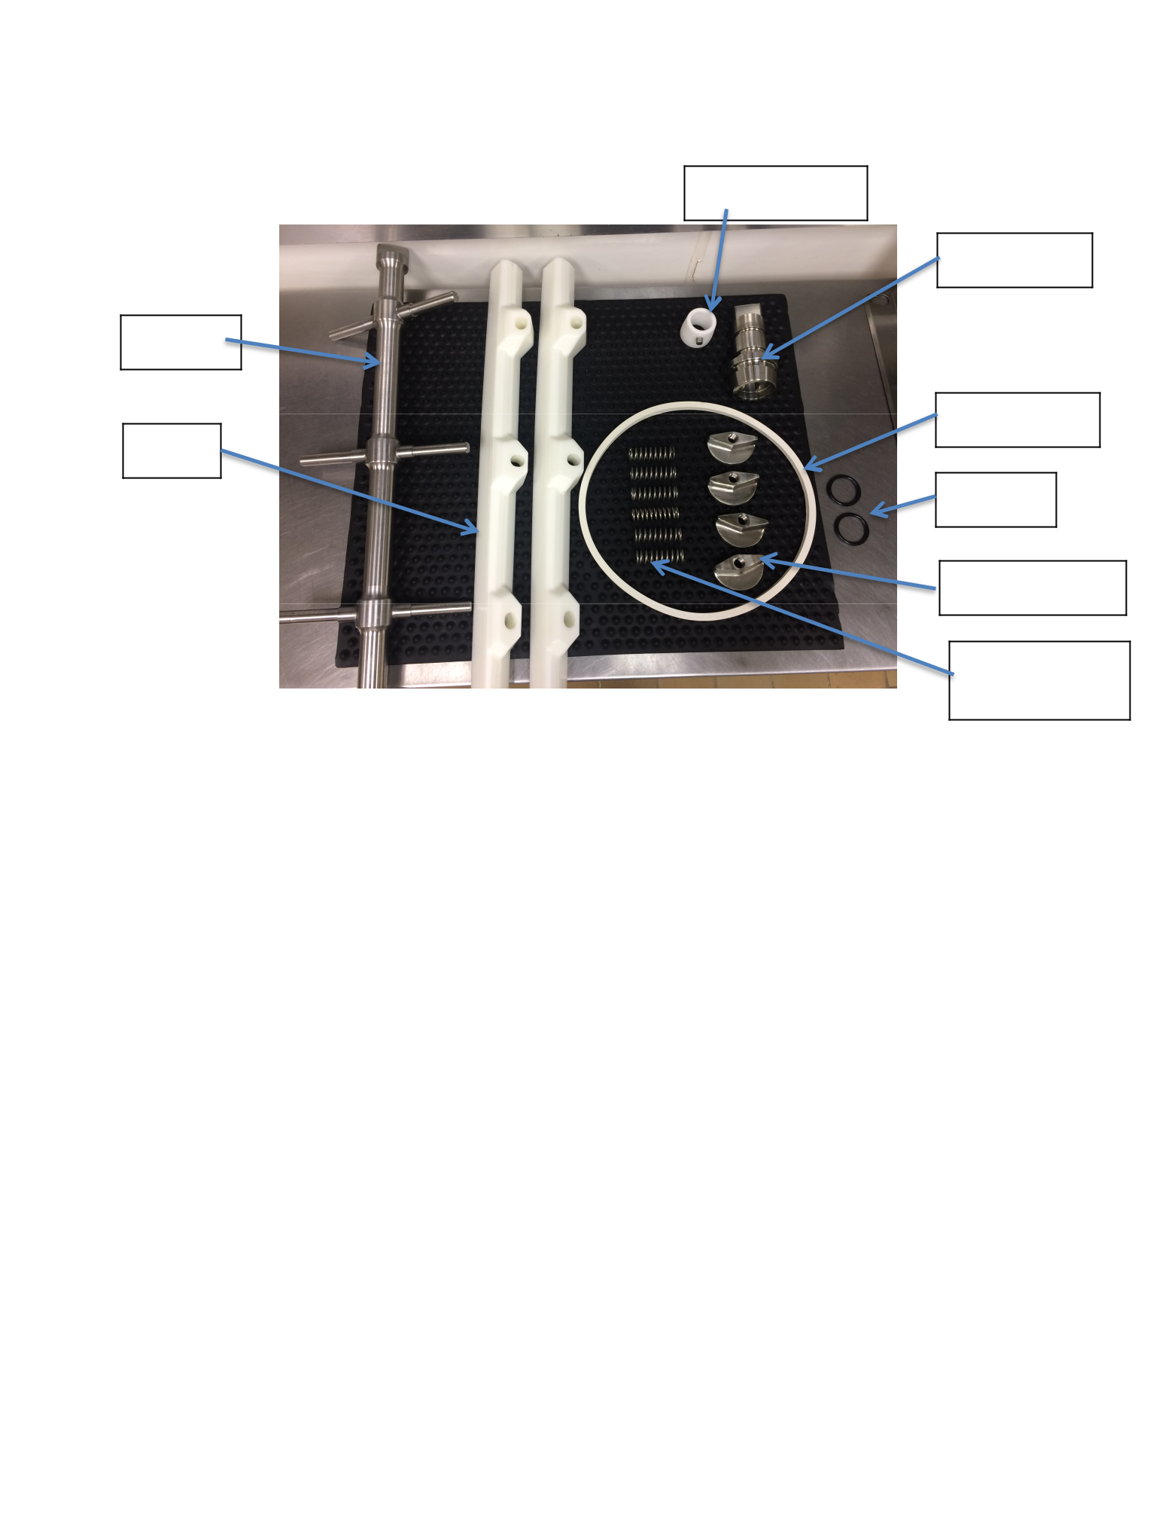Product: Clemson Ice Cream

Plant Name: Clemson’s ’55 Exchange Creamery Issue Date: 8/19/20XX
Address: Creamery, Newman Hall, Clemson, SC 29634 Supersedes: 7/20/20XX
_____________________________________________________________________________________
Machine Diagram
Dasher Bearing

Center Shaft

Dasher

Cover Gasket

Blades

O-Rings

Assemble the batch freezer.

Wing Nuts

Dasher Blade Springs

- Remove the mat from the sanitizer and place it in the middle of the table.

- Remove the machine parts and utensils from the sanitizer bucket and place them on the mat on the table.

- Put the “O” rings on the center shaft

- Apply CIP (Clean in Place) lubrication to the center shaft and “O” rings, and wipe off any excess lube. Place it into the back of the barrel. Turn it to make sure it has locked in place.

- Place the springs on the dasher, followed by the blades. The curved end of the blades should be in the back of the machine.

- Carefully place the dasher into the barrel, locking it in place with the center shaft.

- Apply CIP lube to the cover gasket, dasher bearing, and yoke bearings.

- Place the cover gasket around the opening of the barrel.

- Put the dasher bearing on the end of the dasher, making sure the silver knob fits in the grove on the door before closing.

- Close the door to the freezer and place the studs on the yoke bearings and tighten them as much as possible by hand. Then, further tighten it further by lightly tapping each yoke bearings once with the mallet.

- Turn on the compressor water hose that is located behind the machine.

- Now you can pull the switch that powers the machine, located above the table. Completely remove the lock and place it in a safe spot (on the box folding table) to ensure that the power can be turned off easily in an emergency.

PRODUCTION TRAINING MANUAL 11

Product: Clemson Ice Cream

Plant Name: Clemson’s ’55 Exchange Creamery Issue Date: 8/19/20XX
Address: Creamery, Newman Hall, Clemson, SC 29634 Supersedes: 7/20/20XX
_____________________________________________________________________________________

Sanitizing assembled freezer.

- Pour the bucket of sanitizer into the batch freezer. Make sure that the gate door is closed before pouring. Run the dasher on low speed, turning on and off for at least TWO minutes. For the last 20 seconds, turn on the compressor switch to allow the barrel to pre-chill. Then empty out the sanitizer into a waste bucket.

Monitoring Sanitation for Set-Up

- After sanitation is complete, equipment and parts must be inspected again for cleanliness and damage and then reassembled using the previous instructions.

- Sanitation and inspection completion must be recorded on the Daily Sanitation Record.

Adding the ingredients.

- Before adding ingredients, and depending on the day’s production, check the list of ice cream recipes, which is located in the white binder next to the production list of the day. It will tell you which ingredients to use, and how much to use, for each ice cream flavor.

- Ingredients and ice cream mix are located in the walk-in cooler and freezer and should be moved, as needed, to the creamery with the insulated cart.

- Mix is unboxed in the creamery. Shake the mix jug and then dunk into the 200-ppm sanitizer bucket for a minimum of 30 seconds.
- Remove the lids of the mix by pulling the tamper evident tab making sure to keep the lid and tamper evident tab attached.

- Pour all five gallons of mix and the needed flavorings into the batch freezer.

- Push out the air of the milk gallons and cap them and throw in the trash can. Recapping the gallons allows us to make sure all lids and tamper evident tabs are accounted for and did not end up in the ice cream.

Trash and waste disposal

- Milk jugs are thrown in unlined trashcan and the trash is taken out as needed throughout the day to the dumpster beside Newman Hall. No designated work clothing can be worn when taking out the trash.

- Cardboard boxes are disassembled and placed next to box-making station. At the end of production, all of the cardboard is then recycled in bin behind Newman Hall.

- Waste containers must be emptied and cleaned daily by Production Staff.

PRODUCTION TRAINING MANUAL 12

Product: Clemson Ice Cream

Plant Name: Clemson’s ’55 Exchange Creamery Issue Date: 8/19/20XX
Address: Creamery, Newman Hall, Clemson, SC 29634 Supersedes: 7/20/20XX
_____________________________________________________________________________________

Start the freezing process.

- Make sure the compressor water hose behind the machine is turned on.

- Next turn the dasher on to low (super premium ice cream setting) and turn the compressor on (flip the right switch up).
- WARNING! Never leave the compressor on while the dasher is turned off -- it will freeze the dasher in place!

- Put the lid on top of the cover.

- At 6 minutes, manually increase the speed of the machine to 200 RPM for the remaining time.

- Each run should last approximately 8-9 minutes.

Add other ingredients.

- At the required time and depending on the flavor (look in the recipe book for these exact instructions), and add the correct amount of fruits, nuts, or other ingredients to the batch freezer. If needed, slow the dasher to allow all of the ingredients to incorporate.

- Once all the ingredients are in, turn the dasher back to the original speed (165 RPM for super premium).

Remove the finished product.

- After the timer has reached 8-9 minutes, the ice cream should be ready to pull.

- Before pulling, turn off the compressor and wait 30 seconds before pulling.

- Place an ice cream box on the shelf, right under the lip. Start by pulling on low speed and only move to high (234 RPM) when the ice cream is coming out slowly. Turning it on high will help to get the rest of the ice cream to come out.

- Open the gate door and slowly let the ice cream flow into the box with a thick consistency. If the ice cream is not firm, close the gate, turn the compressor back on and wait for a few minutes and proceed again.

- Continue to pull the ice cream until no more comes out. You will fill approximately 4 boxes.

- Place the filled boxes in the -40 degrees F freezer for hardening. Each box should have the production code date, which is the mix code date followed by the date (MM/DD/YY) you are doing production, as well as the name of the flavor on the side and top of the box.

  - Example Code: 07516071916 where 07516 is the mix code and 071916 is the date

PRODUCTION TRAINING MANUAL 13

Product: Clemson Ice Cream

Plant Name: Clemson’s ’55 Exchange Creamery Issue Date: 8/19/20XX
Address: Creamery, Newman Hall, Clemson, SC 29634 Supersedes: 7/20/20XX
_____________________________________________________________________________________

Rinse between runs (if noted on the production sheet)

- After the ice cream is finished being pulled, fill the freezer with water and run the dasher on low speed, turning on and off for a couple of minutes, and then empty the water out into the 5-gallon waste bucket. This may have to be repeated depending on the flavor just made and the flavor that comes next. On the last run of water, turn the compressor on for 20 seconds to allow the barrel to re-chill. Some flavors are fine to have carryover from the previous batch (for example, chocolate to dark chocolate chip) but others (for example, lemon to mint chocolate chip) need a rinse in between.

Disassembly

- After the last batch is completed, turn off the dasher and compressor.

- Fill the freezer with water and run the dasher on low speed, turning on and off for a couple of minutes, and then empty the water out into the 5-gallon waste bucket. Repeat several times until the water comes out of the machine fairly clear.

- Turn off the power switch (from the source) and lock. Also be sure to turn off the compressor water hose behind the machine.

- Disassemble the freezer and clean all parts in the sink and scrub the machine using the white bristle brush (paying extra attention to removing all soil, especially in the very back of the machine). Rinse the cleaning solution off. Do not sanitize the machine or machine parts. Keep the machine open to dry overnight.

- Allow pieces of the ice cream machine to dry by leaving the pieces on the cleaned table.

- Do not reassemble the batch freezer; the parts will be cleaned and sanitized before next use.

Clean-up

- After the initial wipe down of the gross build-up using a reusable cleaning cloth, pre-rinse the surfaces of tables and equipment using warm, clean water at low pressure (make sure to minimize spray by controlling the pressure and direction to prevent cross-contamination).

- Scrub the table top, and the freezer and refrigerator doors with a concentrated soap (2171 General Cleaner) solution and a yellow bristle brush. Rinse with warm water.

- Squeegee the table top and the top of the machine and place the black mats back down.

- Squeegee the floors, including around the machine and under the sinks and freezers.

- Return all ingredients to where they were originally found.

- Wash any remaining equipment and utensils.

- Sweep the walk-in freezer and cooler area and then mop the area.

- Rinse the insulated cart. Leave the insulated cart open to dry.

- Turn off the water hose under the hand wash sink.

PRODUCTION TRAINING MANUAL 14

Product: Clemson Ice Cream

Plant Name: Clemson’s ’55 Exchange Creamery Issue Date: 8/19/20XX
Address: Creamery, Newman Hall, Clemson, SC 29634 Supersedes: 7/20/20XX
_____________________________________________________________________________________

- Dump out all buckets and clean them inside and out. Place them in the sink or the lower shelf of the table, off the floor.

- Push table and ladder in front of both -40F freezers, so the doors don’t pop open during the night.

- Tape up boxes and take out the trash. Rinse/wash the trashcan.

- Squeegee any remaining water from the floor.

- Turn off the lights and lock the door.

Monitoring Sanitation for Set-Up

- After sanitation is complete, equipment and parts must be inspected again for cleanliness and damage.

- Sanitation and inspection completion must be recorded on the Daily Sanitation Record.

- If sanitation is inadequate, it must be repeated.

Other Standard Operating Procedures

- Keep containers well maintained (no cracks or leaks) and clean.

- The production manager must ensure areas such as storage areas and office are kept clean and organized.

- Vehicles used to transport food products must be kept clean. This includes cleaning out the carts at the end of production days by spraying it down with the hose. Cross-contamination of ingredients, food products, packaging materials and chemicals used in sanitation or maintenance must be prevented during transportation by not transporting incompatible materials (for example, food and chemical sanitizers) at the same time. One cart is strictly for production days and will be kept inside Newman Hall at all times. One cart will be used for deliveries to the Hendrix Center (retail store). The carts will be clearly labeled in order to avoid confusion and unnecessary contamination.

PRODUCTION TRAINING MANUAL 15

Product: Clemson Ice Cream

Plant Name: Clemson’s ’55 Exchange Creamery Issue Date: 8/19/20XX
Address: Creamery, Newman Hall, Clemson, SC 29634 Supersedes: 7/20/20XX
_____________________________________________________________________________________

TROUBLESHOOTING

Problem

If the batch freezer isn’t freezing after 10 minutes

Solution

- Check the compressor hose behind the machine to make sure water is coming out.
- If no water is coming out, turn on the water hose behind the machine.

- If still nothing is happening, take front right side panel off machine and press green button. You should hear the freezer turn on.

If you drop something (i.e. a spatula) into the freezer

If DHEC comes

If you get a minor cut

If you are seriously injured

- Turn off the dasher.

- Turn off power switch (located above table).

- Open up machine and remove contents.

- Rinse, wash and sanitize (see procedures for details).

- Reassemble machine.

- Continue on with next scheduled run.

- Call people starting at the top of the call list.

- Get a Band-Aid from the First Aid kit and use a rubber or latex glove for the remainder of the production runs.
- If there is any blood, clean and sanitize the area.

- Depending on the seriousness of the injury either call people on call list or go to Redfern.
- If it is an emergency, call 911.

PRODUCTION TRAINING MANUAL 16

Product: Clemson Ice Cream

Plant Name: Clemson’s ’55 Exchange Creamery Issue Date: 8/19/20XX
Address: Creamery, Newman Hall, Clemson, SC 29634 Supersedes: 7/20/20XX
_____________________________________________________________________________________

THE SCIENCE OF ICE CREAM

Ingredient Functionality (In Our Mix/Ice Cream) ¹

Mix Ingredients: Milk, Cream, Sugar, Nonfat Dry Milk, Whey, and Ranger Stabilizer Blend

- Milk and Cream

o Milk and cream both add fat to the ice cream, which adds richness. It also stabilizes the base mix and improves the density and smoothness of the texture. It also increases the flavor of the ice cream.
• Sugar (100% Sucrose)

o Sugar not only sweetens the ice cream, but also improves the texture and the body. Sugar also reduces the freezing point; therefore the ice cream does not freeze rock-solid and can be easily scooped!
• Nonfat Dry Milk and Whey

o Nonfat dry milk and whey both add more solids to the ice cream to help with the body, texture, and smoothness of the ice cream. Having too few solids in the ice cream can lead to larger ice crystal formation and the ice cream becoming icy. If there are too many solids, the ice cream will have a sand-like texture, so it is important to have the right balance.

• Ranger Stabilizer Blend (Guar Gum, Mono & Diglycerides, Cellulose Gum, Polysorbate 80, Carrageenan, Locust Bean Gum)
o The stabilizer blend has both stabilizers and emulsifiers. The emulsifiers (Mono & Diglycerides, and Polysorbate 80) help to keep the mix combined. The stabilizers (Guar Gum, Cellulose Gum, Carrageenan, and Locust Bean Gum) improve the structure, the texture (by reducing ice crystal formation), and reduce the melt down speed of the ice cream (so the ice cream doesn’t drip as quickly).
• Air

o The tiny air cells that are whipped into the ice cream during freezing are responsible for the consistency of the ice cream and affect the texture and volume.
• Flavoring Ingredients

o Flavoring ingredients are also more solids (similar to nonfat dry milk) and help with the body, texture, and smoothness of the ice cream. The flavors and other ingredients, such as cookies, increase the sweetness of the ice cream and create different flavors. If you add too much of a sugary ingredient, it will reduce the freezing point and the ice cream will be too soft!

¹ http://www.icecreamnation.org/science-of-ice-cream/

PRODUCTION TRAINING MANUAL 17

Product: Clemson Ice Cream

Plant Name: Clemson’s ’55 Exchange Creamery Issue Date: 8/19/20XX
Address: Creamery, Newman Hall, Clemson, SC 29634 Supersedes: 7/20/20XX
_____________________________________________________________________________________

Ice Crystal Formation²

Ice crystals are formed when the water content in the base freeze. The ice crystals give the ice cream solidity and body, as well as determining how fine or grainy the ice cream is. If large ice crystals form, the ice cream will taste icy and grainy. Therefore, we want small ice crystals, which will produce a finer and smoother texture.

- Freezing (in the barrel of the machine)- the churning motion of the machine allows the ice cream to freeze quickly and uniformly, producing small ice crystals. When the ice cream begins to freeze, a thin layer on the wall of the barrel freezes with rapid nucleation, which is the formation of many small ice crystals. The more small ice crystals, the less room for large ice crystals to form. The ice cream should be pulled (removed) from the machine when the temperature is about 23ºF.

- Hardening- Only about 50% of the water in the ice cream is frozen after the freezing step. In order to freeze the rest of the water quickly for a smooth texture, the ice cream is placed in the -40ºF freezer. If the ice cream is not hardened quick enough, the water will bind to the small ice crystals and begin to form larger, coarse ice crystals when frozen. Therefore it is necessary to place the ice cream in the -40ºF freezer as soon as the box is filled.

Slow Freezing = Large Ice Crystals (bad)

Quick Freezing = Small Ice Crystals (good)

Overrun

The overrun of ice cream refers to the amount of air that is incorporated into the mixture when frozen. To calculate overrun, use the following formula:

- ₌−₁₀₀

For example, if the volume of the ice cream doubled (final volume = 10 gallons, initial volume = 5 gallons), the overrun is equal to 100%. We produce our ice cream with an ideal overrun of about 80-90%. In order to check that our ice cream is meeting this overrun, the weight of a 3-gallon box should be >13.5 lbs., and a 58 oz. tub should be >2.3 lbs.

- http://icecreamscience.com/formation-of-ice-crystals/

PRODUCTION TRAINING MANUAL 18

Product: Clemson Ice Cream

Plant Name: Clemson’s ’55 Exchange Creamery Issue Date: 8/19/20XX
Address: Creamery, Newman Hall, Clemson, SC 29634 Supersedes: 7/20/20XX
_____________________________________________________________________________________

CHEMICAL LIST

The authorized chemicals used in the facility can be found in the table below. The Material Safety Data Sheets (MSDSs) for all chemicals provided by the chemical supplier(s) are located at the end of the production training manual binder located in the creamery.

Chemical Supplier Used for MSDS #

2171 General Cleaner

Dibac Sodium Hypochlorite (Ecolab XY-12)

Ecolab

Ecolab

Cleaning all equipment and

utensils

Sanitizing all equipment and

utensils

Hand Soap Ecolab Hand-washing stations

PRODUCTION TRAINING MANUAL 19

Product: Clemson Ice Cream

Plant Name: Clemson’s ’55 Exchange Creamery Issue Date: 8/19/20XX
Address: Creamery, Newman Hall, Clemson, SC 29634 Supersedes: 7/20/20XX
_____________________________________________________________________________________

VISITOR POLICY

All visitors to the ’55 Exchange Creamery must wear designated close toed shoes, and a hair net when entering the food handling and processing areas. When entering the production facility they will sign in on the visitor log.

- No exposed jewelry can be worn.

- Hands must be washed thoroughly.

- No eating, drinking, smoking, chewing gum or tobacco, or spitting is allowed.

- Anyone that has or shows symptoms of a disease or illness that can be transmitted through food is not allowed inside the creamery.

- Anyone with a cut or open wound must cover the area with a bandage.

- An employee must accompany all visitors. This employee will ensure that visitors follow the company’s personnel practices program.

PRODUCTION TRAINING MANUAL 20

Product: Clemson Ice Cream

Plant Name: Clemson’s ’55 Exchange Creamery Issue Date: 8/19/20XX
Address: Creamery, Newman Hall, Clemson, SC 29634 Supersedes: 7/20/20XX
_____________________________________________________________________________________

GLOSSARY

To be able to use and maintain the batch freezer, it is important to know what each part is and its importance to the overall performance of the machine. Here is a list of machine parts you should know about and will come in contact with.

Barrel/Freezing Chamber

The liquid mix is frozen in this area of the freezer. This is the large round opening, in the middle of the machine, that holds the dasher.

Center Shaft

The center shaft is located in an opening in the very back of the freezing chamber. Two rubber rings, the “O” ring and the “V” ring are placed on the center shaft before it is put in the back of the freezer. The center shaft is what holds the back end of the dasher in place, and rotates it.

Compressor/Refrigerant

The compressor is the cooling unit in the machine that makes the ice cream freeze. Cool water cycles through to chill the barrel. The compressor switch is on the top right of the front of the ice cream machine.

Compressor Hose

A compressor hose is attached to the backside of the machine. There is an inlet and outlet hose. The outlet hose drains into a drain. The inlet compressor hose must be turned on in order for the compressor to properly work and freeze the ice cream.

Cover

The cover is the opening at the very top of the freezer door. A stainless steel “peep cover” sets on top of it. To fill the freezer, remove the peep cover and pour the ingredients into the cover. Also, the peep cover may be removed so that you can view the ice cream at its different stages of freezing.

Cover Gasket

The cover gasket is a large, white rubber ring. It is place around the outside edge of the freezing chamber. It provides a layer of protection between the door and freezer. It also helps prevent leakage around the edges of the door.

PRODUCTION TRAINING MANUAL 21

Product: Clemson Ice Cream

Plant Name: Clemson’s ’55 Exchange Creamery Issue Date: 8/19/20XX
Address: Creamery, Newman Hall, Clemson, SC 29634 Supersedes: 7/20/20XX
_____________________________________________________________________________________

Dasher

The dasher, which fits into the freezing chamber and can be easily removed, is an important part of the batch freezer. It has two main parts, the scraper blades and the beater. At the back end of the dasher, there is a hole that fits around the center shaft. On the front of the dasher there is a whipper pin, which fits inside of the dasher bearing, in order to hold the dasher in place. The dasher performs the following functions: (1) It aids in the transmission of refrigeration by keeping the mix in continuous contact with the freezer walls. (2) It scrapes the freezer walls free of ice crystals. (3) It beats air into the mix. (4) It continually pushes mix forward, which is necessary when unloading the freezer. Always have the dasher in proper alignment, which means that it is secured around the center shaft and is placed properly inside of the dasher bearing. Make sure the blades are sharp. Remember to be cautious of the sharp blades and always hold the dasher by the frame rods.

Dasher Bearing

The dasher bearing is what holds the front of the dasher in place. It is a plastic ring that is placed inside the door to the freezer. When the door is closed, the whipper pin on the end of the dasher fits into the dasher bearing.

Gate

The gate is located on the front of the door to the freezer. When the ice cream is finished freezing, it will be retrieved by opening the gate. Also, the gate is used to empty water when rinsing and sanitizing the machine.

Gate Handle

The gate handle is attached to the gate link, which connects to the gate. It is used to open and close the gate.

Lip

The lip is located at the bottom of the door, beneath the gate. It is a metal chute. When ice cream exits the gate, it slides down the lip, into its container.

Overrun

Increase in volume of ice cream over the volume of mix used to produce that amount of ice cream through the incorporation of air. For example, a 100% overrun would mean that for every gallon of mix used, two gallons of ice cream would be produced.

Wing Nuts and Studs

There are four wing nuts on the front of the freezer. There are threads around each wing nuts (similar to the threads on a screw). After the door to the freezer has been shut, the studs are placed on the wing nuts. The studs are then tightened down until they are touching the door. The four studs, screwed into the wing nuts, are what hold the batch freezer door closed.

PRODUCTION TRAINING MANUAL 22

Product: Clemson Ice Cream

Plant Name: Clemson’s ’55 Exchange Creamery Issue Date: 8/19/20XX
Address: Creamery, Newman Hall, Clemson, SC 29634 Supersedes: 7/20/20XX
_____________________________________________________________________________________

Daily Production GMP Monitoring Records

Instructions:

Monitoring procedure: During every production, the production manager monitors to ensure each requirement is met. Put a check in the box if OK. Put an X in the box if something is WRONG. Corrective actions: If requirements are not met, the monitor takes corrective action (ex. verbal warning, retrain, etc.) and records on this sheet.
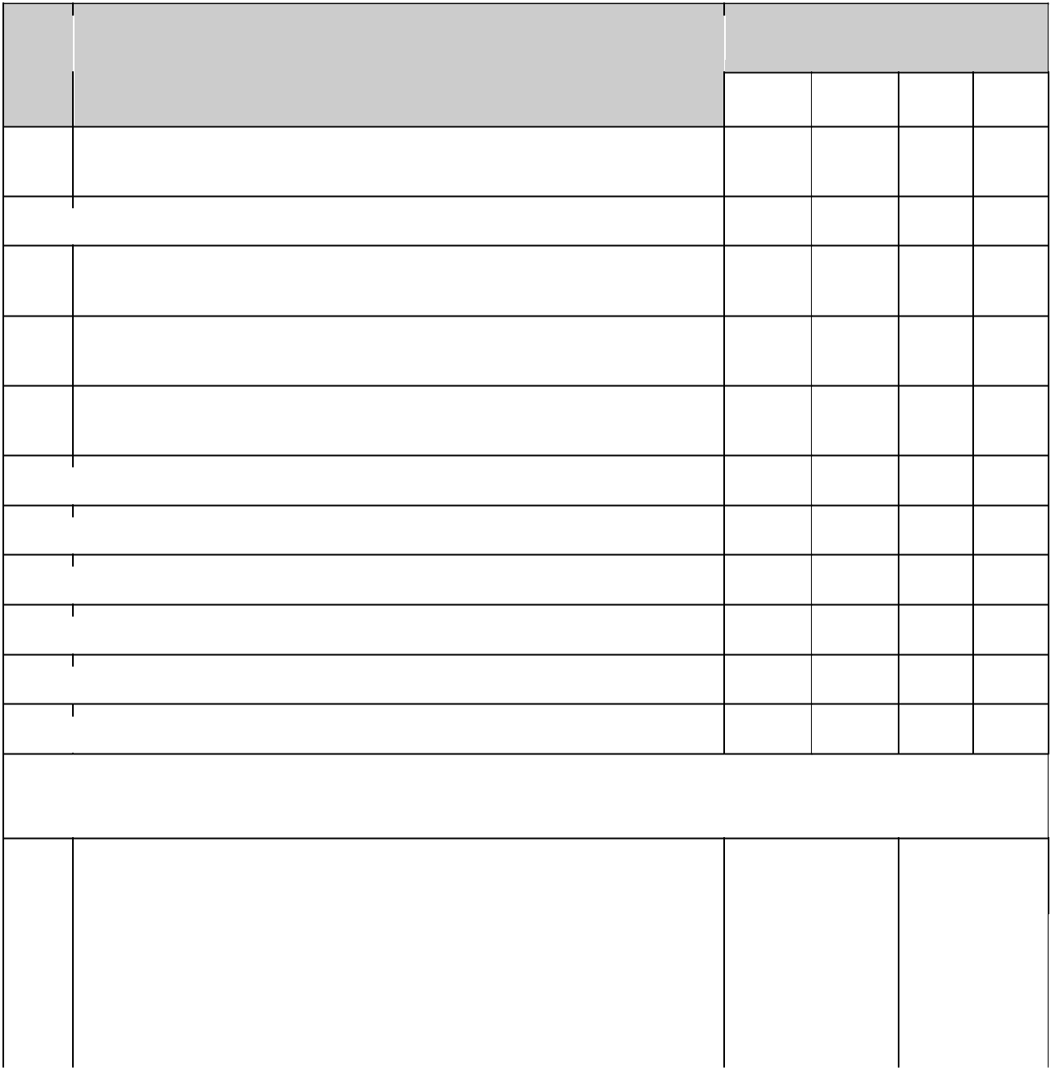

# Requirement Date

- Employees come to work clean and follow good personal hygienic practices during work

2 Employees follow hand washing procedure and wash hands frequently

- Employees wear designated clothing in good repair and follow clothing, headwear, and footwear procedures

- Employees report to management any injury occurred during work and cover it to prevent cross contamination

- Employees with a transmittable disease do not handle food or work in production area

6 Visitor access to facility is controlled

7 Visitors follow personnel practices policy

8 All lids and tamper evident tabs off mix jugs are accounted for

9 Boxes are properly labeled with the correct flavor

10 Ingredients are stored in proper location (nut allergens)

Initials

Corrective Actions

Date |  | Deviation |  | Corrective |  | Corrected
 |  |  |  | Action |  | By:

Reviewed by: _________________________________________ Date: __________________________

PRODUCTION TRAINING MANUAL 23

Product: Clemson Ice Cream

Plant Name: Clemson’s ’55 Exchange Creamery Issue Date: 8/19/20XX
Address: Creamery, Newman Hall, Clemson, SC 29634 Supersedes: 7/20/20XX
_____________________________________________________________________________________

Incident Report/ Corrective Action Form

(This includes personal injury/safety, food quality and/or safety.)

*Personal injury must also complete University Form.

Completed by: _____________________________________________________________

NOTE: When an incident occurs, management must be notified immediately. Follow up by filling in this form and giving it to management.

Information on the incident

Date: ____________________________________________________________________

Time of incident: __________________________________________________________

Nature of incident: ________________________________________________________

Location of incident: ______________________________________________________

Employee name: __________________________________________________________

Description of the incident: _________________________________________________

_________________________________________________________________________

(Complete this section only if the incident affected food safety.)

Supervisor’s name: ________________________________________________________

Shift: ____________________________________________________________________

Product affected: _________________________________________________________

Code Date: _______________________________________________________________

Action taken: _____________________________________________________________

_________________________________________________________________________

Additional comments: _____________________________________________________

_________________________________________________________________________

Supervisor’s signature: ____________________________________________________

Reviewers Signature:___________________________________ Date:_______________

PRODUCTION TRAINING MANUAL 24

Product: Clemson Ice Cream

Plant Name: Clemson’s ’55 Exchange Creamery Issue Date: 8/19/20XX
Address: Creamery, Newman Hall, Clemson, SC 29634 Supersedes: 7/20/20XX
_____________________________________________________________________________________

Daily Sanitation Control Records

 | Pre-Op |  | Start Post-Op |  |  | Comments and | Operator
 | Time: |  | Time: |  | Time:
Sanitation Area and Goal |  |  |  |  |  | Corrections | Initials

Condition of Equipment (Is all equipment

working properly and intact?) (S/U)

Equipment is cleaned and sanitized (no

visible residue, not slimy to touch, etc.)
(S/U)

Prevention of allergen cross contact

(clean after nuts) (S/U/NA)

Tables cleaned and sanitized (S/U)

Floors and wall splash zones cleaned

and sanitized (S/U)

S= Satisfactory
U= Unsatisfactory (write correction to make satisfactory)

NA= Not applicable because nut allergens are run after other products
Verification Signature: Date:

PRODUCTION TRAINING MANUAL 25

Product: Clemson Ice Cream

Plant Name: Clemson’s ’55 Exchange Creamery Issue Date: 8/19/20XX
Address: Creamery, Newman Hall, Clemson, SC 29634 Supersedes: 7/20/20XX
_____________________________________________________________________________________
Semester Creamery Sanitation Tasks

Directions: Place a check in the "Completed" Column once task is complete. Person who completed the task initials in the next column.

Task #

1

2

3

4

5

6

7

8

9

10

11

12

13

14

15

16

Verified by:

Task Completed Initials
Clean rain boots (use red brush)

Clean drying rack (scrub and reorganize)

Clean defrosted -40F freezers (inside and out)

Wipe down sinks, splashguard, under sinks and all surrounding area

Wipe down dry storage shelves and reorganize in creamery

Wipe down dry storage shelves and reorganize in Newman 114

Clean and sanitize tub and lid containers (white storage containers)
Clean and sanitize all buckets

Scrub trash can

Mop dry storage area of creamery

Pressure wash/scrub floors/grout (hose and red brush)

Scrub floor trimming (red brush)

Clean all walls (yellow brush). Sanitize with 200 ppm sanitizer.
Clean hose and nozzle

Wipe down all doors and door handles

Clean windows

Date:

PRODUCTION TRAINING MANUAL 26

