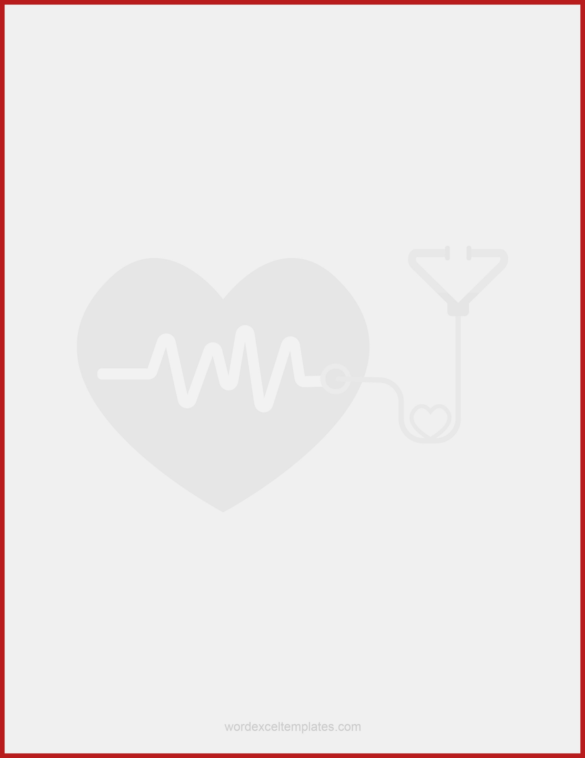­

HHHH+

+555 555 5555

info@email.com

City, State, Zip Code

| Date | Nursing Progress Notes |
| --- | --- |
| 24/05 | |
|  | |
|  | |
|  | |
|  | |
|  | |
|  | |
|  | |
|  | |
|  | |
|  | |
|  | |
|  | |
|  | |
|  | |
|  | |
|  | |
|  | |
|  | |
|  | |
|  | |
|  | |
|  | |
|  | |
|  | |
|  | |

RN

HOSPITAL ABC