Roommate Agreement

Welcome to Nipissing University Residence: your NU Home! The purpose of the Roommate Agreement is to facilitate communication between roommates and mutually establish guidelines for living together. Positive roommate relationships are built on open, honest communication and compromise.

Where to start: The best way to determine how you want to live with roommates is by thinking about your expectations. What do you expect the year ahead to look like? What is important to you when living with others? What makes a good roommate? What are your likes, dislikes, needs, wants, and habits in a living arrangement? What are you willing to compromise on when your roommates' living styles look different from your own? Recognize that your expectations will differ from your roommates, and that’s okay! Review the Residence Community Living Standards (RCLS) for more information.

COVID-19 (Coronavirus) and Your Roommate Agreement:

COVID-19 presents new challenges for roommates and individuals, specifically in regards to health and safety. It is of the utmost importance that you keep your health and safety - and the health and safety of those around you (including roommates) - in mind at all times. As you complete this agreement and engage in a dialogue about living preferences, it is integral that you and your roommates strictly adhere to health and safety rules and guidelines, and respect one another's needs and concerns in relation to these.

Suite/House Number: Complex (circle one): CH GH FH TRC

Roommate Names:
Communication

Communicating openly and honestly is a necessary part of living successfully with others. During COVID-19, communicating with your roommates may look different. While you discuss the prompts below, consider how you will communicate safely and how you might communicate if one or more roommates are unwell.

How do you want to be communicated with regarding regular day-to-day conversation? (Group chats, texting, Snapchat, video calls, DMs, Facebook Messenger, phone calls, face-to-face). How will you communicate if a roommate is unwell? (Video calls can be an excellent substitute if a roommate is unwell).

What communication method will you use should a conflict and/or issue arise? It is recommended that roommates work through conflict face-to-face, unless one or more roommates are unwell, in which case video calling or phone calls are an excellent substitute. Please also discuss how you react during conflicts (becoming quiet, defensive, needing time) and how you will communicate with roommates who have different reactions to conflict than you.

Behavior/Habits

Roommates who make attempts to understand and accommodate each other's differences help build positive roommate relationships! Keep in mind that some roommates may have additional concerns due to COVID-19. It is important to listen to and respect these concerns in order to ensure that you and your roommates feel supported.

Do you have any particular likes or dislikes your roommates should know about? (Loud music, food preparation and/or allergies, scent sensitivity, social activities, swearing/bad words, any pet peeves, etc.)

What are some habits you think your roommates should know about? (Showers/baths, napping, musical instruments, loud talker, sleep walking, cleanliness, etc.)

What concerns do you have about the habits listed above in relation to COVID-19? What can you do as roommates to address these concerns? (e.g. if a roommate takes frequent baths, how can they ensure that the tub is sanitized properly? How can common TV remotes/consoles be wiped down consistently?)

Food, Shopping, & Personal vs. Shared Items

How will we share cupboard, fridge, and freezer space? Will you label what belongs to you?

Will we share food/groceries? (Items to consider: butter, eggs, milk, toilet paper, cleaning supplies, Tupperware). If you are not willing to share food/grocery items, how will you communicate with roommates what is "off limits"? (Ideas to consider: labelling, keeping items in your room, etc.)

How will we split costs if we are grocery shopping for shared items? (Ideas to consider: buying on an equitable rotational schedule, splitting costs equally or sending money to the roommate purchasing the items, etc.) How will we make sure that grocery shopping responsibilities for shared items are shared equitably by all roommates?

How do you feel about lending personal items? (Items to consider: clothes, makeup, games, gaming controls/consoles, electronics, musical instruments, etc.) How will we ask to borrow items? Will guests be allowed to borrow items? What items are off limits?

What items are we willing to share in the shared spaces of our suite/house? (Shared spaces include: bathrooms, living room, kitchen, storage spaces or TRC loft, bedroom hallways) (Items to consider: toaster, microwave, coffee makers, television, video gaming consoles, musical instruments, etc.) What items are off limits?

Guests

Guest include: any individuals who do not live in your suite/house, any individuals living in another Nipissing University residence complex, and any individuals who do not live in one of our residence communities (this could include parents/guardians, siblings, other family members, significant others, friends from outside the residence community, etc.) Refer to pages 10-11 in the Residence Handbook: Residence Community Living Standards (RCLS) for more specific information about guests.

COVID-19 presents additional challenges in regards to guests. It is of the utmost importance that roommates follow provincial and Nipissing University Residence rules and standards for guests.

How far in advance should we know that a guest(s) is visiting? Check the box that all roommates have agreed on.

hour(s) before the guest(s) arrive

week(s) before the guest(s) arrive

day(s) before the guest(s) arrive

Other (elaborate)

Does your above-listed choice change based on your relationship to the guest(s)? (Parents/guardians vs. siblings vs. other family members, vs. significant others, vs. friends not known by all roommates, vs. friends known by all roommates). If yes, detail how this will affect the time frame for alerting your roommates to a guest's visit.

How long can a guest stay? Check the box that all roommates agree on. Note: guests are not permitted to stay for more than 2 nights in a row, and they are not permitted to stay for more than 6 nights in one month (RCLS, page 10). Additionally, guests are not permitted to stay overnight during Orientation Week and during April and December exam periods (RCLS, page 10).

hour(s) 1 night overnight (except during Frosh Week, Orientation

Week, and April/December exams)

2 nights overnight (except during Frosh Week, Orientation Week, and April/December exams)

Other (While following the RCLS guest guidelines)

(elaborate)

When will we not have guests? (This includes not hosting overnight guests during Frosh Week, Orientation Week, and April and December exam periods). Do we prefer guests during the day or at night? Both? Neither?

What do we define as an issue with a guest(s)? (Things to consider: noise level, frequency of visits, undesired behaviour(s), etc.) We will refer to the communication section of our Roommate Agreement when addressing issues related to guests.

Do we have any additional concerns in regards to COVID-19 and guests? How will we address these concerns as roommates? As residents, you are also expected to adhere to provincial and residence guidelines regarding guests, visiting, and safety.

Noise & Sleep

How late is too late for noise? For reference, residence quiet hours are 11PM to 10AM Sunday through Thursday and 1AM - 10AM on Fridays and Saturdays (RCLS, page 9). If there are issues with noise, we will refer to the communication section of our Roommate Agreement.

What time(s) do you like to sleep? (Things to consider: weekend vs. weekday, napping vs. sleeping). When do you like to sleep in? Are you a night owl or an early bird? How much or how little noise do you prefer when you are sleeping?

Study Habits

What are your preferred places to study/do schoolwork within the suite? (Kitchen table, living room, your own bedroom, a few different spaces in the suite?) What time(s) do you like to study/do schoolwork? (Morning vs. night, weekday vs. weekend).

What is your preferred noise level for studying/doing schoolwork? Does this change based on your location in the suite, the time of day, or day of the week? We will refer to the communication section of our roommate agreement to address issues/concerns related to noise and studying.

How will you communicate with each other when you need to participate in an online lecture/seminar/lab, or need the time and space to study/do schoolwork? (Ideas to consider: posting class schedules somewhere prominent, creating a roommate calendar together, etc.)

Parties

Residents are expected to respect and follow residence standards regarding hosting and attending parties in residence. Specific residence standards in regards to parties and partying (guests, alcohol and cannabis policies, noise, etc.) can be found in the RCLS.

What constitutes a "party" vs. "hanging out" vs. "having friends over"? (Things to consider: number of people, environment, noise level, activities involved, etc.)

Residents will follow Residence and provincial rules and guidelines in order to protect the health and safety of the residence community.

When Residence Life notifies residents that it is safe to host a party, will we host a party? Is so, how often do we like to host parties? We will refer to the communication section of our Roommate Agreement to address issues related to "partying" (guests, noise, social activities involved, time frame, time of day/night, etc.)

Do we have any concerns related to parties/partying and COVID-19? How will we address these concerns?

Residents are expected to follow Residence and provincial rules and guidelines in order to play a positive role in keeping everyone in our community healthy and safe!

Alcohol

This section of the Roommate Agreement pertains to residents who are 19 or older. Residents who are 19+ may consume alcohol responsibly within a residence suite/house and bedroom space. Residents may not consume alcohol in common spaces of a residence complex such as residence lounges or hallways. Specific standards related to alcohol in residence can be found on page 8 in the RCLS.

Where in our suite/house is it acceptable to consume alcohol? (Bedroom vs. shared spaces of the suite/house). We will refer to the communication section of our Roommate Agreement when addressing issues related to alcohol consumption in our suite/house.

Do we have any concerns about guests consuming alcohol in our suite/house. What will we do to address these concerns?

Please also consider discussing cannabis (e.g.: if roommates consume cannabis through smoking, how will they ensure that they "air out" clothing items before coming back to campus as cannabis cannot be consumed on campus, level of comfort and accountability surrounding cannabis products and consumption, etc. ) Please refer to the RCLS (page 8) for more information about cannabis specific to residence.

Safety & Security

Every resident has the right to feel safe and secure in residence, and the responsibility to ensure that their actions do not detract from their own safety and security or that of the residence community.

When will we be locking our suite/house door? (Residents must bring their keys with them when leaving their suite/house/complex to avoid being accidentally "locked out"). Check all that apply.

When all of us are home

When none of us are home

When other roommates are home

Everytime we leave the suite/house

Other:

Cleanliness & Cleaning Responsibilities

Roommates must decide how to equitably share cleaning responsibilities in shared spaces. Roommate must sanitize shared spaces once every week according to the cleaning instruction posters in their bathrooms, living room, and kitchen. Refer to page 10 in the RCLS for specific cleanliness standards. A cleaning schedule template is attached to your Roommate Agreement if you'd like to use it!

Shared spaces are spaces used by all residents in a suite/house and include:

Kitchen

Both bathrooms

A/B or 1/2/3 bedroom hallways C/D or 4/5/6 bedroom hallways

Living Room space

Loft (TRC Only) and Storage Spaces

Residents must aim to sanitize their shared spaces once every week according to the posters in the kitchen, bathrooms, and living room. How will we divide these shared sanitizing responsibilities? (Chore charts or calendar schedules are great ways to divide tasks equitably!) We will refer to the communication section of our Roommate Agreement to address issues or conflicts related to cleaning shared spaces.

How often will we do our dishes? Are we responsible for doing our own dishes? Are dishes allowed to stay in the sink or the drying rack? If so, how long? (Some ideas to consider: personal dish bins, keeping dishes in your room until you're ready to wash them, having one set of dishes/cutlery/cups for each resident so you know whose is whose (this can be especially helpful for sanitary purposes!)). We will refer to the communication section of our Roommate Agreement to address issues or conflicts related to dishes.

How will we share the responsibility of taking out the garbage and recycling in our shared spaces? Note: after sanitizing shared spaces according to the posters in your suite/house, garbage must be disposed of immediately in order to maintain the sanitary space you worked hard to clean! We will refer to the communication section of our Roommate Agreement to address issues or conflicts related to garbage/recycling.

What concerns do you have about the shared cleaning tasks in regards to COVID-19? How will you address these concerns as roommates? Are there any additional agreements that you'd like to make as roommates in regards to the shared, above-listed cleaning tasks?

Bathrooms

How will we divide bathroom cleaning tasks? Bathrooms must be sanitized minimally once every week using the instructions on the bathroom cleaning poster. (Some ideas to consider: A/B or 1/2/3 bedrooms clean the A/B or downstairs TRC bathroom and C/D or 4/5/6 bedrooms clean the C/D or upstairs TRC bathroom, sanitizing the tub/shower stall after each use).

What time of day do you prefer to bathe/shower? Will you use a shower schedule?

Additional Expectations

Are there any other living expectations that weren't discussed in the Roommate Agreement that are important to you or your roommate group?

Your Voice is Powerful...

Allowing others, including parents, to advocate for you in a conflict does not mean the conflict will be resolved. You are your own best advocate! Please note that the best way to resolve any conflict is by speaking face-to-face or, to accommodate for healthy & safety, through video call. Notes on white boards, social media messages, texts, or conversations through parents and friends are often misconstrued and can cause conflicts to escalate. For tips on conflict resolution, reach out to your Residence Don or Community Assistant.

We acknowledge that we can negotiate or review our Roommate Agreement at any point during our time together as roommates by discussing it with all roommates present, or by contacting our Residence Don. If we feel the need for changes, all roommates must be present to discuss the changes we wish to implement.

By signing our names below, we are agreeing that we have openly and honestly discussed every item in our Roommate Agreement, that we agree to the values and terms we have outlined in the agreement, and will do our best to continue to communicate openly, honestly, and respectfully with each other.

You've completed your Roommate Agreement! All that's left to do is sign together as roommates and give your agreement to your Residence Don!

Date: Residence Don Signature

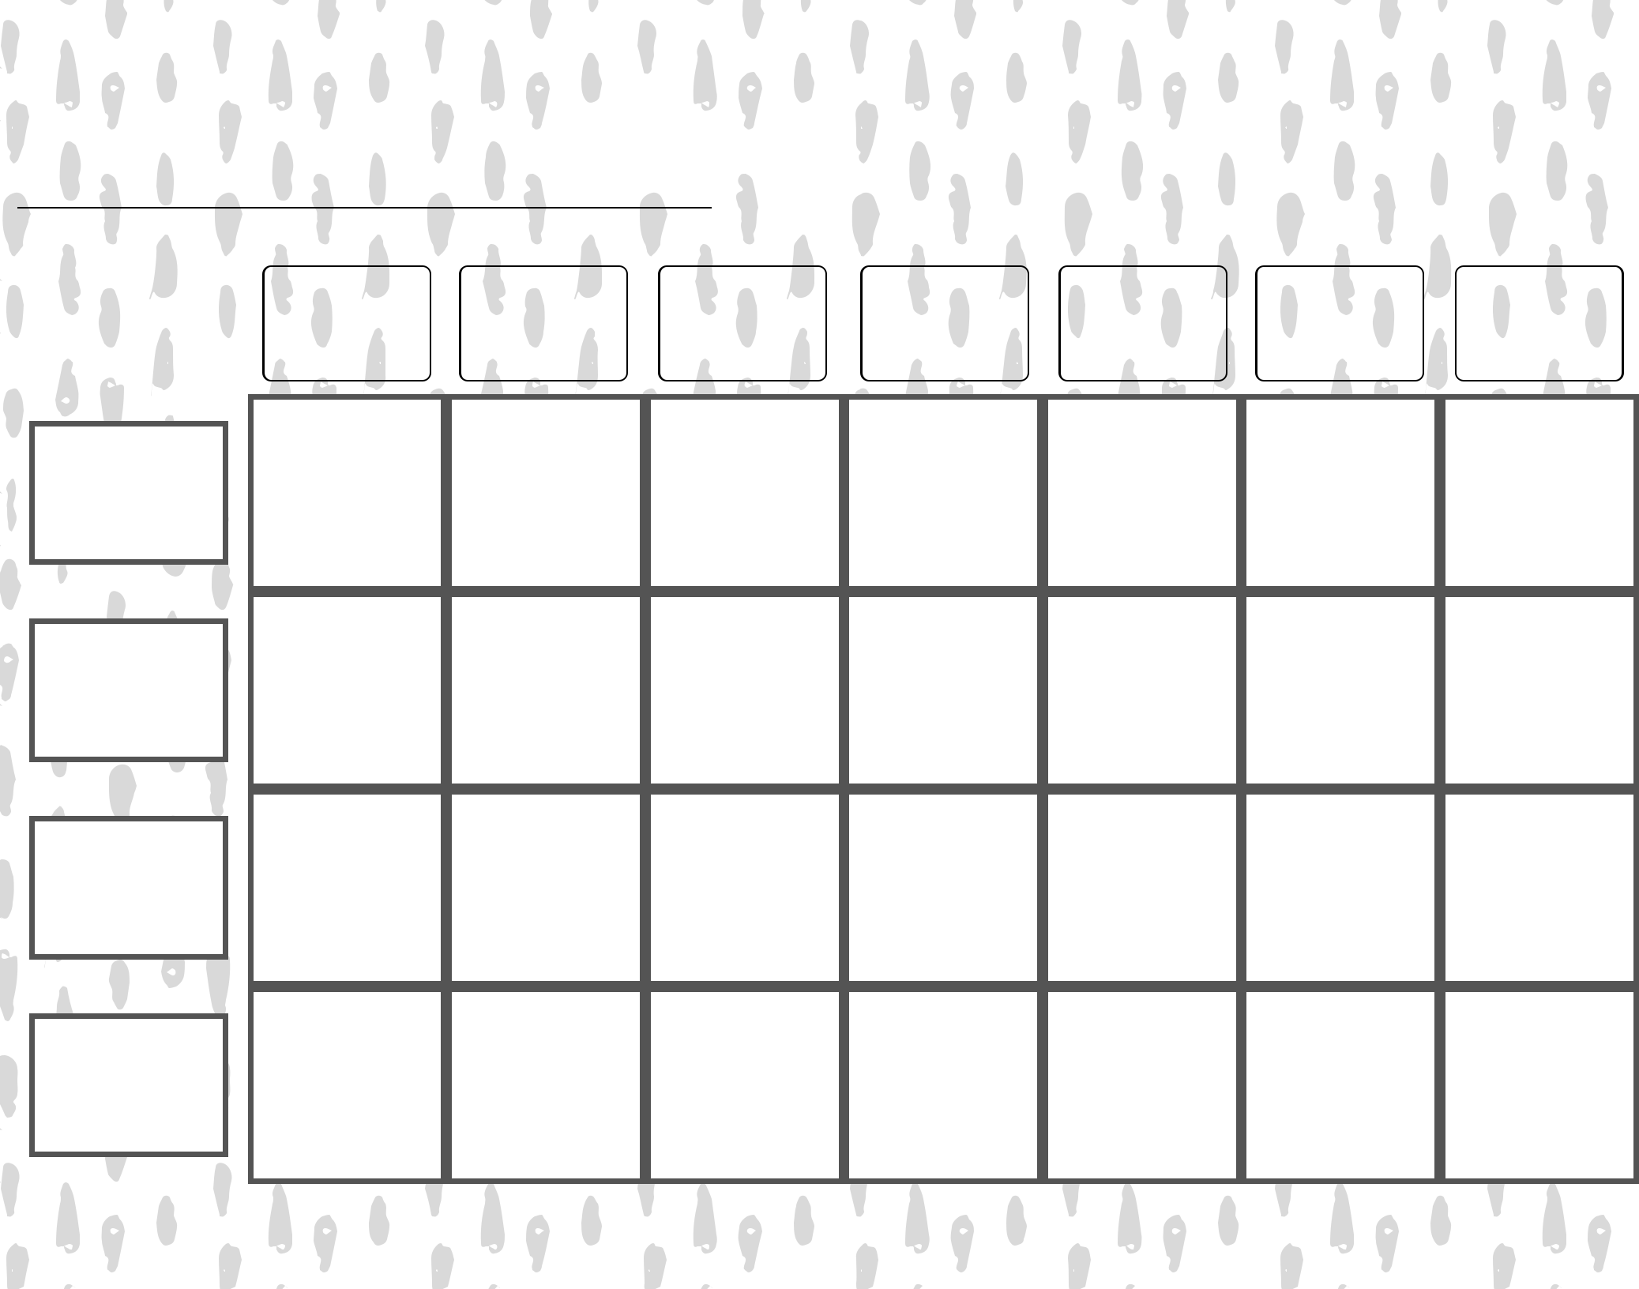Cleaning Schedule

Suite/House Number

Sunday Monday Tuesday Wednesday Thursday Friday Saturday

Names

