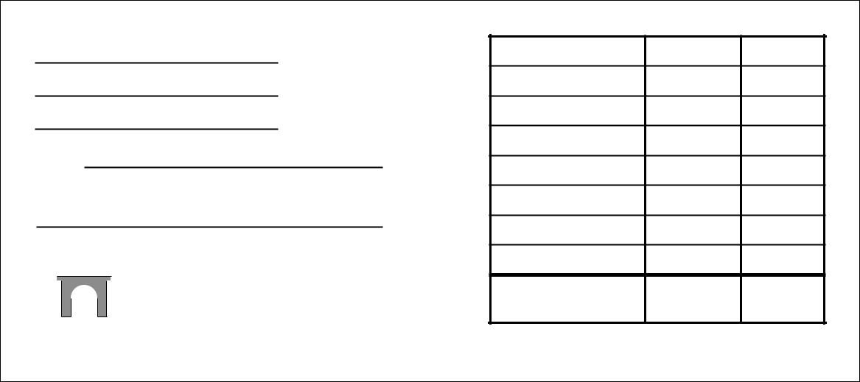DEPOSIT SLIP

DATE

DEPOSITS MAY NOT BE AVAILABLE FOR IMMEDIATE WITHDRAWAL

SIGN HERE FOR CASH RECEIVED (IF REQUIRED)*

ROME
FINANCIAL BANK

DOLLARS CENTS

CASH $100

LIST CHECKS SINGLY

SUB TOTAL

LESS CASH RECEIVED

TOTAL

04 200013 5171151007

