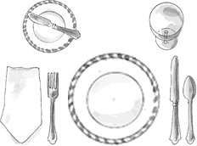

1. Knife blades always face the plate
2. The napkin goes to the left of the fork, or on the plate The bread and butter knife are optional

* Picture the word "FORKS." The order, left to right, is: F for Fork, O for the Plate (the shape!), K for Knives and S for Spoons. (Okay, you have to forget

the R, but you get the idea!)

Some other things to know:

* Holding your hands in front of you, touch the tips of your thumbs to the tips of your forefingers to make a lowercase 'b' with your left hand and a lowercase 'd' with your right hand. This reminds you that "bread and butter" go to the left of the place setting and "drinks" go on the right. Emily Post could have used that trick--she was often confused about which bread and

butter belonged to her--and sometimes she used her neighbor's! In which case, when it was called to her attention, she would

say to the dismayed lady or gentleman, "Oh, I am always mixing them up. Here, please take mine!"

For a basic table setting, here are two great tips to help you--or your kids--

remember the order of plates and utensils:

Basic Table Setting

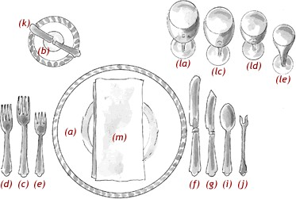

**(d) Fish Fork:** If there is a fish course, this small fork is placed to the left of the dinner fork because it is the first fork used.

**(c) Dinner Fork:** The largest of the forks, also called the place fork, is placed on the left of the plate. Other smaller forks for other

courses are arranged to the left or right of the dinner fork, according to when they will be used.

**(b) Butter Plate:** The small butter plate is placed above the forks at the left of the place setting.

**(a) Service Plate:** This large plate, also called a charger, serves as an underplate for the plate holding the first course, which will be brought to the table. When the first course is cleared, the service plate remains until the plate holding the entree is served, at which

point the two plates are exchanged. The charger may serve as the underplate for several courses which precede the entree.

* Appetizer: Shellfish
* First Course: Soup or fruit Fish Course
* Entree
* Salad

The placement of utensils is guided by the menu, the idea being that you use utensils in an "outside in" order. For the illustrated place

setting here, the order of the menu is:

The one rule for a formal table is for everything to be geometrically spaced: the centerpiece at the exact center; the place settings at equal distances; and the utensils balanced. Beyond these placements, you can vary flower arrangements and decorations as you like.

Formal Place Setting