When in an Early Learning and Childcare setting all children have a useful section within their Profile called ‘All About Me’. For some children more information is needed due to their Additional Support Needs.

The sharing of extra information is crucial at different stages in a Child’s journey through the education system. The main reason for creating an enhanced ‘All About Me’ type of booklet, over and above what is already in their Profile, is to ensure all relevant information is easily accessible and in one place for those who need it.

The booklet should be person-centred, written in the child’s voice, for those who cannot easily speak for themselves. It should be proportionate to need and fit for purpose. Some could be more detailed to support the child’s transition or new staff. Others could be more streamlined and only hold key information about the child.

Booklets are a way of gathering complex information together and presenting it in an easy to read format. They should follow these key principles from CALL Scotland:

* *Present the person positively as an individual, not as a set of 'problems' or disabilities;*
* *Provide a place for the person's own views and preferences to be recorded and drawn to the attention of others;*
* *Reflect the person's unique character, sense of humour etc.;*
* *Describe the person's most effective means of communication and how others can best communicate with, and support the person;*
* *Draw together information from past and present, and from different contexts, to help staff and conversation partners understand the person and have successful interactions;*
* *Place equal value on the views of all who know the person well, as well as the views of the specialist professionals*.

Other topics covered within an ‘All About Me’ booklet could be:

* Sensory needs and strategies to help with self-regulation
* Personal Care Needs
* Reference to Protocols and other information staff should refer to including medical needs
* Strategies which best support the child’s play, social interaction and learning
* Motivators, triggers and positive behaviour supports

These booklets could be hand-written or electronic but compiled with a sensitive approach so as to respect the wishes of the child and family around content and who the booklet is shared with. It is important to consider storage and access to maintain confidentiality.

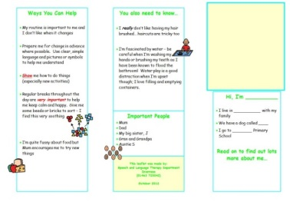Various forms of this type of booklet exist and information, templates and examples are readily available online. Choose one which best suits the child and the main purpose for sharing information or make up your own. Try:

CALL Scotland https://www.communicationpassports.org.uk/About/

# An example of a tri-fold Communication Passport from Speech and Language Therapy Department, Inverness, (01463 720042)

The following document is one example of an **enhanced** ‘All About Me’ booklet.

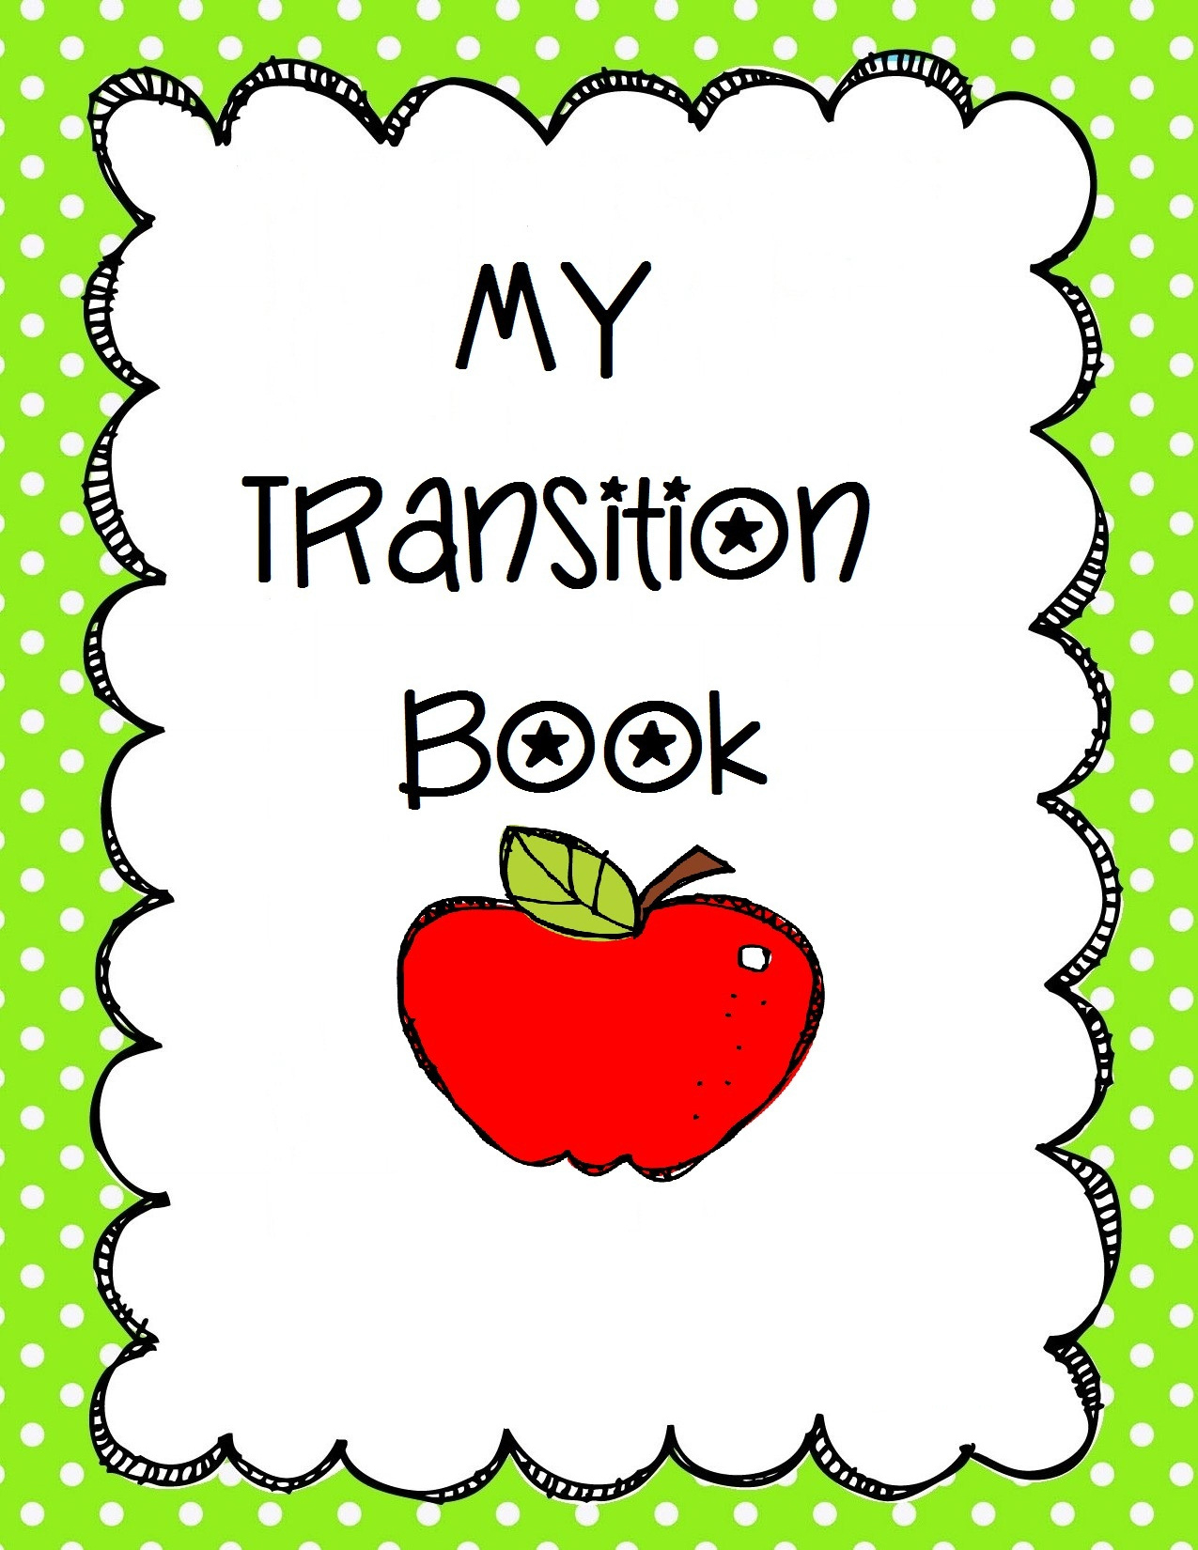

My

All About Me

Book

**By**



**My name is**

**My birthday is on**





Photos here

I live at home with

Important Information

**A Bit Of Information About Me**



**Some More Info About Me**

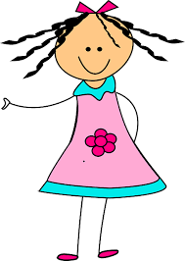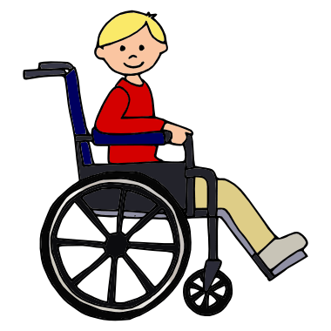

My favourite things to do and play with are

My favourite things to eat and drink are

If I am happy I will

If I am unhappy I will

Things I can do for myself are

Things I need someone to help me with or do for me are

How I come to ELC/ school

My buddy is ____________________

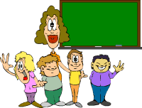

**Some Things My Key Worker/ Teacher and PSAs Should Know About Me**

**PSA**

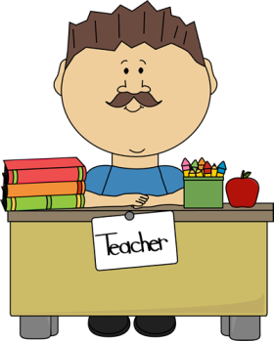



**More Information, Tips and Strategies I Think You Should Know**

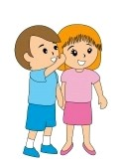

**Sometimes I Cannot Express Myself The Way I’d Like. Here Are Some Tips On What I Do And What I Mean**

**How I Communicate With You**



**Things I Don’t Like and Things that Bother Me**

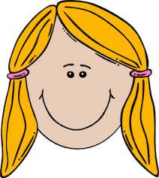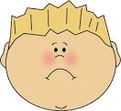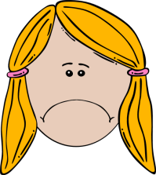

**How You Can Help To Put Me At Ease**



**Support I Might Need During Breaks, Inside and Outside**

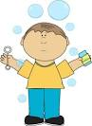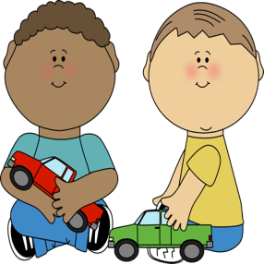



**Support I Might Need to Eat My Snack or Lunch**

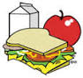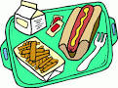



**Support I Might Need with Personal Care**

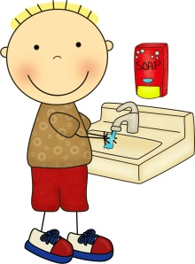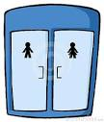



**It is really important that this booklet, or one similar, is kept up to date with relevant information to help new people get to know me and how best to work with me.**

**This is the responsibility of the person co-ordinating my future transitions.**

PLEASE DO NOT LEAVE THIS BOOKLET LYING AROUND FOR OTHER PEOPLE TO READ.

THANK YOU

**IMPORTANT:**

**Contact Information:**